Employment in the United States

Bryant & Stratton college | Mr. McKay

Workplace Math 101

RI. BOWMAN.YOLANDA.m

2019

|  |
| --- |
| The U.S. Department of Labor, Bureau of Labor Statistics (BLS) provides data of the employment history. The facts are based on the current growth in the economy trends. Then separated by age, sex, and other characteristics. As of Oct 2019, the unemployment rate for the United States was at 3.7. Virginia's independently at 5.4 for the state. The information is reflecting from a rise of 130,000 temporary positions of employment across the state. Rates haven't been robust since The Great Recession of 2009 when employment rates were at 9.9, overall. According to the department of Labor, 514,355 people were unemployed. In  2004, The Labor Force was at 15%. The Labor Statistics for 2024 predictions conclude that this should decreased to 11%. |

Civilian Labor Force in the United States from 2004 to 2024

Age 16-24 25-54 55 and older

2004 22,268 102,122 23,011

2014 21,295 100,767 33,860

2024 18,498 104,697 40,575

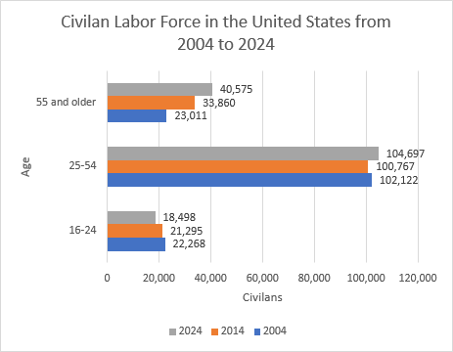

|  |  |  |  |
| --- | --- | --- | --- |
| Sources: U.S. Department of Labor, Bureau of Labor Statistics. |  |  |  |

|  |  |  |  |  |
| --- | --- | --- | --- | --- |
| In 2004, The Labor Force was at 15%, Over the years, the 2024 statistics conclude that has decreased to 11%. |  |  |  |  |
|  |  |  |  |  |
|  |  |  |  |  |
|  |  |  |  |  |

|  |  |  |  |  |  |  |  |  |
| --- | --- | --- | --- | --- | --- | --- | --- | --- |
| United States Unemployment Rate from 2007 to 2014 |  |  |  |  |  |  |  |  |
| Year | 2007 | 2008 | 2009 | 2010 | 2011 | 2012 | 2013 | 2014 |
| Unemployment Rate | 4.60% | 5.80% | 9.30% | 9.60% | 8.90% | 8.10% | 7.40% | 6.20% |
| Employed | 95.40% | 94.20% | 90.70% | 90.40% | 91.10% | 91.90% | 92.60% | 93.80% |
|  |  |  |  |  |  |  |  |  |

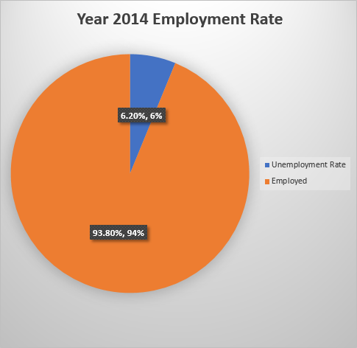

|  |  |  |  |  |  |  |  |
| --- | --- | --- | --- | --- | --- | --- | --- |
| The U.S. unemployment trend decreases for years 2007 -2014 by 3%. Although, unemployment rates spiked until 2010, but slowly increased thereafter. |  |  |  |  |  |  |  |
|  |  |  |  |  |  |  |  |

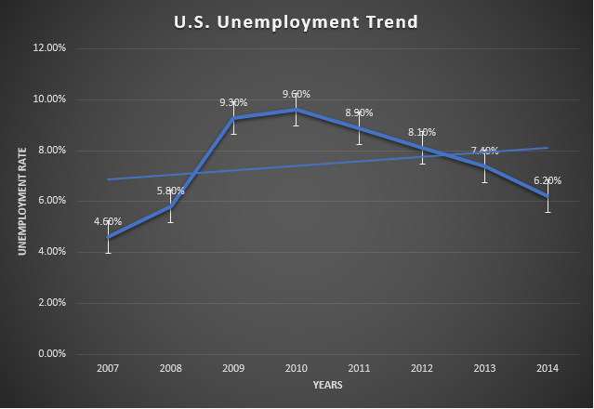

|  |
| --- |
| Sources: U.S. Department of Labor, Bureau of Labor Statistics. |

|  |
| --- |
| In Conclusion, Human Resources support knowledge, skills and capabilities of gathered information within the workplace. The company or employer would like to have factual resources available for the timeline given. The ability to organize and categorize all gather information is essential when following state and federal laws. As well as, being able to create and produce official documents for developmental presentations for guidance. I am attending Bryant & Stratton College as a Human Resources Specialist. Our goal is to organize and specifying the importance of the task to achieve goals in a timely manner. |

|  |  |  |  |  |
| --- | --- | --- | --- | --- |
|  |  |  |  |  |
|  |  |  |  |  |
|  |  |  |  |  |