Arcane Corporation Growth Strategy: Technological Recommendations
Laura M. Ross
Bryant and Stratton College

Contents
Technical Recommendation Overview 4
Current Infrastructure 4
Personnel 4
Software 4
Scope of Growth Future Infrastructure Planning 5
Overview 5
Timeline 6
Stakeholders 6
Anticipated Software Needs 7
Windows Server Needs 8
Active Directory Design and Domain Structure 10
Equipment 12
Servers 12
Routers 13
Switches 13
Firewalls 14
IP Addressing 14
Subnets 14
Static IP Addresses 15
Network Layout 21
Bibliography 25

Technical Recommendation Overview
Arcane Corporation is experiencing tremendous growth, and as such needs to expand its technological infrastructure to keep pace with increased demands. The company currently employs approximately 500 individuals, comprises 5 departments, and expects to achieve a 10 percent growth each year for the next 5 years. This network plan is based on a 5-year projection and must allow for scalability. It is expected that an additional 300 employees will be hired within that timeframe. Additionally, a new operations center will be constructed and equipped, and this is anticipated to be completed within the next year. This technical needs assessment and recommendation report will incorporate the anticipated growth requirements and propose timelines, equipment needs, network design, network deployment, and security considerations.

Current Infrastructure
The current center of operations is located in Orlando, Florida. The current network infrastructure includes:

Personnel
Currently the Orlando departments employ the following number of individuals (approximate): 500
- Administration Department: 14
- Marketing Department: 42
- Sales Department: 45
- IT Department: 14
- Accounting Department: 385

Software
- Office 365: 504 licenses
- Database: Oracle
- Adobe Acrobat Pro: 40 licenses
- Cisco Webex: 35 licenses
- Adobe Creative Suite Subscriptions: 22 licenses
- Windows Server 2016 Standard: 16 licenses
- Accounting Software

Scope of Growth Future Infrastructure Planning

Overview
Future infrastructure will need to accommodate a 10% annual growth. Employee expected growth is as follows:
Year | Administration Dept. | Marketing Dept. | Sales Dept. | IT Dept. | Accounting Dept. | Total Employees by Year End
1 | 15 | 45 | 50 | 16 | 424 | 550
2 | 16 | 51 | 55 | 17 | 466 | 605
3 | 18 | 56 | 60 | 19 | 512 | 665
4 | 20 | 61 | 66 | 21 | 564 | 732
5 | 22 | 67 | 73 | 23 | 620 | 805

The goal of this project is to account for this growth and plan toward future scalability. This plan may include incorporating cloud services with on-site services, as well as server virtualization.
An operations center is planned for Seattle, Washington, and this center is expected to house state-of-the-art technology. Because the two locations will need fast communications an ultra-high-speed network will be necessary.

Timeline
The new operations center purchasing, inventory control, installation, quality control and testing, and final rollout is expected to take 8 months and is anticipated to be completed in January 2020.

Stakeholders
Stakeholders: Each department will need to be incorporated into the plan. As department needs expand so will technology concerns. With departments spanning coast-to-coast good communication and active workgroup participation is needed. Weekly touch-base meetings will include all those listed below. Core group meetings will include all department heads or designee and be scheduled as the project requires.
- Administration Department:
  - CEO as needed
  - COO as needed
- IT Department:
  - Department Director
  - Transformation Team Lead
  - Project Specialists
- Marketing Department:
  - Department Director
  - Creative Director
- Accounting Department:
  - Department Director
  - Team Leads as needed
- Sales Department:
  - Department Director
  - Team Leads as needed

Anticipated Software Needs
The core software needs for the organization include office suite software (email, word processing, spreadsheet, presentation, database), professional creative software, accounting software, and SaaS virtual meeting software. Based on the anticipated employee increase and new Operations Center the following new/additional software licenses are recommended (by year):
Year | Office Suite Software* | Creative Software for Marketing Needs | Accounting Software | Virtual Meeting Software (including optional video, screen share, and recording features)
1 | 50 | 3 | 39 | 2
2 | 55 | 6 | 42 | 2
3 | 60 | 5 | 46 | 3
4 | 67 | 5 | 52 | 2
5 | 73 | 6 | 56 | 3
Total | 305 | 25 | 235 | 12
* Some office suite software supplies multiple installs per license. This is not accounted for in these numbers

Creative software is now licensed as a SaaS cloud service. This means increased bandwidth needs as image files are quite large. Because of this, the marketing department will need fast connections with ample bandwidth speeds to each workstation. The accounting department is the largest department within the organization and they access the custom database as well as accounting software. Each user does not require a lot of bandwidth, but in aggregate they will need sufficient for accessing the Seattle database. Additionally, newer versions of the accounting software are offered as a cloud SaaS solution with several desirable feature add-ons. It is suggested that a security assessment be conducted, and once completed this be strongly considered as a good alternative. The virtual meeting software will take a moderate amount of bandwidth. There are expected to be anywhere from 2 to 10 meetings per day using the service, and minimum data speed recommended is 8 Mbps. This is well within the expected bandwidth allotted for each work station, and special consideration should not be necessary.

Windows Server Needs
To determine Windows Server needs the first consideration must be the new datacenter. Current file and application servers can be replaced with state-of-the-art datacenter servers at the new location. A WAN with High-speed 10 Gigabit Ethernet connections will facilitate fast communication from the corporate office in Orlando, Florida to the Seattle, Washington location. These new servers will be virtualized to maximize their potential and increase efficiency.
The Orlando office will continue to use the DHCP, DNS, Print, and Proxy Servers currently in service. The Seattle office will purchase and maintain their own DHCP, DNS, Print, Proxy, and Backup Servers as well as the File Servers, Database Servers, Application Servers, Email Servers for use by all Arcane Corporation employees. Backup Servers will be housed at both locations.
The server roles and services needed for both are listed below:
- Active Directory Certificate Service to create security certificates
- Active Directory Domain Services (for network authentication)
- DNS Server for domain name resolution
- DHCP Server role for IP address assignment
- File and Storage services
- Group Policy Management
- Hyper-V for vitualization of servers (this will increase efficiency and decrease cost)
- Print and Document Services to oversee network printers
- Remote Access for VPN access
- Volume Activation Services to install and manage Windows OS
- Windows Server Update Services to manage Windows updates
- SMTP server for email
- SNMP Service to monitor network usage and performance

Active Directory Design and Domain Structure
Windows Active Directory consists of the primary domain, www.arcanecorp.com, containing all departments within. There are two sites, but to begin with there will be one domain. This will keep departments together so the various department employee and management OUs aren’t split by location. In the future, the organization may require two sub-domains. This will be closely monitored, and if sub-domains are required the structure can be amended and various OUs split according to location.
The active directory structure, showing how organizational units are arranged, is shown on the following page.

Equipment

Servers
It is recommended that 11 servers be purchased for the Orlando and Seattle locations. The table below provides a guide for specification recommendations based on the server’s purpose.

Server Type | CPU | Memory | Storage | Purpose
Server 1 (Orlando)  DHCP  DNS  Print  Email | Intel Xeon Processor Family | 32GB | 6TB HDD | Provide IP address assignment, domain name resolution, print services for network printers, and email services
Server 2 (Seattle)  DHCP  DNS  Print  Email | Intel Xeon Processor Family | 32GB | 6TB HDD | Provide IP address assignment, domain name resolution, print services for network printers, and email services
Server 3 (Seattle)  Application  File  Database | Intel Xeon Processor Family | 64GB | 2x10TB HDD | Host in-house applications, house files and databases. The application and databases will be available for the Orlando office.
Server 4 (Seattle)  mirror of 3 | Intel Xeon Processor Family | 64GB | 2x10TB HDD | Host in-house applications, house files and databases.
Server 5 (Orlando)  File | Intel Xeon Processor Family | 32GB | 4TB HDD | Host files
Server 6 (Orlando)  mirror of 5 | Intel Xeon Processor Family | 32 GB | 4TB HDD | Host files
Server 7 (Orlando)  Proxy | Intel Xeon Processor Family | 64 GB | 150GB HDD | Provide gateway from internal network and external network
Server 8 (Seattle)  Proxy | Intel Xeon Processor Family | 128 GB | 300GB HDD | Provide gateway from internal network and external network
Server 9 (Orlando)  Backup | Intel Xeon Processor Family | 64 GB | 5x10TB HDD | Backup file, database, application, email servers
Server 10 (Seattle)  Backup | Intel Xeon Processor Family | 64 GB | 5x 10TB HDD | Backup file, database, application, email servers
Server 11 (Orlando)  Primary Domain Controller 1 | Intel Xeon Processor Family | 16 GB | 50 GB  HDD | Primary domain controller for network authentication
Server 12 (Seattle)  Backup  Domain  Controller | Intel Xeon Processor Family | 32 GB | 100 GB  HDD | Secondary domain controller for network authentication

Routers
The Orlando office currently has 3 wireless access points for the conference rooms, as well as two Cisco 4000 Series Integrated Services Routers connecting the current subnets. The Orlando office will require one router that connects the Administration and Sales Departments subnets, one router that connects the Marketing and IT Departments subnets, a router for the Accounting department subnet, and these three routers will connect to a Cisco Network Convergence System 5000 Series router acting as the primary default gateway router.
The Seattle office will have six wireless access points for the various conference rooms, one router that connects the Administration and Sales Departments subnets, one router that connects the Marketing and IT Departments subnets, a router for the Accounting department subnet, and these three routers will connect to a Cisco Network Convergence System 5000 Series router acting as the primary default gateway router (and to connect the WAN).

Switches
There are currently 20 (28 port) switches connecting all devices in the Orlando office. By the end of year 5 approximately 32 (28 port) switches will be needed to accommodate all devices on the network. It is recommended to purchase Cisco brand switches, as the routers are currently Cisco and maximum interoperability is ideal.

Firewalls
The organization will use both host-based and network-based firewalls. The perimeter of each network will have a dedicated (hardware) firewall to prevent threats. Host-based firewall configurations will be done via Group Policy, with careful attention to public network firewall settings. VPN will be used, so associated ports should be open for those with VPN access (for
instance SSTP requires port 443 be open).

IP Addressing
The DHCP server will be configured to provide IP addressing. Both private and public IP addresses will be used.

Subnets
The following subnets will be used
Site | Department | IP Address Range | Subnet Mask
Orlando | Administration | 172.17.0.1 - 172.17.0.100 | 255.255.255.0
 | Sales | 172.17.1.1- 172.17.1.100 | 255.255.255.0
 | Marketing | 172.17.2.1 - 172.17.2.100 | 255.255.255.0
 | IT | 172.17.3.1 - 172.17.3.100 | 255.255.255.0
 | Accounting | 172.18.0.1 - 172.18.127.254 | 255.255.128.0
 | Servers | 172.17.4.1 - 172.17.4.17 | 255.255.255.0
 | Router inter-connection | 172.17.5.1 - 172.17.5.6 | 255.255.255.0
Seattle | Administration | 172.20.0.1 - 172.20.0.100 | 255.255.255.0
 | Sales | 172.20.1.1- 172.20.1.100 | 255.255.255.0
 | Marketing | 172.20.2.1 - 172.20.2.100 | 255.255.255.0
 | IT | 172.20.3.1 - 172.20.3.100 | 255.255.255.0
 | Accounting | 172.21.0.1 - 172.21.127.254 | 255.255.128.0
 | Servers | 172.20.4.1 - 172.20.4.21 | 255.255.255.0
 | Router inter-connection | 172.20.5.1 - 172.20.5.6 | 255.255.255.0

Static IP Addresses
Site | Resource | Device Name | IP Address - Static | Subnet Mask
Orlando | Server | Server 1 DHCP | 172.17.4.1 | 255.255.255.0
 | Server | Server 1 DNS | 172.17.4.2 | 255.255.255.0
 | Server | Server 1 Print | 172.17.4.3 | 255.255.255.0
 | Server | Server 1 Email | 172.17.4.4 | 255.255.255.0
 | Server | Server 5 File | 172.17.4.5 | 255.255.255.0
 | Server | Server 6 File | 172.17.4.6 | 255.255.255.0
 | Server | Server 7 Proxy | 172.17.4.7 | 255.255.255.0
 | Server | Server 9 Backup | 172.17.4.8 | 255.255.255.0
 | Server | Server 11 Primary Domain Controller | 172.17.4.9 | 255.255.255.0
 | Access Point | Wireless Access Point 1 | 172.17.0.5 | 255.255.255.0
 | Access Point | Wireless Access Point 2 | 172.17.1.4 | 255.255.255.0
 | Access Point | Wireless Access Point 3 | 172.18.0.5 | 255.255.128.0
 | Router | Primary Default Gateway Router | 176.201.0.1 external  172.17.4.10 Interface for Server Subnet (A)  172.17.4.11 Interface for Server Subnet (B)  172.17.5.1 Interface for Router 1  172.17.5.2 Interface for Router 2  172.17.5.3 Interface for Router 3 | 255.255.0.0  255.255.255.0  255.255.255.0  255.255.255.0  255.255.255.0  255.255.255.0
 | Router | Default Gateway Router 1 Interface for Subnet 1 | 172.17.0.1 | 255.255.255.0
 | Router | Default Gateway Router 1  Interface for Subnet 2 | 172.17.1.1 | 255.255.255.0
 | Router | Default Gateway Router 1  Interfaces for Server Subnet | 172.17.4.12 (A)  172.17.4.13 (B) | 255.255.255.0  255.255.255.0
 | Router | Default Gateway Router 1 Interface for Primary Default Gateway | 172.17.5.4 | 255.255.255.0
 | Router | Default Gateway Router 2  Interface for Subnet 3 | 172.17.2.1 | 255.255.255.0
 | Router | Default Gateway Router 2 Interface for Subnet 4 | 172.17.3.1 | 255.255.255.0
 | Router | Default Gateway Router 2  Interfaces for Server Subnet | 172.17.4.14 (A)  172.17.4.15 (B) | 255.255.255.0  255.255.255.0
 | Router | Default Gateway Router 2 Interface for Primary Default Gateway | 172.17.5.5 | 255.255.255.0
 | Router | Default Gateway Router 3 Interface for Subnet 5 | 172.18.0.1 | 255.255.128.0
 | Router | Default Gateway Router 3  Interface for Server Subnet | 172.17.4.16 (A)  172.17.4.17 (B) | 255.255.255.0  255.255.255.0
 | Router | Default Gateway Router 3 Interface for Primary Default Gateway | 172.17.5.6 | 255.255.255.0
 | Printer | Printer 1 | 172.17.0.2 | 255.255.255.0
 | Printer | Printer 2 | 172.17.0.3 | 255.255.255.0
 | Printer | Printer 3 | 172.17.1.2 | 255.255.255.0
 | Printer | Printer 4 | 172.17.2.2 | 255.255.255.0
 | Printer | Printer 5 | 172.17.3.2 | 255.255.255.0
 | Printer | Printer 5 | 172.18.0.2 | 255.255.128.0
 | Printer | Printer 6 | 172.18.0.3 | 255.255.128.0
 | Fax Machine | Fax Machine 1 | 172.17.0.4 | 255.255.255.0
 | Fax Machine | Fax Machine 2 | 172.17.1.3 | 255.255.255.0
 | Fax Machine | Fax Machine 3 | 172.17.2.3 | 255.255.255.0
 | Fax Machine | Fax Machine 4 | 172.17.3.3 | 255.255.255.0
 | Fax Machine | Fax Machine 5 | 172.18.0.4 | 255.255.128.0
Seattle | Server | Server 2 DHCP | 172.20.4.1 | 255.255.255.0
 | Server | Server 2 DNS | 172.20.4.2 | 255.255.255.0
 | Server | Server 2 Print | 172.20.4.3 | 255.255.255.0
 | Server | Server 2 Email | 172.20.4.4 | 255.255.255.0
 | Server | Server 3 Application | 172.20.4.5 | 255.255.255.0
 | Server | Server 3 File | 172.20.4.6 | 255.255.255.0
 | Server | Server 3 Database | 172.20.4.7 | 255.255.255.0
 | Server | Server 4 Application | 172.20.4.8 | 255.255.255.0
 | Server | Server 4 File | 172.20.4.9 | 255.255.255.0
 | Server | Server 4 Database | 172.20.4.10 | 255.255.255.0
 | Server | Server 8 Proxy | 172.20.4.11 | 255.255.255.0
 | Server | Server 10 Backup | 172.20.4.12 | 255.255.255.0
 | Server | Server 11 Domain Controller | 172.20.4.13 | 255.255.255.0
 | Access Point | Wireless Access Point 1 | 172.20.0.6 | 255.255.255.0
 | Access Point | Wireless Access Point 2 | 172.20.1.5 | 255.255.255.0
 | Access Point | Wireless Access Point 3 | 172.20.2.5 | 255.255.255.0
 | Access Point | Wireless Access Point 4 | 172.20.3.4 | 255.255.255.0
 | Access Point | Wireless Access Point 5 | 172.21.0.7 | 255.255.128.0
 | Access Point | Wireless Access Point 6 | 172.21.0.8 | 255.255.128.0
 | Router | Primary Default Gateway Router | 176.201.0.2 external  172.20.4.14 Interface for Server Subnet (A)  172.20.4.15 Interface for Server Subnet (B)  172.20.5.1 Interface for Router 1  172.20.5.2 Interface for Router 2  172.20.5.3 Interface for Router 3 | 255.255.0.0  255.255.255.0  255.255.255.0  255.255.255.0  255.255.255.0  255.255.255.0
 | Router | Default Gateway Router 1  Interface for Subnet 1 | 172.20.0.1 | 255.255.255.0
 | Router | Default Gateway Router 1  Interface for Subnet 2 | 172.20.1.1 | 255.255.255.0
 | Router | Default Gateway Router 1  Interfaces for Server Subnet | 172.20.4.16 (A)  172.20.4.17 (B) | 255.255.255.0  255.255.255.0
 | Router | Default Gateway Router 1 Interface for Primary Default Gateway | 172.20.5.4 | 255.255.255.0
 | Router | Default Gateway Router 2 Interface for Subnet 3 | 172.20.2.1 | 255.255.255.0
 | Router | Default Gateway Router 2 Interface for Subnet 4 | 172.20.3.1 | 255.255.255.0
 | Router | Default Gateway Router 2 Interfaces for Server Subnet | 172.20.4.18 (A)  172.20.4.19 (B) | 255.255.255.0  255.255.255.0
 | Router | Default Gateway Router 2 Interface for Primary Default Gateway | 172.20.5.5 | 255.255.255.0
 | Router | Default Gateway Router 3  Interface for Subnet 5 | 172.21.0.1 | 255.255.128.0
 | Router | Default Gateway Router 3  Interfaces for Server Subnet | 172.20.4.20 (A)  172.20.4.21 (B) | 255.255.255.0  255.255.255.0
 | Router | Default Gateway Router 3 Interface for Primary Default Gateway | 172.20.5.6 | 255.255.255.0
 | Printer | Printer 1 | 172.20.0.2 | 255.255.255.0
 | Printer | Printer 2 | 172.20.0.3 | 255.255.255.0
 | Printer | Printer 3 | 172.20.1.2 | 255.255.255.0
 | Printer | Printer 4 | 172.20.1.3 | 255.255.255.0
 | Printer | Printer 5 | 172.20.2.2 | 255.255.255.0
 | Printer | Printer 6 | 172.20.2.3 | 255.255.255.0
 | Printer | Printer 7 | 172.20.3.2 | 255.255.255.0
 | Printer | Printer 8 | 172.21.0.2 | 255.255.128.0
 | Printer | Printer 9 | 172.21.0.3 | 255.255.128.0
 | Printer | Printer 10 | 172.21.0.4 | 255.255.128.0
 | Fax Machine | Fax Machine 1 | 172.20.0.4 | 255.255.255.0
 | Fax Machine | Fax Machine 2 | 172.20.0.5 | 255.255.255.0
 | Fax Machine | Fax Machine 3 | 172.20.1.4 | 255.255.255.0
 | Fax Machine | Fax Machine 4 | 172.20.2.4 | 255.255.255.0
 | Fax Machine | Fax Machine 5 | 172.20.3.3 | 255.255.255.0
 | Fax Machine | Fax Machine 6 | 172.21.0.5 | 255.255.128.0
 | Fax Machine | Fax Machine 6 | 172.21.0.6 | 255.255.128.0

Network Layout
The following diagrams are a suggested layout of the key network connections, including servers, routers, switches, and wireless access points. The diagram shows the layout of the Orlando office, which will be the basic layout for the Seattle office as well. The structure maximizes redundancy in the connections. In the event of a switch or router failure only isolated groups will be affected.

The WAN carrier technology recommended is OC-3, which is a standardized transmission rate for WAN over fiber optic cabling. OC-3 has transmission rates of 155.52 Mbps. The protocol that will be used is Multiprotocol Label Switching (MPLS), which is a packet-switching technology that supports variable-length frames. It is a connection-oriented protocol and is compatible with the Cisco routers that are in use.
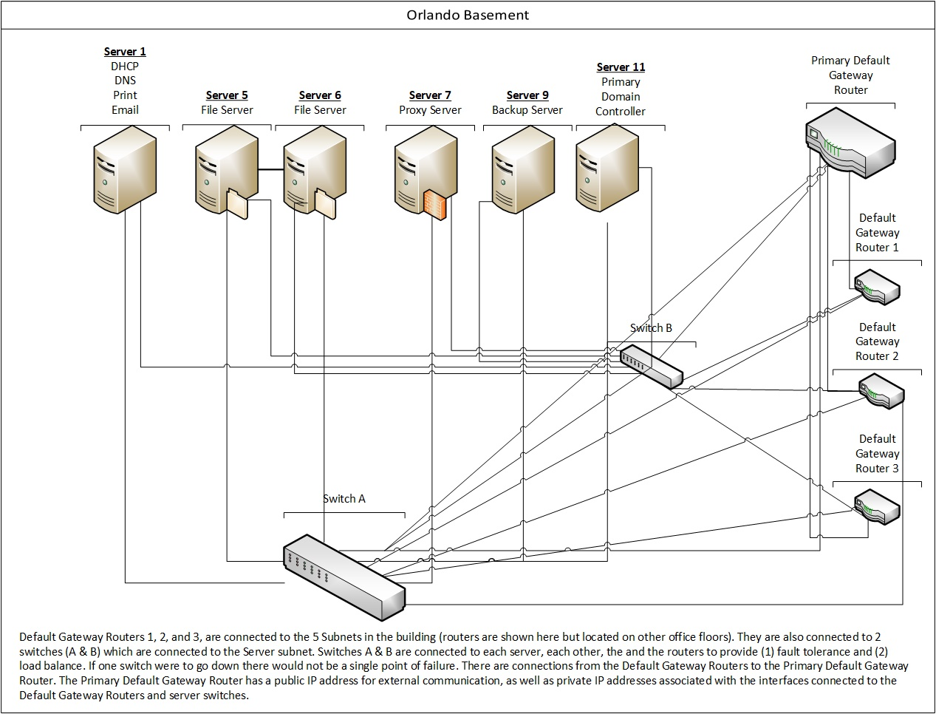
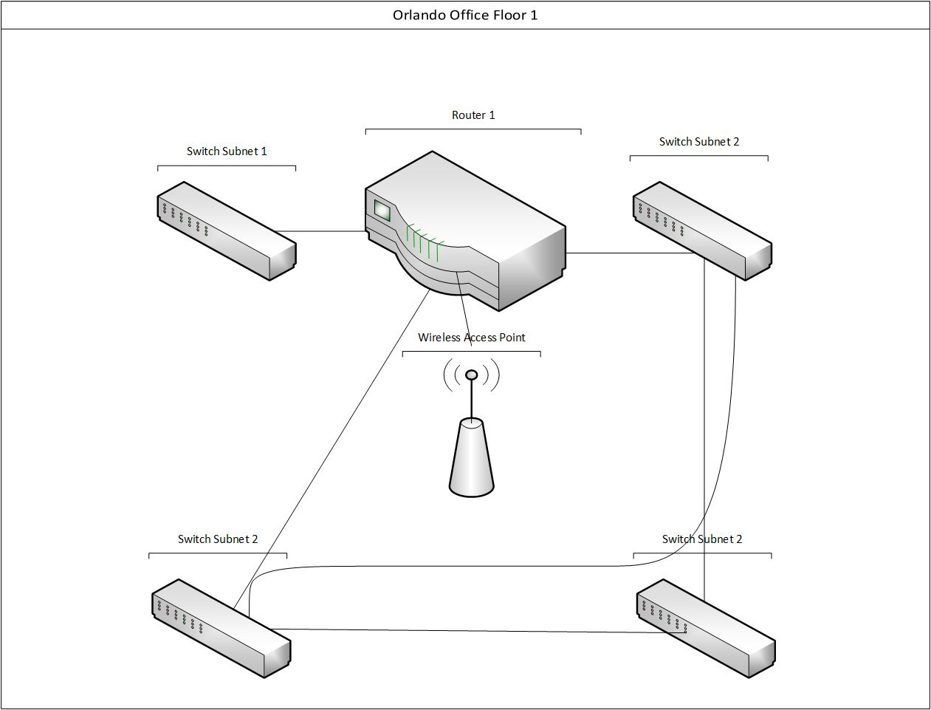
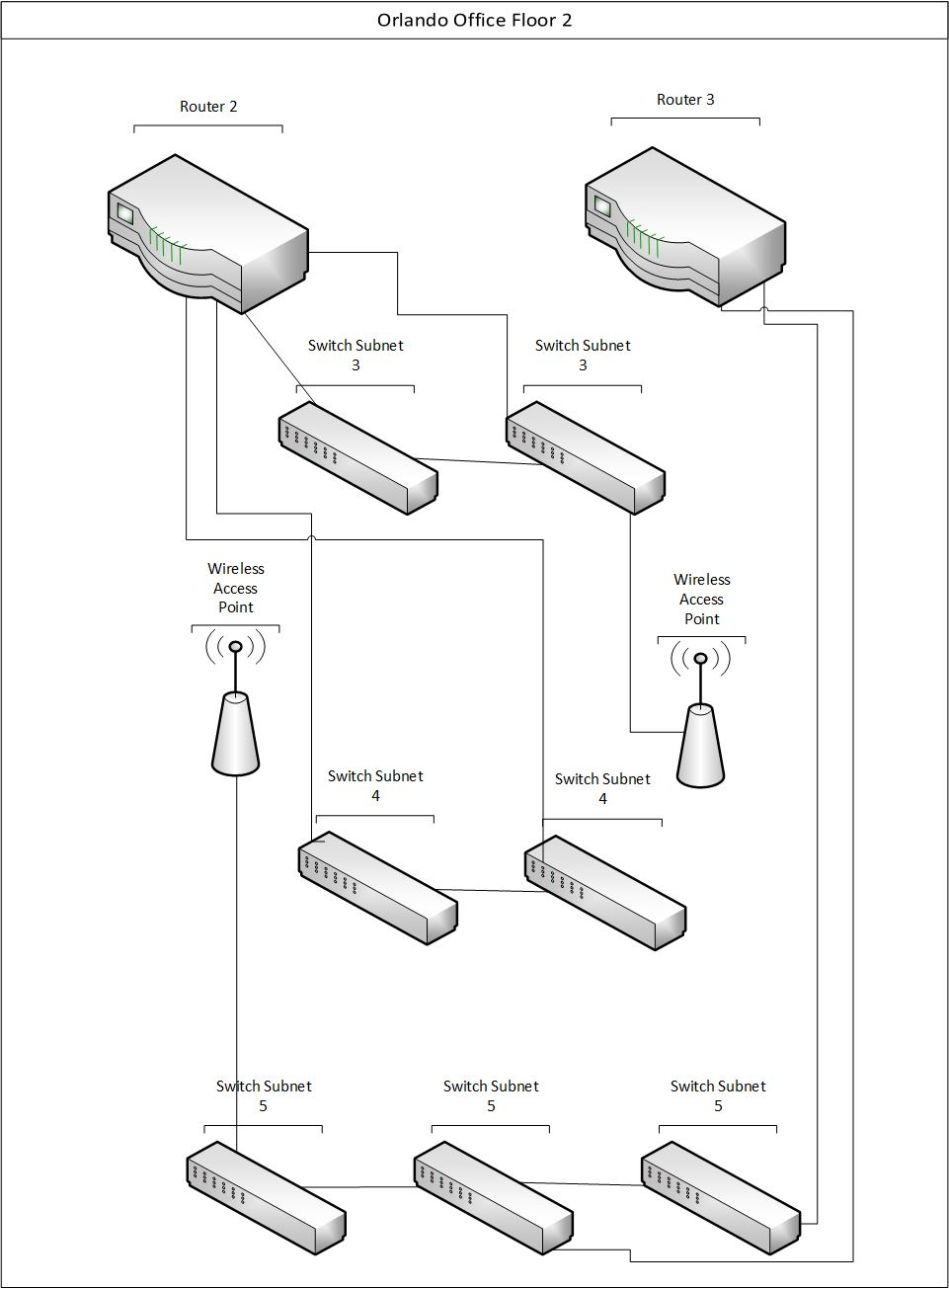

Bibliography
TestOut Corp. (2018). LabSim TestOut Network Pro (section 11.1.1-8). Retrieved from http://www.testout.com
TestOut Corp. (2018). LabSim TestOut Network Pro (section 3.3.1-3). Retrieved from http://www.testout.com
Shaw, Keith. (January 18, 2018). What is a wide-area network? A definintion, examples and where WANs are headed. Retrieved from https://www.networkworld.com/article/3248989/lan-wan/what-is-a-wide-area-network-a-definintion-examples-and-where-wans-are-headed.html

