

DIRECTIONS FOR LOGGING IN TO WELLCONNECT

Click the link to WellConnect on the Navigation Panel in your COMM104 Course.

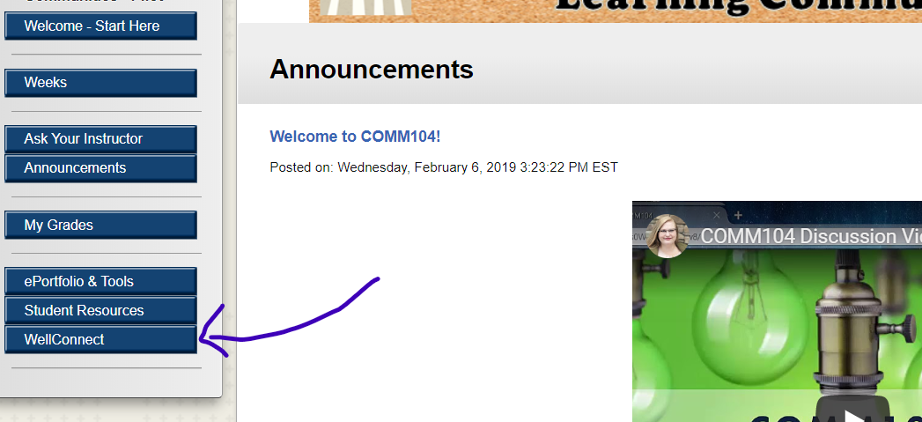

Enter the school code: BSCO-STU

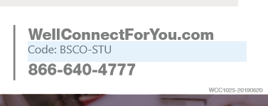

Once you are in the site, take a look around---the orientation video is a great place to start!
