Advanced Procedures
 | December 7-10, 2017 | 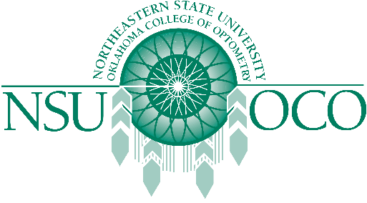

Course Information
The Rosenberg School of Optometry and Northeastern State University Oklahoma College of Optometry will present Surgical Procedures for the Opotometric Physician and Laser Therapy for the Anterior Sergment on December 7-10, 2017 in San Antonio, TX at the Rosenberg School of Optoemtry. The 32 COPE approved Expanded Therapeutic (ETP) course will be presented by both lecture and workshops.
The Minor Surgical Procedures course will be covered on the 7th and the 8th. The Laser course is covered on the 9th and the 10th. The schedule has the course on Thursday, the 7th beginning at 1pm, and the course will be finished by 1:00pm on Sunday, December 10th.

