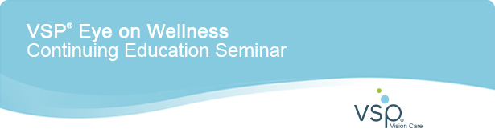
Earn up to Four Hours of COPE-approved CE Credit at this FREE Seminar  What:  Attend this special VSP Eye on Age-related Macular Degeneration (AMD) CE Seminar and get the latest research and treatment strategies for your patients.  Program includes morning snack and lunch.  When:  Sunday, July 20, 2014  9:00 a.m. – 3:00 p.m.  Where:  San Francisco Airport Marriott Waterfront  1800 Old Bayshore Highway  Burlingame, CA 94010  Cost:  FREE!  COURSES  Course 1: Where We've Been, Where We Are, and Where We're Going  41870-PS, 2-hour course (2 credits)  Course 2: Advanced Strategies for AMD Management  41869-PS, 2-hour course (2 credits) |   Speakers  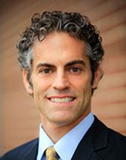  Jeffry Gerson  OD, FAAO  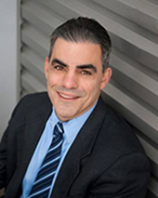  A. Paul Chous  MA, OD, FAAO  Questions? E-mail  eyeonwellness@vsp.com
Get on the path to Premier  Join us at 9:00 a.m. to learn more about the VSP Global® Premier Program, an innovative way to provide a high-value experience for VSP members and providers who choose to participate. It's designed to bring you MORE – more patients, more revenue, and more support. | With support from  

To unsubscribe, click here. By unsubscribing, you will no longer receive important VSP Vision Care e-mail correspondence including updates regarding critical policy and procedural changes and other valuable information pertinent to your practice.
HIPAA Privacy Policy | Terms of Service | Contact Us | Legal
©2014 Vision Service Plan. All rights reserved.
VSP | 3333 Quality Drive | Rancho Cordova, CA 95670
VSP and VSP Global are registered trademarks of Vision Service Plan. All other brands are trademarks or registered trademarks of their respective owners.

