Advanced Procedures
 | September 13-16, 2018 | 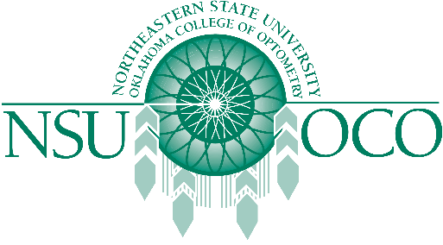

Course Information
The Rosenberg School of Optometry and Northeastern State University Oklahoma College of Optometry will present Surgical Procedures for the Optometric Physician and Laser Therapy for the Anterior Segment on September 13-16, 2018 in San Antonio, TX at the Rosenberg School of Optometry. The 32 COPE approved Expanded Therapeutic (ETP) course will be presented by both lecture and workshops.
The Minor Surgical Procedures course will be covered on the 13th and 14th. The Laser course is covered on the 15th and 16th. The schedule has the course on Thursday, the 13th beginning at 1pm, and the course will be finished by 1:00pm on Sunday, September 16th.

