Advanced Procedures
 | September 1-4, 2016 | 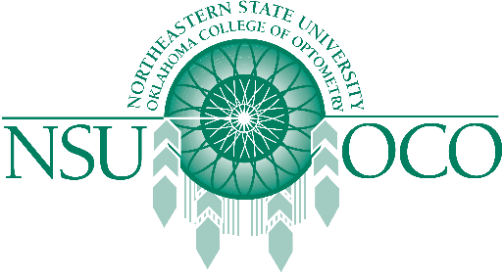

Course Information
Register for the Advanced Procedure's Course being offered in Charlotte, North Carolina. This course will be offered Thursday, September 1 - Sunday, September 4, 2016 by the Oklahoma College of Optometry at the Omni Hotel & Resort in downtown Charlotte. 32 Hours of COPE approved CME will be available.
Space is limited to 50 attendees.
Where
Omni Charlotte Hotel
132 E. Trade Street
Charlotte, North Carolina 28202
USA
704-414-4826
When
Thursday, September 1, 2016 - Sunday, September 4, 2016
1:00 PM - 1:00 PM
Eastern Time

