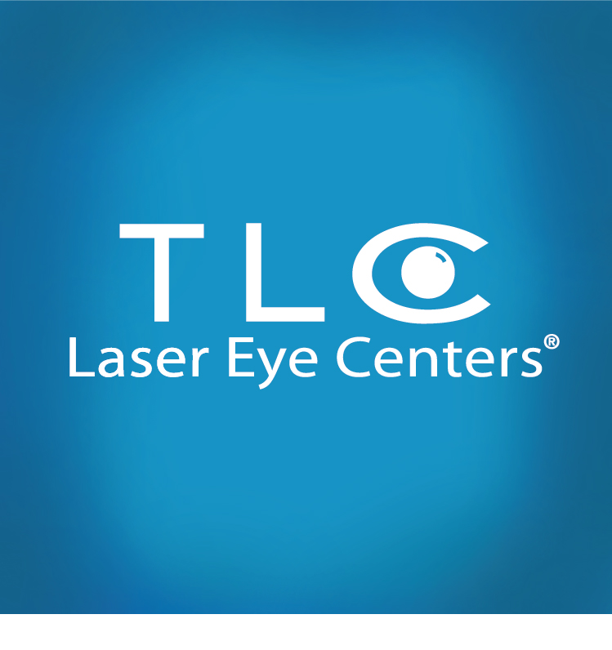

REMINDER:
TLC Laser Eye Centers presents:
6 hours of Continuing Education
(COPE approval pending)

Sunday March 30th from 8:00am-3:00pm

Newton Marriot Hotel
2345 Commonwealth Ave
Newton, MA 02466
7:30-8:00: Breakfast & Registration
8:00-9:00: Retinal Imaging Matthew Forgues, OD
9:00-10:00: Premium Intraocular Lenses Santiago Villazon, MD
10:00-11:00: Cataract Co-management & Billing Santiago Villazon, MD
11:00-12:00: Dry Eye Management David Murakami, OD
12:00-1:00 Lunch
1:00 – 2:00: Corneal Collagen Cross-Linking Grace Lytle, OD
2:00-3:00: Refractive Surgery Grand Rounds Kristen Brown, OD F.A.A.O.

**Continental Breakfast & Lunch will be served**

There will be a $100 charge for this event. Please mail your check to TLC 400 Fifth Ave Suite 510 Waltham, MA 02451
or bring with you to the event.

Limited space is still available. Please RSVP to Sarah Rowe at
(401) 451-0831 or sarah.rowe@tlcvision.com

