Laser Therapy for the Anterior Segment
 | December 13-14, 2016 | 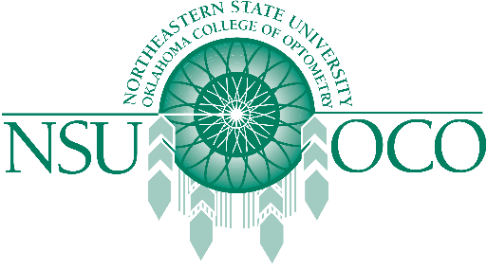

NSUOCO and Midwestern University presents Laser Therapy for the Anterior Segment Course in Glendale, AZ. This course offers 16 hours of COPE approved continuing education!

Course Details
- Tuesday, 12/13/16 & Wednesday, 12/14/16
- Held Midwestern University in Glendale, AZ

