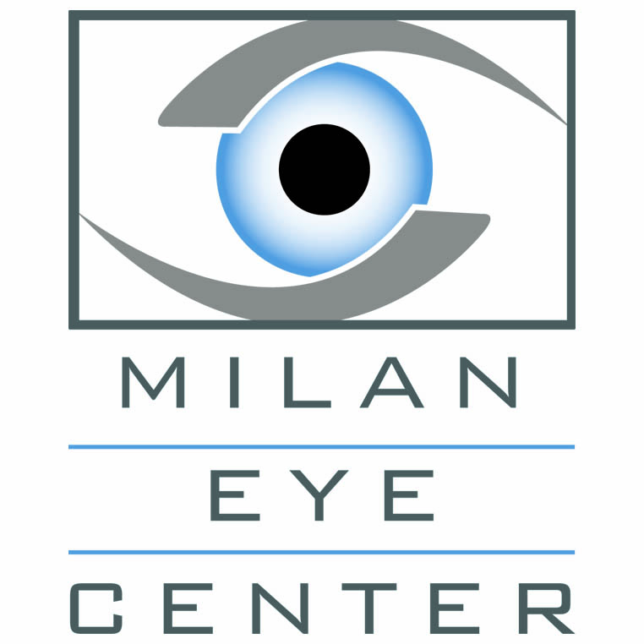

We would like to personally extend an invitation to you to join us for our upcoming **Continuing Education Presentation and Dinner:**

**Part 1: Patient Selection and Post-Operative Care for Your Refractive Surgery Patients**

**Presented by Cameron Johnson MD -1 hour COPE Approved Credit**

**Part 2: Primer on Upper Eyelid Surgical Procedures**

**Presented by Kiran Sajja, MD -1 hour COPE Approved Credit**

Date Location

**Thursday, Aug 11th, 2016** **Stratus Kitchen & Bar**

400 Laurel Canyon Pkwy

Canton, GA 30114

**Limited Seating**

Time

**Hors d’oeuvres at 6:30pm**

**Dinner and presentation at 7:00pm**

We look forward to spending time with you at this continuing education event for **2 hours of COPE approved continuing education credit**.

Please remember to bring your ARBO OE tracker card or number with you to the event or download the OE Tracker app to have your credits immediately uploaded to your account (<http://www.arbo.org/oetapp.php>).

**RSVP:** Please email Shai at [soliver@milaneyecenter.com](mailto:soliver@milaneyecenter.com) or call

770-820-2608 to RSVP

|  |  |  |  |  |  |  |
| --- | --- | --- | --- | --- | --- | --- |
| 970 Sanders Road  Suite 100  Cumming, GA 30041 | 6300 Hospital Pkwy  Suite 325  Johns Creek, GA 30097 | 3775 Roswell Road  Suite 150  Marietta, GA 30062 | 1995 Mall of GA Blvd.  Suite A  Buford, GA 30519 | 201 Kimberly Way  Suite 106  Canton, GA 30114 | | 134 Ansley Drive  Dahlonega, GA 30533 |
| Office: 678-381-2020 | | milaneyecenter.com | | | Fax: 678-381-2015 | |
| ***Milan Eye Center – Where Compassion Meets Excellence in Eye Care*** | | | | | | |

**Milan R. Patel, M.D.**

*Cataract, Corneal & Refractive Surgery*

**Niraj Desai, M.D.**

*Cataract, Corneal & Refractive Surgery*

**Kiran Sajja, M.D.**

*Reconstructive & Aesthetic Oculofacial Plastic Surgery*

**Samir Vira, M.D.**

*Cataract, Corneal & Refractive Surgery*

**Cameron Johnson, M.D.**

*Cataract, Corneal & Refractive Surgery*

**Priyal Gadani, O.D.**

*Optometrist*

*Johns Creek*

**Vishal Patel, O.D**.

*Optometrist*

*Buford*

**Bart Hahn, O.D**.

*Optometrist*

*Dahlonega*

**Charlie Ficco, O.D**.

*Optometrist*

*Cumming*

*Dahlonega*

**Charlie Ficco, O.D**.

*Optometrist*

*Cumming*

MILAN EYE CENTER