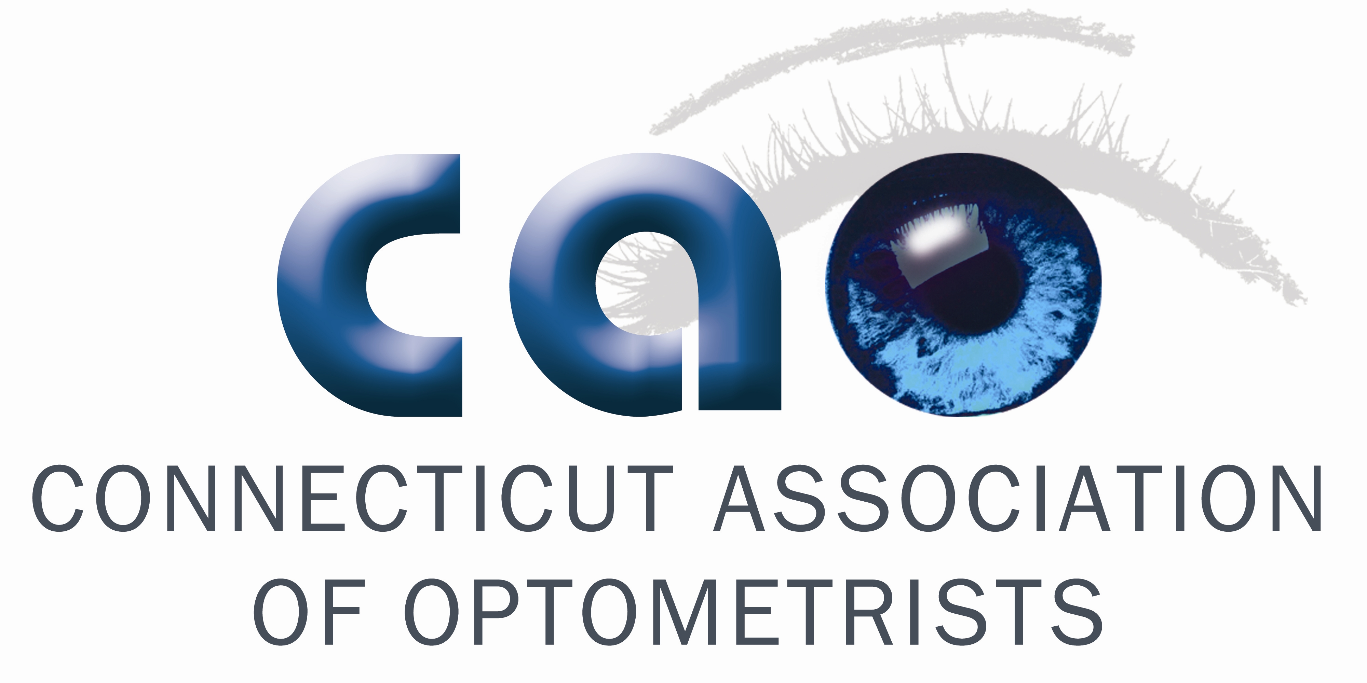
OptometrY 2020 – First Series

Wednesday, March 16, 2011

Rocky Hill Marriott
100 Capital Boulevard, Rocky Hill, CT

Registration & Complimentary Buffet Lunch – 12:00 p.m.
1:00 p.m. – 5:00 p.m.

22974-AS - Posterior Segment Complications of Anterior Segment Surgery (1 CE)
This course will review some of the significant complications such as cystoid macular edema, retinal detachment and infection utilizing a case presentation approach. The lecturer will present current thinking in regard to evidence that pretreatment with NSAID’s may decrease the incidence and severity of cystoid macular edema after cataract surgery in predisposed patients.

23183-PS - High Myopia- Problems/solutions (1 CE)
This course will emphasize frequently encountered MACUlAR issues that the high myope may encounter. Included will be retinal hemorrhages, RPE atrophy, and CNVM in high myopia. Current management options are discussed.

26950-PD - 40 Year Later - My Top 10 Educational Cases (2 CEs)
This course provides an overview of 10 important cases from a 40-year career in optometry. Through interactive grand rounds, each case will be discussed along with the clinical significance for primary care optometrists.

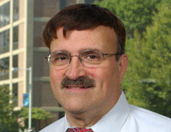
Presented by: Matthew J. Garston, OD
Dr. Garston is a Senior Staff Optometrist at the M.I.T. Medical Department in Cambridge MA.
He is a Professor at the New England College of Optometry in Boston and also a clinical faculty member for NEEI contact lens service for the past 30 years. Dr. Garston is a founding fellow of the Optometric Retina Society (ORS). Over the past 43 years, he has given many continuing education lectures and been a contributor to many publications to the optometric literature. Dr. Garston organized the first clinical diagnostic drug certification course given in the United States for the State of Rhode Island and later in all of the other New England States and also organized and taught in the certifying therapeutic drug courses for three of the six New England States.

* * * IMPORTANT NOTE * *

SEATING IS LIMITED! Registrations will be accepted on a first come / first served basis until sold out, but accepted NO LATER THAN Monday, March 7th, please complete the registration form and return by mail to:

35 Cold Spring Road, Suite 211, Rocky Hill, CT 06067 or via fax to: 860-529-4411

---------------------------------------------------------------------------------------------------------------------------------------------------------------------------------------------------------------------------------- Optometry 2020 First Series Registration Form – March 16, 2011

❒ Optometry 2020 FIRST SERIES Participant: Free  CAO Member: $185.00

OD Name (please print):______________________________________________________________________

Method of Payment:

❒ Check  Visa  MasterCard  American Express

Name on Credit Card: ______________________________________________________________________

Credit Card #: _______________________________ Exp. Date: ______________ CVV2 Code: ____________

Billing Address:

Signature:

Directions to Rocky Hill Marriott
100 Capital Boulevard, Rocky Hill, CT
Phone: 860-257-6000

From Points North:
Take I-91 South to Exit 23. Turn left at end of exit. The hotel is on the right.

From Points South:
Take I-91 North to Exit 23. Turn right at end of exit. The hotel is on the right.

