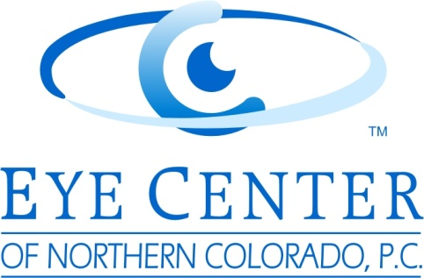
We cordially invite you to attend a dinner and continuing education event at 7:00am on the day of November 1, 2014
Topics to include Billing and Coding from guest speaker John Rumpakis, OD, LASIK update, Complex Catartact Cases, Oculoplastics and the Tear System, Contact Lenses for Keratoconus, and Diabetic Maculopathy

Presented by: The Eye Center of Northern Colorado
Saturday, November 1, 2014
7:00am – 3:30pm
The Embassy Suites
4705 Clydesdale Pkwy
Loveland, CO 80538
Please RSVP to Patrick Rosen at marketing@eyecenternoco.com, or at (970)221-2222 by October 31, 2014
Each doctor will present a COPE approved presentation. This presentations will be worth a total of 8 COPE approved continuing education hours.

