Michigan Ophthalmic Procedures
 | August 11-14, 2022 | 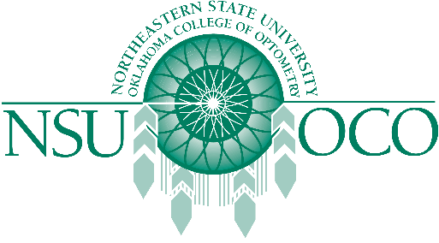

Course Information
Ophthalmic Procedures gives you the opportunity to receive the latest Ophthalmic Procedures hands on training with our upcoming COPE accredited 32 hour Ophthalmic Procedures Course.
The 11-12th will offer 16 hours of Surgical Procedures.
The 13-14th will offer 16 hours of Laser Therapy for the Anterior Segment.

