Annual Meeting and CE Seminar

"Optometry Today - What You Need To Know"

April 25-27, 2014
Chicago, IL
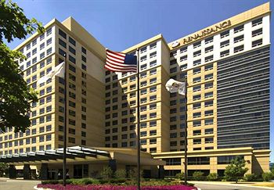
The Annual Optometric CE Seminar will be held April 25 -27, 2014 at the Chicago Renaissance O'Hare, an All-Suite Hotel. The lectures will touch on today’s must know topics in Optometry, including lectures on Coding and Audits, Neuro OP, Ocular Trauma, Anterior Segment Ocular Disease, , and CNS - Nutrition and Disease, and ARMD, to name a few.
We have top-tier speakers including Dr. Ernie Bowling speaking on Ocular Trauma: Triage and Treatment and a separate lecture on Clinical Case Challenges in Anterior Segment Ocular Disease, Dr. James Fanelli, speaking on Clinical Utilization of Target Pressure and Structure/Function in Improving Glaucoma Outcomes and a separate lecture on Mind Bending Neuro OP Grand Rounds, Dr. Steven Newman giving new clinical lectures focusing on ARMD and CNS and the Nutritional relationships that it are sure to be fast paced and engaging, and one of our attendee favorites, Speaker Robert Rebello lecturing on billing and coding, focusing on Glaucoma and avoiding/surviving Audits. All courses are COPE approved.
There will be networking opportunities and The Optometric Society will hold its Member Meeting prior to the start of the Optometric CE meeting. Early Bird Registration is now open and savings are significant! Spouse and staff are welcome. We hope we'll see all of you there!

