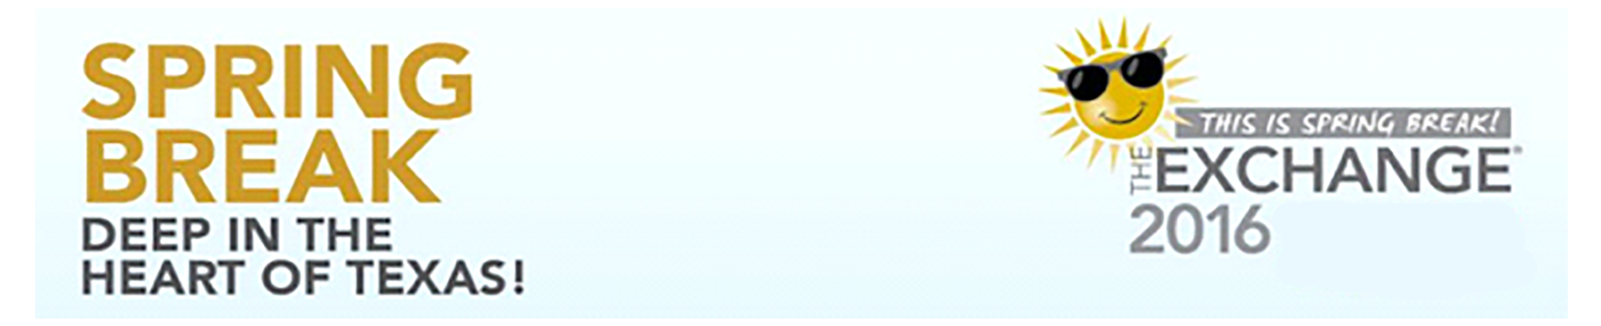
REGISTRATION FOR THE 2016 EXCHANGE® IS NOW OPEN!

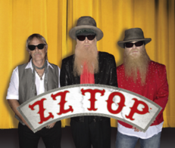
March 16-19, 2016
Henry B. Gonzalez Convention Center
San Antonio, Texas

The Exchange®, the annual meeting of Vision Source® members, is now one of the largest and most influential meetings in Optometry. Last year saw a record attendance of 3,400 and we expect even more in 2016. Here's why:


More CE Opportunities: Doctors can earn up to 11 hours of CE credit and staff can earn up to 7, all free provided by our education partners, Distinctive Education.

Huge Opening Night Party starring that "Little 'Ol Band from Texas", ZZ Top.
We'll be kicking off the 2016 Exchange® in a big way. On Wednesday, March 16 at 7:30 PM, we'll gather at the Tobin Center for our opening night reception that will include a performance by ZZ Top, exclusively for attendees.

Big Name Keynote Speakers
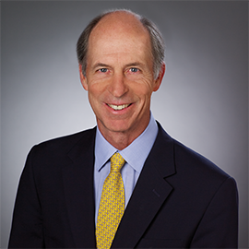 | 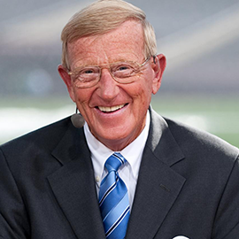 | 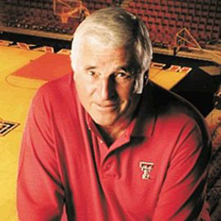
DAVE RIDLEY | LOU HOLTZ | BOB KNIGHT

The 2016 Exchange® will feature 3 dynamic keynote speakers. On Thursday, March 17, Dave Ridley, former Southwest Airlines executive, will share lessons learned on how to build and sustain a professional environment that delivers Legendary Customer Service. Then, on Friday, March 18, Lou Holtz and Bob Knight, two coaching legends, will share the stage in a casual "fireside chat" discussing their experiences and offering their insights into creating a culture within an organization that leads to greater success and overall fulfillment.

Choose your CE classes, pick your Learning Labs and
reserve your hotel room today.

https://registration.experientevent.com/ShowVSM161/

