Colorado Ophthalmic Procedures
 | July 22-25, 2022 | 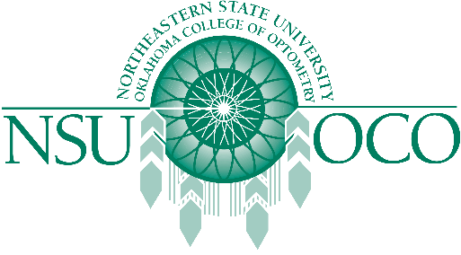

Course Information
Ophthalmic Procedures gives you the opportunity to receive the latest Ophthalmic Procedures hands on training with our upcoming COPE accredited 32 hour Ophthalmic Procedures Course.
The 22-23rd will offer 16 hours of Surgical Procedures.
The 24-25th will offer 16 hours of Laser Therapy for the Anterior Segment.
Held in Snowmass, Colorado.

