Laser Procedures
 | August 25-26, 2018 | 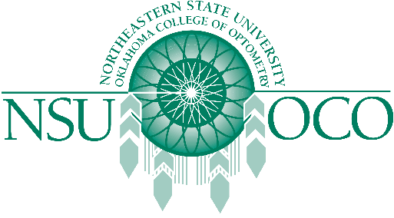

NSUOCO and the Connecticut Optometric Association presents the Laser Procedures for the Anterior Segment Course in Fairfield, CT. This course offers 16 hours of COPE approved continuing education.

Course Details
- Saturday, 8/25/18 - Sunday, 8/26/18
- Opthalmic Consultants of Connecticut (1375 King Highway, Fairfield, CT, 06824)

