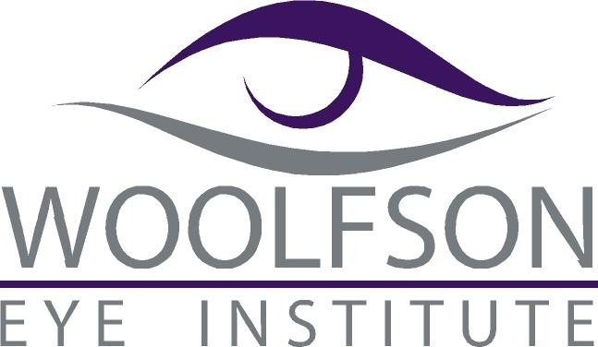

Please Join Us:

Dinner and 3 Hours of Continuing Education

## Thursday, July 14, 2016

## 5:30 – 6:00 pm: Registration and Dinner

## 6:00-9:00 pm: Continuing Education (3 Hours!)

## Hilton Atlanta Marietta Hotel & Conference Center

## 500 Powder Springs St.

## Marietta, GA 30064

**Course Presentations:**

“**Unusual Cataract Case**”

(COPE # 46621-PO)

**Lecturer: Jason Brody, MD**

“**Ophthalmic Surgery Update**”

(COPE # 41955-PO)

**Lecturers: Thomas Spetalnick, OD, Joseph Walrath, MD, R. Doyle Stulting, MD, PhD, Jonathan Woolfson, MD, Byron “Trip” Cook, MD**

“**Corneal Collagen Crosslinking Update**”

(COPE # 40765-AS)

**Lecturers: R. Doyle Stulting, MD, PhD, Jonathan Woolfson, MD, Thomas Spetalnick, OD**

Please RSVP via fax (404-237-6002) or email (dallen@woolfsoneye.com ).

Name:_______________________________________ Number of Attendees:____

E-Mail:______________________________________________________________

Phone: ______________________ Fax: _______________________________