2024 Winter CE Series
JANUARY 28 - APRIL 7, 2024
pENDING cOPE aCCREDITATION
REGISTER NOW
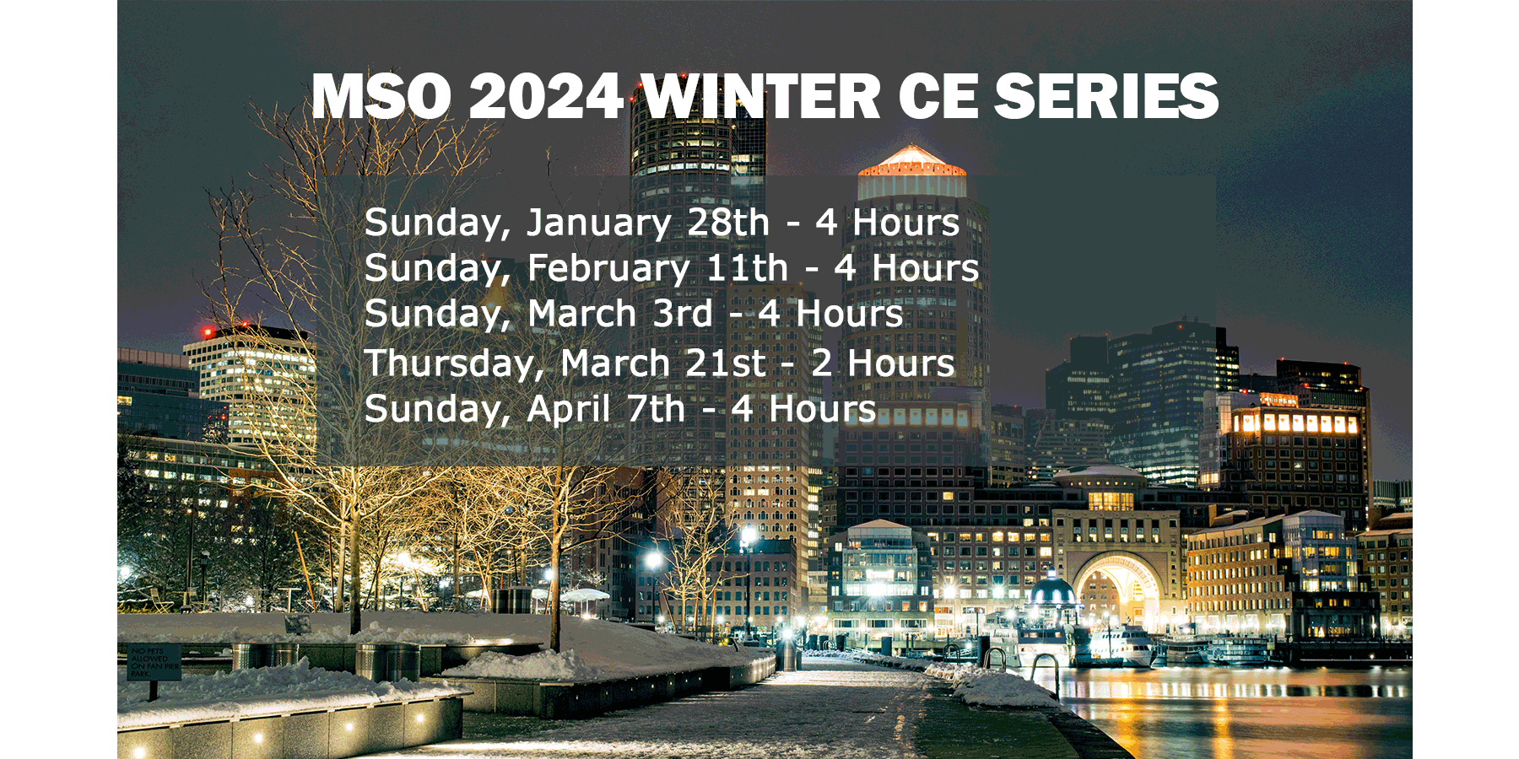

This Winter CE Series is a webinar synchronous format. Your 2024 Glaucoma and Opioid Education requirements are all covered in this CE series.

The 2024 series offers 4 hours of Glaucoma CE.
Registration Fees
Package pricing only, no ala carte options. All CE registrations are final, no refunds or credits.
Registration closes on Thursday, January 18, 2024, no exceptions.

Sunday, January 28 ^{th}
COPE Activity ID #127513
8:00 AM - 9:00 AM
Addressing Structural Puzzles in Diabetic Eye Disease
Dr. A Paul Chous, MA, OD, FAAO
COPE Course ID# 85286-TD
9:00 AM - 10:00 AM
Sleep Disorders: What Optometrists Need to Know
Dr. A Paul Chous, MA, OD, FAAO
COPE Course ID# 89157-SD
10:00 AM - 11:00 AM
Hot Topics in Glaucoma
Dr. Murray Fingeret, OD, FAAO
COPE Course ID# 88410 - GL
11:00 AM - 12:00 Noon
Personalized Care in Glaucoma
Dr. Murray Fingeret, OD, FAAO
COPE Course ID# 88415 - GL
Sunday, February 11 ^{th}
8:00 AM - 10:00 AM
Maximizing Practice Success
Dr. Jessilin Quint, OD, MBA, FAAO
COPE Course ID# 89019 - PM
10:00 AM - 12:00 Noon
Myopia Management Course
Dr. Kevin Chan, OD, MS, FAAO, IACMM
COPE Course ID# Pending
Sunday, March 3 ^{rd}
8:00 AM - 10:00 AM
The Glaucoma Puzzle: When The Pieces Don't Always Fit
Dr. Mark Dunbar, OD, FAAO
COPE Course ID# 86932-GL
10:00 AM - 12:00 Noon
Opioid Issues for the Patient and Practitioner
Dr. Gregory Caldwell, OD
COPE Course ID# 83672-PH
Thursday, March 21 ^{st}
7:00 PM - 9:00 PM
Overcoming Obstacles to Ocular Surface Disease Management
Dr. Kristen Brown and Dr. Amy Nau
COPE Course ID# 89090 - TD
Sunday, April 7 ^{th}
8:00 AM - 10:00 AM
Dr. Kathryn Deliso, OD, FAAO
COPE Course # Pending Approval
10:00 AM - 12:00 Noon
Lecture Contract Pending

