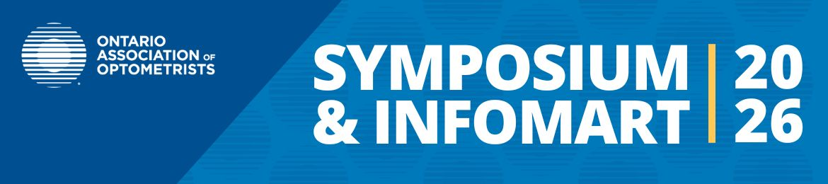
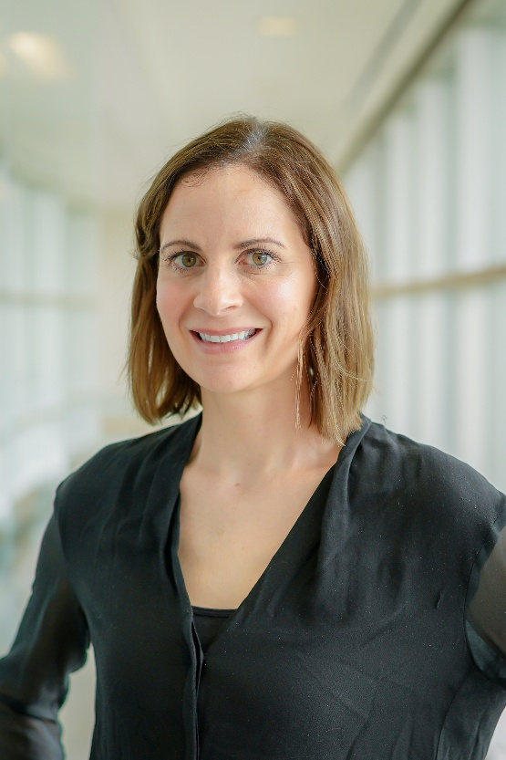

March 27-29, 2026
Rogers Centre, Ottawa
Join us at the OAO Symposium & InfoMart to hear from Dr. Sarah MacIver, an optometrist and associate clinical professor at the University of Waterloo School of Optometry and Vision Science.
﻿Dr. MacIver has a special interest in the treatment and management of chronic ocular disease, specifically glaucoma, retinal imaging and dry eye, for which she has been invited to speak at various continuing education events across North America. She is a Fellow of the American Academy of Optometry and a Fellow of the Canadian College of Specialties in Optometry. She is a member of the Optometric Glaucoma Society and program chair for the American Academy of Optometry’s Glaucoma section.
CE is COPE Accredited
Lectures:
- Bringing Artificial Intelligence Use in Glaucoma from Concept to Clinic
- Ocular Nutrition and Wellness Panel Discussion
Register Now

