Advanced Procedures
 | May 16-19, 2019 | 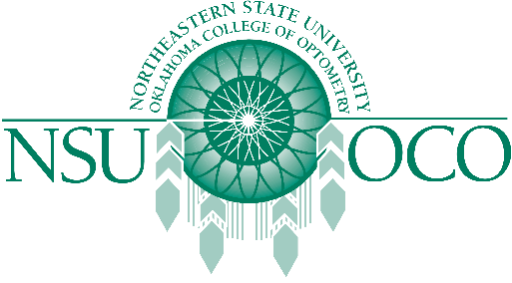

Course Information
The Pennsylvania College of Optometry and the Northeastern State University Oklahoma College of Optometry will present Surgical Procedures for the Optometric Physician and Laser Therapy for the Anterior Segment courses on May 16-19 in Elkins Park, PA at the Pennsylvania College of Optometry The 32 COPE approved Expanded Therapeutic (ETP) course will be presented by both lecture and workshops.
The Minor Surgical Procedure course will be covered on the 16th & 17th. The Laser course is covered on the 18th & 19th. The schedule has the course on Thursday, the 16th beginning at 1 pm, and the course would be finished by 1:00 pm on Sunday, May 19th.

