Advanced Procedures
 | June 20-23, 2019 | 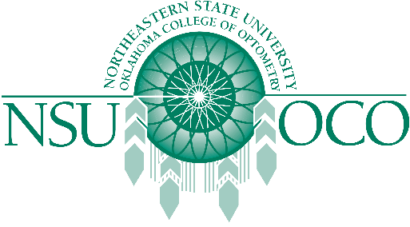

Course Information
June 20-23, 2019
Course Information
The American Optometric Association and Northeastern State University Oklahoma College of Optometry will present Surgical Procedures for the Optometric Physician and Laser Therapy for the Anterior Segment courses on June 20-23 in St. Louis, MO at America’s Center Convention Complex. The 32 COPE approved Expanded Therapeutic (ETP) course will be presented by both lecture and workshops.
The Minor Surgical Procedure course will be covered on the 20th & 21st. The Laser course is covered on the 22nd & 23rd. The schedule has the course on Thursday, the 20th beginning at 1:00 pm, and the course would be finished by 1:00 pm on Sunday, June 23rd.

