 green 2020 symbol without COPE Event #XXXXX “Be Seen in 2020” tag line

OAO Virtual Symposium
May 22-23, 2020

10 hours of COPE/Category A lectures:
- Laser Peripheral Iridotomy LPI: What’s the Controversy
- In-Office Electrodiagnostics for Non-Glaucoma Patients
- Thyroid Dysfuntion and the Eye
- Fundus Autofluorescence Applications for Clinical Practice
- Bringing the Love Back to the Visual Field
- My Greatest Spikes: Challenging Glaucoma Cases (2 hours)
- Taking the Mystery Out of Abnormal Pupils
- Laser Therapy for the Open Angle Glaucoma
- The Oh Crap Moment When Ocular Emergencies Happen

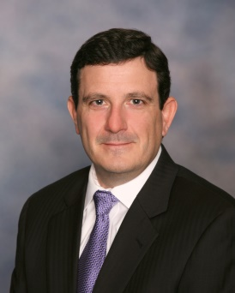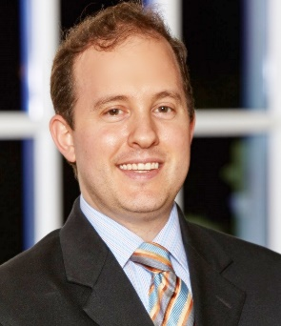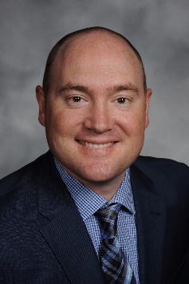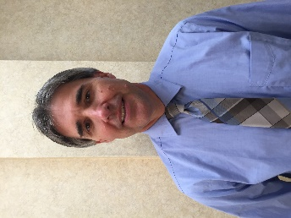
Dr, Greg Caldwell Dr. Michael Cooper Dr. Nathan Lighthizer Dr. Brad Sutton

Don’t miss out - register today!
www.optom.on.ca/Symposium

