Ophthalmic Procedures
Registration Fees:  Surgical - $1,000  Laser- $1,000  Laser & Surgical- $1850 | January 5-8, 2023 | 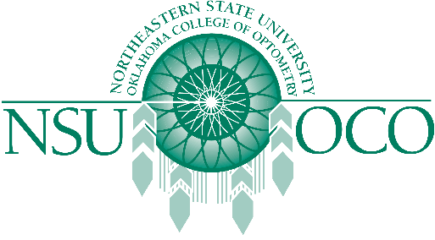

Course Information
Held in the heart of green country (Tahlequah, Oklahoma), Ophthalmic Procedures gives you the opportunity to receive the latest Ophthalmic Procedures hands on training with our upcoming COPE accredited 32 hour Ophthalmic Procedures Course.
The 5th-6th will offer 16 hours of Surgical Procedures.
The 7th-8th will offer 16 hours of Laser Therapy for the Anterior Segment.

Hotel Information (Mention NSUOCO and receive a discount!)

Holiday Inn Express

2142 Mahaney Ave
Tahlequah, OK 74464
918-506-4545

