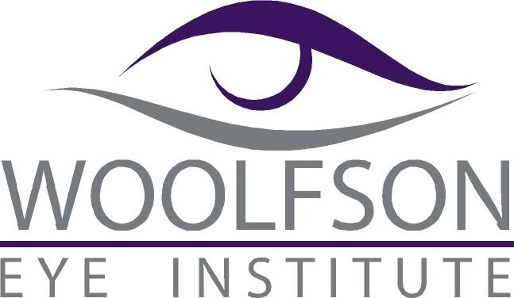

Please Join Us for Dinner
plus 1 hour of Continuing Education

October 13, 2014; Dinner @ 6:00pm; Lecture @ 6:30pm

Schaeffer Eye Center
2019 Highland Ave.
Birmingham, AL 35205

“Corneal Collagen Crosslinking Update”
(COPE# 40765-AS)
Instructor: Jonathan Woolfson, MD
Founder and Medical Director of
Woolfson Eye Institute

Please RSVP via fax (205-328-2020) or email ( kristinas@schaeffereyecenter.com)

Name:________________________________________________________

E-Mail:________________________________________________________

Phone: ______________________ Fax: ___________________________

# Attendees:____________________________________________________

