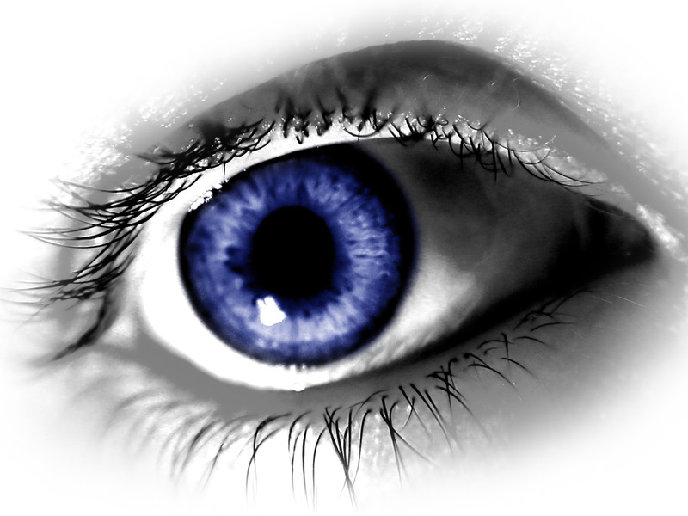
Continue Education
PRESENTED BY: TLC LASER EYE CENTER

2 CME credits COPE (pending)
(meeting, social, supper)
Grand Dakota Lodge and Conference center
532 15th Street West

9:00 Golf Bully Pulpit Medora

4:00 pm Refractive Surgery “Then and Now” presented by Larry Womack MD

6:00 pm Supper- Spouse or guest invited

*If you choose not to golf a $30.00 gift certificate from Euphoria will be provided

___________________________________________________________________
Please RSVP by Sept 15th, 2010 - fax back to 701-293-7998

PRINT NAME __________________________________
___I will be attending CME
___I will be golfing, Handicap_____
___I will be doing the spa
___ will be attending supper(1 or 2)

