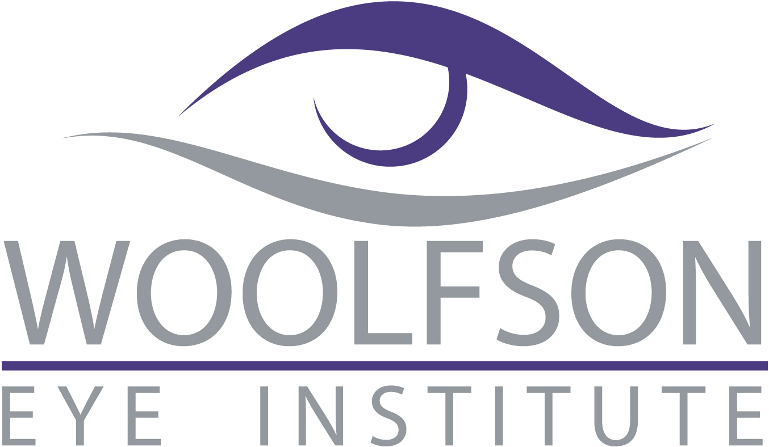

Woolfson Eye Institute

Chattanooga

Tel: 423-894-5300
______________________________________________________________________________

Please Join Us for Dinner and CE

“Update on Corneal Collagen Crosslinking”

Instructor: Dr. Jonathan Woolfson

Monday, April 7, 2014
6:30 pm

This event will be held at:
ChopHouse Restaurant
Chattanooga, TN 37421

Please RSVP via fax to: (423) 894-8331
Call/Text Susan: 423.580.8147

Please reply by April 4th

Name: ____________________________________________________

Phone: _______________________ Fax: ________________________________

