Advanced Procedures
 | June 21-24, 2018 | 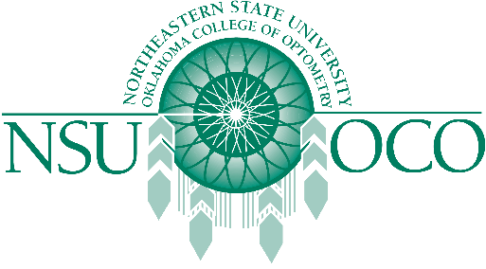

Course Information
Will you please copy and paste this into this link? Thank you!
https://optometry.nsuok.edu/ContinuingEducation/ScheduleofEvents/AdvancedProcedures/AdvancedProcedures-PA.aspx
June 21-24, 2018
Course Information
The American Optometric Association and Northeastern State University Oklahoma College of Optometry will present Surgical Procedures for the Optometric Physician and Laser Therapy for the Anterior Segment courses on June 21-24 in Denver, CO at the Colorado Convention Center. The 32 COPE approved Expanded Therapeutic (ETP) course will be presented by both lecture and workshops.
The Minor Surgical Procedure course will be covered on the 21st & 22nd. The Laser course is covered on the 23rd & 24th. The schedule has the course on Thursday, the 23rd beginning at 1:00 pm, and the course would be finished by 1:00 pm on Sunday, June 24th.

