Advanced Procedures
 | June 14-17, 2018 | 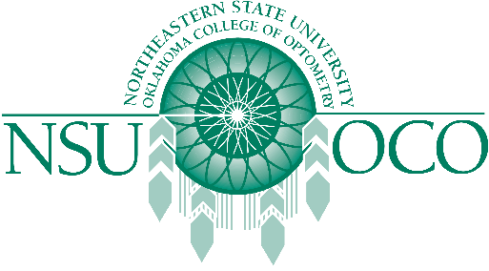

Course Information
The Pennsylvania College of Optometry and the Northeastern State University Oklahoma College of Optometry will present Surgical Procedures for the Optometric Physician and Laser Therapy for the Anterior Segment courses on June 14-17 in Elkins Park, PA at the Pennsylvania College of Optometry The 32 COPE approved Expanded Therapeutic (ETP) course will be presented by both lecture and workshops.
The Minor Surgical Procedure course will be covered on the 14th & 15th. The Laser course is covered on the 16th & 17th. The schedule has the course on Thursday, the 14th beginning at 1 pm, and the course would be finished by 1:00 pm on Sunday, June 17th.

