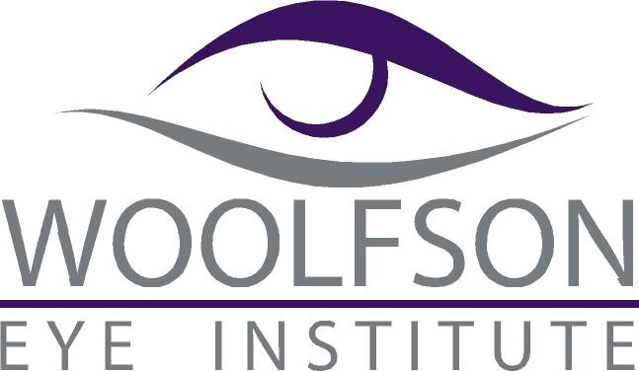
Please Join Us:
Dinner and 3 Hours of Continuing Education

Thursday, May 10, 2018

5:30 – 6:00 pm: Registration and Dinner

6:00-9:00 pm: Continuing Education (3 Hours!)

Hilton Atlanta/Marietta
Hotel & Conference Center

500 Powder Springs St.

Marietta, GA 30064

Course Presentations:

“Co-Management of Cataracts Medications and Complications”
(COPE # 50816-PO) 2 Hours
Lecturers: Trip Cook, MD, Jason Brody, MD, Jim Hays, MD, Vanessa Ngakeng, MD, Brian Salmenson, MD, Doyle Stulting, MD, PhD

“Diagnosis and Surgical Management
of Lower Eyelid Disorders”
(COPE 50719-SP) 1 Hour
Lecturer: Joe Walrath, MD

Please RSVP via fax (404-237-6002) or email (dallen@woolfsoneye.com ).

Name:_______________________________________ Number of Attendees:____

E-Mail:______________________________________________________________

Phone: ______________________ Fax: _______________________________

