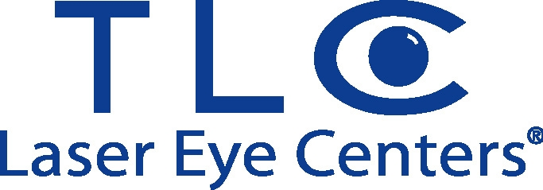

You are cordially invited to TLC LASER EYE CENTER Spring CE Program 2012

Refractive Cataract Surgery Comes To Age

Case Studies in Laser Vision Correction

3 Cope Approved Credits
COPE ID: #33744-GO, 33982-RS

Presenters: Eric Donnenfeld, MD
Dana Morschauser, OD

When: Thursday, April 26, 2012
Time: 7:15-10:15 pm
Where: La Parma Restaurant
707 Willis Avenue
Williston Park, NY 11596

Dinner will be served.

RSVP to Andrea Wallace at (918) 557-4929
Or Email: andrea.wallace@tlcvision.com

