Colorado Ophthalmic Procedures
 | February 8-11, 2023 | 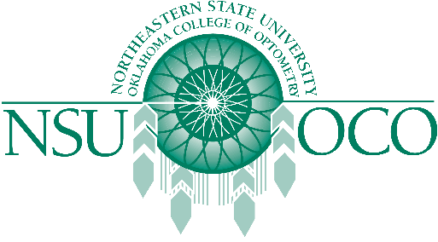

Course Information
Ophthalmic Procedures gives you the opportunity to receive the latest Ophthalmic Procedures hands on training with our upcoming COPE accredited 32 hour Ophthalmic Procedures Course.
The 8-9th will offer 16 hours of Surgical Procedures.
The 10-11th will offer 16 hours of Laser Therapy for the Anterior Segment.
Held in Colorado Springs, Colorado.

