
  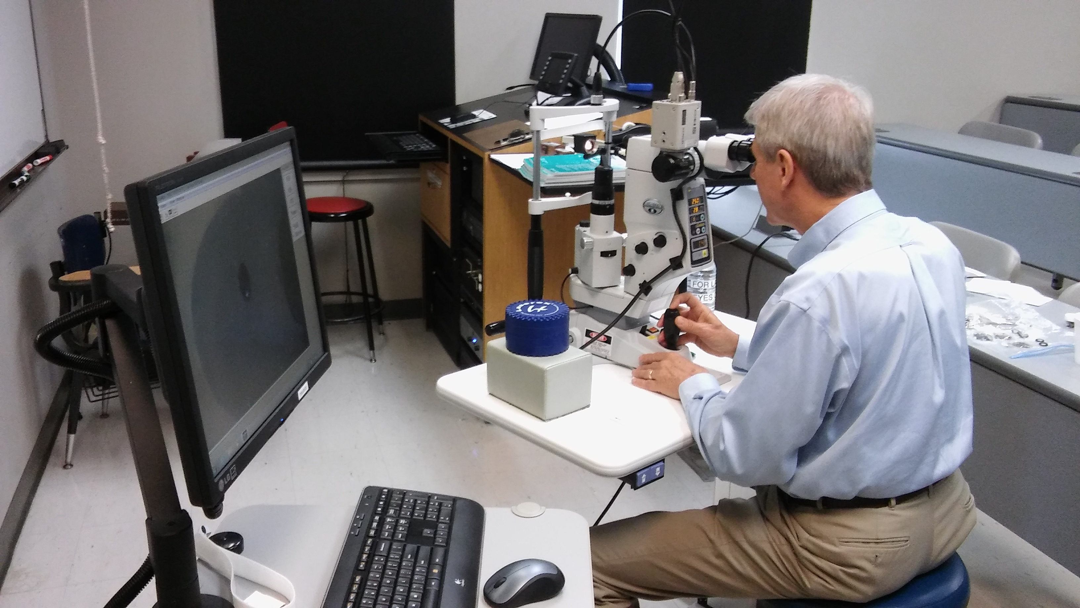
    - January 7-10, 2016
  Advanced procedures 32-hour certification course
  16 hours laser
  16 hours surgical procedures
  Advanced Procedures
  32 Hour Certification Course
  $1,500 registration fee
  $1,
  Tahlequah, OK
  Nsuoco
  Callie McAtee
  918-444-4033
  mcateec@nsuok.edu
  optometry.nsuok.edu

Basic Surgical Concepts- 47705-SP

Essential Surgical Skills- 47706-SP

Office Based Procedures Disscusion- 47707-SP

Surgical Workshop- 45842-PO

Laser Physics Hazards & Safety- 41892- LP

Laser Tissue Interactions- 41893- LP

Clinical Workshops- 45787-LP

Gonioscopy- 47536-GO

Laser Therapy for the Open Angle- 45781-GL

Laser Therapy for Narrow Angle- 45822-LP

Yag Capsulotomy- 45828-LP

Managing Laser Complications- 42663-LP

Medicolegal Aspects of Anterior Segment Panel- 45786-PO

Laser Hands on Lab- 45785-LP

Exam- 41914-PO

