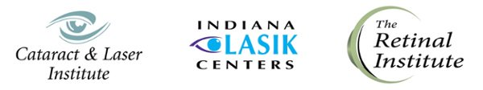



Mishawaka, IN Seminar
Wednesday, October 17, 2018
8:00am - 1:00pm
The St. Joseph Conference Center at the Holiday Inn Mishawaka
1208 E. Douglas Rd.
Mishawaka, IN 46545
Fort Wayne, IN Seminar
Wednesday, October 17, 2018
3:00pm - 8:00pm
Ramada Plaza Fort Wayne Hotel & Conference Center - Marquis Ballroom
305 E. Washington Center Rd.
Fort Wayne, IN 46825
5 Hours of COPE Continuing Education Credit Applied For
----------------------------
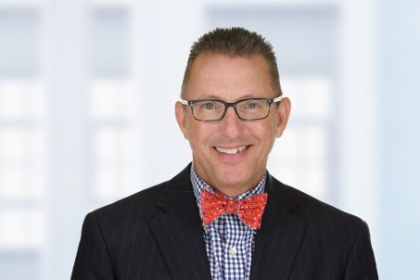
Featuring Mark T. Dunbar, O.D., F.A.A.O.
Dr. Mark T. Dunbar graduated from the Michigan College of Optometry at Ferris State University in 1986 and did a Fellowship in Ocular Disease at the Omni Eye Services of Lexington, KY. Dr. Dunbar has been a member of the optometric staff at the University of Miami’s Bascom Palmer Eye Institute for almost 30 years. He currently serves as the Director of Optometric Services and the Optometry Residency Supervisor.
Dr. Dunbar is a Fellow of the American Academy of Optometry and is a founding member of both the Optometric Glaucoma Society (OGS) and the Optometric Retina Society (ORS).
Dr. Dunbar also serves on the Editorial Boards for Advanced Ocular Care and Review of Optometry where he writes the monthly column “The Retina Quiz“.
Register Online Today!
Click the link below to begin.
Registration Deadline: October 12, 2018
If you have questions or to register by phone, please call 877-664-2499.


REGISTER

We look forward to seeing you there!

Cataract & Laser Institute | Indiana LASIK Centers | The Retinal Institute

