January 30, 2017

Dear Doctor:

The New Orleans Contact Lens Society will be holding its 59th annual seminar on Saturday and Sunday**, March 25th and 26th, 2017** at the **Marriott Metairie at Lakeway**, located at 3838 N. Causeway Blvd, Metairie, Louisiana. We decided to move the meeting to Metairie this year to better control our seminar coasts.

**ALL COPE APPROVED HOURS**: A total of 16 hours of cope approved continuing education will be offered over this weekend. The NOCLS will be sponsoring 8 hours of **non-therapeutic CE** on Saturday, March 25th. The UAB School of Optometry will be sponsoring 8 hours of **therapeutic CE** on Sunday, March 26th.

**REGISTRATION FORM**: A registration form is enclosed. Please complete all information accurately and follow the instructions carefully in order to avoid any delays in processing your form. Enclosed you will also find a preliminary **SEMINAR OUTLINE**, listing the speakers and their course titles. Please see the **MAP** on the reverse side of the seminar outline for driving directions to the hotel.

**REGISTRATION**: Registration will be held each morning from 7am until 8am. The meeting will begin promptly at 8:00 am. **All attendees must sign-in at the registration desk by 8:10 am each morning to receive full course credit.**

**EXHIBITOR FAIR:** An exhibitor fair will be held at the end of lectures on Saturday from 5:30 pm to 7:30 pm. Please make plans to attend this event to meet our exhibitors and to thank them for their support. Dinner will be provided.

**HOTEL RESERVATIONS:** If you will be arriving from out of town, hotel reservations can be made by calling the Marriott Metairie Lakeway at (504) 836-5253. Please request the group rate for the New Orleans Contact Lens Society Seminar. This rate is only available on reservations made before **March 3, 2017**. You are encouraged to make your room reservation early, as accommodations will be limited.

We look forward to seeing you at the Marriot Metairie at Lakeway on March 25th and 26th. If more information is needed, please contact us at (504) 432-5963 or by email at: **nocls2020gmail.com**.

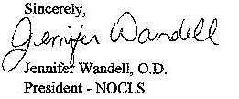

REGISTRATION FORM

PLEASE PRINT

NAME _________________________________________________________________________

MAILING ADDRESS_____________________________________________________________

CITY _______________________________ STATE & ZIP ______________________________

PHONE (O)_______________________ (HOME or CELL) _________________________

STATE LIC NO. ______________O.E. TRACKER NO (required for COPE Credit) ___________

E-MAIL ADDRESS (If you would like confirmation of registration, and if you would like to be able to view the lecture materials online): __________________________________________

PLEASE CHECK THE APPROPRIATE BOX: (Note: You must be registered for Saturday to attend Saturday meal functions, and you must be registered for Sunday to attend Sunday meal functions. Please notify us if the below information changes.)

# YES NO

I will attend the lunch on Saturday (for doctors only).

I will attend the exhibitor fair and dinner on Saturday night.

My spouse or date will also attend the exhibitor fair and dinner on Saturday night.

I will attend the champagne brunch on Sunday.

My spouse or date will attend the champagne brunch with me on Sunday.

**REGISTRATION FEES**: PLEASE CHECK THE APPROPRIATE BOX:

Saturday & Sunday: March 25th and 26th, 2017 (12-16 Hrs.) . . . . . . . . .. . $375.00

Saturday only: March 25th, 2017 (8 NON-TPA Hrs.) . . . . . . .. . . . . . . … $250.00

Sunday only: March 26th, 2017 (8 TPA Hrs.) . . . . . . . . . . . . . . . . . …… ..$250.00

LATE REGISTRATION FEE: (must be added to the above fees if payment is postmarked after the March 10, 2017 registration deadline . . . . . . . . . ….. .$ 50.00

**NOTE:** You may deduct $10.00 from the above amount if you recently submitted your membership dues.

PLEASE MAKE CHECK PAYABLE TO: **NOCLS** AND **MAIL IT ALONG WITH A COPY OF THIS REGISTRATION FORM TO:**

New Orleans Contact Less Society

P.O. Box 73928

Metairie, LA 70033

AMOUNT SUBMITTED: _____________

**\*registration deadline: March 10th, 2017**

* **AFTER March 10th, on-site registration is available. Must pay by check only.**

**SATURDAY, MARCH 25, 2017 (8 HOURS NON-THERAPEUTIC) -NOCLS**

7:00 am- 8:00 am Registration (Continental Breakfast)

8:00 am- 10:00 am **Bruce Onofrey, OD, RPh, FAAO COPE ID: 50107-PH**

My Doc Told Me to Get an Eye Exam Because

10:00 am- 11:00 am **Whitney Hauser, OD COPE ID: 51091-AS**

Dry Eye Disease Its Not What You Think

11:00 am-12:00 pm **Whitney Hauser, OD**  **COPE ID: 50978-AS**

Diagnosis of Dry Eye Disease New Technologies

and their Role in Clinical Practice

12:00 pm- 12:30 pm Alcon Speaker

12:30 pm- 1:30 pm LUNCH

1:30 pm-2:30 pm **Bruce Onofrey, OD, RPh, FAAO COPE ID: 50435-PH**

SECO Presents What’s My Beef with Pharmacists

2:30 pm –3:30 pm **Chad Rosen, OD, FAAO COPE ID: 45655-CL**

Applications of Tinted Contact Lenses in the Clinical Practice and Research

3:30 pm – 5:30 pm **Chad Rosen, OD, FAAO COPE ID: 52626- CL**

Staying Current With Contact Lens Technologies

5:30pm – 7:30 pm EXHIBITOR FAIR AND DINNER

**SUNDAY, MARCH 26, 2017 (8 HOURS THERAPEUTIC) – UAB School of Optometry**

7:00 am- 8:00 am Registration (continental Breakfast)

8:00 am – 10:00 am **Blair Lonsberry, MS, OD, MEd, FAAO COPE ID: 51456-SD**

Diagnosing and Managing Ocular Emergencies and Urgencies

10:00 am- 12:00 pm **Blair Lonsberry, MS, OD, Med, FAAO COPE ID: 42831-OP**

Oral Pharmaceuticals in Ocular Surface Infection and Inflammation

12:00 pm – 1:00 pm BRUNCH

1:00 pm – 2:00 pm **Leo Semes, OD, FAAO COPE ID: 50655-GL**

SECO Presents Stem cell Technology in Glaucoma

2:00 pm – 3:00 pm **Leo Semes, OD, FAAO COPE ID: 50412-GL**

Imaging Techniques in Glaucoma

3:00 pm- 5:00 pm **Leo Semes, OD, FAAO COPE ID : 47833-PS**

A day in the Retina Clinic

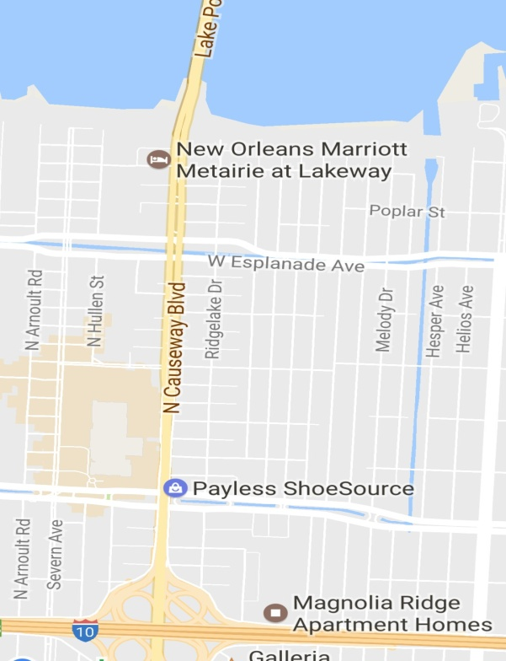 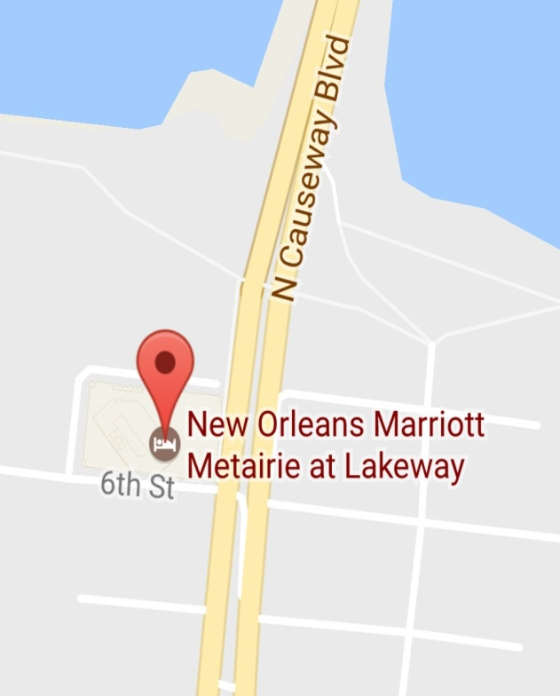Top of Form

Bottom of Form

Via I-10:

I-10 to the North Causeway Boulevard exit #228. Take North Causeway Boulevard to 6th Street .Turn left onto 6th Street. At the next light, turn right, and again right into the Porte Cochere and you have arrived at the hotel. 3838 N. Causeway Boulevard Metairie L.A.

Via Causeway Bridge:

Exit the Causeway Bridge. Make a Right on 6th Street . Make a Right on Lakeway Dr. the Marriott Metairie is on the left.