**2016 Advanced Procedures Course**  
  
The OAL proudly presents our third 32 hr COPE approved Advanced Procedures Course (APC).  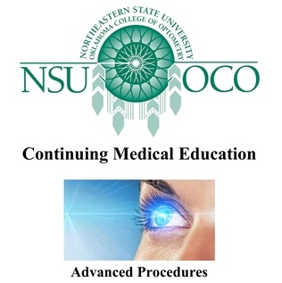The 2016 APC will be provided by the distinguished faculty of NSUOCO (Northeastern State University Oklahoma College of Optometry) and will include lectures & hands-on workshops.  This course will be held concurrently, during the OAL Annual Convention.  Course dates for the APC will be Thursday Afternoon, June 16 through Sunday afternoon, June 19, 2016 (exact times will be available soon, upon publication of the final course schedule).  Coursework, labs, and testing will be in Baton Rouge at the Crowne Plaza Executive Center.   
  
Both the 2014 & 2015 APC Courses received tremendous post course evaluations!  **T*his is your opportunity to attend the 2016 course, so please act quickly to register for the course,*** ***which will be limited to only 50 attendees***.  
  
Pre registration is CONTINUING!  
  
***OAL members***: login & click the "CE & Events" menu tab to find "2016 Advanced Procedures Course: PreRegister"