Arkansas Advanced Procedures
 | November 15-18, 2018 | 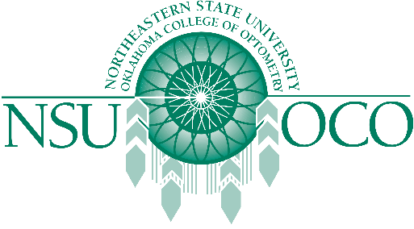

Course Information
The Arkansas Optometric Association and the Northeastern State University Oklahoma College of Optometry will present Surgical Procedures for the Optometric Physician and Laser Therapy for the Anterior Segment courses on November 15-18, 2018 in Little Rock, AR. The 32 COPE approved Expanded Therapeutic (ETP) course will be presented by both lecture and workshops.
The Minor Surgical Procedure course will be covered on the 15th & 16th. The Laser course is covered on the 17th & 18th. The schedule has the course on Thursday, the 15th beginning at 1:00 pm, the course would be finished by 1:00 pm on Sunday, the 18th. Both courses are COPE approved.

