Advanced Procedures
 | October 4-7, 2018 | 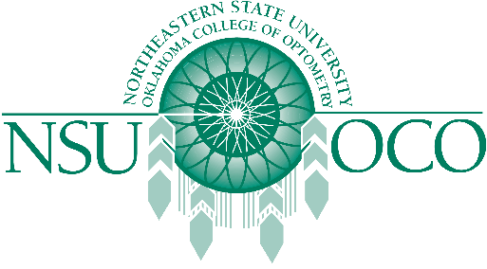

Course Information
The Wyoming Optometric Association and Northeastern State University Oklahoma College of Optometry will present Surgical Procedures for the Optometric Physician and Laser Therapy for the Anterior Segment on October 4-7, 2018 in Casper, Wyoming at the Casper College. The 32 COPE approved Expanded Therapeutic (ETP) course will be presented by both lecture and workshops.
The Minor Surgical Procedures course will be covered on the 4th and 5th. The Laser course is covered on the 6th and 7th. The schedule has the course on Thursday, the 4th beginning at 1pm, and the course will be finished by 1:00pm on Sunday, October 7th.

