Midwestern Advanced Procedures
 | December 6-9, 2018 | 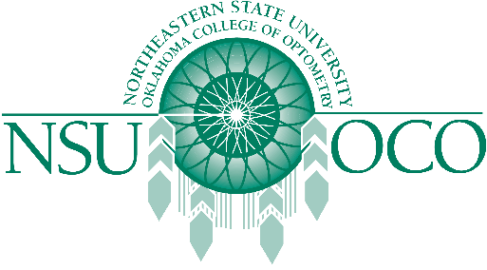

Course Information
Midwestern Chicago College of Optometry and the Northeastern State University Oklahoma College of Optometry will present Surgical Procedures for the Optometric Physician and Laser Therapy for the Anterior Segment courses on December 6-9, 2018 in Chicago, IL. The 32 COPE approved Expanded Therapeutic (ETP) course will be presented by both lecture and workshops.
The Minor Surgical Procedure course will be covered on the 6th & 7th. The Laser course is covered on the 8th & 9th. The schedule has the course on Thursday, the 6th beginning at 1:00 pm, the course would be finished by 1:00 pm on Sunday, the 9th. Both courses are COPE approved.

