Advanced Procedures
 | October 27-30, 2016 | 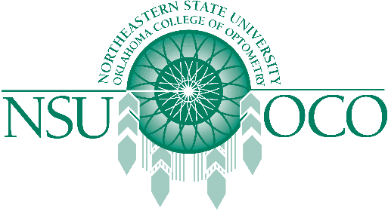

NSUOCO and the North Carolina Optometric Society presents the Advanced Procedures Course in Raleigh, North Carolina. This course offers 32 hours of COPE approved continuing education!

Course Details
- Thursday, 10/27/16 - Sunday, 10/30/16
- Embassy Suites Raleigh-Durham Airport/Brier Creek (8001 Arco Corporate Drive)
Registration Details
- The course is limited to 50 attendees - register today!
- NCOS Members: $1650
- Non-Member: $2200
Room Block Information
- A room block is available. Room availability is based on hotel availability; book your room early/at the time of registering

