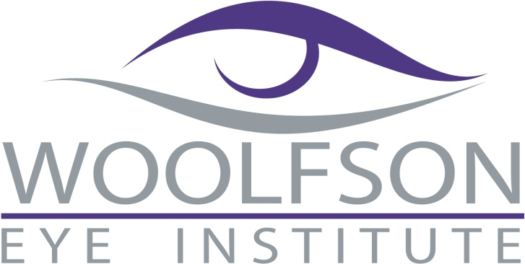

###### *Woolfson Eye Institute*

###### *Knoxville*

*Tel: 865-604-7244*

_**_____________________________________________________________________________**

Please Join Us for BREAKFAST and 1 hour CE

# **“Corneal Collagen Crosslinking Update” – 1 hour, COPE approved**

Corneal Collagen Crosslink Update covers the indications, methods and results of the treatment of keratoconus and post-LASIK ectasia via the instillation and corneal saturation of riboflavin drops followed by UV light application.

***Instructor: Jonathan Woolfson, M.D.***

*Founder & Medical Director of Woolfson Eye Institute*

**Tuesday, July 15, 2014**

7:30 am – 8:30 am

This event will be held at **Rothchild’s, 8807 Kingston Pike, Knoxville, TN 37923**.

### Please RSVP by July 10th for appropriate arrangements to be made

### via fax (865) 691-7478

### or email Amy at [amynatt@woolfsoneye.com](mailto:amynatt@woolfsoneye.com)

#### Name: ____________________________________________________

Phone: _______________________ Fax: ________________________________

Email: _____________________________________________________________

Would you like to receive a phone, email or text reminder for this event? _____________