

Dear Conference Attendee,

We would like to personally welcome each of you to the 4th annual International Vision Conference. It’s an exciting time for us as we continue to grow, remaining always adaptable, motivated and responsive to your needs. OD Excellence (ODX) is aware of the many changes occurring in health care and the new ICD 10 regulations. At this conference we will continue to bring inspired people together in forums like this, to ensure you and your practice remain at the cutting edge.

We would like to give you an idea of what you can expect and what we hope to achieve during this year’s International Vision Conference:

- 18 hours of “COPE” approved education for doctors
- 12 hours of staff education leading to certification
- 14 hours of staff training
- One-on-one coaching by leading consultants
- Exhibitors delivering unmatched savings
- Social events sponsored by our exhibitors
- Networking with your peers in beautiful San Diego where the weather is always near perfect during summer.
We’d like to give you a brief update on where ODX is today. For 2014, we have rolled out a Boot Camp on ICD 10 and health care, and have taken it across the country. We have also instituted information sharing meetings in many states as well as online for those who cannot make the meeting. We have built a guarantee program so members have no membership dues and receive discounts better than any buying group. We also offer a benchmark program, (called ODX profit) in addition to an advocate program, and much more.

We’re transforming the way we operate to continuously improve our ability to deliver the tools you need to grow your practice. Our team of professionals at ODX, whom you will meet at the conference, have continued to meet the challenges and to excel in supporting our valued and potential members. We are very proud of where we are today and our contributions to the industry, and excited about where we are headed.

The ODX team would like to thank each of you for attending the IVC and bringing your staff and families to our 2014 International Vision Conference. You are truly our greatest asset today, tomorrow and in the future. We could not accomplish what we do without your support. Throughout this conference I ask you to stay engaged, and help to shape the future of our profession.

ODX is your host at the IVC so please let any of us know what we can do to enhance your experience.

A special thank you to each of you,


Jerry Lieblein, OD, CEO Jerry Sude, OD, Chairman
jlieblein@odexcellence.com jsude@odexcellence.com

Table of Contents
Conference Agenda* 4
THURSDAY, July 31, 2014 4
FRIDAY, August 1, 2014 4
SATURDAY, August 2, 2014 4
Pricing Information 5
Registration Information 7
Student Registration 7
Hotel Accommodations 7
Registration Questions? 7
OD Excellence Practice of the Year 8
Doctor and Office Staff Education Information 8
Doctor Educational Information 9
Educational Information 9
Doctor Education Schedule 10
THURSDAY, July 31, 2014 10
FRIDAY, August 1, 2014 10
SATURDAY, August 2, 2014 11
Staff Education Schedule 12
FRIDAY, August 1, 2012 12
SATURDAY, August 2, 2014 12
Faculty Background 13
Jerome Lieblein, O.D. 13
Jerome Sude, O.D. 13
John A. McGreal Jr., O.D. 14
John W. Lahr, O.D., FAAO 14
Jim Grue, O.D. 15
Valerie Manso 15
Jay Binkowitz 15
Paul Chous, MA, O.D. 16
Sam Quintero, O.D., FAAO, Diplomate, American Board of Optometry 16
Arthur B. Epstein, O.D., FAAO, FBCLA, DPNAP 17
Bob Schultz 17
Pam Lowe, O.D., FAAO 18
Rebecca Johnson 18
Jon Weeding 19
Phernell Walker, BSB, ABOM 19
Meeting Room Floorplan 20

Conference Agenda*

THURSDAY, July 31, 2014
11:00 am – 6:00 pm |  | Registration  Seaport Foyer
1:00 pm – 6:00 pm |  | Education Classes  Seaport Ballroom A-B-C
6:00 pm – 8:00 pm |  | Exhibit Hall Hours
6:00 pm – 7:30 pm |  | Welcome Reception in Exhibit Hall  Seaport Ballroom D-E-F-G-H

FRIDAY, August 1, 2014
8:00 am – 6:00 pm |  | Registration  Seaport Foyer
8:00 am – 9:00 am |  | Personal Coaching Sessions**
9:00 am – 12:00 pm |  | Education Classes
12:00 pm – 2:00 pm |  | Lunch in Exhibit Hall  Seaport Ballroom D-E-F-G-H
2:00 pm – 6:00 pm |  | Education Classes
6:00 pm – 8:00 pm |  | Reception with Food Stations in Exhibit Hall  Seaport Ballroom D-E-F-G-H

SATURDAY, August 2, 2014
8:00 am – 6:00 pm |  | Registration  Seaport Foyer
8:00 am – 9:00 am |  | Personal Coaching Sessions**
9:00 am – 12:00 pm |  | Education Classes
12:00 pm – 2:00 pm |  | Lunch in Exhibit Hall  Seaport Ballroom D-E-F-G-H
2:00 pm – 6:00 pm |  | Education Classes

See Individual Doctors Schedule on page 10 and Staff Schedules on page 12.

Limited seating available – Coaching Sessions will be first come, first serve - advance sign-up required.
Coaching Sessions have been expanded for this conference – each session will be one hour and will be held in a private meeting area.

COACHING SESSIONS**
FRIDAY 8:00 AM - 9:00 AM:
CODING AND BILLING– LED BY CONSULTANT, DR. JOHN MCGREAL (La Jolla)
Healthcare Exchanges/Managed Care– LED BY CONSULTANT, DR. JOHN LAHR (Balboa A)
STAFFING/TRAINING – LED BY CONSULTANT, VALERIE MANSO (Balboa B)
PRACTICE MANAGEMENT– LED BY CONSULTANT DR. SAM QUINTERO (Old Town)
PRACTICE ACQUISITIONS - LED BY CONSULTANT GARY WARE (Gaslamp)

SATURDAY 8:00 am - 9:00 AM:
OPERATIONS - LED BY CONSULTANT, DR. JERRY SUDE (La Jolla)
PRACTICE MANAGEMENT - LED BY CONSULTANT, JAY BINKOWITZ (Balboa A)
FINANCES - LED BY CONSULTANT, BOB SCHULTZ (Balboa B)
HEALTH CARE REFORM - LED BY CONSULTANT, DR. JIM GRUE (Old Town) *Agenda is subject to change
COMPLIANCE ISSUES - LED BY CONSULTANT, JON WEEDING (Gaslamp) ** Open to doctors and management only

Pricing Information

ODX Affiliate Member Registration ($1,380.00 Value) is FREE and includes:
Credit for up to 1 night stay at the Manchester Grand Hyatt in San Diego, CA $240
Admission to Thursday Welcome Cocktail Reception with Guest $100
Admission to Friday Cocktail Reception with Guest $160
Coaching Sessions** $100
Admission to Exhibit Hall (includes Lunch Fri/Sat and includes a guest) $240
All Education Classes $540

Free Package Requirement for Affiliate:
To qualify for the free Affiliate Member registration package, you must be an Affiliate Member of OD Excellence at least three months prior to the conference or have paid for a minimum of three months dues prior to the start of the conference. Members must be in good standing or have payment arrangements approved by the ODX Finance Department prior to receiving the benefits of the free package.

ODX Associate Member Registration Package ($890.00 Value) and includes:
Admission to Thursday Welcome Cocktail Reception $50
Admission to Friday Cocktail Reception $80
Coaching Sessions** $100
Admission to Exhibit Hall (includes Lunch Fri/Sat) $120
All Education Classes $540
ODX will give Associate Member a 50% discount towards their 2014 IVC registration fees. Total cost will only be $445.00.

Package Requirement for Associate:
To qualify for the 50% discounted Associate Member registration package, you must be an Associate Member of OD Excellence at least three months prior to the conference or have paid a minimum of three months dues prior to the start of the conference. Members must be in good standing or have payment arrangements approved by the ODX Finance Department prior to receiving the benefits of the free package.

ODX D.E. Member Registration Package, employed by Affiliate, no guests, ($890.00 Value) and includes:
Admission to Thursday Welcome Cocktail Reception $50
Admission to Friday Cocktail Reception $80
Coaching Sessions** $100
Admission to Exhibit Hall (includes Lunch Fri/Sat) $120
All Education Classes $540
Total package is $890.00. ODX will give D.E. Member a $375.00 discount towards their 2014 IVC registration fee. Total cost will only be $515.00.

Package Requirement for D.E Member:
To qualify for the $515.00 discounted D.E. registration package, you must be a D.E. Member of OD Excellence at least three months prior to the conference or have paid a minimum of three months dues prior to the start of the conference. Members must be in good standing or have payment arrangements approved by the ODX Finance Department prior to receiving the benefits of the free package.

Non-Member RegistrationPackage is $760.00 and includes:
Coaching Sessions** $100
Admission to Exhibit Hall (includes Breakfast & Lunch Fri/Sat) $120
All Education Classes $540
Register before 4/30 for 30% Discount Discount ($228.00) for cost of $532.00
Register by 5/30 for 20% Discount ($152.00) for cost of $608.00
Register by 6/30 for 10% Discount ($76.00) for cost of $684.00
After 6/30, cost is $760.00
Education Only (Exhibit Hall and meals not included):
All Thursday Education Classes $120
All Friday Education Classes $210
All Saturday Education Classes $210
All Education Classes $540

Office Staff Registration Package ($550.00 Value) is $275.00 (50% off) and includes:
Admission to Thursday Welcome Cocktail Reception $ 50
Admission to Friday Cocktail Reception $ 80
Admission to Exhibit Hall (includes Lunch Fri/Sat) $120
All Staff Education Classes $300

Office Manager Certification Course (Full 2-day program) $700.00 Value is $350.00 (50% off) if attending with a doctor and includes:
Admission to Thursday Welcome Cocktail Reception $ 50
Admisssion to Friday Cocktail Reception $ 80
Admission to Exhibit Hall (includes Lunch Fri/Sat) $120
OMCC Program $450

Guest badges available at registration booth only
**Coaching is open to Doctors and staff management only

Registration Information

Please access online registration by clicking on the “Registration” link on the IVC web site at http://ivisionconf.org.
Student Registration
ODX supports students working to enter our profession! Student Registration is complimentary for active, full-time optometry students, if you register no later than May 31, 2014. Student registration applies to students currently attending optometry school or those enrolled for the following semester. Space is limited. Registration will be accepted on a first-come, first-serve basis. There is no guarantee of space availability after May 31, 2014.
Note: Student Registration does not include any meal function or Exhibit Hall. Meal functions with Exhibit Hall admission can be purchased separately.
Exhibit Hall Only Registration
Admission to the Exhibit Hall is included with registration packages and includes Lunch. No children under the age of 16. All individuals are required to wear their registration badge for admittance into the Exhibit Hall.
Cancellation/Refund Policy
ALL CANCELLATIONS MUST BE SUBMITTED IN WRITING. All cancellations and requests for refunds must be sent to johanna@ivisionconf.org no later than June 30, 2014. A full refund minus a $50 administrative fee will be provided for cancellations received on or before April 15, 2014. A 50% refund will be provided for cancellations received between April 16, 2014 and June 30, 2014. No refunds will be given after June 30, 2014.
Substitutions are allowed. Please contact the IVC Coordinator at johanna@ivisionconf.org with substitution information.
Please Note: No refunds will be provided for “No-shows.”

Hotel Accommodations
We have secured a block of rooms at The Manchester Grand Hyatt Hotel in San Diego. To make your reservations, please click on the “Housing” link on the IVC web site at http://ivisionconf.org.

All Affiliate members will receive a credit for a 1 night stay (Value $240.00) as an Affiliate member benefit. Hotel reservation deadline is May 31, 2014.

It is recommended that reservations be made as early as possible due to limited space. We have negotiated a special rate for conference attendees onlyshould they wish to extend their stay. The rate will be at $249 night + applicable taxes (3-Day Pre/Post event upon availability).

Registration Questions?
Contact the ODX/IVC Office toll-free at 855-2011-ODX (855-201-1639)or e-mail johanna@ivisionconf.org

OD Excellence Practice of the Year

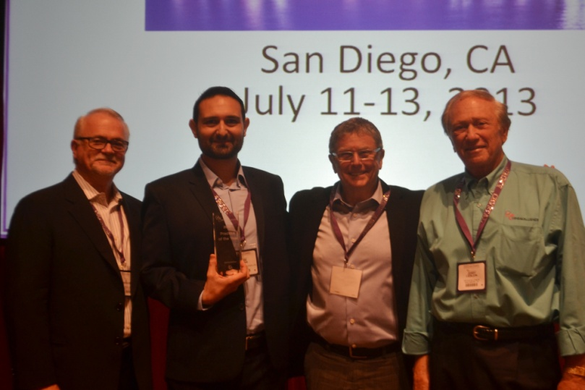
2013 ODX Practice of the Year Winner Dr. Najib Albina,
with ODX Chairman Dr. J. Sude, ODX CEO Dr. J. Lieblein and Ed Buffington, National Vice President for VSP Strategic Partnerships

The International Vision Conference includes optometric professionals from all across the world. Many attendees are also members of the OD Excellence Practice Management program. At the IVC, we recognize the achievements of one of our ODX Members as the OD Excellence Practice of the Year, sponsored by VSP Global.

The award distinguishes the practice that utilizes the ODX tools available to increase their practice top line while decreasing their cost of goods.

Other qualifications for this award include having a thirst for continued knowledge and taking advantage of the wealth of educational classes offered while building a firm foundation with the medical model while utilizing the practice management tools available.

In 2012, OD Excellence and VSP Global recognized its first Practice of the Year Award, earned by Dr. Stephen Hedges of Hedges Family Eyecare, who was able to achieve a 37% increase in his top-line by being a member of ODX.

In 2013 OD Excellence and VSP Global recognized Dr. Najib Albina of The Eye Care Center in Chicago, Illinois. Dr. Albina used the tools ODX provides as part of his membership to understand billing and coding, how to market properly using a “call to action” approach, and most importantly, training staff to interact and educate patients in a friendly and empathetic manner.

Please click here to download the application for the 2014 ODX Practice of the Year award, or contact yliu@odexcellence.com with any questions.

Doctor and Office Staff Education Information

Doctor Educational Information
You must be in attendance for 50 minutes per class to receive COPE Continuing Education Credits.
In the conference package you receive after registration, you will receive the attendance form for all of the Continuing Education classes. At the conclusion of each class, a Student Ambassador will be located at the exit to confirm your attendance. Please submit this attendance form to your State Board/National Accreditation agency for license renewal.
The ODX courses will be submitted to COPE for consideration of Continuing Education Credit approval. Most State Boards of Optometry now accept COPE approved courses. For specific State Board of Optometry license rules and regulations pertaining to the COPE acceptance, please contact your State Board directly. COPE approved courses are accredited in Canada.
Courses fill up quickly, so we recommend that you register early to secure your seat. Note: All optometrists are required to provide their ARBO/OE Tracker number for COPE when registering for continuing education courses.
OE Tracker Number
Contact ARBO at http://www.arbo.org if you do not know or have not been issued an OE tracker number.
Educational Information
In the conference package you receive after registration, you will receive the attendance form for all of the Continuing Education classes. At the conclusion of each class, a Student Ambassador will be located at the exit to confirm your attendance. Additional instructions and information will be provided at the Conference. There will be 19 hours of Doctor education and 14 hours of staff education, ABO and CPC pending.
Thank you! We look forward to seeing you in San Diego!

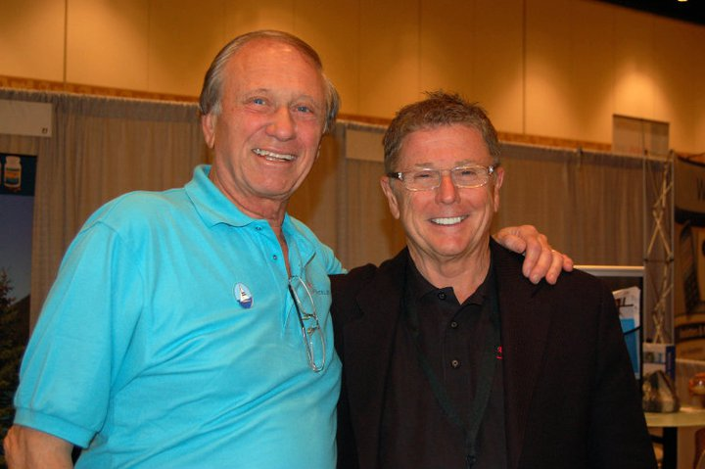
Jerry Lieblein, CEO and Jerry Sude, Chairman
International Vision Conference sponsor OD Excellence

Doctor Education Schedule

THURSDAY, July 31, 2014
All sessions are in Seaport Ballroom A-B-C except where noted
1:00 PM – 1:15 PM |  | Dr. Jerry Sude  Welcome  Introduction of ODX Staff and Student Volunteers
1:15 PM – 2:05 PM |  | Jay Binkowitz, COPE # 32171-PM  Measuring For Success
2:05 PM – 2:55 PM |  | Dr. Paul Chous, OD, COPE# 37201-SD  Diabetes: An inside look
2:55 PM – 3:10 PM |  | Break  Litrenta Foyer
3:10 PM – 4:00 PM |  | Dr. Paul Chous, OD, COPE # 37201-SD  Diabetes: An Inside Look (Continued)
4:00 PM – 4:50 PM |  | Dr. Paul Chous, OD, COPE # 37506-SD  Diabetes Disasters
4:50 PM – 5:40 PM |  | Dr. Paul Chous, OD, COPE # 38934-SD  The Diabetes Visual Function Supplement Study
5:40 PM – 6:10 PM |  | Speakers: Dr. Chous OD, Jay Binkowitz  Moderator: Dr. Jerry Sude, OD  Q&A

FRIDAY, August 1, 2014
All sessions are in Seaport Ballroom A-B-C except where noted
8:00 AM – 9:00 AM  Coaching Sessions |  | Dr. Sam Quintero: Associate Doctors Compensation:  Dr. John Lahr: Healthcare Exchanges/Managed Care  Dr. Jerry Sude:  Dr. Jim Grue:  Bob Schultz:  Rooms: Old Town, Gaslamp A, Balboa A-B, La Jolla
9:00 AM – 9:50 AM |  | Gary Ware, COPE# (TBD)  Practice Appraisals for Buyers and Sellers
9:40 AM – 10:40 AM |  | Dr. Art Epstein  Dry Eyes, an Update
10:40 AM – 10:55 AM |  | Break  Litrenta Foyer
10:55 AM – 11:05 AM |  | Current Trends
11:05 AM – 11:55 AM |  | Dr. John McGreal COPE# (TBD)  The New ICD-10 Codes
12:05 PM – 2:00 PM |  | Lunch  Exhibit Hall
2:00 PM – 2:10 PM |  | Current Trends
2:10 PM –3:50PM |  | Dr. Pam Lowe COPE # (TBD)  Anterior Segment Updates
3:50 PM – 4:05 PM |  | Break  Litrenta Foyer
4:05 PM – 4:15 PM |  | Current Trends
4:15 PM – 5:00 PM |  | Dr. Pam Lowe COPE # (TBD)  How to Profit in a Contact Lens Practice Today
5:05 PM – 6:00 PM |  | Speakers: Drs. Epstein, McGreal, Lowe  Moderator: Dr. Jerry Sude, OD  Q&A Panel

SATURDAY, August 2, 2014
All sessions are in Seaport Ballroom A-B-C except where noted
8:00 AM – 9:00 AM  Coaching Sessions |  | Dr. John McGreal:  Jon Weeding:  Gary Ware:  Valerie Manso:  Jay Binkowitz:  Rooms: Old Town, Gaslamp A, Balboa A-B, La Jolla
9:00 AM – 9:50 AM |  | Bob Schultz COPE# 33342-pm  Anatomy of a Successful Practice: Planning, Preparations, Expectations
9:50 AM – 10:00 AM |  | Current Trends
10:00 AM – 10:50 AM |  | Dr. John McGreal COPE# (TBD)  ICD-10 Workshop
10:50 AM – 11:05 AM |  | Break  Litrenta Foyer
11:05 AM – 11:15 AM |  | Current Trends
11:15 AM – 12:00 PM |  | Dr. Jim Grue COPE #- (TBD)  The latest HCR delivery models
12:00 PM – 2:00 PM |  | Lunch  Exhibit Hall
2:00 PM – 2:10 PM |  | Current Trends
2:10 PM – 3:50PM |  | Dr. John McGreal, OD COPE # 38281  Technology and Innovation
3:50 PM – 4:05 PM |  | Break  Litrenta Foyer
4:05 PM – 4:15 PM |  | Current Trends
4:15 PM – 5:15 PM |  | Dr. John Lahr, OD COPE# 33339-AS  Management of Ocular Surface Disease Cases
5:15 PM – 6:00 PM |  | Speakers: Drs. John Lahr, John McGreal, Jim Grue, Bob Schultz  Moderator: Dr. Jerry Sude  Q & A Panel
Total hrs = 19 (Medical = 12 hrs, Practice Management = 7 hours)

Staff Education Schedule

FRIDAY, August 1, 2012
9:00 am – 5:00 pm |  | Valerie Manso  Office Manager Certification Course —Part One All day program  Balboa A-B
9:00 am – 10:50am |  | Jay Binkowitz  Patient Communications and Sales Strategies  La Jolla A-B
10:50 am – 11:10 am |  | Break
11:10 am – 12:00 pm |  | Phernell Walker  Paraoptometric/Optician General session  (Sales Topic)  La Jolla A-B
12:00 pm – 2:00 pm |  | Lunch Break  Exhibit Hall
Break-out Sessions |  | Track I  (Ophthalmic Optics) | Track II  (Practice Management/Billing and coding)
2:00 pm – 2:50 pm |  | Phernell Walker  Digital lenses (ABO & AOA)  La Jolla A-B | Stephen Farebrother  Improving capture rate (ABO, NCLE, AOA)  Old Town A-B
2:50 pm – 3:00 pm |  | Break
3:00 pm – 4:00 pm |  | Phernell Walker  Sunglasses (ABO & AOA)  La Jolla A-B | Stephen Farebrother  Billing and coding made easy (ABO & AOA)  Old Town A-B
4:00 pm – 5:00 pm |  | Dr. John McGreal cope# (TBD)  The New ICD-10 Codes for staff  La Jolla A-B
5:00 pm – 6:00 pm |  | Jay Binkowitz, , Valerie Manso and Rebecca Johnson  Panel discussion Subject TBD (ABO & AOA)  Balboa A-B

SATURDAY, August 2, 2014
9:00 am – 4:00 pm |  | Valerie Manso  Office Manager Certification Course —Part Two  Balboa A-B
9:00 am – 9:50 am |  | Jay Binkowitz  The Mathematics of Board Management  La Jolla A-B
9:50am - 10:50 am |  | Jay Binkowitz  Implement The Right Warranty and Drive Sales  La Jolla A-B
10:50 am – 11:05 pm |  | Break
Break-out Sessions |  | Track I  (Ophthalmic Optics) | Track III  (Practice Management/Billing and coding)
11:05 am – 12:00 pm |  | Phernell Walker  Frames (ABO & AOA)  La Jolla A-B | Stephen Farebrother  VSP Coordination of benefits  Old Town A-B
12:00 pm – 2:00 pm |  | Lunch Break  Exhibit Hall
2:00 pm – 3:40 pm |  | Valerie Manso  Multiple Pairs (ABO & AOA)  Balboa A-B
3:40 pm – 4:00 pm |  | Break
4:00 pm – 5:00 pm |  | Phernell Walker, Stephen Farebrother, Valerie Manso  Panel discussion:Subject TBD (ABO & AOA)  Balboa A-B

Faculty Background

We are excited to introduce our distinguished 2014 International Vision Conference Faculty:

Jerome Lieblein, O.D.

Chief Executive Officer, OD Excellence

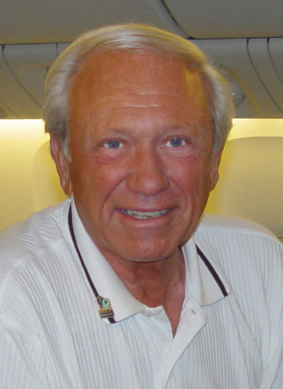
Dr. Lieblein is the Chief Executive Officer of OD Excellence, LLC, and is a consultant in practice management and meeting planning, and author of 92 published articles. He is currently Executive Director and Facilitator of the American Society of Eye Care Specialists, a collaborative vision care business group. Previously he was Optometrist and Senior Partner in a California private practice. Dr. Lieblein is a Past President of the International Association of State Boards, Past Chairman of the Contact Lens Division of the American Optometric Association, and Past President of the California Optometric Association. He was the Eye Doctor of the Year for California in 1989, and was elected to be one of 100 Doctors in the United States to sit on a National Health panel called "National Association of Practitioners."

Jerome Sude, O.D.

Chairman, OD Excellence


Dr. Sude is Chairman of OD Excellence, LLC, and has extensive experience in establishing multiple optometric sites, including developing one of the largest optometric/ophthalmologic small chains in the U.S. He is an international author, and has been a practice management speaker to several contact lens companies. Dr. Sude is former Midwest Medical Director for Sauflon. Currently he is EVP of the Novus Clinic, a multidimensional group of optometrists and ophthalmologists. He is a Past President of the American Society of Eyecare Specialists and a former President of the Summit County Optometric Society.

John A. McGreal Jr., O.D.

Director of Professional Education, OD Excellence

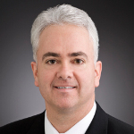
Dr. McGreal is a graduate of Albright College and the Pennsylvania College of Optometry. He was Chief of Eye Services at Greater Atlantic Health service in Philadelphia, where he also had a private practice. He was a founding partner in Vision Care Consultants, a managed eye care company in Pennsylvania. He was Center Director and Vice President for Vision America Incorporated for seven years. Currently, he is Director of the Missouri Eye Associates, a medical and surgical private practice in St. Louis. He is adjunct faculty at the University of California, Berkeley School of Optometry, the Pennsylvania College of Optometry and the University of Missouri. He is internationally recognized for his educational endeavors. Dr. McGreal served on the continuing education committee for the North Central States Optometric Council and is past member of the Congress continuing education subcommittee of the American Optometric Association. He is a clinical examiner for the National Board of Examiners in Optometry; he was the 42nd Peter's Memorial Lecturer at the University of California; and the Nussenblatt Lecturer at the University of Houston in 2004. Dr. McGreal was the 1998 Missouri Optometrist of the Year, and the 2005 University of Missouri School of Optometry Educator of the Year.

John W. Lahr, O.D., FAAO

National Executive, OD Excellence

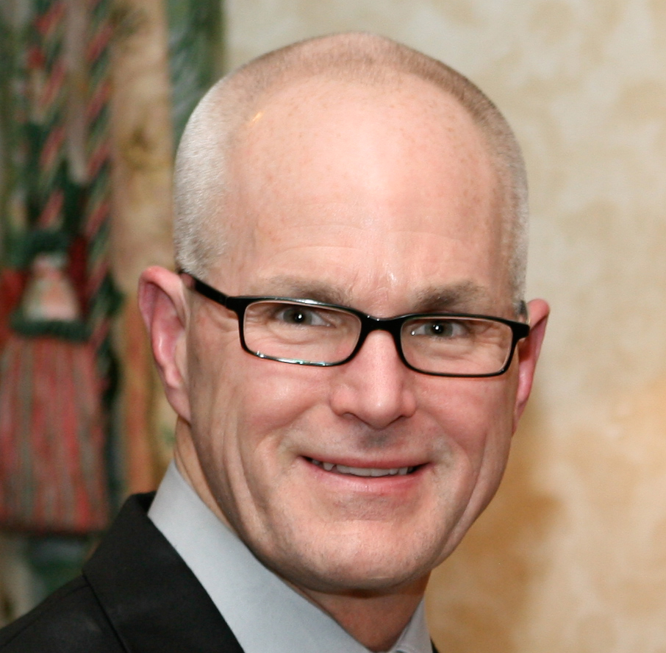
Dr. Lahr received his Doctor of Optometry degree from the Indiana University School of Optometry in 1974. He was the founder of The Eye Clinics, a five-office primary eye care group practice in East Central Minnesota. In 1984, Dr. Lahr integrated his practices with ophthalmology and began providing his patients with co-managed care while developing care models with several ophthalmologists. He was an original member of the Clinical Practice Guidelines Committee of AOA to develop practice standards and protocols for the profession. Dr. Lahr served as AOA's first representative to the American Medical Association's CPT coding committee while serving on the Eye Care Benefits Center. He is a Past President of the Minnesota Optometric Association and was the MOA Optometrist of the Year in 1989. Over the past decade, Dr. Lahr has worked closely with ophthalmic and optical corporate entities including Allergan, AMO, Bausch + Lomb, Biosyntrx, EyeMed Vision Care, Nordic Naturals and Oasis Medical.

Jim Grue, O.D.
Director of Health Policy Integration for OD Excellence
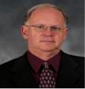
Dr. Jim Grue joined EMRlogic in 2006, specializing in the development of software as a clinical solution that would exceed health care reform and pay-for-performance standards and is now their VP Clinical Outcomes & Connected Care.

Retired from full-time practice, he has been an avid observer of all that happens in Washington pertaining to health care, and eye care in particular. Jim is a frequent speaker on health care reform and its implications for eye care. He is generally considered one of the significant thought leaders of the eye care profession. Dr. Grue is a graduate of the Pennsylvania College of Optometry.

Valerie Manso
RVP, VSP and President, Manso Management Resources, Inc.
Director of Staff Education for OD Excellence


Valerie Manso is Regional Vice President of Strategic Partnerships for VSP and President of Manso Management Resources, Inc., a training and development company specializing in the ophthalmic industry since 1993. Valerie is a 40+ year veteran of the optical industry and she brings a wealth of expertise to her training programs.

Valerie is also the Director of Staff Education for OD Excellence, and administers the Company’s innovative Office Management Certification Course (OMCC) and Excellence in Management (EM) programs.

Jay Binkowitz
Optometric Business Consultant
President of GPN

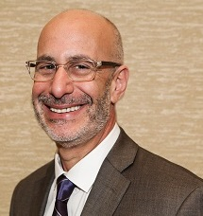
Over the last 30 years Mr. Binkowitz has had extensive experience in retail operations, merchandising & marketing, manufacturing & distribution, technology development, national sales, and on site interactive consulting. Over the last ten years he has dedicated his time and resources to developing lectures and workshops at major industry events and has published numerous articles for key industry publications. With the development of GPN he has created a unique support company that can provide infrastructure and strengthen independent practitioners with new business management tools and processes. Mr. Binkowitz has and continues to develop critical information and philosophies to support and strengthen the goals of independents while working collaboratively with consultants, MBA’s and leading business owners.

Paul Chous, MA, O.D.
Recognized Expert and Consultant on Diabetic Eye Disease
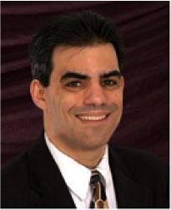
Dr. Paul Chous grew up in Southern California. He was diagnosed with Type 1 diabetes mellitus at age five. Paul completed his undergraduate education at Brown University and UC Irvine. He received his Masters Degree in 1986 and his Doctorate of Optometry in 1991, both with highest honors from UC Berkeley. Dr. Chous was selected as the Outstanding Graduating Optometrist in 1991. He developed proliferative diabetic retinopathy in 1986 and underwent multiple laser treatments to save his vision.
Dr. Chous has practiced optometry with a special emphasis on diabetic eye disease and diabetes education for 20 years in the State of Washington, winning the American Diabetes Association’s Distinguished Public Service Award in 1998. Upon the birth of his son in 2000, he began work on a book for patients and doctors alike about the myriad effects of diabetes on the eyes and visual system, Diabetic Eye Disease: Lessons From a Diabetic Eye Doctor (Fairwood Press, 2003), which has been called "one of the most practical and down to earth books on this topic ever written" by noted diabetes specialists (see reviews at www.DiabeticEyes.com)
Dr. Chous lectures and writes frequently on the subjects of diabetic eye disease and emerging treatments for diabetic eye disease. He has served as a consultant to Children With Diabetes, the Diabetes Exercise and Sports Association, is on the editorial review board of Review of Optometry, and is a member of the Pharmacy/Podiatry/Optometry/Dentistry (PPOD) work group of the National Diabetes Education Program. He practices in Tacoma, WA and lives with his wife, Dr. Elizabeth Chous, and sons, Atticus and Charlie, in Maple Valley, WA.

Sam Quintero, O.D., FAAO, Diplomate, American Board of Optometry
Associate Professor University of Houston College of Optometry
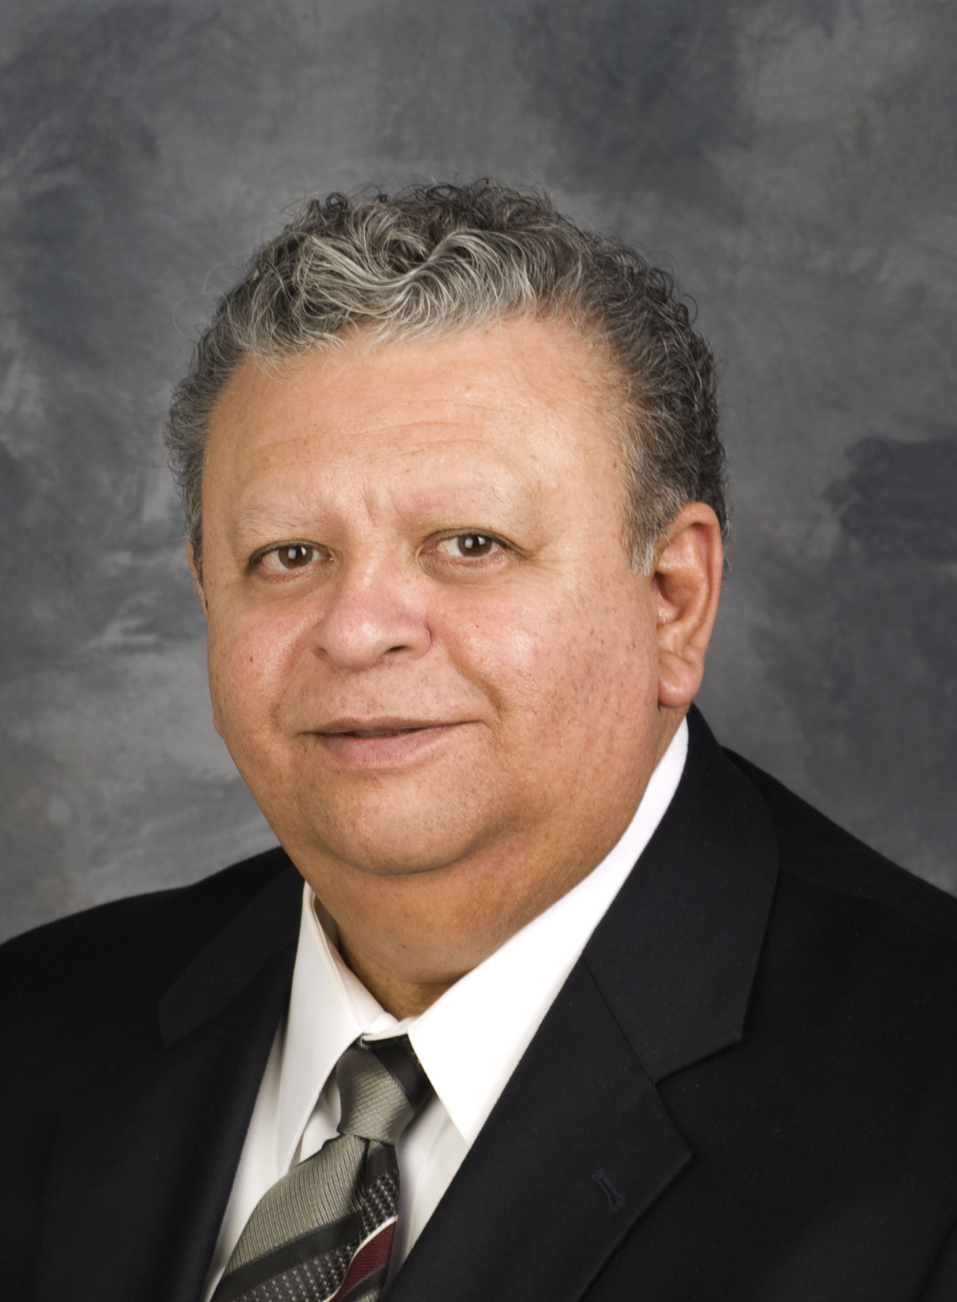
Dr. Sam Quintero received his optometric training at the University of Houston College of Optometry. After receiving his doctorate in 1972, he joined the faculty of the University of Houston College of Optometry. Dr. Quintero served as the Chair of the Department of Clinical Sciences at the University of Houston College of Optometry from 2004 to 2008.

He is certified as a Therapeutic Optometrist and his interests and areas of teaching include contact lens practice, diagnosis and management of ocular disease and laser and other refractive procedures, refractive anomalies, practice management, critical thinking and clinical techniques.

Dr. Quintero is a Fellow of the American Academy of Optometry and has served as Chair of the Section on Optometric Education for the American Academy of Optometry. He is Vice Chair of the Association of Practice Management Educators. He is a member of the Texas Optometric Association and also a member of the American Optometric Association. He has served on several task forces for the Association of Schools and Colleges of Optometry (ASCO).

He has been recognized for his contributions to education by the Texas Optometric Association having received the Educator of the Year Award in 2005. He was also recognized for his contributions to the American Academy of Optometry, receiving the Eminent Service Award in 1998.

In addition to his academic interests, Dr. Quintero maintains an active private practice in Houston, Texas. In 2011, he successfully fulfilled the requirements as Diplomate of the American Board of Optometry and is active in maintaining his Diplomate status.

Arthur B. Epstein, O.D., FAAO, FBCLA, DPNAP
Co-founder of Phoenix Eye Care, PLLC and the Dry Eye Center of Arizona, PLLC

Dr. Epstein is a native New Yorker who graduated from the State University of New York, State College of Optometry.
After relocating to Phoenix, AZ. Dr. Epstein co-founded Phoenix Eye Care, PLLC and The Dry Eye Center of Arizona, PLLC. He heads the practice’s Dry Eye - Ocular Surface Disease Center and serves as its Director of Clinical Research. Dr. Epstein is a highly regarded educator and popular speaker. He serves as Clinical Adjunct Associate Professor at the Midwestern University, Arizona College of Optometry and has presented in excess of 1000 invited lectures throughout the world. He is also a prolific author who has published hundreds of articles, scientific papers and book chapters. Dr. Epstein is a reviewer for numerous clinical and scientific journals. He is a Fellow of the American Academy of Optometry and American Board of Clinical Optometry, a Distinguished Practitioner of the National Academies of Practice and a diplomate of the American Board of Certification in Medical Optometry.
A Contributing Editor for Review of Optometry and Executive Editor of Review of Cornea and Contact Lenses he founded, and serves as Chief Medical Editor of Optometric Physician™, the first E-Journal in optometry.
Bob Schultz
President and CEO, Vision One Credit Union
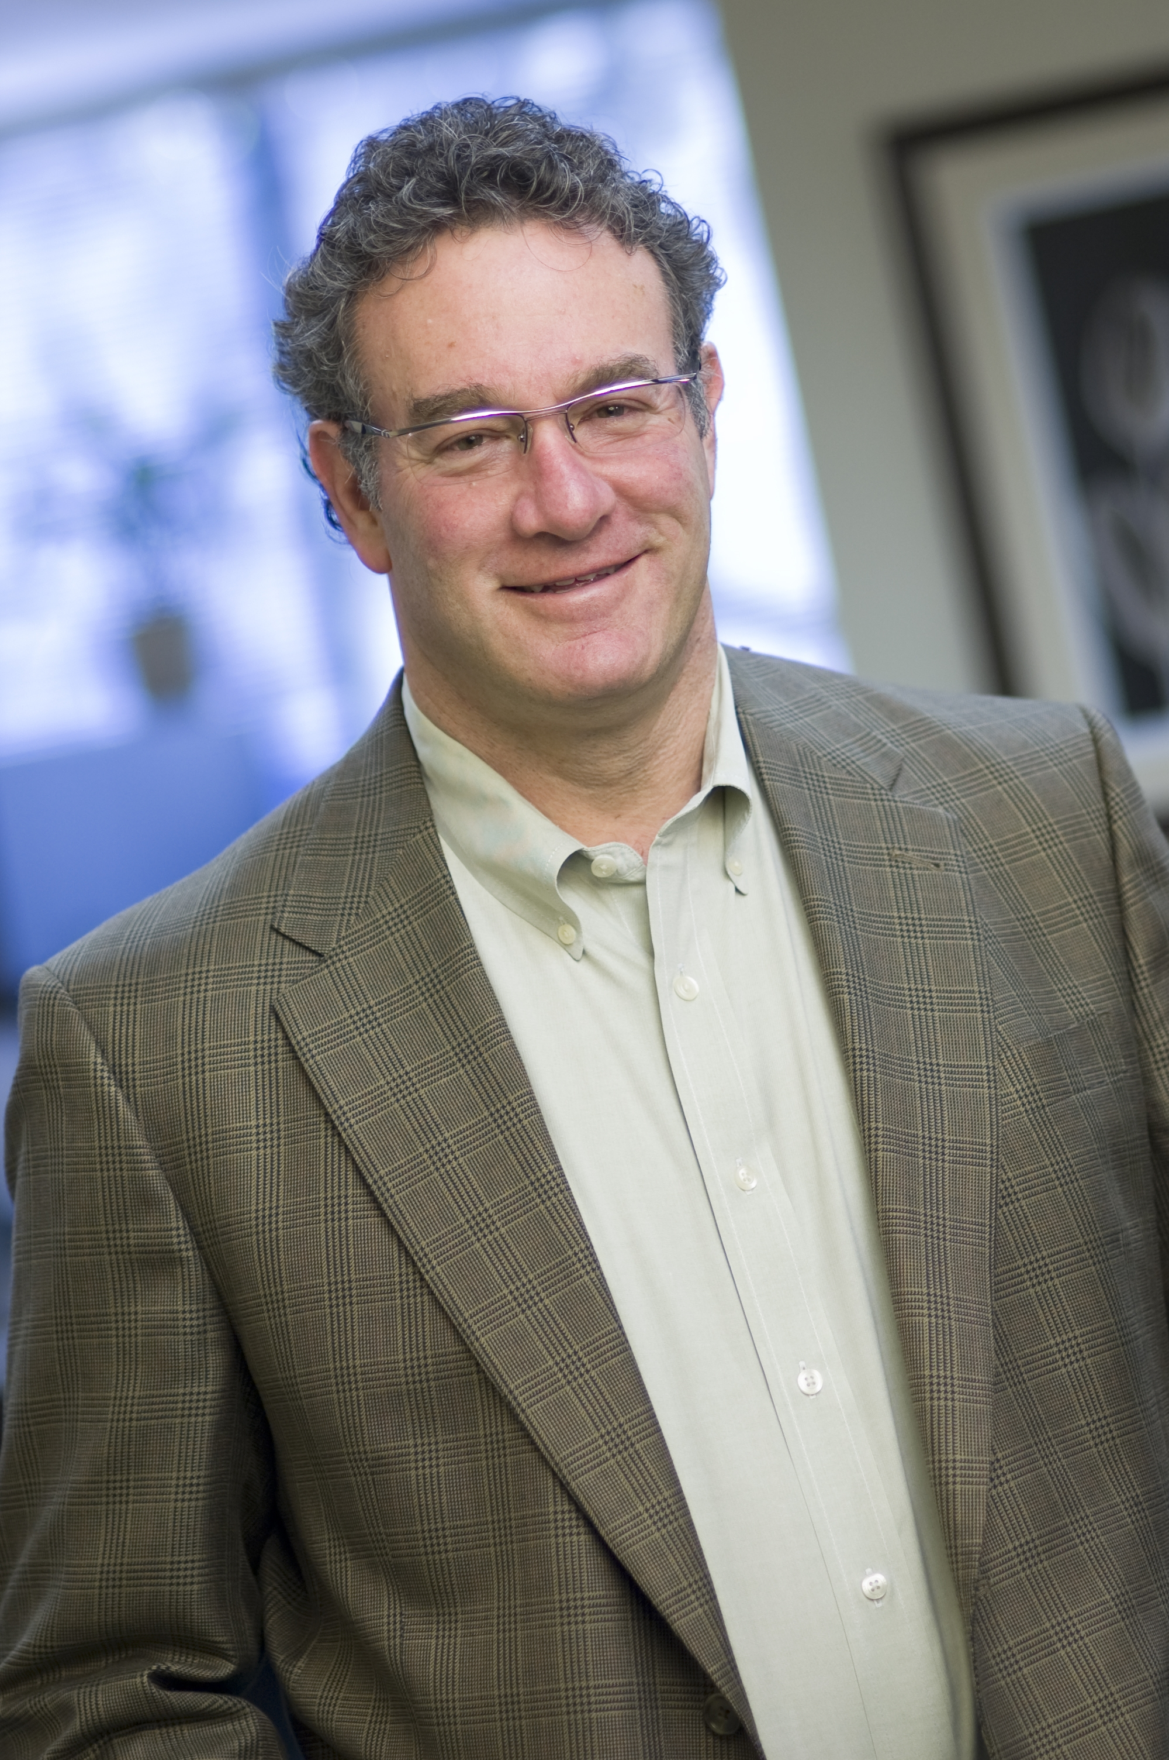
With over 25 years of experience in commercial banking across the U.S., Mr. Bob Schultz specializes in relationship banking for the small to medium sized business entrepreneur. He joined Vision One Credit Union (VOCU) as President and CEO in 2000.

As a non-profit financial institution owned by independent optometry, Vision One Credit Union is focused on the health and financial success of private optometric practices. Under Bob’s direction, VOCU develops loan and deposit programs to help ODs enter practice ownership, build wealth and achieve retirement goals. VOCU offers practice financing and deposit services; specializing in practice acquisition, equipment, remodel / relocation loans as well as high yield depository accounts.

Pam Lowe, O.D., FAAO
Director/President of Professional Eye Care Center, Inc.
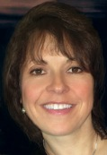
Dr. Pam Lowe is currently Director/President of Professional Eye Care Center, Incorporated, a private practice she founded in 1992 on Chicago’s Northwest Side. She received her Bachelor of Science degree from Loyola University of Chicago in 1984 and graduated with honors from the Illinois College of Optometry in 1988. The college named her the Alumnus of the Year in 2002.

Dr. Lowe is active in organized optometry and is a Past President of the Illinois Optometric Association. Dr. Lowe was awarded Illinois’s Young Optometrist of the Year in 1995 and Optometrist of the Year in 2006. She has been a career long member of the American Optometric Association and currently serves as an AOA Media Spokesperson and is a Key-person for AOA Advocacy and serves on the AOA Communications Committee; she is a Fellow with the American Academy of Optometry and a Diplomate of the American Board of Optometry.

Dr. Lowe stays active on the education side of her profession by serving as an Adjunct Clinical Professor for the Illinois College of Optometry with her office serving as part of the Cornea/Contact Lens Residency Program rotation. She has lectured on many topics including retinal disease, cataract extraction, laser vision correction and currently travels throughout the country speaking on early detection and new technologies for macular degeneration, wave-front guided spectacle lenses and the latest technologies/trends in contact lenses. She has had the distinction of serving as a Clinical Examiner for the National Board of Optometry, Past Chair for the Illinois Department of Professional Regulation State Board for Optometry and Past-President of the Illinois College of Optometry Alumni Council.

Rebecca Johnson
Executive Director of Business Services, GPN

Rebecca Johnson is an enthusiastic and motivational ophthalmic staff trainer, a nationally recognized speaker and the Executive Director of Business Services for GPN. She has been honored as a recipient of American Optometric Association Paraoptometric Special Service Award and Vision Monday's "Most Influential Women in Optical". Rebecca also is a regular columnist for Administrative Eyecare, Optometric Management, and INVISION Magazine.

Jon Weeding
Founder and President, CS Eye

Jon started CS EYE in 2004 and has helped over 600 practices in 40 states realize enhanced compliance and increased profitability. He has 20+ years of business and medical industry experience. An innovative entrepreneur, he built Microsurgery Distributing Inc. into one of the largest ear, nose and throat distributorships in the country before transitioning to the eye care industry. Mobile Diagnostics, Inc., a mobile glaucoma scanning company was built into a leading regional provider prior to Midwest Surgical Services, a subsidiary of TLC Vision, acquiring the company in 2005. He is a proven business strategist and has an extensive background in practice building and working with Medicare and Third Party Providers.

Phernell Walker, BSB, ABOM
Nationally Recognized Speaker and Author
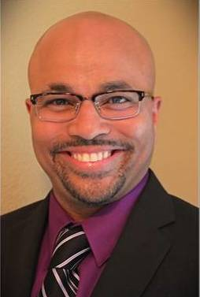
Mr. Walker is a nationally recognized speaker and author of the text-book, Pure Optics. He is the first African American in history to receive the prestigious Beverly Myer’s Achievement Award in Ophthalmic Optics for his on-going work in Optics. Mr. Walker is a Master in Ophthalmic Optics, earned a Bachelor's in Business Management Degree, Associate Science Degree in Ophthalmic Optics and is Certified by the both the American Board of Opticianry and National Contact Lens Examiners. Mr. Walker is an authority and expert in advanced geometric and applied optics and served as a faculty member for the American Optometric Association, American Academy of Ophthalmology, International Vision Expo, American Board of Opticianry National Conference, Professional Optician's of Florida, Armed Forces Optometric Society, and at eye care professional conventions in 43-states. He has authored articles on lens deisgn and optomertic practice management for Ophthalmology Times and Vision Care Products News Magazine. Mr. Walker was honored in Vision Monday’s “Forty under Forty”, which listed forty of the nations brightest and innovative ECP's in the country in 2004. Mr. Walker is currently the Eyefinity EHR Product Manager.

Meeting Room Floorplan
