Advanced Procedures
 | June 1-4, 2017 | 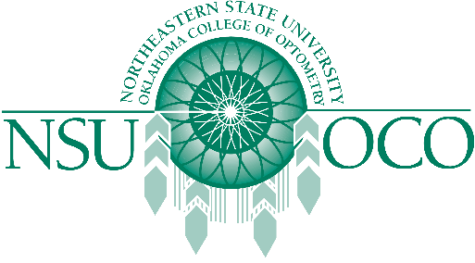

NSUOCO and the Pennsylvania School of Optometry presents the Advanced Procedures Course in Elkins Park, PA. This course offers 32 hours of COPE approved continuing education!

Course Details
- Thursday, 6/1/17 - Sunday, 6/4/17
- Pennsylvania School of Optometry (8360 Old York Rd, Elkins Park, PA 19027)

