You’re invited to dry eye’s largest virtual event: Eyes On Dry Eye

Registration is now open for dry eye’s most exclusive digital experience. Join us, for free, February 24th-25th, to:
- Earn up to 7 hours FREE COPE-accredited CE
- Advance your dry eye business with 14+ sessions on ocular surface disease
- Ask your biggest questions to innovators, like Ahmad Fahmy, OD, FAAO; Damon Dierker, OD, FAAO; Preeya K. Gupta, MD; Laura M. Periman, MD; and more
- Make powerful connections with global dry eye specialists
- Win up to $3,000 in prizes
- See complex case studies you won’t find anywhere else
- Learn what the latest light therapies can do for your practice
- Unlock access to the latest innovations and therapeutics

Learn more
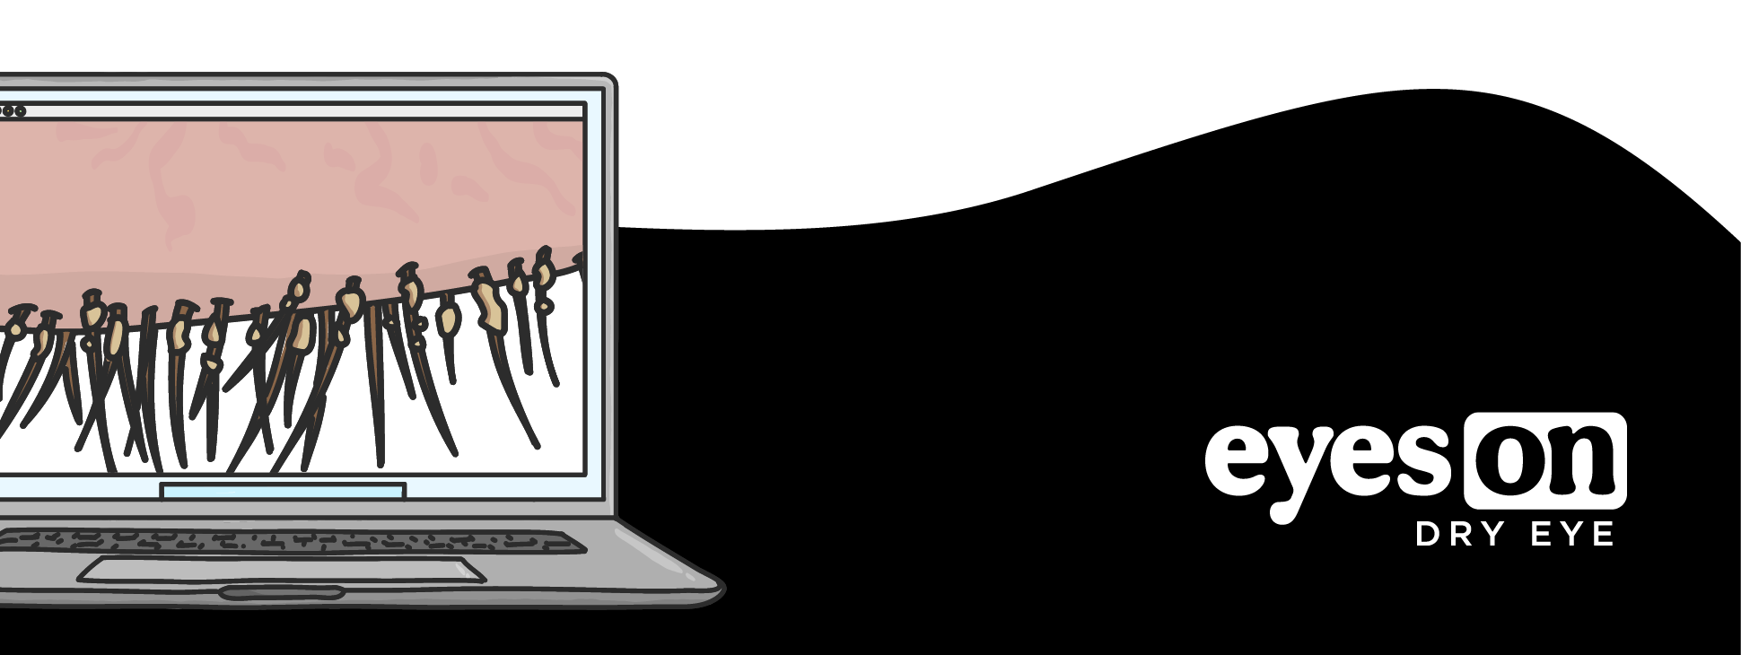

Can't make it? Take a break from Eyes On Dry Eye emails 😴

Advertise | Become a Writer | Contact Us

