Title: Green Innovation and Carbon Neutrality: Supply Chain Approach
Track: Operations, Logistics and Supply Chain Management
Paper Type: Developmental
Word Count: 1529

Abstract
In recent years, scholarly attention has increasingly turned toward the study of green innovation (GI) as a pathway to achieving carbon neutrality. However, the complexity of the interconnected global landscape suggests that GI alone may not suffice to meet carbon neutrality target. This paper investigates the dynamic interplay between GI, supply chain mapping (SCMAP), supply chain visibility (SCVIS) and their combined influence on the attainment of carbon neutrality target within manufacturing supply chains. Employing a mixed-methods approach, we first conduct a quantitative study, leveraging Partial Least Squares Structural Equation Modeling (PLS-SEM) to analyse data gathered from 229 respondents in the manufacturing sector. Subsequently, a qualitative inquiry is undertaken to enrich our understanding of these relationships. Our preliminary findings underscore the pivotal role played by supply chain management practices, alongside GI, in propelling the transition toward carbon neutrality in manufacturing operations. This study contributes to advancing knowledge on the integrative impact of GI and supply chain practices (i.e., SCMAP and SCVIS) on carbon neutrality. We discuss the implications of these findings for practitioners and policymakers.
Keywords: Supply Chain Mapping; Supply Chain Visibility; Green Innovation; Carbon Neutrality

- Introduction
Carbon neutrality gained significant attention in 2006 when the New Oxford American Dictionary designated it its term of the year (Sloam et al., 2023). This concept embodies achieving a balance between carbon emissions released into the atmosphere and those absorbed by natural carbon sinks like forests, soil, and seas. However, despite the crucial role of natural sinks in absorbing CO2, there remains a notable absence of effective manmade carbon sinks capable of mitigating global emissions on a large scale. As a result, organisations looking for carbon neutrality typically pursue one of two avenues: either dramatically cut carbon emissions to net zero or offsetting emissions through carbon credits (Mabidi et al., 2024).
While carbon neutrality has emerged as a global imperative, particularly evidence on Wall Street, its integration into business practices is relatively recent. Businesses now aim to achieve zero greenhouse gas emissions primarily through the adoption of renewable energy sources (Gil and Bernardo, 2020). Although various definitions of carbon neutrality exist in the literature, companies, ranging from small startups to large corporations, are increasingly committing to carbon neutral, net-zero, or even climate-positive initiatives (Zhao et al., 2022). Despite the proliferation of terms like "carbon-neutrality," "net-zero," and "climate positive" (Kachi et al., 2020), their widespread adoption in mainstream marketing may contribute to consumer confusion. Companies should communicate clearly and transparently to avoid misinterpretation and promote proactive involvement. The Paris Climate Agreement states that there are only 29 years left to achieve worldwide net zero emissions (Chen et al., 2022). Therefore, the knowledge of these concepts becomes essential for identification of companies intending to minimize or eliminate their carbon print (Chandra Voumik et al., 2023). Scope 1 net zero initiatives argue for a comprehensive framework for carbon accounting in order to focus on reducing emissions of CO2 (Zhang et al., 2024). This typically begins with calculating a company's carbon footprint which is simplified through the use of Carbon Management software (Roemer et al., 2024). In addition, there is an increasing expectation by stakeholders that companies measure and report Scope 3 emissions, which comprise of all indirect emissions generated in a company’s value chain. Aimed at lowering carbon emissions from the supply chain, Scope 3 net zero strategies are implemented. Organizations can identify and deal with their major sources of CO2 emission by understanding the whole picture in terms of a complete life cycle assessment. Through supply chain approach we aim to answer how firms can achieve carbon neutrality target?
- Literature review and conceptual framework
Shan et al. (2021) highlights the importance of green innovation (GI) in achieving carbon neutrality targets through renewable energy resources. GI is critical for durable environmental management in organisations (Roh et al., 2022). Given the serious threats posed by environmental degradation and climate change, firms are keen to adopt green practices which facilitate GI, ultimately aiding environmental, social, and economic benefits (Asadi et al., 2020). GI involves the development of new products and technology aiming to address environmental challenges such as pollution and resource depletion (Shi et al., 2024). Wu et al. (2022) noted that GI is crucial in achieving carbon neutrality targets.
Furthermore, a growing body of existing literature address supply chains sustainability through the lens of supply chain integration (SCI) (Kamble et al., 2023), coordination (Junaid et al., 2023), and collaboration (Jraisat et al., 2023). However, there is a scant literature that explores the role of supply chain mapping (SCMAP) and visibility in fostering GI and net zero emissions (Junaid et al., 2022). Previous literature deals with the importance of SCI in achieving sustainability performance (Khan et al., 2021). Thus, undermining the potential of SCMAP and supply chain visibility (SCVIS) in facilitating GI and carbon neutrality targets (CNT). SCMAP and SCVIS offer transparency, which are necessary for firms when turning their operations to green. SCMAP entails capturing information about the supply chain partners to generate a map that helps in strategy formulation to achieve net zero targets (Khan et al., 2021; Mubarik et al., 2023). Alternatively, SCVIS provide real time information throughout the supply chain which helps in timely decision-making (Mubarik et al., 2021). Despite the potential benefits of SCMAP and SCVIS there is scant research elucidating whether or how these practices contribute to carbon neutrality target. Therefore, this research seeks to examine the integrative impact of GI and supply chain practices (i.e. SCMAP and SCVIS) on carbon neutrality. Figure 1 explains the conceptual framework of this study.
Carbon Neutrality
Supply Chain Mapping
Supply Chain Visibility
Green Innovation
Figure 1: Conceptual Framework
- Methodology
  - Population and Sampling
To answer the research question, this study planned to collect the data in two phases. In the first phase, a questionnaire survey was shared with operations and supply chain department of manufacturing firms in China through electronic and face to face methods. Through continuous efforts and follow-ups, we managed to collect 253 responses during the first stage. Twenty-four questionnaires were discarded due to the missing observations, duplications, and errors. The final sample size consists of 229 responses from the six categories of the manufacturing sector: automobile, electronics, fertilizers, food & beverages, rubber & plastics, and textile. During the second stage, we are in process of interviewing supply chain professionals in manufacturing firms in China to gain the more in-depth sights on this issue. We have successfully conducted 10 interviews till now and planning to conduct at least 25 interviews.

3.2Data Collection Instrument
Regarding the quantitative study, the measuring items of the constructs were adapted from previously established studies and are presented in Table 1.
Table 1: Sources of Constructs and Measuring Items
Construct | Sub-constructs | Items | Sources
Supply Chain Mapping | Upstream Mapping  Midstream Mapping  Downstream Mapping | 25 | Mubarik et al. (2021)
Supply Chain Visibility | Demand Visibility  Supply Visibility  Market Visibility | 12 | Williams et al. (2013); Mubarik et al. (2021)
Sustainable Innovation | Product Innovation  Process Innovation  Organizational Innovation | 12 | Cillo et al. (2019)
Carbon Neutrality Target |  | 7 | Nara et al. (2021)
  - Analytical Method
This study focuses on mixed methods i.e. qualitative followed by quantitative. Therefore, we employed PLS-SEM to estimate the modeled relationships in the quantitative study. We employed PLS_SEM because it is considered as the most appropriate approach for examining the empirical relationships with low to moderate levels of sample size and can also detect the unobserved heterogeneities in the sample, which helps to check the robustness of the results (Sarstedt et al., 2020). We have applied this approach in two stages. At first, the reliability and validity of the constructs were checked and later on paths were analysed using the bootstrapping approach.
For the qualitative study, we are conducting interviews using semi-structured and open-ended questions regarding implications of these practices in the manufacturing sector.
- Preliminary Results
After ascertaining the reliability and validity of the constructs, the results of path analysis are presented in Figure 2 and Table 2.
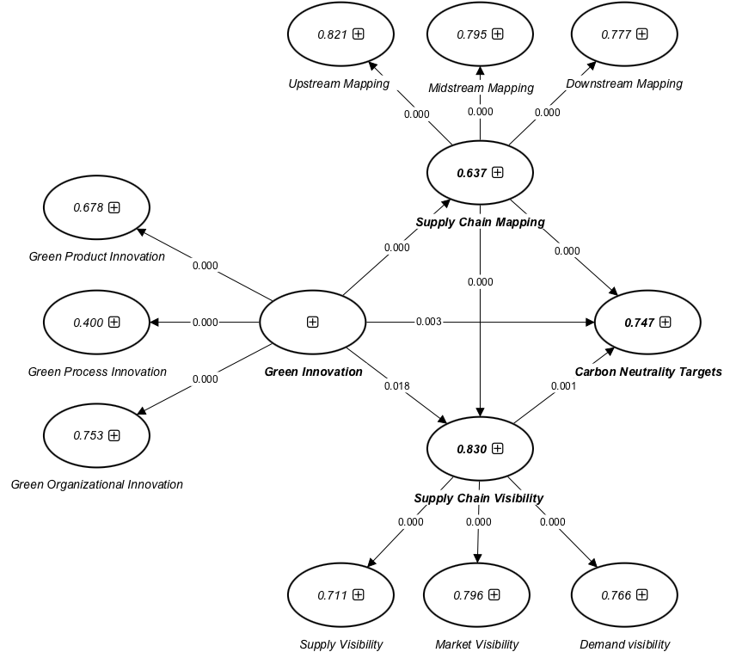
Figure 2: PLS Bootstrapping Results
Table 2: Path Analysis
Paths | Beta | SE | t-value | P Values
GI → Carbon Neutrality Target | 0.203 | 0.069 | 2.944 | 0.003
Green Innovation → Supply Chain Mapping | 0.798 | 0.028 | 28.261 | 0.000
Green Innovation → Supply Chain Visibility | 0.112 | 0.048 | 2.363 | 0.018
Supply Chain Mapping→ Carbon Neutrality Target | 0.403 | 0.102 | 3.947 | 0.000
Supply Chain Visibility → Carbon Neutrality Target | 0.306 | 0.088 | 3.478 | 0.001
Supply Chain Mapping → Supply Chain Visibility | 0.819 | 0.041 | 20.146 | 0.000
- Way Forward
Based on quantitative study, we are conducting a qualitative inquiry to delve deeper into the intricacies discovered earlier. We employ interviews and focus groups to explore the specific mechanisms underlying the relationship between GI, SCMAP, SCVIS and achieving carbon neutrality. This in-depth examination will provide valuable insights into the situational context, organizational procedures, and stakeholder viewpoints. Ultimately, it will enhance our understanding of the multifaceted dynamics at play. The results of the qualitative research will enhance our understanding of green supply chain management methods, complementing the quantitative study. This will guide specific actions aimed at achieving carbon-neutral manufacturing processes.

References
Asadi, S., Pourhashemi, S.O., Nilashi, M., Abdullah, R., Samad, S., Yadegaridehkordi, E., Aljojo, N. and Razali, N.S., 2020. Investigating influence of green innovation on sustainability performance: A case on Malaysian hotel industry. Journal of cleaner production, 258, pp.120860.
Chandra Voumik, L., Ridwan, M., Hasanur Rahman, Md., Raihan, A., 2023. An investigation into the primary causes of carbon dioxide releases in Kenya: Does renewable energy matter to reduce carbon emission? Renewable energy focus, 47, pp.100491-. 10.1016/j.ref.2023.100491.
Chen, L., Msigwa, G., Yang, M., Osman, A.I., Fawzy, S., Rooney, D.W. and Yap, P.S., 2022. Strategies to achieve a carbon neutral society: a review. Environmental Chemistry Letters, 20(4), pp.2277-2310.
Cillo, V., Petruzzelli, A.M., Ardito, L. and Del Giudice, M., 2019. Understanding sustainable innovation: A systematic literature review. Corporate Social Responsibility and Environmental Management, 26(5), pp.1012-1025.
Gil, L. and Bernardo, J., 2020. An approach to energy and climate issues aiming at carbon neutrality. Renewable Energy Focus, 33, pp.37-42.
Jraisat, L., Upadhyay, A., Ghalia, T., Jresseit, M., Kumar, V. and Sarpong, D., 2023. Triads in sustainable supply-chain perspective: why is a collaboration mechanism needed? International Journal of Production Research, 61(14), pp.4725-4741.
Junaid, M., Zhang, Q. and Syed, M.W., 2022. Effects of sustainable supply chain integration on green innovation and firm performance. Sustainable Production and Consumption, 30, pp.145-157.
Junaid, M., Zhang, Q., Cao, M. and Luqman, A., 2023. Nexus between technology enabled supply chain dynamic capabilities, integration, resilience, and sustainable performance: An empirical examination of healthcare organizations. Technological Forecasting and Social Change, 196, pp.122828.
Kachi, A., Mooldijk, S. and Warnecke, C., 2020. Climate neutrality claims. How to distinguish between climate leadership and greenwashing. New Climate Institut. URL: https://newclimate. org/wpcontent/uploads/2020/09/Climate_neutrality_claims_BUND_September2020. pdf (abgerufen am 25.10. 2021).
Kamble, S.S., Gunasekaran, A., Subramanian, N., Ghadge, A., Belhadi, A. and Venkatesh, M., 2023. Blockchain technology’s impact on supply chain integration and sustainable supply chain performance: Evidence from the automotive industry. Annals of Operations Research, 327(1), pp.575-600.
Khan, S.A., Mubarik, M.S., Kusi‐Sarpong, S., Gupta, H., Zaman, S.I. and Mubarik, M., 2022. Blockchain technologies as enablers of supply chain mapping for sustainable supply chains. Business Strategy and the Environment, 31(8), pp.3742-3756.
Khan, S.A.R., Zkik, K., Belhadi, A. and Kamble, S.S., 2021. Evaluating barriers and solutions for social sustainability adoption in multi-tier supply chains. International Journal of Production Research, 59(11), pp.3378-3397.
Mabidi, A., Miambo, D., Chichinye, A. and Sebata, A. 2024. Carbon sink, mitigation, and sequestration under climate change. In Agrofores
Mubarik, M.S., 2023. A firm-based perspective of the notion of “Carbon neutrality”: the role of supply chain mapping. In Recent Developments in Green Finance, Green Growth and Carbon Neutrality (pp. 63-84). Elsevier.
Mubarik, M.S., Naghavi, N., Mubarik, M., Kusi-Sarpong, S., Khan, S.A., Zaman, S.I. and Kazmi, S.H.A., 2021. Resilience and cleaner production in industry 4.0: Role of supply chain mapping and visibility. Journal of Cleaner Production, 292, pp.126058.
Nara, E.O.B., da Costa, M.B., Baierle, I.C., Schaefer, J.L., Benitez, G.B., do Santos, L.M.A.L. and Benitez, L.B., 2021. Expected impact of industry 4.0 technologies on sustainable development: A study in the context of Brazil's plastic industry. Sustainable Production and Consumption, 25, pp.102-122.
Roemer, N., Souza, G.C., Tröster, C. and Voigt, G., 2023. Offset or reduce: How should firms implement carbon footprint reduction initiatives? Production and Operations Management.
Roh, T., Noh, J., Oh, Y. and Park, K.S., 2022. Structural relationships of a firm's green strategies for environmental performance: The roles of green supply chain management and green marketing innovation. Journal of cleaner production, 356, pp.131877.
Shan, S., Genç, S.Y., Kamran, H.W. and Dinca, G., 2021. Role of green technology innovation and renewable energy in carbon neutrality: A sustainable investigation from Turkey. Journal of Environmental Management, 294, pp.113004.
Shi, R., Gao, P., Su, X., Zhang, X. and Yang, X., 2024. Synergizing natural resources and sustainable development: A study of industrial structure, and green innovation in Chinese region. Resources Policy, 88, pp.104451.
Sloam, J., Henn, M. and Huebner, C., 2023, March. Where we live next. Research report for the British academy. Youth, sustainability and democracy: how young people can shape environmental policy in urban spaces. British Academy.
Sarstedt, M., Ringle, C.M., Cheah, J.H., Ting, H., Moisescu, O.I. and Radomir, L., 2020. Structural model robustness checks in PLS-SEM.
Williams, B.D., Roh, J., Tokar, T. and Swink, M., 2013. Leveraging supply chain visibility for responsiveness: The moderating role of internal integration. Journal of operations management, 31(7-8), pp.543-554.
Wu, J., Xia, Q. and Li, Z., 2022. Green innovation and enterprise green total factor productivity at a micro level: A perspective of technical distance. Journal of Cleaner Production, 344, pp.131070.
Zhang, X., Jiang, D., Li, J., Zhao, Q. and Zhang, M., 2024. Carbon emission oriented life cycle assessment and optimization strategy for meat supply chain. Journal of Cleaner Production, 439, pp.140727.
Zhao, Y., Su, Q., Li, B., Zhang, Y., Wang, X., Zhao, H. and Guo, S., 2022. Have those countries declaring “zero carbon” or “carbon neutral” climate goals achieved carbon emissions-economic growth decoupling? Journal of Cleaner Production, 363, pp.132450.

