Developmental Paper:

Why Don’t Digital Businesses Enter Fintech Industry? A Study on Root Causes of Fintech Avoidance

Summary:
Past research shows that most of the Fintech industry players are either big corporate banks or technological companies which have started their main business model on FinTech. However, it seems that many other businesses in digital ecosystem avoid entering this field as a new entrant. On the current research we started the study with an in-depth literature review to recognize the main clusters of current academic research on Fintech, which its result is shared below. On the next step, we plan to have some interviews with FinTech experts to list the challenges on each of the identified clusters. Finally, we will approach the digital businesses to share their perception on those challenges through a Fuzzy DEMATEL approach. The output will be (1) ranking of the main challenges and (2) the cause-and-effect relationship between those challenges. These outputs can be used for policy development in reducing the above-mentioned barriers and challenges.

Track: 6) e-Business and Information Systems Management

Word Count: 2240

Introduction
This research aimed at exploring the dynamics between digital businesses and the growing fintech sector. At its theoretical foundation, our paper intends to offer insights into why diverse organisations refused to enter the fintech industry despite apparent expansion of the fintech and growth opportunities.
The core objective of this paper is to investigate the barriers and challenges that discourage digital business from entering the fintech ecosystem. Through a complex investigation and analysis of factors such as regulatory dynamics, technological obstacle, and competitive landscape, we aim to present a thorough and intricate understanding of the significant challenges prevalent in the fintech ecosystem especially in a developed country like the UK.
The importance of this research transcends academic interest to address urgent questions which have implication for economic development, technological innovation, and business financial inclusion. Significantly, while FinTech has continued to disrupt the traditional financial services and influence the behaviour of consumers, the avoidance of digital businesses to enter fintech ecosystem could lead to missed opportunities to synergistically cooperate and co-create value. By delving into and uncovering the root causes of this reluctance, we aim to spur theoretical discussions and deliberate interventions to foster a more actively involved and inclusive fintech ecosystem.
While rich amount of literature majorly focused on companies that are digitally orientated like corporate banks as well as mainly conducting systematic literature review in the subject area (Thakor, 2020; Basdekis et al., 2022; Anifa et al., 2022; Tarawneh et al., 2024), there is a gap left in understanding why other digital businesses refuse to enter the Fintech ecosystem.
To address this gap, our paper initially builds on existing studies drawn from WOS and also introduces a novel methodological perspective as an advancement to extant research. Based on this, we shall be conducting a depth-interview with Fintech experts to explore their opinion and perception on the challenges and barriers in entering Fintech ecosystem. This is because despite extant studies providing valuable insights into the Fintech ecosystem, they do not sufficiently address the concerns and perceptions of digital businesses. This is significant to provide a comprehensive and thorough analysis by merging emerging themes with freshly collected data and opinion from the field.
To reinforce our methodology rigor, we propose Fuzzy DEMATEL analytical approach for data analysis. Hence, by directly engaging with digital experts and business owners and combining this to literature review, we intend to capture the complex and dynamic nature of challenges and barriers encouraged by digital business when entering fintech ecosystem. The Fuzzy DEMATEL approach shall allow us to methodologically analyze the interrelationships among these barriers leading to holistic understanding and implication of their impact.

Literature Review
Concept of Fintech
Although Fintech is not a recent phenomenon, the concept has continued to receive major attention among scholars and practitioners as result of its major role in the financial model of the global economy. Fintech according to Almulla and Aljughaiman (2021) can be conceptualised as the offering of traditional financial services through the adoption of technology. In involves the intertwining of financial services and products through advanced technologies such as big data, cloud computing, Artificial intelligence, machine learning and other technical innovations (Li et al., 2023). In more elaborate manner, Fintech represents an innovative technology that enhances effective management of financial services dispensed to organisations, shareholders, prospective investors and customers through the adoption of advanced software and personalised applications (Zhang-Zhang et al., 2020; Bhatt et al., 2022). This ensures the automation of financial services signifying a major shift from traditional financial products and services to online financial services. The growth in Fintech according to Anagnostopoulos (2018) result from enabler factors such as increased internet and mobile penetrations, shifting expectations of consumers, cost-efficiency, cyber safety, disintermediation of funds, diversification, disruption in regulations, restructured business model, niche concentration and growth-induced regulation caused by financial crisis.
Anifa et al., (2022) argued that Fintech provides a mechanism for speeding up the rendering of financial services promoting online and physical financial transactions. This is made possible by removing diverse bottlenecks that are prevalent in traditional banking and financial intermediation. However, Fintech has not only brought changes to the ways in which traditional banking institutions operate, but also transformed the competitive landscape in the global financial industry. This is evidence with increased influx of financial technologies companies into the global financial industries causing major disruption, improvement and innovation in financial products and services (Basdekis et al., 2022).
With the increasing innovation of financial technology, the customers taste and preference in the global banking sector have continue to change with traditional banking being pushed to adapts to the competitive dynamic brought by the emergent of Fintech and influx of start-up financial companies. Nevertheless, it should be noted that growth and expansion in Fintech has also led to the development of diverse financial products and services. According to Almulla and Aljughaiman (2021) such financial services include blockchain, micro-lending, digital transaction, crowdfunding, cryptocurrency, digital wealth management and digital-financial advice have emerged to amplify financial services. While Fintech services such blockchain, cryptocurrency and crowdfunding are majorly provided by Fintech companies, there are current regulatory framework designed to support the provision of these services by traditional banking institutions especially in developed countries (Javaid et al., 2022). This is aimed at promoting greater efficiency, access to financial services, transparency, trust, reduction in costs and financial inclusion in general (Mhlanga, 2023).
Hence, it has been argued that Fintech did not totally replace the traditional financing model but has removed diverse complicated challenges impeding access to financial products and services by the excluded population while also improving services and products available to the population already captured in the financial model (Anifa et al., 2022). Therefore, both start-up and traditional financial institutions are often captured in the conceptualisation and studies relating to Fintech. With the emergence of diverse studies, changing taste of financial service users and key issues relating to the full adoption of Fintech, there is need for studying the future direction and trends that will serve as major focus to scholars resulting in need for a comprehensive and critical systematic review in conjunction with insights from industrial experts.

Literature Selection Process
The current study aimed at systemically analyzing extant literature in Fintech to discover the recent trends, emerging and future developments and megatrends in the field. As opposed to existing studies that focus on a particular perspective such as risk inherent in Fintech (Jain et al., 2023); cryptocurrency (García-Corral et al., 2022; Alqudah et al., 2023; Vasudeva, 2023), bitcoins (Merediz-Solà & Bariviera, 2019; Aysan et al, 2021), our study focused on not only Fintech, but also BankTech, “Fintech Service”, and “Fintech Products”. In order to determine and select the relevant documents for our research, the Web of Science (WoS) was explored due to its extensive coverage, indexing of high-quality articles and global acceptability. The search commenced by defining and setting the search limit to 2003 and 2023 with surpassed previous studies by capturing current data and literature in the field of Fintech. The Web of Science has been widely employed in extant studies and it offers a robust and huge collection of diverse studies in different disciplines (Sutikno, 2021; Verhoef et al., (2021) Ke et al., 2024). It argued also that, Web of Science is the oldest database and performed better compared to other database in terms of total coverage and retrieval of unit items (Adriaanse & Rensleigh, 2013; Li et al., 2017; Birkle et al., 2020).
Following the initial search of the main keyword “Fintech”, 2,848 documents were obtained. However, in order streamline the search to obtain more relevant documents, combination of diverse keyword such as “Fintech”, Digital Finance, Financial Technology, Fintech Innovation were utilised. Also, all articles that were not published in English Language were excluded at this stage.
In addition, subject areas such as Business Finance, Economics, Management, and Business were chosen for the study. The search process also filtered out documents such as early access, proceeding paper, book chapters, and retracted publication to focus mainly on articles which have passed through peered reviewed process to ensure quality in the selection of documents. Following the implementation of this research process, 180 revenant documents were obtained; however, articles published in journals such as Elsevier, Emerald Publishing Group, MDPI, Springer Nature, Taylor and Francis, Wiley, Sciendo, Sage and IGI global were further selected at this stage. This is aimed at ensuring that articles published quality journals and indexed in Scopus enter the final stage of the selection process.

Records found through search of a database (n = 2,484)

Articles not reflecting the Keywords (n = 2,304)

Articles Screened (n = 180)
Articles other than journals and in subject areas other than Business Finance, Economics, Management, and Business (n = 33)

Articles Retrieved (n = 147)
Articles not published in the field of Fintech (n = 11)

Articles Assessed for Quality
(n = 136)
Articles finally include in the research (n = 98)
Articles not published in Elsevier, Emerald Publishing Group, MDPI, Springer Nature, Taylor and Francis, Wiley, Sage and IGI global (n = 38)

The result of doing this literature review using VosViewer software is shared below. We concluded that there are 4 main clusters in academic research on Fintech. As shared earlier, these 4 clusters build our initial framework for the interviews and find the main challenges/barriers of entering the FinTech industry.
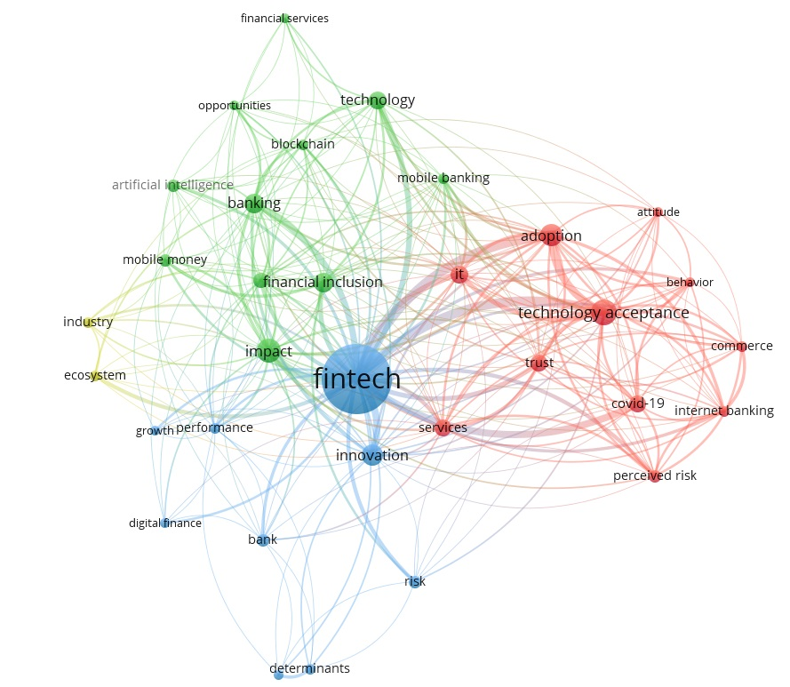

Methodology
From here onward, the research aims to understand the main barriers of digital businesses to enter the Fintech industry as a new entrant in the United Kingdom. This will happen through a set of interviews. We will analyze the cause-and-effect relationship between the barriers found above and in order to do so, the study explores explicitly cause-and-effect relationships using a mixed method approach – semi-structured interviews and the Fuzzy DEMATEL method. In so doing, we gain a deeper understanding of the specific challenges and barriers of being a new entrant in the Fintech industry. We adopt the following steps to analyze the interconnection between the emerging factors from the literature review and interviews with digital business owners and leaders (Wu and Lee, 2007; Zhou, Huang, and Zhang, 2011; Farooque et al., 2020; Liu et al., 2021):
Step 1: Determine the decision objective and the factors influencing the study's objective. Many literature reviews are required in this phase to seek and collect helpful information. Furthermore, a committee of experts is required to supply group expertise on relevant topics. Based on the information gathered and expert opinion, this approach determines potential factors influencing the decision objective. Following agreement on the criteria, an expert panel survey evaluates the interaction between each pair of factors. By doing so, linguistic assessments of which factors directly affect each other are obtained.
Step 2: Compile the expert assessments to create the initial direct-relation matrix. Transform the linguistic assessments into triangular fuzzy numbers. Then, using the CFCS approach, aggregate these fuzzy numbers to get crisp scores based on Fuzzy DEMATEL formulae. As a result, a_{ij} denotes the direct impact of factor i on component j. As a result, the initial direct-relationship matrix A is formed.
Step 3: Using the DEMATEL approach, create a cause-effect relationship diagram and a structural model of system factors. The total-relation matrix can be constructed using the original direct-relation matrix produced in Step 2. The importance degree and net impact degree are then computed, and the cause-effect relationship diagram is built; thereby, the structural relationship of factors is visualized.
Step 4: Examine the system factors' structure and find CSFs. Analyze each system factor considering the indices r_{i}, c_{i}, r_{i} + c_{i}, r_{i} − c_{i}, and the depicted diagram. Considering the position of each factor in the overall system, we can determine which ones have the most impact on the system and can significantly enhance system efficiency if these factors are prioritized. Moreover, these are CSFs that are highly crucial for the entire system.

Discussion and Conclusion
Finding the answers to the main research question of the current study using both qualitative interviews with experts and quantitative analysis of collected data from digital business owners, will help us to propose policy recommendations to support digital businesses’ who play a vital role in the business ecosystem of the UK and beyond.
Having both qualitative and quantitative research methods helps us to gain a deeper insight about our research question and by increasing the number of interviewees and respondents, we will make the outputs of the research more generalizable.

References:
- Adriaanse, L.S. and Rensleigh, C. (2013) ‘Web of science, scopus and google scholar’, The Electronic Library, 31(6), pp. 727–744.
- Almulla, D., & Aljughaiman, A. A. (2021). Does financial technology matter? Evidence from an alternative banking system. Cogent Economics & Finance, 9(1), 1934978.
- Alqudah, M., Ferruz, L., Martín, E., Qudah, H., & Hamdan, F. (2023). The sustainability of investing in cryptocurrencies: A bibliometric analysis of research trends. International Journal of Financial Studies, 11(3), 93.
- Anagnostopoulos, I. (2018) ‘Fintech and Regtech: Impact on regulators and Banks’, Journal of Economics and Business, 100, pp. 7–25.
- Anifa, M. et al. (2022) ‘Fintech innovations in the Financial Service Industry’, Journal of Risk and Financial Management, 15(7), p. 287.
- Anifa, M., Ramakrishnan, S., Joghee, S., Kabiraj, S., & Bishnoi, M. M. (2022). Fintech Innovations in the Financial Service Industry. Journal of Risk and Financial Management, 15(7), 287.
- Aysan, A.F., Demirtaş, H.B. and Saraç, M. (2021) ‘The ascent of bitcoin: Bibliometric analysis of Bitcoin Research’, Journal of Risk and Financial Management, 14(9), p. 427.
- Basdekis, C. et al. (2022) ‘FinTech’s rapid growth and its effect on the banking sector’, Journal of Banking and Financial Technology, 6(2), pp. 159–176.
- Basdekis, C., Christopoulos, A., Katsampoxakis, I., & Vlachou, A. (2022). FinTech’s rapid growth and its effect on the banking sector. Journal of Banking and Financial Technology, 6(2), 159-176.
- Bhatt, A., Joshipura, M. and Joshipura, N. (2022) ‘Decoding the Trinity of Fintech, Digitalization and financial services: An Integrated Bibliometric analysis and thematic literature review approach’, Cogent Economics &amp; Finance, 10(1).
- Birkle, C. et al. (2020) ‘Web of science as a data source for research on scientific and scholarly activity’, Quantitative Science Studies, 1(1), pp. 363–376.
- Farooque, M., Jain, V., Zhang, A. and Li, Z. (2020). Fuzzy DEMATEL analysis of barriers to Blockchain-based life cycle assessment in China. Computers & Industrial Engineering, 147, pp. 106684.
- García-Corral, F. J., Cordero-García, J. A., de Pablo-Valenciano, J., & Uribe-Toril, J. (2022). A bibliometric review of cryptocurrencies: how have they grown?. Financial Innovation, 8(1), 1-31.
- Javaid, M., Haleem, A., Singh, R. P., Suman, R., & Khan, S. (2022). A review of Blockchain Technology applications for financial services. BenchCouncil Transactions on Benchmarks, Standards and Evaluations, 100073.
- Ke, Y., Yang, R. and Liu, N. (2024) ‘Comparing open-access database and traditional intensive care studies using Machine Learning: Bibliometric analysis study’, Journal of Medical Internet Research, 26.
- Li, K., Rollins, J. and Yan, E. (2017) ‘Web of science use in published research and Review Papers 1997–2017: A selective, dynamic, cross-domain, content-based analysis’, Scientometrics, 115(1), pp. 1–20.
- Li, Y., Ma, X., Li, Y., Li, R., & Liu, H. (2023). How does platform's fintech level affect its word of mouth from the perspective of user psychology?. Frontiers in Psychology, 14, 1085587.
- Merediz-Solà, I. and Bariviera, A.F. (2019) ‘A bibliometric analysis of bitcoin scientific production’, Research in International Business and Finance, 50, pp. 294–305.
- Mhlanga, D. (2023) ‘Block chain technology for digital financial inclusion in the industry 4.0, towards sustainable development?’, Frontiers in Blockchain, 6.
- Sutikno (2024) ‘A bibliometric analysis of global research on United Nations Security Council sanctions (1990–2023)’, Heliyon, 10(9).
- Tarawneh, A. et al. (2024) ‘A systematic review of Fintech and banking profitability’, International Journal of Financial Studies, 12(1), p. 3.
- Thakor, A.V. (2020) ‘Fintech and banking: What do we know?’, Journal of Financial Intermediation, 41, p. 100833.
- Vasudeva, S. (2023) ‘Cryptocurrency as an investment or speculation: A bibliometric review study’, Business Analyst Journal, 44(1), pp. 34–50.
- Verhoef, P.C. et al. (2021) ‘Digital Transformation: A multidisciplinary reflection and research agenda’, Journal of Business Research, 122, pp. 889–901.
- Wu, W-W., and Lee, Y-T. (2007). Developing global managers’ competencies using the fuzzy DEMATEL method. Expert systems with applications, 32(2), pp. 499–507.
- Zhou, Q., Huang, W. and Zhang, Y., (2011). Identifying critical success factors in emergency management using a fuzzy DEMATEL method. Safety Science, 49(2), pp. 243–252.

