The Influence of Extended Family on Women Entrepreneurship: Lessons from Rural Kenya

Abstract
Contextualization of entrepreneurship debate and the impact of the multiplicity of context(s) dimensions in terms of ‘where’ and ‘when’ entrepreneurship happens has gained momentum in the last decade. The ‘where’ dimension relates to the social, spatial, and institutional environment whereas the ‘when’ context dimension refers to the historical and temporal context (Welter, 2011). Calls for the more research on the interplay of context on women entrepreneurship especially in marginalized and resource-deprived Global South contexts continues to be echoed in recent critical stream of research. Entrepreneurship is often portrayed as a desirable and flexible pathway to women’s empowerment from conditions of subordination, however recent critical entrepreneurship studies have criticized this false promise of entrepreneurship that often ignores the prevailing structural and contextual constraints to women’s entrepreneurial performance. This paper examines the influence of social context, particularly the impact of extended family on Jua Kali women entrepreneurs in rural Kenya. This qualitative study draws data from 20 in-depth interviews with Jua Kali women in Vihiga County in Western Kenya. The findings reveal that rural women entrepreneurs engage in Jua Kali entrepreneurship because of the flexibility and convenience it offers them to juggle between multiple domestic responsibilities, alongside entrepreneurial activities. However, due to women’s household demands and extended family responsibilities, they are faced with intersecting financial and time constraints to their entrepreneurial performance. On a theoretical level, the paper extends the critical entrepreneurialism debate and contextualising entrepreneurship research by exposing the ‘dark side’ of African extended family system and over-embeddedness of family and social networks as a constraint to women’s entrepreneurship, provides rich insights on rural women’s entrepreneurship and ‘mumpreneurship’ from the Global South context, and further proposes recommendations and implications for enterprise policy.

Key words: Women Entrepreneurship, Jua Kali, Gender, Social Context, Extended Family, Mumpreneurship, Rural Kenya, Sub-Saharan Africa, Global South

Introduction
Current research portrays entrepreneurship as a desirable and flexible pathway to women’s empowerment from conditions of subordination, thereby emancipated from shackles of poverty to empower others and further generating a range of benefits for the economy (Rindova et al., 2009; Al-Dajani & Marlow, 2013; Alkhaled & Berglund, 2018). This promise of entrepreneurship is intertwined with contemporary neoliberal post-feminist ideals of upholding individual responsibility for one’s own socio-economic status (De Benedictis & Gill, 2016) that emphasizes individuality, agentic skills, and self-governance to reap the material rewards of entrepreneurship as a solution to poverty and marginalization (McRobbie, 2009; Ahl and Marlow, 2019). However, this neo-liberalist grammar of entrepreneurship (Gill, 2017) portrays a false promise of entrepreneurship that often ignores the prevailing structural and contextual constraints to women’s entrepreneurial performance such as gender discrimination, inflexibility of self-employment due to caring and domestic responsibilities, and lack of welfare benefits (Treanor, Jones & Marlow, 2020).

Increasingly, however, critical streams of research question the often ignored prevailing structural and industry-related differences that could in fact be the cause for women’s underperformance (Ahl, 2004; Foss et al., 2018) and contextual constraints such as uncertainty, long hours of work, multiple caring roles and poor financial returns associated with women’s entrepreneurship (Ahl & Marlow, 2019; Treanor, Jones & Marlow, 2020). Furthering the same view, Ahl and Marlow (2012) contend that if the current patterns on women’s entrepreneurship continues to focus on individual women and the performance of their businesses without bringing the issues of structural, institutional, and social context household and family embeddedness central to the discourse, then research on gender and entrepreneurship is in danger of reaching a dead end as long as these issues remain peripheral.

While recent streams of research have tackled some of these contextual and structural issues such as the ‘cult of domesticity’ (Winter, 2004:2), the ongoing difficulty of achieving work-family balance for women who participate in formal workplaces and self-employment (see Marlow, 2002; Gregory & Miller, 2009; Ahl & Marlow, 2019), and the impact on mumpreneurship and motherhood roles on women’s entrepreneurial participation (Ekinsmyth, 2013a; Duberley & Carrigan, 2012). However, the bulk of these studies are conducted in Western contexts which does not present the structural and context-specific peculiarities operative in Global South contexts. This is especially apparent in the rural sub-Saharan African context that is deeply embedded with cultures of patriarchy and misogynistic gender bias which ascribes women’s role and identity as mainly being a ‘wife, mother, child-bearer, caretaker and food provider’ (Karani, 1987:422). The everyday work-family realities and the influence of extended family on rural women’s Jua Kali entrepreneuring in open-air marketplaces which are peculiar to the Global South contexts are rarely focused on in mainstream entrepreneurship discourse and remains severely under-researched.

Building on the understanding of context suggested Welter’s (2011) who introduced the multiplicity of entrepreneurship context as a continuum along when and where entrepreneurship, this paper focuses on the social context dimension and takes a critical look at the influence of extend family on Jua Kali women’s entrepreneurial activity. In most entrepreneurship studies, where social context has been studied in relation to gender and women’s entrepreneurship, the focus has mainly been on the influence on social networks perspective (Welter, Brush & de Bruin, 2014). In terms of the social network’s perspective, research focus on positive effects and the role of social networks of friends and family in providing financial capital, emotional support and encouragement, potential employees, economic well-being and overcoming liabilities when starting a business (see Greve & Sallaff, 2003; Fletcher, 2006; Carter, 2011; Thorton et al., 2016). For instance, Sindani (2022) shows how rural women’s Chama (self-help groups) networks and social ties provided finance, access to customers and spaces in informal marketplaces for their members.

Recent streams of entrepreneurship research, however, have reconceptualised the social networks approach by incorporating a family and household contexts perspective for entrepreneurial activities (Welter, 2011; Welter, Brush & de Bruin, 2014; Jennings & McDougald, 2007). Although this family and household embeddedness phenomenon is not new (Aldrich & Cliff, 2003; Carter, 2011) a family embeddedness perspective of entrepreneurship has been so far neglect, especially with understanding from the Global South context which is collectivistic in nature and influenced by social relations and extended family dynamics (Chiuri, 2008; Ondiba & Matsui, 2019). Whilst the research above provides some understanding about the how social context impacts on women’s entrepreneurship, there is still the need to explore the everyday experiences of women’s entrepreneurs such as Jua Kali, and the influence of extended family on their entrepreneurial activity. As such, this qualitative study draws on qualitative data gathered through 20 in-depth semi-structured interviews Jua Kali rural women in Vihiga County in Kenya and observational evidence captured in fieldwork photographs to address this research question.

The remainder of the paper is structured as follows. Following this introduction, I outline the literature review on Jua Kali rural women’s entrepreneurship and provide an overview of the Kenyan context on Jua Kali women. I then present the research contest and qualitative methodology. This is followed by a presentation and discussion of the main findings highlighting the intersecting financial and time constrains faced by Jua Kali women due to household demands and extended family responsibilities. Finally, we review the empirical and theoretical contributions of the research, emphasising extended family and household embeddedness of women’s entrepreneurial activity, and further proposing recommendations and implication for policy.

The Kenyan Context and Jua Kali Women’s Entrepreneurship and
In Kenya, the informal sector is known as Jua Kali, a Swahili term which means ‘hot sun’. It refers to the informal economy and unlicensed enterprises that operate in open-air marketplaces, literally ‘under the hot sun’. Jua Kali provides up to 80% of the country’s employment and almost 6 million businesses in Kenya’s Jua Kali are unlicensed establishments (World Bank, 2018). More than 62% of the informal enterprises are led by women (KNBS, 2017). During the colonial period, the Jua Kali sector in Kenya was developed in urban regions, mostly in Nairobi and its peripheries (King, 1996; Kinyanjui, 2006, 2014), hence the term ‘urban informal sector’ (Hosier, 1987). This is because colonisation’s influence on the development of modernity, urbanisation, and formal employment in Kenya was selective. Those who had access to colonial education, and after those who could pay for education in the post-colonial state were acculturated into modernity and formal employment (Kinyanjui, 2014, 2020). Those who were uneducated, or failed to continue with formal education, and the unemployed urban poor, who failed to get white-collar jobs or to access formal employment, were relegated to work in the sprawling informal sector. Here, they engaged in small-scale economic activities as artisans and traders, literally sitting out in open-air marketplaces (Kinyanjui, 2006; Indimuli et al., 2017).

Women in the informal sector occupy the lower segments of the Jua Kali economy (World Bank, 2016; Mang’unyi et al., 2018) and their enterprise concentrated in feminised sectors where they engage in low value-added sectors mostly in food, clothing and services which remain smaller, less profitable and of low growth potential (see Du Rietz and Henrekson, 2000; Marlow, 2020;). Moreover, due to persistent gender inequalities, women have limited chances in Jua Kali and are confronted with a myriad of challenges in their entrepreneurial activities. Several studies on informal sector entrepreneurship have shown the difficulties and barriers faced by women, including lack of access to capital for business start-up and expansion (Mwobobia, 2012, Sindani, 2022). Women lack childcare services and earnings during maternity (ILO, 2020). Moreover, by virtue of operating on the fringe of the formal economy Jua Kali women are excluded from supportive legal and institutional frameworks such as social and welfare benefits (Okungu et al., 2018; Racaud, 2018). While the above studies have highlight structural and institutional challenges facing women Jua Kali, by incorporating a social context and family embeddedness perspective, this study explored the influence of extended family system on women’s entrepreneurial activity. Thus, this makes this study’s objective and context a timely and justified investigation.

Research Context and Methodology
2.1 Research design
This pilot study data was part of a broader PhD research project, titled From the Margins to the Centre: A Feminist Intersectionality Perspective on the Influence of Context on Jua Kali Rural Women Entrepreneurship in Kenya. The project focused on Vihiga County which is located within the Lake Victoria basin in the Western part of Kenya. Overall, this paper adopted an interpretivist research paradigm, which acknowledges that reality is multiple, complex, local, specific in nature and multi-layered (Guba & Lincoln, 1994; Wigren, 2007). As such, this study adopted a qualitative research approach (Hussain, Elyas and Nasseef, 2013) and draws upon 20 in-depth semi-structured interviews with Jua Kali rural women entrepreneurs in Vihiga County which is located within the Lake Victoria Basin in Western region of Kenya.

Additionally, as part of observational evidence, field work photographs were taken to aid in ‘visualising’ the everyday and apparently mundane entrepreneurial places and practices of the Jua Kali women entrepreneurs that is often taken-for-granted in mainstream entrepreneurship literature (see Imas, Wilson and Weston, 2012; Baker and Welter, 2017). This is in keeping with recent streams of critical entrepreneurialism debate in entrepreneurship (see Welter, Baker and Wirsching, 2019:326) who further propose that ‘attention to the visual and – in support of this – the use of the fieldwork photographs in displaying research contexts represent an important frontier in contextualising the everyday entrepreneurship research’ in resource deprived non-western contexts which are far removed and contextually different from the Silicon Valley model of entrepreneurship that is dominant in the Global North entrepreneurship discourse. Therefore, in this study, taking fieldwork photographs illustrate the nature of Jua Kali women’s enterprises and their trading conditions in different marketplaces i.e., the open-air marketplaces, roadside, pedestrian streets/highways, and homesteads. This provides a deeper illustration of the diversity of everyday entrepreneurial places and to give the reader a vivid picture of the everyday type of entrepreneurship performed by Jua Kali women and the different entrepreneurial settings in which they work and allow us to take a closer look at hitherto neglected aspects of contextualising entrepreneurship research in the Global South.

2.2 Sample and participant recruitment
In total, 20 in-depth semi-structured interviews were conducted with Jua Kali rural women entrepreneurs. Being a native of rural Kenya, I approached potential participants in the different trading locations on a one-on-one basis introduced myself and the purpose for my research. Participants were selected via both purposive and snowball /chain referral methods Biernacki & Waldorf, 1981; Creswell & Creswell, 2018), which are non-probability sampling strategies widely used in qualitative research for identification and selection of informant rich. Accordingly, 8 women were recruited via purposive sampling. The remaining 12 women were recruited through snowball strategy, based on the recommendations and initial contact made with participants earlier recruited via purposive sampling. It was a requirement that potential interviewees had to be owning and operating activities within the Jua Kali sector for at least one year. However, the types of enterprises within the Jua Kali sector were left open and unspecified to accommodate a wide range of entrepreneurial activities. Interviewees’ demographics varied by age (20-65), marital status (24 married/16 single), household size (30 had more than 3 children), and educational qualification (24 had little or no education), as well as the Jua Kali sector and marketplaces they operated in.

2.3 Data collection and analysis
The semi-structured interviews took place from June 2019 to July 2019. Considering my researcher's role and reflexivity (Unluer, 2012), I assumed both an insider-outsider positionality. As an insider, being as a native of rural Kenya which is the context of the study was of greater advantage. My familiarity with the participant’s culture, language, political and socio-economic conditions of the context facilitated efficient access to the context and unhindered data collection. Interviews were conducted with women entrepreneurs in two trading locations – homebased/roadside and open-air marketplaces – from which Jua Kali women in rural Kenya operate. Although all of them share the same off-the-books feature of the informal sector (Williams & Gurtoo, 2013), but all have their own distinctive spatial peculiarities which are place dependent. Supported by observational evidence presented in the field photographs, I now turn to briefly describe these two locations in detail and the interview process.

- Homebased/Roadside Spaces
Women entrepreneurs in this category of spaces simply sell from their homesteads, which could either involve selling their wares from the storage rooms or sitting areas inside their houses or erecting a Kibanda (a temporary kiosk/stall/shade made of wood with a roof made of iron sheet or thick plastic or cardboard of about 3-6m²) near the entrance of the homesteads as captured in field photographs below (see picture 1). This category also included women sell by the roadside, most of them lacked the Kibanda in their homestead, as such they carry their merchandise to sell by the roadside not more than 100meteres from their homesteads. They were mostly grocery vendors, but others combined selling grocery, cereals, food kiosks and clothes. Sometimes they construct their own Kibanda by the roadside or ask for permission from formal shop retailers to sell outside their shops on tarpaulins or on portable kiosks outside shop’s verandas (see Picture 2).

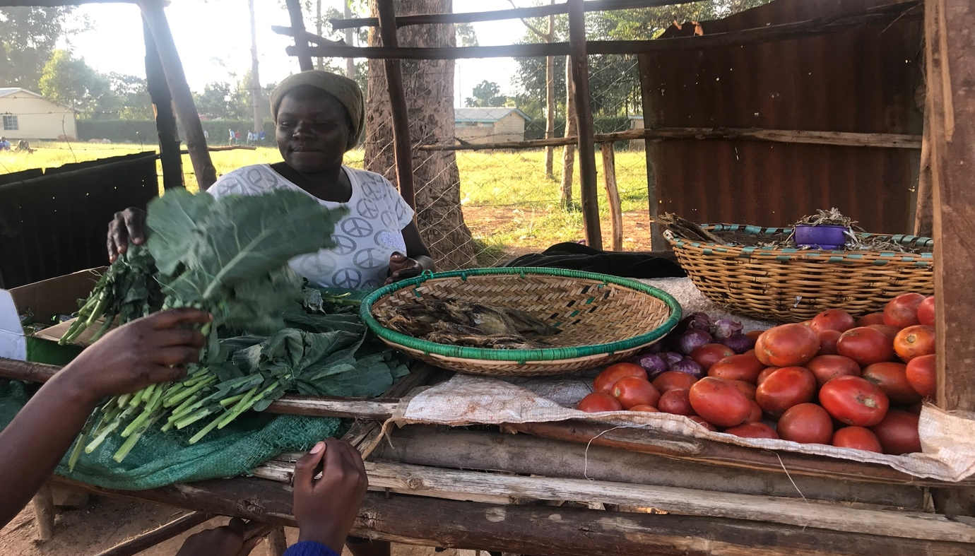
Picture 1

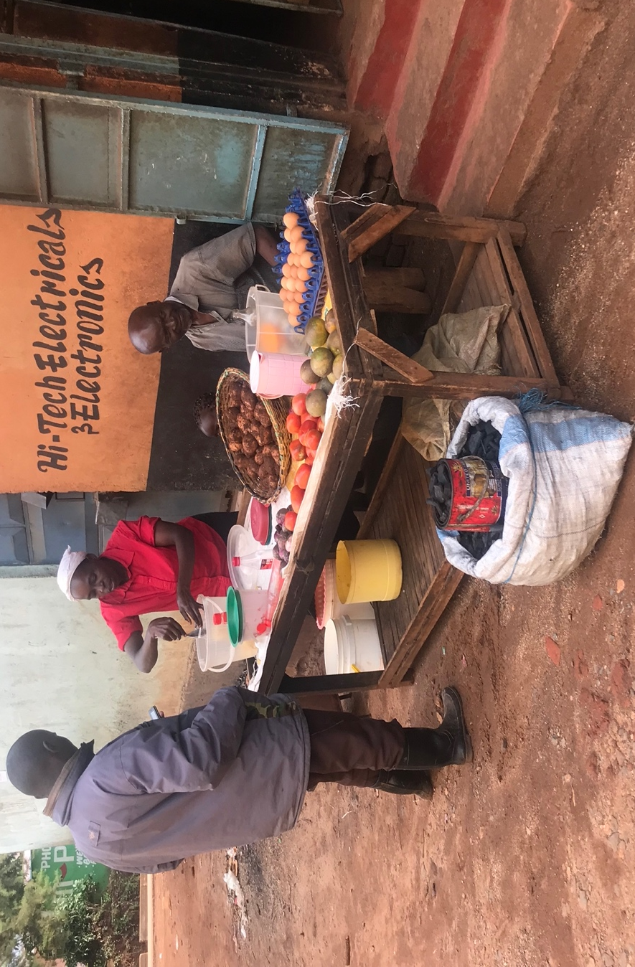
Picture 2

The interviews with roadside sellers mostly took place in the evenings between 3-4pm local time, when they had just come by the roadside to sell, and it was not yet the customers’ rush hour. However, some of the women came late to the roadside which pushed the start of the interviews within the rush hours (6-7pm) because they came late to the roadside marketplace, which led to several long pauses during the interviews when the women attended to their customers. The average duration for these was 45 minutes. The interviews with home-based sellers, were the longest with an average of 1 hour and 20 minutes since the women had more time at home, but still there were many interruptions during the interviews since the women had to attend to domestic responsibilities, farm work, or entertain visitors and relatives. On many occasions, I left and came back later at more convenient times and sometimes the interviews could be stretched over day or two.

- Open-air Marketplaces
Women in this category operate in literary large open-air marketplaces called Soko which are designated in fixed locations by the local municipalities of county governments. These are established as people’s market venues of trading and areas of operation for informal traders as long as they pay the required open-air daily taxes payable to the local county government revenue offices. According to my participant’s response, the daily open-air charges range between Ksh.50-100 ($0.50-1) and varies on different market days of the week and sometimes also depends on the number of stock unit items one has. I observed that there were two categories of open-air Jua Kali – those with Kibanda and those without - meaning they ply their merchandise on large canvases, plastic containers and tarpaulins as shown in the field pictures below.
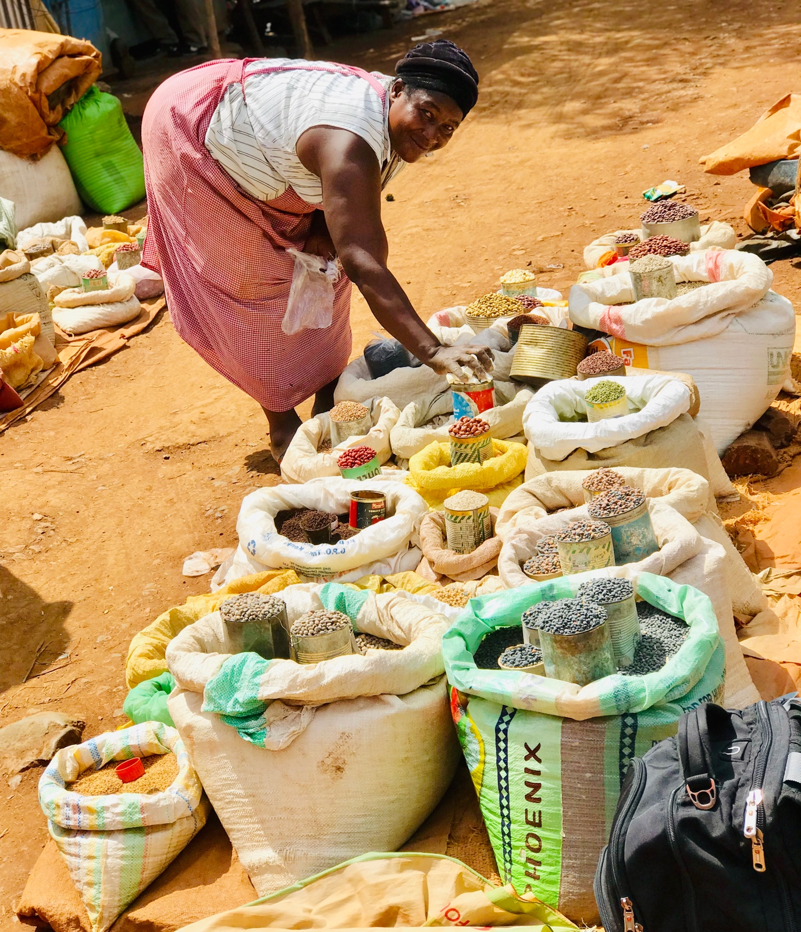

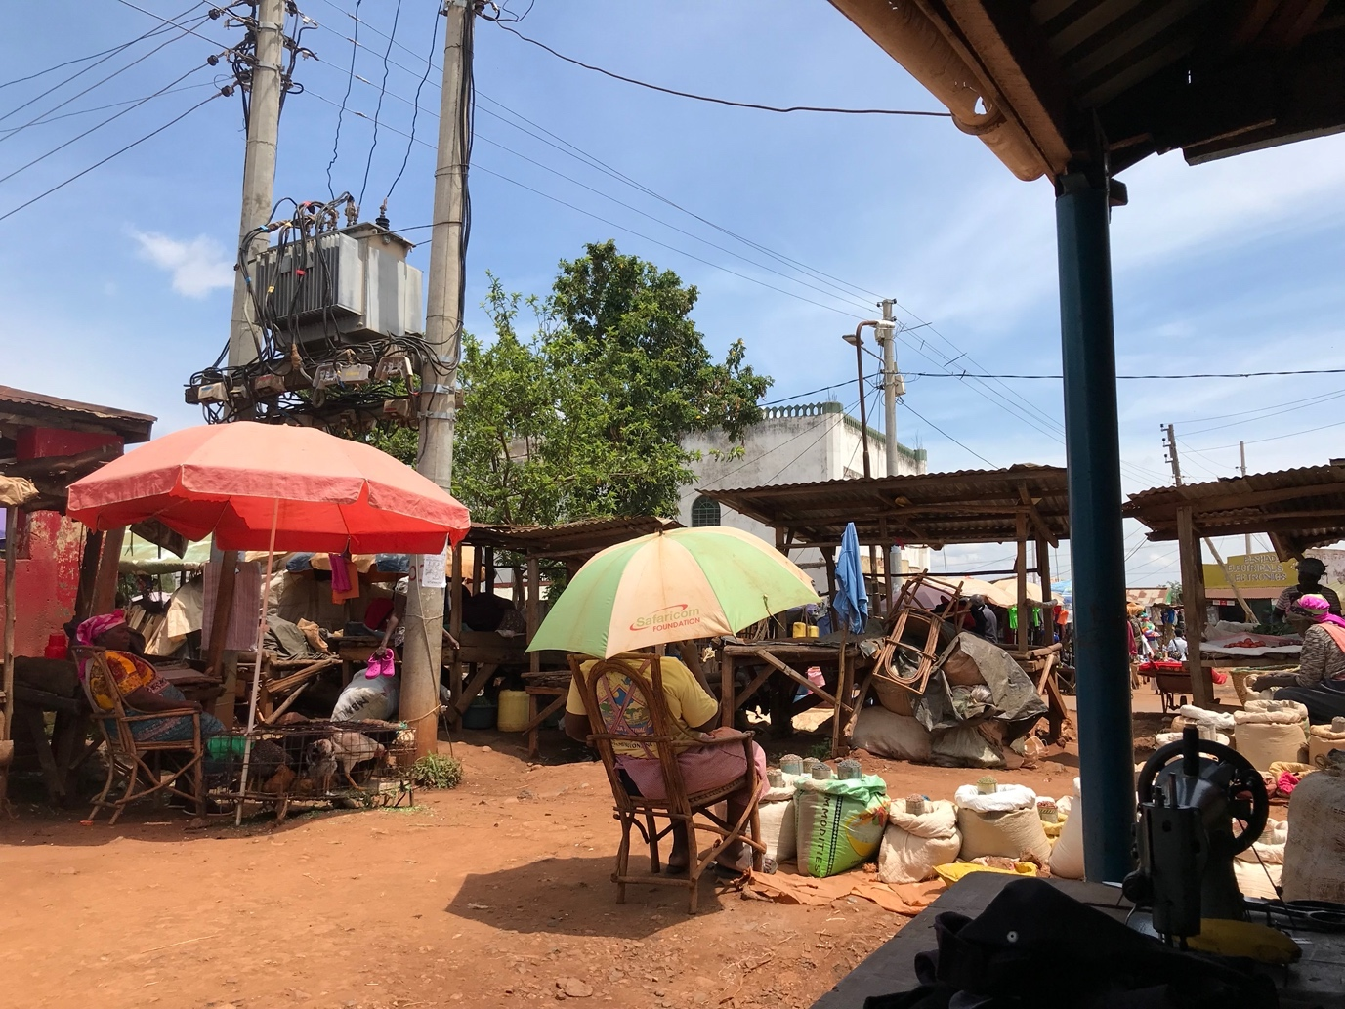

Interviews with open-air marketplace’s vendors took place between 12-2pm local time. The average duration for the interviews was 45 minutes. This could not be extended due to the local conditions of open-air marketplaces or because the women were either busy serving their customers or the interview spot was too crowded with surrounding customers, pedestrians, and other street vendors.

The purpose of Jua Kali women’s interviews was to gain an in-depth understanding of their entrepreneurial experiences in open air-marketplaces and the work-family challenges they encounter. The generic question that bound the interviews was ‘What makes you start a business’ and followed by open-ended questions regarding the nature of their business, work-family challenges they face in running their businesses in their social context. I conducted all the interviews in Kiswahili and Kimaragoli, and subsequently translated them into English as I am a native speaker of the two languages. This allowed women to use their own language and words to describe their entrepreneurial experiences (Barriball & While, 1994; Mero-Jaffe, 2011). With the participants’ consent, all interviews were audio-recorded except for one, who did not give her consent for personal reasons. All data was voice-recorded and transcribed verbatim and thematically analysed (Braun & Clarke, 2006).
- Insert Figure 1 about here -

Findings and Discussion
The findings reveal that rural women entrepreneurs engage in Jua Kali entrepreneurship because of the flexibility and convenience it offers them to juggle between multiple domestic responsibilities, alongside entrepreneurial activities. However, due to household demands and extended family responsibilities, they are faced with intersecting financial and time constraints to their entrepreneurial performance. Inevitably, this finding cuts across all women interviewed irrespective of their marital status whether single mothers, widowed or married, and across the spectrum of home-base/road-side and open-air marketplaces. I now turn to discuss the associated financial and times constraints in detail.

3.1 Extended Family Financial constraints
Most rural women expressed that they are the family’s breadwinner, the responsibility to cater for the daily household upkeep needs lies heavily on women, since most rural-households are women-headed. Regarding this, Josephine and Syphrose said;

Family needs can pose a big financial challenge to business. I am the one in charge of all immediate household needs. And this grocery is what helps me put food on the table, if I don’t do this, we basically won’t have food (Josephine)

You know here we live with extended family and their needs become your needs, the especially when you have a business near home. Like for me, I live with my mother-in-law here in the homestead, and because she’s elderly and sickly I am responsible for her upkeep, so in the evening when I come back from the marketplace, I pass by her house to give her groceries (Syphrose)

Particularly for the rural married women with spouses who have migrated into urban areas in search of employment, they experienced little or no assistance from their husbands as long as they lived away. In relation to this, Linet shared her experience,

I live here at home, but my husband stays in Nairobi, sometimes he sends us some money for family upkeep oftentimes he does not. Even though he sends us something it was not sufficient, it’s a big struggle to make ends meet. So many times, I use the business money for family sustenance. For instance, if the children are sick or sent away from school am forced to use the business money. (Linet)

The above scenarios reveal the familial circumstances and everyday realities that most married women grapple with in rural Kenya. Most rural households have increasingly became female-headed and women taking up the breadwinner’s role (IEA, 2008; Ondiba & Matsui, 2019). As men move to urban areas in search of ‘greener pastures’, women are left domiciled in their patrilocal residence homes (husband’s home), with families to take care of and small rural farm holdings to be cultivated. The issues of rural-urban migration dates to Kenya’s colonial times, where colonization institutionalized modernism and designated economic development to urban areas, leaving rural areas severely underdeveloped (Karani, 1987; Kinyanjui, 2020). This led to the emergence of ‘two household’ African family (Macharia, 2003:7) whereby men commonly have an urban household, and wives are left behind in their rural homes. The burden of single-handedly raising families in the rural is what pushes them to engage in quick Jua Kali as means for family’s sustenance and survival, however, this in turn has an impact on their business growth and profitability as the family feed off directly from the business purse and there is no separation of family and business.

Similarly, most women expressed that an in addition to overdependence of extended family, since their businesses were mostly considered home-based and situated in the informal sector they were not taken seriously as businesses. This is echoed in Coreen and Lillian’s experiences,

You know here in the village people buy a lot on credit with the promise of ‘I will pay you when I get’. And this mostly happens with relatives, friends, and neighbours, people from church, and its sometimes difficult to turn them away, but they take forever to pay back, and even they verbally insult me you when you follow-up for the repayment. ‘Our’ people here don’t respect you when you do business at home or by the roadside, they just think you’re passing time and they don’t give it that ‘business status’. You end up with so many bad debts accrued that you can’t recover because of family members, so the business just stagnates (Coreen)

Relatives can be a challenge to the financial stability of a businesses here. When one has a business here in the rural, it is perceived as an avenue to ‘help’ people for free mostly members of the extended family, uncles, aunties, etc. There is a societal expectation for employment of family members and relatives, and giving merchandise in-kind and for free, so you get their needs off your business. So instead of them supporting your business, they draw you back. (Lilian)

As shown in the above excerpts, the extended family over-reliance on rural women’s business is typical in most rural settings. The pressure to support extended family and persistent interference of familial networks has an impact on Jua Kali women’s entrepreneurial performance. Entrepreneurs are under pressure to providing resources and catering for the needs of their kin and extended family. Previous study (see Kiggundu, 2002; Robson & Obeng, 2008; Chiuri, 2008) indicate that in most sub-Saharan African countries, the African extended family system has an impact on the perisomal of small businesses. Due to the socio-cultural practices, entrepreneurs commit a high percentage of their business resources to family matters at the expense of their businesses, and

The lines of separation between family and work become blurred and their ventures are rarely accorded a ‘business status’ or taken seriously by customers and social networks. Consequently, family needs often get prioritised over the business’ which leads to diversion of the business resources sometimes leading to the ultimate collapse of the businesses. Since the business leans more towards the familial side rather than a standalone business entity, and women focus on maintaining personal and familial relationships at the cost of the business. This finding corroborates previous studies (Mirchandani, 1994; Marlow, 2002, 2020) that have shown that women’s homebased ventures are seen as nonwork or leisure. This finding upholds Jayawarna, Marlow and Swail’s (2020) assertion that due to familial embeddedness, women do prioritise relationships above economic participation which obviously diminishes the profitability of women’s ventures and becomes a challenge for them to grow their ventures.

Notably, most women opined that they are not only required to support their own nuclear families but obligated to support their extended family. By virtue of the multiplicity of extended familial relationships and responsibility culturally held among collectivist societies which is apparent in sub-Saharan Africa, as opposed to the western individualistic cultures (Hofstede, 1990). Most women are faced with more urgent and pressing familial needs – both for their immediate and extended families – related to education, health care, welfare for elderly and aging costs which leads to a frequent and massive diversion of enterprise funds to cover these costs. Regarding familial education costs, women mentioned diverting business resources to educating their own children, siblings, nieces and nephews and other relatives of the extended family. Deresia and Zippy shared their experiences,

At the moment, I am the guardian to four of my daughter’s children (now deceased). Two are in primary and two in secondary school and I literally pay for everything - all school-related expenses, from uniforms, to stationery, notebooks, the Saturday tuition fees, and the school building funds (Deresia)

I have my daughter and niece at the university, though they get the loan for tuition, but livings costs so high in Nairobi. I could have accumulated good money here in the marketplace, but just when I am closing, I get a call from one of my daughters that she needs money for food, tomorrow the other one calls. So, you find even when I make some profit, it is immediately sent out to support their school needs (Zippy)

The above excerpts are representative of many other women’s experiences and the financial burden they bear when it comes to education costs for member of their family. Although the Constitution of Kenya (GoK, 2010) stipulates that every child has a right to free and compulsory basic education, yet education is not free, and most of the school-related costs are out-of-pocket expenses covered by enterprise funds. Another addition financial burden is the healthcare family costs, majority of women indicated that since they do not have the government’s National Health Insurance Fund (NHIF) card because it is expensive to acquire, which leaves most out of the healthcare support. In sharing her experience, Vivian shared;

It is very easy to spend everything you have on health costs until you run down the business. I don’t have NHIF card anymore because I can’t afford it. I can’t afford to keep aside the required Ksh.500 ($5) monthly payments, and sometimes you pay the premiums and its only limited to inpatient cover. I had the card before, but you know with the fluctuating nature of Jua Kali and with so many needs at hand I couldn’t keep up with the monthly instalments. But the challenge is when I got sick, I had a micro-finance loan I had taken for the business, I used it to pay the bills and was closed for 3 months. (Vivian)

Most participants indicated that they find it difficult to pay the current monthly premium because it is highly unaffordable and disproportionate to their income levels in Jua Kali. As such, this effectively pushes the financial burden of their medical costs to be paid out-of-pocket often with funds drawn out of the enterprise, as well footing all the medical bills for their ailing, elderly and aging parents and relatives. For most rural women, the unaffordability of the NHIF monthly premiums and incomprehensiveness of the benefits package is a major barrier to accessing to the medical scheme’s membership. As such, the coverage of healthcare costs for most poor rural families is out of pocket, and for most women, its often out of the meagre profits they make from Jua Kali entrepreneurial activities. While NHIF in Kenya is now expanded to cover informal sector workers (IFC, 2011; Muiya & Kamau, 2013), the membership coverage in the informal sector is still very low and is characterised by high attrition rates (Okungu & McIntyre, 2019).

Regarding the financial burden for the elderly care costs, most women mentioned that caring for the elderly members of their families is another major divertor of women’s enterprise funds. This is because of irregular disbursement of the government’s welfare funds set aside for the elderly and ageing population. Adisa and Kula share their experiences:

My mother’s had a stroke, and I am her main caretaker. At times it is such a strain on me financially because I must send her money for medicines and monthly upkeep. Sometimes when there’s an emergency or she needs to go for medical check-up, I have to even get the capital to get her medical treatment (Adisa)

I have elderly parents in their 80’s to take care of and being the first born in my family am their first person point of call whenever they are sick or in any need. Although they have been registered to receive this Pesa ya Wazee (money for the elderly), it’s not something you can rely on, sometimes the money comes, sometimes its delayed even for 6 months, so while we wait for the disbursements (am always relying on the meagre profits I get from my enterprise to support them (Kula)

The above testimonies highlight how the financial burden of welfare costs for elderly and aging family members impacts on Jua Kali women’s ventures. The Kenyan National Policy for Older Persons and Ageing (GoK, 2009) implements the Inua Jamii Senior Citizen’s social protection scheme commonly known as Pesa ya Wazee (money for the elderly) which is a tax-financed social pension offering universal pension coverage for all citizens once they reach 65 years of age. Majority of participants caring for the elderly in their families or some who themselves are in this age bracket and qualify as beneficiaries of the pensions scheme. However, most of them indicated that $40-$80 monthly disbursement is irregular, infrequent, and therefore unreliable. This imposes a direct financial strain on rural women’s enterprises to cover for the welfare costs that would have otherwise been covered under this policy.

3.2 Household Time constraints
Most women face time constrains due to multiplicity of household roles as resident homemakers and extended family responsibilities; they are torn between the work-home time pressures it ripples to poorer entrepreneurial financial returns. The following excerpts evidence this point;
I can say Jua Kali is somehow flexible, but household and family responsibility comes first, and the responsibilities of homemaking are many – farm work, cut napper grass for the cattle, prepare lunch for my children returning from school. So, before I leave home for the marketplace, I must ensure the home is in order, so I end up opening late, but again the finances are distributed across my family needs, it cuts both ways in terms of time and finances. (Joyce)

Yes, my family roles in a way interferes with the opening and closing hours for my business, so I don’t have a regular schedule for running the shop, and here in the rural farm work also takes most of my time, I have lost many customers who come and find it closed while am still attending to household duties. (Maureen)

From the excerpts above most women indicated that due to the traditional gender role expectations, most women must organise their entrepreneurial activities around domestic work schedules. This cut across the spectrum of home-base/road-side and open-air marketplaces traders most came to their business premises or displayed their wares at mid-day only after completing all family and household duties chores. Most rural women’s lives are dominated by an intersecting triple burden of domestic responsibilities of household chores, childcare, and subsistence farm work. This is what Winter (2004:2) calls ‘the cult of domesticity’ and unpaid labour that most rural women find themselves tied up with. Especially with regards to subsistence farming responsibilities, most rural women mentioned when its sowing, weeding and harvesting time I normally close the business for extended periods of time even 4-5months, and by the time they return to the marketplace, they have lost quiet a considerable amount of customers. The actual time spent on domestic tasks is highly disproportionate to that committed to their enterprise, for the home-based women entrepreneurs, going to the roadside marketplaces at 4pm in the afternoon they spend only 4 hours on their ventures. Whereas those in the open-air marketplaces have more time spent on business, as they start their operations between 10am and midday, hence spend about 8 hours per day on business. As such, the tension between work and family life remains unresolved and the balance they sought is beyond reach. This finding is consistent with Lock and Lawton-Smith’s study (2015) showing that on average most women entrepreneurs spent 20 hours per week on their businesses and 30-40 hours per week on completing their household tasks, the few who committing more the 40 hours on business also hired a house help, which most poor women cannot afford.

Women’s Bruni et al (2008) posit that the women’s entrepreneurial activities allow for flexibility in working hours that permits them to effectively combine their household and caring roles as well as running their business ventures hence contributing to national economic growth. However, a critical look at the evidence from this study suggests that there is a dark side of flexibility (Marlow, 2020) because of household and extended family responsibilities, the supposed work-life balance that women Jua Kali would help them achieve is rarely ever achieved. Instead, it creates both time and financial constraints for Jua Kali women, and as result of the overwhelming domestic demands on rural women, they face more time constraints which culminates into lower income earnings. This finding corroborates previous studies (see Kelan, 2010; McGowan et al., 2012; Marlow, 2020) that flexibility only recreates both new time and financial costs which hinders women’s entrepreneurial participation and undermines the supposed flexibility rationale of achieving work-family balance. Due to the gendered roles ascribed to them by patriarchal cultural practises, the dual role conflict often leads to rural women’s their lack of time to plan and manage their businesses which explains the dismal performance of their businesses (Kihara et al., 2017).

Conclusion and Implications for Policy
The aim of this paper was to investigate the influence of extended family on rural women entrepreneurial activity. Through empirical data derived from 20 in-depth semi-structured interviews with Jua Kali rural women entrepreneurs in a pilot study in Kenya, the analysis reveals the underlying household demands and extended family responsibilities, they are faced with intersecting financial and time constraints to their entrepreneurial performance. Overall, this study contributes to our understanding of female entrepreneurship in two ways.

First, this paper contributes to extending the critical entrepreneurialism debate, by exposing the ‘dark side’ of the African extended family system and its influence on women’s entrepreneurship. This paper forth a critic on the social, household and family embeddedness of women’s entrepreneurial activity which has been highly romanticised in research (see Greve & Salaff, 2003; Welter, 2011; Jayawarna, Rouse & Macpherson, 2014) for providing emotional support and resources for women, yet findings confirm this can equally be a stumbling block that cause economic disadvantages for women and leads to venture underperformance. Further this paper, de-centres and problematises the emancipatory and empowering potential of entrepreneurship (Rindova et al., 2009; Al-Dajani & Marlow, 2013), by showing the contradictory effects of over-embeddedness of family and social networks can recreate new time and financial constraints that hinder entrepreneurship. Second, by drawing evidence from rural Kenya and informal sector entrepreneuring, this study brings forth the much-needed empirical insights into the diversity of the everyday entrepreneurship and ‘other’ forms of entrepreneuring in resource-deprived and institutionally constrained Global South contexts (see Tedmanson et al., 2012; Baker & Welter, 2016) which rarely ever take full centre stage in entrepreneurship discourse. Moreover, the findings in this study offers a strong critique to the concept of ‘mumpreneurship’ as understood from a Western-based patriarchal assumption, in which motherhood roles would mostly revolves around nuclear family, whereas for the rural women in this study’s Global South context, their daily motherhood roles go beyond their own immediate families to taking caring for extended family members including taking care of their grandchildren and the elderly.

Although it is premature to draw implications from this Kenyan study as it was still an ongoing PhD project, the wider knowledge base does enable certain theoretical and policy implications to be drawn. The findings make relevant recommendations and implications for policy, considering the intersecting influence of family embeddedness and social context on rural women’s entrepreneurship, there is a frequent diversion of their enterprise funds to meet extended family needs. Policy research suggest (Acs et al., 2016; Smallbone, 2016), enterprise policies must be holistic and broader to address other market failures within the business environment to support entrepreneurship and these may not likely sound as entrepreneurship policy per se rather they would include other social welfare support policies aimed at improving the environment in which entrepreneurship can flourish. As such, the study propose three recommendations and implications for policy is for the Kenyan government to adopt a holistic and expansive approach to enterprise policy by having sectoral social policies (education, healthcare, elderly welfare, and childcare) to solve pressing socio-economic circumstances facing women which curtail their entrepreneurial potential and outcomes. First, a policy recommendation for expedited implementation of the Universal Health Care (UHC) initiative for affordable health care coverage country wide (GoK, 2018). Second, the elderly allowance be regularised as a monthly stipend and be disbursed through M-Pesa (a mobile money transfer) to ease the time strain for rural women entrepreneurs in interrupting their entrepreneurial engagements. Third, to subsidise education costs for the new Kenyan Competency based Curriculum (CBC) launched by Kenyan Institute of Curriculum Development (KICD, 2017). Altogether, these policy recommendations will ease the family financial burden for women, so that they can repossess the resources that have often been diverted to healthcare, education and elderly care, to facilitate rural women’s concentration of their hard-earned meagre profits to the expansion of their already low-growth and low-profit ventures. Otherwise, as it stands, Kenya’s Vision 2030 (GoK, 2018) and the sustainable goals of women’s empowerment agenda cannot be achieved if the full potential of more than half the rural women’s population at the periphery is continually undermined.

References
Acs, Z., Åstebro, T., Audretsch, D. and Robinson, D.T. (2016) Public policy to promote entrepreneurship: a call to arms. Small Business Economics, 47(1), pp.35-51.
Ahl, H. (2004) The scientific reproduction of gender inequality: A discourse analysis of research texts on women's entrepreneurship. European Feminist Research Conference. 20-24 August. Sweden: Lund University, pp. 1-17
Ahl, H. and Marlow, S. (2019) Exploring the False promise of entrepreneurship through a postfeminist critique of the enterprise policy discourse in Sweden and the UK. Human Relations, https://doi.org/10.1177/0018726719848480
Alkhaled, S., & Berglund, K. (2018) ‘And now I’m free’: Women’s empowerment and emancipation through entrepreneurship in Saudi Arabia and Sweden. Entrepreneurship and Regional Development, 30(7–8), 877–900.
Aldrich, H.E. and Cliff, J.E (2003) The pervasive effects of family on entrepreneurship: Toward a family embeddedness perspective. Journal of business venturing, 18(5), pp.573-596.
Al-Dajani, H., and Marlow, S. (2013) Empowerment and entrepreneurship: A theoretical framework. International Journal of Entrepreneurial Behaviour & Research.
Anderson, A. R. and Obeng, B. A. (2017) Enterprise as socially situated in a rural poor fishing community, Journal of Rural Studies, 49, pp. 23–31. doi: 10.1016/j.jrurstud.2016.11.015.
Baker, T. and Welter, F. (2017) Come on out of the ghetto, please! – Building the future of entrepreneurship research International Journal of Entrepreneurial Behaviour and Research, 23(2), pp. 170–184. doi: 10.1108/IJEBR-02-2016-0065.
Baker, T. and Welter, F. (2020) Contextualizing entrepreneurship theory, Routledge, New York. doi: 10.4324/9781351110631.
Barriball, L. K. and While, A. (1994) Collecting data using a semi-structured interview: a discussion paper, Journal of Advanced Nursing, (19), pp. 328–335.
Biernacki, P. and Waldorf, D., (1981) Snowball sampling: Problems and techniques of chain referral sampling. Sociological methods & research, 10(2), pp.141-163.
Braun, V. and Clarke, V. (2006) Using thematic analysis in psychology, Qualitative Research in Psychology, 3(2), pp. 77–101. doi: 10.1191/1478088706qp063oa.
Bruni, A., Gherardi, S. and Poggio, B. (2008) ‘Doing gender, doing entrepreneurship: an ethnographic account of intertwined practice’, Gender, Work and Organization, Vol. 11 No. 4, pp. 406-29.
Chiuri, W. (2008) Men’s Role in Persistent Rural Poverty: Lessons from Kenya, Masculinities in contemporary Africa, pp. 163–76.
De Benedictis, S. and Gill, R. (2016) Austerity neoliberalism: A new discursive formation. OpenDemocracyUK, 15 July. Available at: https://bura.brunel.ac.uk/bitstream/2438/16499/1/Fulltext.pdf.
Du Rietz, A. and Henrekson, M. (2000) Testing the female underperformance hypothesis. Small Business Economics, 14(1), pp.1-10.
Duberley, J., and Carrigan, M. (2012) The career identities of 'mumpreneurs': Women's experiences of combining enterprise and motherhood. International Small Business Journal, 31(6): 629-651.
Ekinsmyth, C. (2013a) Managing the business of everyday life: The roles of space and place in “mumpreneurship”. International Journal of Entrepreneurial Behaviour & Research, 19(5): 525-546.
Gioia, D. A., Corley, K. G., and Hamilton, A. L. (2013) Seeking Qualitative Rigor in Inductive Research: Notes on the Gioia Methodology. Organizational Research Methods. https://doi.org/10.1177/109442811245215
Gill, R. (2017) The affective, cultural and psychic life of postfeminism: A postfeminist sensibility 10 years on. European journal of cultural studies, 20(6), pp.606-626.
Gregory, A. and Milner, S. (2009) ‘Editorial: Work-life balance: A matter of choice?’, Gender, Work and Organization 16(1): 1-13
Greve, A. and Salaff, J.W. (2003) Social networks and entrepreneurship. Entrepreneurship theory and practice, 28(1), pp.1-22.
Government of Kenya (2009) National Policy on Older Persons and Ageing in Kenya. on the Big Four Development Agenda. Available at: http://www.partners-popdev.org/ageing/docs/National_Policy_on_Older_Persons_and_Ageing_Kenya.pdf
Government of Kenya (2018) The President’s Delivery Unit on the Big Four Development Agenda. Available at: https://www.delivery.go.ke/flagship(Accessed: 22 June 2018)
Government of Kenya (2018) Vision 2030, Concept Note on Medium Term Plan 2018-2022 (March 2017), 1–23.
Guba, E. G. and Lincoln, Y. S. (1994) Competing Paradigms in Qualitative Research, in Denzin, N. K. and Lincoln, Y. S. (eds) Handbook of Qualitative Research. Thousand Oaks: SAGE Publications, pp. 105–117.
Hofstede, G., Neuijen, B., Ohayv, D.D. and Sanders, G. (1990) Measuring organizational cultures: A qualitative and quantitative study across twenty cases. Administrative science quarterly, pp.286-316.
Hussain, A. M., Elyas, T. and Nasseef, O. A. (2013) ‘Research Paradigms: A Slippery Slope for Fresh Researchers’, Life Science Journal, 10(4), pp. 2–4. Available at: http://www.lifesciencesite.com.
Institute of Economic Affairs (IEA) (2008) Profile of Women’s Socio- Economic Status in Kenya, Institute of Economic Affairs, Nairobi-Kenya.
Indimuli, S. O. et al (2017) Jua Kali in Kisumu: History, Opportunities and Challenges. Available at: https://macleki.org/stories/jua-kali-in-kisumu/.
Imas, J. M., Wilson, N. and Weston, A. (2012) Barefoot entrepreneurs, Organization, 19(5), pp. 563–585. doi: 10.1177/1350508412459996.
ILO (2020a) Quality childcare services for workers in the informal economy. ILO and WEIGO Policy Brief No.1
IFC (2011) Creating Markets in Kenya: Unleashing Private Sector Dynamism to Achieve full Potential, Available at: https://www.ifc.org/wps/wcm/connect/9cdd17da-fccb-4ca8-a71c-ea631593463a/201907-CPSD-Kenya.pdf?MOD=AJPERES&CVID=mMGBDRv (Accessed 04 March 2020)
IPS (2019) NHIF Reform Critical to Affordable Health for All in Kenya. Available at:
http://www.ipsnews.net/2019/03/nhif-reform-crtical-affordable-health-kenya/ (Accessed: 22 June 2018)

Jayawarna, D., Marlow, S. and Swail, J. (2020) A Gendered Life Course Explanation of the Exit Decision in the Context of Household Dynamics, Entrepreneurship: Theory and Practice. doi: 10.1177/1042258720940123.
Jayawarna, D., Rouse, J. and Macpherson, A. (2014) Life course pathways to business start-up, Entrepreneurship & Regional Development, 26(3–4), pp. 282–312. doi: 10.1080/08985626.2014.901420.
Karani, F. A. (1987) The Situation and Roles of Women in Kenya: An Overview, The Journal of Negro Education, 56(3), pp. 422–434. doi: 10.2307/2295235.
Kenya National Bureau of Statistics (KNBS) (2017) Women and men in Kenya facts and Figures 2017. Available at: https://www.knbs.or.ke/download/women-men-kenya-facts-figures-2017/.(Accessed 04 February 2019)
Kelan, E.K. (2010) Gender logic and (un) doing gender at work, Gender, Work and Organization, Vol. 17 No. 2, pp. 174-194.
Kinyanjui, M. N. (2006) Governance and its Implications for Gender Inequalities in the Jua Kali Economy in Nairobi.
Kinyanjui, M. N. (2014) Women and the informal economy in urban Africa: From the margins to the centre. Zed Books Ltd.
Kinyanjui, M. N. (2020) Mama Jua Kali : Female Resistance and Resilience to the Coloniality of Modernism and Neoliberalism in Nairobi , Kenya, 11(1), pp. 39–53.
KICD (2017) Kenya Institute of Curriculum Development – Competency based Curriculum (CBC). Available at: https://kicd.ac.ke/ (Accessed: 22 June 2018)
Kihara, D., Orero, R. and Kithinji, M. (2017) Factors Affecting Growth of Small-Scale Women Entrepreneurs: A Case Study of Mutindwa Market in Nairobi County, International Journal of Entrepreneurship, 1(4), pp.50-71.
Kiggundu, M. N. (2002) Entrepreneurs and Entrepreneurship in Africa: What is Known and What Needs to be Done, Journal of Developmental Entrepreneurship, p. 171.
Macharia, K. (2003) Migration in Kenya and Its Impact on the Labor Market, Comparative and General Pharmacology, pp. 4–7.
Mang’unyi, E. E., Mwanzia, C. W. and Govender, K. K. (2018) Employment creation in Kenya: Exploring the Jua Kali enterprises. Problems and Perspectives in Management, 16(4), 453–467.
Marlow, S. (2002) Women and Self-Employment: A Part of or Apart from Theoretical Construct? The International Journal of Entrepreneurship and Innovation, 3(2), 83–91.
Maseno, L. and Kilonzo, S.M. (2011) Engendering development: Demystifying patriarchy and its effects on women in rural Kenya. International Journal of Sociology and Anthropology, 3(2), pp.45-55.
Mirchandani, K. (1999) Feminist insight on gendered work: New directions in research on women and entrepreneurship, Gender, Work and Organization, 6(4), pp. 224–235. doi: 10.1111/1468-0432.00085.
Mero-Jaffe, I. (2011) ‘Is that what I Said?' Interview Transcript Approval by Participants: An Aspect of Ethics in Qualitative Research, International Journal of Qualitative Methods, 10(3), pp. 231–247. doi: 10.1177/160940691101000304.
McRobbie, A. (2009) The Aftermath of Feminism: Gender, Culture and Social Change. London: SAGE.
McGowan, P., Redeker, C.L., Cooper, S.Y. and Greenan, K. (2012) Female entrepreneurship and the management of business and domestic roles: Motivations, expectations and realities. Entrepreneurship & Regional Development, 24(1-2), pp.53-72.
Mwobobia, F. M. (2012) The Challenges Facing Small-Scale Women Entrepreneurs: A Case of Kenya’, International Journal of Business Administration, 3(2), pp.112-121 doi: 10.5430/ijba.v3n2p112.
Muiya, B. M. and Kamau, A. (2013) Universal health care in Kenya : Opportunities and challenges for the informal sector workers, International Journal of Education and Research, 1(11), pp. 1–10.
Ondiba, H. A. and Matsui, K. (2019) Social attributes and factors influencing entrepreneurial behaviors among rural women in Kakamega County, Kenya, Journal of Global Entrepreneurship Research, 9(2), pp. 1–10. doi: 10.1186/s40497-018-0123-5.
Okungu, V. et al (2018) Extending coverage to informal sector populations in Kenya: Design preferences and implications for financing policy, BMC Health Services Research, 18(1), pp. 1–11. doi: 10.1186/s12913-017-2805-z.
Racaud, S. (2017) Ambiguous Resource: “Informal” Street Trading in Kisumu, Kenya, Articulo – revue de sciences humaines, (17–18). doi: 10.4000/articulo.3702.
Rindova, V., Barry, D. and Ketchen Jr, D.J. (2009) Entrepreneuring as emancipation. Academy of management review, 34(3), pp.477-491.
Robson, P. J. A. and Obeng, B. A. (2008) The barriers to growth in Ghana, Small Business Economics, 30(4), pp. 385–403. doi: 10.1007/s11187-007-9046-1.
Smallbone, D. (2016) Entrepreneurship policy: issues and challenges. Small Enterprise Research, 23(3), pp.201-218.
Sindani, T. M. (2018) Factors Influencing the growth of rural female entrepeneurs, a case of Vihiga County, Kenya. University of Newcastle.
​​Sindani, T. M. (2022) From The Margins To The Centre: A Feminist Intersectionality Perspective On The Influence Of Context On Jua Kali Rural Women Entrepreneurship In Kenya, University of Roehampton
Tedmanson, D., Verduyn, K., Essers, C. and Gartner, W.B. (2012) Critical perspectives in entrepreneurship research, Organization, Vol. 19 No. 5, pp. 531-541.
Treanor, L., Jones, S. and Marlow, S. (2020) State of the Art Review Is Time Up for The Hero Male Entrepreneur? A Review of Enterprise Discourse and its Effects. Available at: https://www.enterpriseresearch.ac.uk/wp-content/uploads/2020/03/No34-Women-and-Enterprise-SOTA-1-Treanor-et-al.pdf.

Unluer, S. (2012) Being an Insider Researcher While Conducting Case Study Research, The Qualitative Report 2012. Edited by Intergovernmental Panel on Climate Change. Ske: Cambridge University Press, 17(58), pp. 1–30. Available at: http://www.nova.edu/ssss/QR/QR17/unluer.pdf%0ABeing.

Welter, F. (2011) Contextualizing entrepreneurship—conceptual challenges and ways forward. Entrepreneurship theory and Practice, 35(1), pp.165-184.
Welter, F., Brush, C. and De Bruin, A (2014) The gendering of entrepreneurship context. Institut für Mittelstandsforschung Bonn (Hrsg.): Working Paper, 1, p.14.
Welter, F., Baker, T. and Wirsching, K. (2019) Three waves and counting: the rising tide of contextualization in entrepreneurship research’, Small Business Economics, 52(2), pp. 319–330. doi: 10.1007/s11187-018-0094-5
Wetherell, M. (2008) ‘Subjectivity or psycho-discursive practices? Investigating complex intersectional identities’, Subjectivity 22: 73–81.
Winter, T. (2004) Cult of domesticity. In American masculinities: A historical encyclopedia (pp. 120-122). SAGE Publications, Inc.
Wigren, C. (2007) Assessing the quality of qualitative research in entrepreneurship, in Handbook of Qualitative Research Methods in Entrepreneurship, pp. 383–405. doi: 10.4337/9781847204387.

Jua Kali is a Swahili term, referring to an informal economy whose unlicensed enterprises operate in open-air marketplaces, literally ‘under the hot sun’.
Specifically, the ‘when’ context dimension refers to the historical and temporal context.
The ‘where’ dimension relates to the social, spatial, and institutional environment.

