Title: Expanding Psychological Contract Formation: The Context of Family Businesses.
Abstract: This exploratory study delves into the intricate dynamics of employment relationships within family businesses, examining the formation of psychological contracts (PC) among family and non-family employees. Conducted through in-depth semi-structured interviews and the critical incident technique with family and non-family employees in four independent family-owned retailers in Ireland, the study finds that family and non-family employees' PC formation is influenced by critical factors such as pre-entry and post-entry episodes, information sources, and agency relationships. Family members undergo early organic PC experiences rooted in familial ties, while non-family employees follow standard organisational entry processes. The research uncovers distinctive patterns in PC formation for both groups, challenging conventional psychological contract theory. It provides actionable and practical insights for practitioners in family firms to manage employment relationships conscientiously, considering the formative influences and different pathways to entry. These insights can empower practitioners in family firms to navigate the unique dynamics of their businesses and foster healthy employment relationships. This study contributes to both psychological contract theory and the unique context of family businesses, equipping the academic community and practitioners with valuable tools for their work.

Presenting Author: Dr Olivia O’Leary, University College Cork
Co-Authors: Dr Linda Murphy, Dr Ultan Sherman, Dr James Duggan University College Cork.

Track: Human Resource Management
Word Count: 7676

- Introduction:
The psychological contract (PC) is a powerful and central paradigm in the analysis and understanding of employment relationships (Sherman & Morley, 2015). As Rousseau (1989) highlighted, the construct encompasses the mutual beliefs and implicit obligations that influence how employees perceive their roles and commitments in the workplace. Individuals’ beliefs about these reciprocal obligations arise in the context of the relationship between an organisation and the employee (Rousseau, 1990). Therefore, the dynamics of the PC are difficult to comprehend without research into its formation (Rousseau, 2001). Despite the body of research conducted through the lens of PC theory, minimal research has been undertaken in the nuanced employment context in family businesses (Gagné et al., 2014; Lambrechts & Gnan, 2022).
Although we arguably know less about the formation process in the extant PC theory literature (e.g., Kozhakhmet et al., 2023; Rousseau et al., 2018), research on PC formation has been called to investigation the family business field (Lambrechts & Gnan, 2022). Traditional research suggests that the PC develops at organisational entry (e.g., De Vos et al., 2005; Rousseau, 1995; Shore & Tetrick, 1994), where both individual (e.g., information-seeking and sensemaking) and organisational factors (e.g., recruitment activities, socialisation) have a strong capacity to influence the formation process (Sherman & Morley, 2015). While this is where work-related interactions and information are most likely to be processed, the nuanced family business has been overlooked. Therefore, it is no surprise that scholars have called for more exploratory context-specific research in this domain (Kraak et al., 2024).
Therefore, this paper asks: “How do family and non-family employees create their psychological contracts?”
To address this inquiry, this study employs an exploratory qualitative approach to investigating the working relationships of family and non-family in four independent family-owned retailers in Ireland. Ten family and twenty-one non-family employees were interviewed in depth using the Critical Incident Technique (CIT), alongside the examination and triangulation of field notes and company documents.
This paper makes a compelling contribution to both theory and practice by demonstrating how family and non-family employees construct their employment relationships in family businesses. First, this article contributes to the body of knowledge of family and non-family members (E.g., Barnett & Kellermanns, 2006; Luu, 2022; Ward et al., 2007) by discerning differences in their PC formation processes.
Secondly, given that family business researchers have a scarce and fragmented view of HR practice (e.g., Pittino et al., 2018), this article provides solid insights into HR processes in family firms. By capturing the relationship between pre-hire (e.g., recruitment) and post-hire (E.g., orientation and socialisation) that solitary research has overlooked (Tabor et al., 2018). Including onboarding processes offers novel empirical insights where, to date, no known research in the family business has been conducted (Marler et al., 2021).
Finally, this article challenges and extends psychological contract theory in the family business context by identifying family members’ interactions with the business long before organisational entry (e.g., Handler, 1990; Murphy & Lambrechts, 2015). Introducing family membership as a novel antecedent to the PC. Additionally, it introduces the protracted psychological exchange process for the emergence of the PC for family employees in family firms. The following section will discuss the context of employment in family firms.
- Contextualising Employment Relationships in Family Firms:
The extant literature on employment relationships in family firms focuses on the influence of family membership on non-family employees (e.g., Barnett & Kellermanns, 2006; Carsrud, 2006; Sieger et al., 2011; Van der Heyden et al., 2005), with less consideration for family employees (with respect to, e.g., Behrens & Tseitlin, 2019; Carmon & Pearson, 2013). As an unintended consequence, it leads to a dearth of understanding of family member employment relationships in the family business. Equally, the HR processes and practices in family firms remain scarce and fragmented (Botero & Litchfield, 2013; Combs et al., 2018; Gomez-Mejia et al., 2011; Pittino et al., 2018). The research conducted suggests varying outcomes across family firms with little theoretical explanation for heterogeneity (Marler et al., 2021; Neubaum, 2018).
Family involvement and influence in the company may uniquely affect the fairness of HR practices regarding recruitment selection and later promotion, particularly as they relate to non-family employees (Kellermanns & Eddleston, 2004). The HR policies and procedures within a family business system often contain family values and goals that integrate with the business (Barnett & Kellermanns, 2006), which can influence employee perceptions and expectations. The owner family’s unique influence on the design of the HR practice system (e.g., Barnett & Kellermanns, 2006; Daspit et al., 2018; Hauswald et al., 2016) and the unique characteristics of family business human capital (Ireland et al., 2003) may be difficult to box.
There is an assumption that family owners tend to use alternative practices to recruit individuals, such as employing individuals from their social family network (Steijvers et al., 2017). This may have drawbacks, as externally, family-oriented goals can deter potential candidates (Krueger et al., 2021), making them less attractive to qualified prospective employees. On the contrary, communicating family influence in a family firm can increase job seekers’ willingness to enter a long-term employment relationship with the business (Hauswald et al., 2016). Leveraging positive attributes, family firms can signal their bonding ties, sense of belonging and identity, increasing trust and commitment to the company firm (e.g., Claver-Cortés et al., 2015). However, Marler and Stanley (2018) argue that job-seeker perceptions of family firms may vary through both individual-level characteristics and macro-level factors that have the capacity to influence a job-seeker’s preference to work for a family firm. Therefore, the job-seeker’s early perceptions warrant further investigation in order to manage the employment relationship.
Non-Family Employment Relationships
When employed in the family firm, a lack of delegation (Sieger et al., 2011) creates ingroup–outgroup perceptions of non-family employees (e.g., Barnett & Kellermanns, 2006). Nepotism is said to be rife in family firms, keeping the ownership and management within the domain of family members (Ramos et al., 2014; Zhang & Ma, 2009). These unique aspects of family firms can lead to injustice perceptions of non-family employees (Barnett & Kellermanns, 2006; Carsrud, 2006; Van der Heyden et al., 2005). On the other hand, family firms can harness a sense of belonging and inclusivity (Arregle et al., 2007; Kidwell et al., 2012). Employees may consider themselves steward-caretakers to work meticulously towards the organisation’s goals (Kellermanns et al., 2012). While we discuss the outcomes of perceptions in family firms, we omit the micro-aspects of how and why employees develop these perceptions and how these perceptions translate into the employment relationship. What is largely unclear is the relationship between pre-employment and post-entry experiences (Tabor et al., 2018). Our lack of knowledge on onboarding employees, socialisation and training among non-family employees is lacking and requires much more attention (Marler et al., 2021).
Family Employment in Family Firms
One of the key complexities in managing family employees is that competing norms govern the family and business domains (Eddleston et al., 2018). That is, individuals in the context of family relationships are bound by expectations to nurture and care for each other despite the contribution they make, whereas in a ‘traditional’ business setting, individuals are expected to contribute to the firm in order to earn rewards (Eddleston et al., 2018; Lansberg, 1983; Van der Heyden et al., 2005). Therefore, the entanglement of family as family, family as colleagues, and family as employees heightens the complexities of employment relationships, which research fails to address.
The influence of parental relationships has long been recognised as a pre-determinant of next-generation family members personal development (Barbera et al., 2015; De Massis et al., 2008; Miller et al., 2003). Parents might (implicitly or explicitly) plan the career path for their child, thereby posing a significant influence, such as children groomed for succession introduced to the business from an early age (Perricone et al., 2001). Exposure to the family business and helping from an early age is a natural behaviour that becomes ingrained in individuals’ roles as family members (Murphy et al., 2019). The family member employee may be exposed to the business from a young age, creating a compromised viewpoint of the business and their career path (Achtenhagen et al., 2022; Eckrich & Loughead, 1996; Handler, 1990; Murphy et al., 2019).
Commitment research addresses the question of why next-generation family members choose to pursue their careers in their family firms, such as when family expectations are for next-generation members to take over the business (Sharma & Irving, 2005). From another point of view, nepotism emerges within this perspective as a route to keeping ownership and management within the domain of family members (Ramos et al., 2014; Zhang & Ma, 2009). Nepotism, in this view, is likely to pose a salient influence on the employment aspirations of family employees. For next-generation family members, it is a double-bind situation as they struggle to make career decisions both as family members and as potential successors (Achtenhagen et al., 2022; Murphy & Lambrechts, 2015).
Therefore, communication is a likely and important determinant of how next-generation members grasp their relationship with the business and how they may contribute (Barbera et al., 2015).To build values, frequent communication has been suggested to build common family values and transmit them to the business (Melin et al., 2014). Yet, the question of what kind of communication is effective or ineffective in building values in family firms remains to be addressed (Gagné et al., 2014). For the next-generation members, in particular, expectations may be challenging to navigate because of the duality of roles between family and business members, where they often find difficulties in managing the complex expectations set by themselves, their parents, and their families (Barbera et al., 2015). Therefore, the following section will position the PC in the family business context.
- Positioning the Psychological Contract in Family Firms
The multifaceted nature of the PC can inform a multitude of unsolved complexities in family firm employment. The organisation provides the context within which an individual’s psychological contract will develop (Rousseau & Greller, 1994). Therefore, the consideration for context, which is “situational or environmental constraints and opportunities that have the functional capacity to affect the occurrence and meaning of organisational behaviour” (Johns, 2017, p. 577), is not given sufficient attention in family businesses.
The PC is defined as “a cognitive schema, or system of beliefs, representing an individual’s perceptions of his or her own and another’s obligations, defined as the duties or responsibilities one feels bound to perform” (Rousseau et al., 2018, p. 1081). While there are a multitude of ways to examine the PC, it is the foundational knowledge of PC formation that will inform future research. This line of inquiry focuses on the antecedents, initial expectations, and perceived promises in the employment relationship through which the types of arrangements are created (Sherman & Morley, 2015).
Psychological Contract Formation
Fundamental research in the area of PC formation discusses the antecedents of the PC, which act as a precursor to the employment relationship (Cavanaugh & Noe, 1999). Such preceding items include previous work experience, work values, career strategy and careerism (Cavanaugh & Noe, 1999). However, research fails to address the family business context to highlight next-generation family members’ involvement as a compromising antecedent (Handler, 1990; Murphy & Lambrechts, 2015).
Rousseau (2001) asserts that the antecedents of PCs become activated through pre-employment experiences, recruitment, and early on-the-job socialisation. In their prior employment experiences, individuals develop personal beliefs regarding their occupations and organisations that may elicit certain responses from the employing organisation (Bunderson, 2001; Goodrick & Meindl, 1995). While this may be true for all employees, family employees may live within the family and work within the business from an early age (Chirico & Salvato, 2008; Zahra et al., 2007), which may pose a salient influence on the relationship they build with the business. Family members are subject to earlier conversations and observations, which can influence their subsequent work socialisation process, yet we have yet to determine how this transpires in forming the PC.
Episodes of Psychological Contract Formation
The process of PC formation is intermittent and episodic (Sherman & Morley, 2018). PC formation undergoes phases of pre-employment, recruitment, early socialisation, later experiences, and evaluation (Rousseau, 1995; Sherman & Morley, 2015, 2018). Earlier research has suggested that individuals’ expectations about their employment relationship are influenced by their individual needs, attitudes toward work, relevant job knowledge and experience (Portwood & Miller, 1976). While this may be true for all employees, we are divided in our knowledge of the influence of the owning business family on family and non-family employees (Combs et al., 2018) and the process through which the PC is formed.
Individual Factors
PCs are often deficient in the initial stages of formation, whereby employees are motivated to seek new information (Rousseau, 2001). This “information-seeking phase” will likely have a lasting effect on the PC, depending on whether high-quality information that is trusted, clear, and explicit is available. Therefore, the schema provides individuals with a valuable knowledge base that serves as a guide for interpreting information, actions, and expectations, thereby simplifying the evaluation process (Bartlett, 1932; Engle & Lord, 1997; Lord & Foti, 1986). At organisational entry, new hire employees possess a basic PC that becomes more ornate throughout the individuals’ tenure with the organisation (e.g., De Vos et al., 2005; D. et al., 2001; Shore & Tetrick, 1994). The employment schema develops from acquiring new information from signals from various organisational processes that differentially shape the formation of the PC (Sherman & Morley, 2018). However, the research fails to address the impact of more protracted pre-entry experiences and exchanges, which can be influential for PC development for family employees.
Organisational Factors
Organisational factors such as organisational agents, work policy and procedures, mentors, and work have a strong capacity to influence the formation process of the PC (Sherman & Morley, 2015). Research into the organisation’s role in PC formation has focused on agency relationships and expressions of organisational policy recruitment activities ( Rousseau, 1995; Shore & Tetrick, 1994) and co-workers (e.g., Rousseau, 1995; Tomprou & Nikolaou, 2011). These have been recognised as sources of work-related interactions and information that are likely to affect the formation process of the PC. When PCs have reached a level of ‘completeness’, that is, linkages exist among their elements, they are deemed durable (Rousseau, 2010). However, the role or influence of the family on the PC (e.g., Combs et al., 2018; Hoon et al., 2019) in forming the PC in family firms has yet to be explored. The PC is created through a process of information seeking as the new recruit encounters multiple organisational agents at organisational entry (Rousseau, 2001).
Organisational Agents and Contract Makers
Organisational agents are typically the most prominent or influential in constructing different expectations (Cullinane & Dundon, 2006). Recruitment, socialisation, repeated interactions throughout the employment relationship (e.g., performance reviews) and interactions with managers and co-workers are occasions where promise-making and exchange are expected to occur (Sherman & Morley, 2015). There are also secondary contract makers, such as the organisation’s structural signal design (e.g., staff handbooks, compensation systems, mission statements, and job titles) and other influences (e.g., compensation, benefits, career path, performance review, training, and staff handbooks). These tools are often used in organisations to reinforce their message and can themselves become contract-making mechanisms relied upon by the HR function (Rousseau, 1995).
Yet, a challenge remains in knowing who represents the organisation within the context of the PC (Rousseau, 1995). According to Cullinane and Dundon (2006), in larger organisations, employees are likely to come into contact with a wide range of organisational agents, creating multiple exchanges. There are also factors associated with being in a smaller firm (e.g., informal labour relations, closer personal ties) and the informality of HR practices that can impact PCs in the workplace (Nadin & Cassell, 2007). Employees are often faced with ambiguity when identifying the role of the organisational agent; therefore, knowing whether the deal maker is a ‘contract maker’ and is acting on their own behalf (Rousseau, 1995). The agency issue could be heightened or diminished in the underexplored context of family businesses.
Some individuals may consider the human resource manager as the first point of contact, the organisation’s owner through financial inducement or their direct supervisor through day-to-day interaction, for example. In family firms, the head of the household may also be the head of the business, which increases the complexities related to family employees. Understanding with whom individuals create their expectations or promises is vital (i.e., “the contract maker”) to better understand with whom promise-making and exchange are expected to occur (Sherman & Morley, 2015). Understanding the organisational context is imperative, as this is what shapes the formation of the PC.
Non-family employees are likely to gather new information, and individuals and organisational agents engage in communication seeking/signalling and, later, evaluating transmitted information. This is likely to be how non-family employees build and construct their PCs, aligned with general research (e.g., De Vos et al., 2005; D. et al., 2001; Shore & Tetrick, 1994). Communication is likely to be an important determinant of how next-generation members grasp their relationship with the business (Barbera et al., 2015). Yet, role expectations may be challenging to navigate because of the dyadic roles between family and business members, where family employees try to manage the complex expectations set by themselves, their parents, and their families (Barbera et al., 2015).
To answer the question: “How are psychological contracts created in family and non-family employees in family firms? The following section will discuss the empirical research undertaken.
- Methodology
Study Design
Kraak et al., (2024) highlight the limitations of psychological contract theory to date, calling for exploratory qualitative approaches to uncover its contextualised aspects. Therefore, this qualitative study employed in-depth semi-structured interviews with family and non-family employees, triangulating interview data with field notes, websites, and company policy documents (Mayring, 2014). The choice and rationale for this approach will be discussed in detail in the data collection section below.
Sampling and Recruitment
Four independent family-owned and managed businesses operating in the retail sector in Ireland, employing family and non-family employees, were recruited through the researcher’s private network. This study’s sector specificity is twofold: (1) employment remained consistent and relatively undisrupted throughout the COVID-19 pandemic. (2) The PC is influenced by the context it is operationalised.
Table 1: Overview of Company Information
Company’s pseudonym | Ownership and Involvement Structure | Number of employees | Retail Type: | Year of Establishment
Company A | First-generation ownership, second, second-generation involvement. | 550 Employees | Supermarket and Convenience | 1985
Company B | Second-generation ownership, third-generation involvement. | 250 Employees | Convenience | 1980
Company C | Second-generation ownership. | 240 Employees | Supermarket | 1996
Company D | Third-generation ownership, fourth-generation involvement. | 140 Employees | Supermarket | 1920
A total of 31 participants were selected, including 10 family and 21 non-family participants. In each company, family employees were asked directly to voluntarily participate in the study, given that the number of family members working in the organisation was limited. Non-family employees were also asked to participate voluntarily in the study. They were recruited by sharing information on the staff notice board, by word of mouth, and by information circulated through the staff email. Participants were provided with information sheets and consent forms prior to the study. The list of participants and their demographic profiling can be found in Table 2.

Table 2: Participant Profile and Demographic Information
Company’s pseudonym | Participant’s Pseudonym | Job title | Gender | Kinship status | Full/Part-time | Employment
A | Participant 1 | Operations Director | Male | NFE | Full-time | 12 years
A | Participant 2 | Business Development Manager | Male | Owner’s Son | Full-time | 4 months
A | Participant 3 | Customer Service Manager | Female | NFE | Full-time | 21 years
A | Participant 4 | HR Administrator | Female | NFE | Full-time | 4 years
A | Participant 5 | Accounts administrator | Female | NFE | Full-time | 13 years
A | Participant 6 | HR Manager | Female | NFE | Full-time | 12 months
A | Participant 7 | Managing director | Male | Founding father | Part-time | 30 years
A | Participant 8 | Admin role | Female | Owner’ daughter | Part-time | 7 years
A | Participant 9 | Senior Manager | Male | NFE | Full-time | 28 years
B | Participant 10 | Managing Director | Male | Son of founder/ brother | Full-time | 42 years
B | Participant 11 | Operations director | Male | Son of founder/brother | Full-time | 21 years
B | Participant 12 | Staff Trainer  Food Safety  HR Audits | Female | Daughter of founder/ sister | Full-time | 11 months
B | Participant 13 | Store manager | Male | NFE | Full-time | 16 years
B | Participant 14 | Store manager | Female | NFE | Full-time | 10 years
B | Participant 15 | Assistant Manager | Female | NFE | Full-time | 1 year
B | Participant 16 | Duty Manager | Male | NFE | Full-time | 3 Years
B | Participant 17 | Supervisor | Female | NFE | Full-time | 4 years
C | Participant 18 | Director | Male | Son of founder | Full-time | 8 years
C | Participant 19 | HR Manager | Female | NFE | Full-time | 17 years
C | Participant 20 | Operations director/store manager | Male | NFE | Full-time | 20 years
C | Participant 21 | Manager | Female | NFE | Full-time | 24 years
C | Participant 22 | Duty Manager | Male | NFE | Full-time | 1 year
C | Participant 23 | Duty Manager | Female | NFE | Full-time | 2 years
D | Participant 24 | Managing Director | Male | NFE | Full-Time | 42 years
D | Participant 25 | Director/Bakery Assistant | Female | FAM | Part-Time | 4 years
D | Participant 26 | Manager | Male | NFE | Full-time | 3 years 6 months
D | Participant 27 | Supervisor | Female | NFE | Part-time | 24 years
D | Participant 28 | Accounts administrator | Female | NFE | Full-time | 23 Years
D | Participant 29 | Check-out Operator | Female | NFE | Full-time | 17 years
D | Participant 30 | Store Assistant | Female | NFE | Full-time | 29 years
D | Participant 31 | Scanning manager | Male | NFE | Full-time | 19 Years

Data Collection
The primary data collection involved face-to-face semi-structured interviews with family and non-family employees conducted in on-site offices. The advantage of interviews over other qualitative inquiry modes is that they offer flexibility and allow the researcher to ask probing questions about participant responses. All interviews ranging from (36 mins -1 hr 47 mins) were recorded. The interviews adhered to the interview protocol, using the Critical Incident Technique (hereafter CIT) to focus and analyse the interviews. To capture psychological contract formation, it is essential to uncover the interpretation of formative events where promise-making occurs, such as during recruitment or the socialisation process, when organisational communications are most likely to be interpreted as promises (Rousseau, 2001).
The adapted CIT as an interview technique (e.g. Murphy et al., 2019; O’Brien and Linehan, 2018) enables the collection of in-depth retrospective accounts of psychological contract formation. Given that the PC formation occurred in advance of the interviews and potentially some time ago, the CIT was useful to stimulate the antecedents of the PC and the early expectations (Nadin & Williams, 2011) through 'interpretations of critical incidents' and 'structural signals such as human resource practices' (Rousseau, 2001, p. 532). Advocates of CIT (e.g., Bankins (2014) and Rousseau (2001) suggest that implicit promises arise, such as in the recruitment process and in the times when organisational communications are most likely to be interpreted as promises. Following the initial analysis of the primary interviews and the investigation of company records, participants 2, 3 and 13 were asked to participate in a second interview to clarify specific incidents.

Data Analysis
Data analysis was multidimensional and included numerous coding exercises within and across the four cases, adhering to a thematic analysis strategy, as outlined by Braun and Clarke (Braun & Clarke, 2006, 2019; Clarke & Braun, 2018) and supported by NVivo 20. The use of qualitative analysis software ensures rigour as it supports the researcher in systematically coding and organising large volumes of data (De Massis & Kotlar, 2014). The researcher devised the analytical strategy as a memo at the offset of data analysis, which was a guide throughout the analysis. In addition, memos were created and updated for each company and each participant to ensure all thoughts and reflections were captured throughout the analytical process. NVivo 20 proved beneficial in developing categories as it provides a means of systematically grouping codes together and tracing linkages between concepts. It can better help the understanding of relationships among categories (De Massis & Kotlar, 2014). Scholars such as McAdam et al. (2023) advocate this software, as it is valuable for improving the rigour of the analytical steps for validating the data, which does not reflect the researcher’s impressions of the data.
Braun & Clarke’s Six-step Approach to Thematic Analysis
Braun & Clarke's (2006, 2019) six-step approach to thematic analysis provided clear guidelines and deliberate and rigorous means of conducting thematic analysis. Adhering to this approach has enabled the researcher to systematically analyse the data to ensure reliability, rigour, and validity. The primary researcher facilitated the initial inductive coding process, where two other members of the research team cross-checked the coding at multiple stages to ensure adequate interpretations were represented. See Figure 1 for full details of the iterative process of thematic analysis.
Figure 1: Researcher’s Phases of Thematic Analysis.
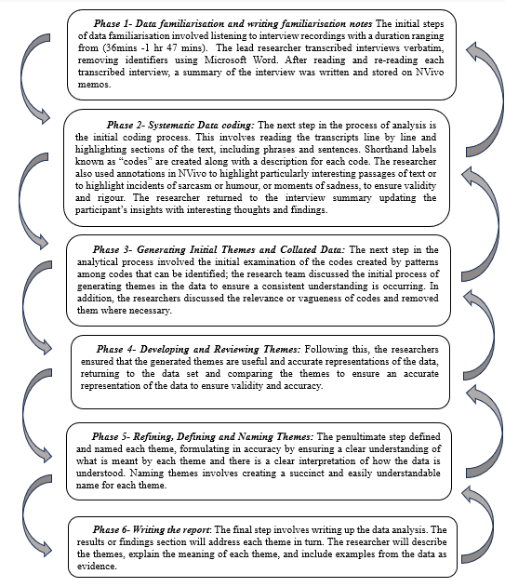
5. Findings
This study delved into the rich and nuanced perspectives of family and non-family employees in the context of family firms. This data-led and researcher-interpretive exercise systematically established (T1)Becoming an Employee: pre-entry,(T2) Becoming a Member: post-entry, (T3)Sources of information, and (T4) Agency relationships as key themes and determinants in how family and non-family employees create their psychological contracts in family firms.
Theme 1: Becoming an Employee: Pre-Entry
For family employees, family membership has a distinctly organic and shaping influence on the formation of the PC, which occurs much earlier and slower over time compared with non-family employees. Unsurprisingly, non-family employees create their PCs more quickly through standardised recruitment-related activities. Figure 2 illustrates the conceptually related elements in PC formation in the pre-entry period.
Figure 2: NVivo Project Map of Thematic Coding: Pre-Entry
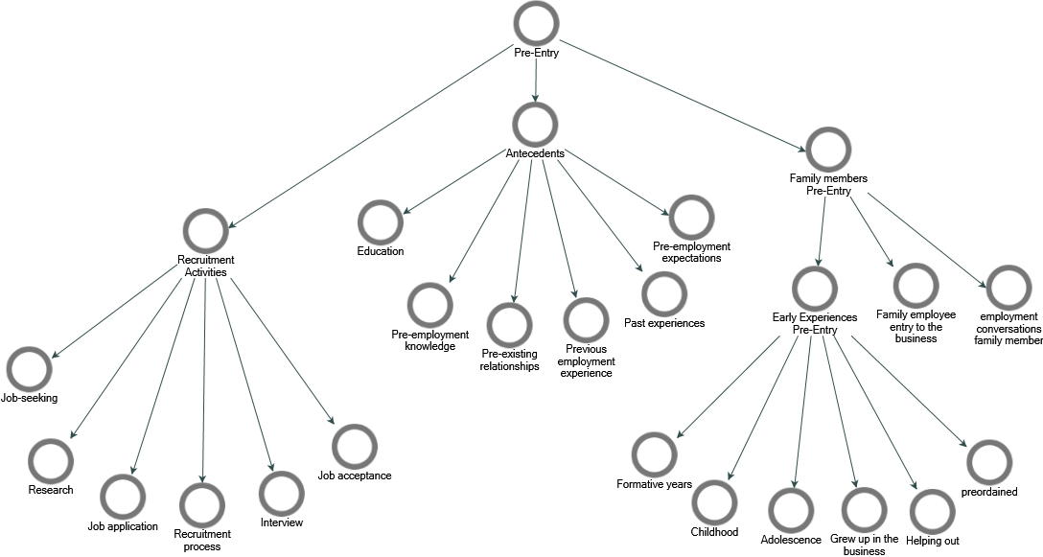
Non-family jobseekers’ go through several steps before becoming employees in the family firm, including job-seeking, research, job application, and other related recruitment activities. In these critical episodes in the pre-entry period, non-family employees gather information about the family business and build their preliminary perceptions and expectations. Pre-entry recruitment activities can be found in the P5 experience.
“I applied through the (Case 2) recruitment page. I just remember getting a phone call from…the senior trainee manager…just invited me for an interview. I remember doing my interview in…. with the managers, and they put me at ease straight away.”
Non-family employees described how these activities enabled them to gather PC information through company website information and job specifications. The opportunity to share and exchange expectations in interviews enabled them to build a relatively comprehensive view of what employment would entail, at which point their anticipatory PC began to emerge.
Family participants, on the other hand, discussed how family membership acted as a critical distinguisher in their pre-entry experience, and PC formation was a much more protracted and temporal process. The pre-entry experience of family members contains deeper layers. Depending on family dynamics (i.e., next-gen, marriage), early influential experiences, i.e., childhood through exposure to the business, helping out and growing up in the business, can influence PC creation, such as P10, who:
“I worked in the business from a very young age, eight years of age, serving customers and that sort of stuff.”
A pre-determined path in another view, through membership of the family, like P7 who:
“I just probably always felt like it was preordained, I guess. Not in the same way that (older brother), he was different; he went down a different route to start with. I kind of just fell into it, and it's partially down to who I am as a person.”
Spousal relationships highlighted a unique dynamic such as FP25 who:
“I married into the business”.
Family employees described how their enduring experiences and pre-existing relationships influenced how they established their employment relationship with the firm. In the ‘recruitment’ phase, they engaged in informal employment conversations with family members, unlike the standardised steps for non-family employees.
Theme 2: Becoming a Member: Post-Entry
Our findings reveal that an integral part of the PC formation unfolds in the post-entry episode for both family and non-family employees influenced by individual and organisational factors, as illustrated in Figure 3. There are stark and surprising findings in the difference in family and non-family employee’ experiences post-entry.
Figure 3: NVivo Project Map of Thematic Coding: Post-Entry
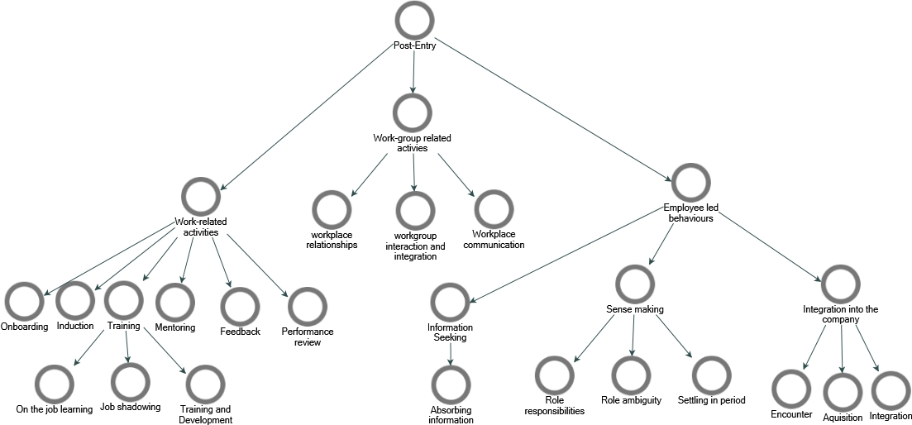
Our findings demonstrate that family and non-family employees engaged in subjective behaviours through the information-seeking period, gathering relevant PC information about the organisation. Depending on the level of formalisation in the business at the time of entry, some non-family members received intensive organisational support in the way of formal work-related activities (e.g., induction, onboarding, training), as found in P14:
“Then with the induction, it was probably within the first week it's where I got my contract, the policies and everything like that done manual handling you watch kind of video and stuff like that. I’d say that was in the within the first week, signed everything, then gave it back, and then yeah, we just slowly kept being introduced into more jobs.”
Others heavily relied on workgroup-related activities through on-the-job learning and informal work-group interaction and integration, which involved immersion into the workgroup, adapting to group norms and developing relationships with organisational members that influenced the formation of the PC as can be seen in P13:
“I never expected such a warm welcome without any prejudice. Straight away, I was one of them.”
Despite the formality in the processes, orientation to the organisation facilitated a transition from becoming an employee to becoming a member of the organisation. In contrast, family members entered the family business through informal processes and ambiguous agreements and did not undergo the same orientation experience as can be seen in P2:
In [previous role], where you advertise for somebody, there is a distinct need: you draft a job spec, advertise if you're happy, you interview, hire someone, and then this is their job. This is what their job would be. Here, all those roles exist and are filled in a normal way, and I'm just an extra pair of legs and a head that's been put into the equation whose kind of sitting here now occupying an office.”
Family participants experienced limited organisational support in the way of formal work-related activities, onboarding, and workgroup interaction is minimal, as witnessed in P12:
“In my other job I've had before…you could have talked to a work colleague who could have exactly the same thing, so I thought that was one aspect, yes, being a family member probably to a certain extent… people maybe won't open up as much because they feel you're part of the family.”
For this reason, family employees had heightened role ambiguities and most notably, a lack of informal information sharing within the workgroup created a deficient adjustment to the organisation. The post-entry process proved difficult to navigate for family employees as the period of adjustment can be further nuanced due to family membership. Family participants relied on their family members to gain insights into organisational reality and struggled to find collegial support and relationships. Without access to formal and informal information, through organisational support and work-group integration, family employees established “imposter syndrome” within their own family firm.
Theme 3: Sources of information
Our findings uncover several key sources of information that family and non-family participants rely upon to establish their reciprocal responsibilities in the organisation (Figure 4). Given that non-family employees' pre-entry and post-entry episodes are facilitated by more formal proceedings, non-family employees are provided with more work-specific sources of PC information resources than their non-family employee counterparts, as found in P14:
“When I started on tills, I got a contract, a sales assistant, a job description, an employee handbook, all the checkout procedures there was I already had everything from the food safety”.
Non-family participants accessed formal and informal information through human contract makers and information resources. They were provided with clear guidelines about role responsibilities, work policies and additional informal knowledge shared within the workgroup.
Figure 4: Theme 3: NVivo Map of Theme Sources of information
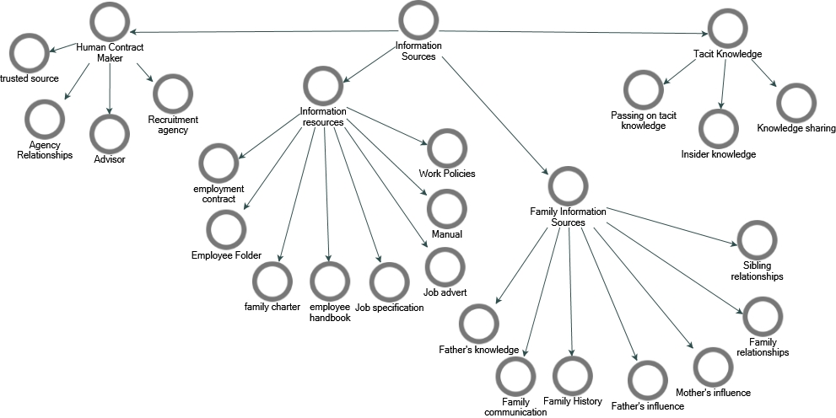
In comparison, family employees were found to rely heavily on information provided by family members. The family as a source of information signified the role that family membership plays in obtaining and acquiring PC information in the business. There was a significantly lower expectation to access formal agreements (i.e., employment contracts and work policies). Instead, family employees largely relied on their family members to gain insights into the organisation, as found in P2:
“I’d be like, OK, but I don't understand why, so then I push him I to understand why. And he’d say, because I said so, but I’d be like, why because I need to understand I need to know why because now, trying to explain to him a few times, like whatever, 30 years of your knowledge”.
As can be seen from P2, this over-reliance leads to heightened complications, as can be witnessed through the experienced pushback in the knowledge sharing from father to son, which can only add to vague agreements. In addition, the lack of unbiased sources of information in work-group interaction lessened their ability to access impartial advice through the informal network, as found in P7:
“I trust a lot of people that I work with. That's not what…it's…I don't feel like I can get. What is the word if I say? Advice from the outside. From the outsiders or don't know is there is a specific word. Biased? I don't feel like I can get advice that isn’t unbiased to the situation”.
Overall, our findings reveal that organisational processes, PC-related information sources and both family and non-family employees have a key role to play in knowledge transfer to employees in the family firm. The following section will discuss the important role of agents in forming the PC.
Theme 4: Agency Relationships
Our findings highlight the importance of and the multitude of organisational actors in PC formation, see Figure 5. An interesting finding in the context of family firms is the variety of agents representing the organisation and the different influences that multiple agents have on PC creation at all organisational levels. Agents include senior agents (i.e. in roles of seniority, such as supervisor, manager, and owner) Work-group through workplace relationships and interaction, and work-specific agents such as the in-store trainer, HR representative and/or colleagues, as found in P6:
“There were two people that were kind of in charge, and they were two kinds of supervisors at the time…They were the people that I go to {for}the correct answer, for the proper training or anything like that. But, like you could ask anyone in there at any time, they wouldn't mind.”

Figure 5: Theme 4: NVivo Map of Theme Agency Relationships
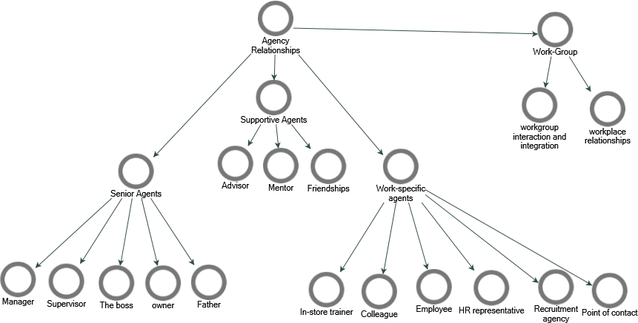
Supportive agents such as advisors, mentors, and friendships as can be found in P24:
“Jim would have been a huge support and crutch, like you know, I suppose he steered me away from making inexperienced decisions maybe at the time. And he was solid, like yeah…And to this day, we're still friends, like, you know, very, very closely attached to me.”
Our findings show that in the family firm, relationships extend far beyond the traditional dyadic relationship, and the role of multiple voices can contribute to implicit and explicit expectations and obligations being formed among actors in the organisation. As can be seen in Figure 5, the family firm is built up of a social network of individuals, and our findings reveal that any point in the employment relationship can influence the employment relationship. We found that while the PC is formed, it is also developed by the ongoing reciprocity that is found within multi-foci relationships. Our findings reveal the importance of multiple relationships in the context of the family firm.
- Discussion
The findings from our study show that PC formation in family and non-family employees is linked to a series of episodes, sources of information and agents of the organisation that consequently shape the formation of the PC in family firms. Through our analysis and interpretation, we have illustrated the important elements that explain how the PC emerges, building on the knowledge that the PC is a cognitive schema of conceptually related elements that incorporate individual beliefs shaped by the organisation regarding an exchange agreement between individuals and their organisation (Rousseau, 1995; Rousseau & Tijoriwala, 1998).
Examining how the PC is constructed is valuable because it facilitates an understanding of how to manage and develop the PC over time (Sherman & Morley, 2015). Therefore, this article upholds that agency relationships and expressions of organisational policy (e.g., Rousseau, 1995), recruitment activities (e.g. Rousseau, 1995; Shore & Tetrick, 1994), and co-workers (e.g., (Tomprou & Nikolaou, 2011) significantly influence PC formation. However, to our surprise, these elements are largely facilitated for the purpose of non-family employees, which leaves family employees with a heightened sense of ambiguity (Eddleston & Kidwell, 2012).
Previous literature highlights the perceived inequities of non-family employees in HR practices (Chrisman et al., 2013) and ingroup–outgroup perceptions, particularly as they relate to non-family employees (e.g., Barnett & Kellermanns, 2006). Whereas our study finds an alternative view of bifurcation bias (e.g., Jennings et al., 2018) negatively impacting the family employee experience. Therefore, our study challenges the assumptions of favourable treatment (e.g., nepotism) by unearthing the unfavourable influence of family membership on HR practice and work-group receptions for family employees. Consequently, our findings show that nepotism significantly impacts family employees’ integration into the family firm.
Pre-entry and Post-entry
Our findings incorporate recruitment-related activities and family membership as key contributors to the formation of the PC in family firms. Through pre-entry, both family and non-family, new recruits create anticipatory PCs largely based on what they hope their working relationship will entail (e.g., de Hauw & de Vos, 2010). This is built upon the culmination of knowledge and experience and the preparatory phase that integrates and guides the employment schema in the next episode of post-entry to the family firm. The key difference between family and non-family employees is rooted in the pre-entry episode, whereby a key distinction evolves through family membership as a novel antecedent.
For next-generation members of a family business, the relationship with the business is embedded in early experiences throughout stages of their childhood, whereby obtaining employment becomes a natural pre-determination. These findings build on earlier research investigating the careers of next-gen members and exposure to the business (Murphy & Lambrechts, 2015). Therefore, for family employees, their system of beliefs and perceptions of their obligations to the business and what is owed in return is largely influenced by the culmination of experiences in the pre-entry episode. This challenges existing PC theory, as the formation of the psychological contract occurs much earlier than the organisational entry period (e.g., Tomprou & Nikolaou, 2011). Ongoing exposure to the business and family within the business build implicit expectations and obligations to the business that pre-determine their future employment relationship with the business, which can explain why key behaviours in family firms emerge, such as stewardship (Kellermanns et al., 2012) and nepotism (Ramos et al., 2014; Zhang & Ma, 2009).
In the preparatory phase, our findings show that family employees are subject to conversations with other family members working within the business. Family employees have subjective organic experiences based on the role they are expected to play, which is often unspecified. Without access to written and explicit information and role responsibilities, this leads to a vague exchange agreement. Non-family employees, on the other hand, were found to undergo a more rigorous preparatory episode, whereby recruitment-related activities facilitate a smoother integration process from candidate to employee and can increase job seekers’ willingness to enter a long-term employment relationship with the business (Hauswald et al., 2016), as can be seen by the long-tenured employees in Table 2. However, there are stark differences in how family and non-family employees come to create initial perceptions of “the duties or responsibilities one feels bound to perform”(Rousseau et al., 2018, p. 1081).
There are clearer guidelines in the post-entry episode that provide resources for non-family employees when seeking information and making sense of the organisation. These include organisational support through onboarding and induction processes and access to the workgroup through on-job-learning and training that give non-family employees a holistic understanding of their expectations, obligations, and role duties within the family firm. Family employees, in contrast, experience informal onboarding processes and their induction to the business is built around conversations with family members within the business. Although all experiences are subjective for each individual, the general finding is that family employees are unsure of their “place” as agreements are largely implicit. As we know, the “information-seeking phase” will likely have a lasting effect on the PC, depending on whether high-quality information that is trusted, clear, and explicit is available. When PCs have reached a level of ‘completeness’, that is, linkages exist among their elements, the PC is deemed durable (Rousseau, 2010), yet the lack of information available to family employees can have damaging repercussions.
Earlier research found that family firms create ingroup–outgroup perceptions, particularly related to non-family employees (e.g., Barnett & Kellermanns, 2006). Our study, in stark contrast, found that family employees feel outsider perspectives; they do not have access to informal networks or unbiased sources and create conditional friendships. A lack of informal information sharing within the workgroup can cause a deficient adjustment to the organisation (Anderson & Thomas, 1996), leading to “imposter syndrome”.
Sources of Information and Agency Relationships
Our research confirms that informal structures characterise family firms and a lack of clarity in work contracts (Steier et al., 2004), particularly as they relate to their family employees. While formalised procedures are in place for non-family employees, family members largely navigate the process without resources, with the exception of the family as the source. “The organisation cannot be considered a single party to the psychological contract, and it does not always speak with one voice. Recruiters, managers, personnel policies/handbooks, and colleagues may all send different messages to employees” (Schalk & Rousseau, 2002, p. 136). Our research significantly concurs with this statement, whereby the context of the family firm adds the complexity of kinship relationships that create additional voices in the employment relationship. This adds to the conversation of multiplicity in the PC (i.e., multiple contract makers) (Alcover et al., 2017a; Knapp et al., 2020; Sherman & Morley, 2020).
- Implications
Theoretical implications
The formation of the PC is critical in identifying how family and non-family employees navigate their employment relationships in family firms. The contribution of this study is two-fold; the theoretical contribution of this research is expanding the knowledge of PC theory, focusing on the key formation process, where for family employees, this is a much more protracted experience in contrast to earlier research (e.g., Rousseau, 1995). The critical contribution of this research uncovers a crucial understanding of the processes that influence subjective employment relationships in family firms, distinguishing family, and non-family employees through family membership. The formation of the PC in the family firm provides a novel contribution to HR and family firm research that, to date and to our knowledge, has been unexplored.
Incorporating schema theory to explain the differences in family and non-family employee employment relationships extends our knowledge of how perceptions translate into expectations that can emerge in employment arrangements. The multiple agents involved in forming the PC, build upon research into exchange relationships in organisations (e.g., Alcover et al., 2017) and extend our understanding of the multi-foci phenomena to the family firm. This research offers a novel contribution to the family firm literature highlighting heterogeneity in the micro-aspects of the organisation, namely within the individual actors and their subjective employment relationships. This research highlights key areas that remain underexplored in family firms.
Practical Implications
The practical implications of this research highlight the cruciality of preparing family employees to enter the family business beyond the guise of family ties. Through adequate support, access to information, sufficient onboarding and creating a collegial culture to ensure there is a successful integration into the business. By understanding the formative influences and different pathways to entry, practitioners in the family firm domain can conscientiously manage the employment relationships of family and non-family employees.
- Limitations and Future Research
Limitations
Despite the obvious constraints of qualitative research, the key limitation of this study is the sector-specificity to retail and the smaller organisational form. Although this may limit generalisability, future research is encouraged to investigate the PC in more diverse sectors in family firms and larger organisations, in which this research can offer a foundation for future investigations. Furthermore, this study takes a unilateral approach to understanding the psychological contract formation process. Given the nature of the findings and the significant influence of agency relationships, a multifocal (e.g., Sherman & Morley, 2020) may have added an additional layer to the study’s findings.
Future Research
Future research must be examined in light of the study's limitations. Researchers in the family business field and HR should build upon this foundational research to investigate the implications of how family and non-family employees create their PCs. While we investigate how the PC is formed, we compel researchers to investigate what is formed, which is found within the content dimensions of the PC. This significant research can lead us to a better understanding of the employment relationship in family firms. The significance of investigating the PC content dimensions, i.e., the quid pro quo elements of the exchange agreement- ‘additional work for a reward’- can help in understanding the employee and employer obligations that constitute the exchange agreement between the two parties, workers, and organisations. This research will provide a future springboard for understanding the important elements that lead to PC fulfilment and violation in employment relationships in family firms.
- Conclusion
The psychological contract (PC) remains a pivotal framework for comprehending employment relationships, embodying the mutual beliefs and implicit obligations between employees and organisations. This study, in response to calls by a number of Lambrechts & Gnan (2022) and Kraak et al. (2024), focuses on the nuanced dynamics within family businesses, addresses the gap in the existing literature and highlights the distinct formation processes of PCs for family and non-family employees. By employing an exploratory qualitative approach and leveraging in-depth interviews, this research unveils how pre-hire and post-hire activities influence PC formation and development differently for these groups.
The insights from this study enrich our understanding of HR practices within family firms, offering a more comprehensive view of recruitment, orientation, and socialisation processes, which addresses a significant gap as emphasised by Marler et al., (2021). This study also challenges traditional PC theory by introducing family membership as a novel antecedent which exposes the protracted psychological formation process unique to family employees. These findings not only advance theoretical discussions but also offer practical implications for HR management in family businesses, underscoring the need for tailored approaches to effectively manage diverse employment relationships. Ultimately, this research underscores the importance of context-specific investigations, as advocated by Kraak et al., (2024), in the study of psychological contracts, paving the way for future explorations that can further elucidate the complexities of employment relationships in varied organisational settings

Achtenhagen, L., Haag, K., Hultén, K., & Lundgren, J. (2022). Torn between individual aspirations and the family legacy – individual career development in family firms. Career Development International, 27(2), 201–221. https://doi.org/10.1108/CDI-06-2020-0156
Alcover, C. M., Rico, R., Turnley, W. H., & Bolino, M. C. (2017a). Multi-dependence in the formation and development of the distributed psychological contract. European Journal of Work and Organizational Psychology, 26(1). https://doi.org/10.1080/1359432X.2016.1197205
Alcover, C. M., Rico, R., Turnley, W. H., & Bolino, M. C. (2017b). Understanding the changing nature of psychological contracts in 21st century organizations: A multiple-foci exchange relationships approach and proposed framework. Organizational Psychology Review, 7(1). https://doi.org/10.1177/2041386616628333
Anderson, N., & Thomas, H. D. (1996). Work group socialization. In Handbook of work group psychology (pp. 423–450).
Arregle, J. L., Hitt, M. A., Sirmon, D. G., & Very, P. (2007). The development of organizational social capital: Attributes of family firms. Journal of Management Studies, 44(1). https://doi.org/10.1111/j.1467-6486.2007.00665.x
Bankins, S. (2014). Delving into promises: Conceptually exploring the beliefs constituting the contemporary psychological contract. Journal of Management & Organization, 20(4), 544–566. https://doi.org/10.1017/jmo.2014.42
Barbera, F., Bernhard, F., Nacht, J., & McCann, G. (2015). The Relevance of a Whole-Person Learning Approach to Family Business Education: Concepts, Evidence, and Implications. Academy of Management Learning & Education, 14(3). https://doi.org/10.5465/amle.2014.0233
Barnett, T., & Kellermanns, F. W. (2006). Are we family and are we treated as family? Nonfamily employees’ perceptions of justice in the family firm. Entrepreneurship: Theory and Practice, 30(6). https://doi.org/10.1111/j.1540-6520.2006.00155.x
Bartlett, F. C. (1932). A study in experimental and social psychology. Cambridge University Press.
Behrens, J., & Tseitlin, L. (2019). Perceptions of transgenerational intentions and nonfamily employees’ commitment in family firms. 79th Annual Meeting of the Academy of Management 2019: Understanding the Inclusive Organization, AoM 2019. https://doi.org/10.5465/AMBPP.2019.147
Botero, I. C., & Litchfield, S. R. (2013). Exploring human resource management in family firms: A summary of what we know and ideas for future development. In Handbook of Research on Family Business, Second Edition. https://doi.org/10.4337/9781781009383.00029
Braun, V., & Clarke, V. (2006). Using thematic analysis in psychology. Qualitative Research in Psychology, 3(2), 77–101. https://doi.org/10.1191/1478088706qp063oa
Braun, V., & Clarke, V. (2019). Reflecting on reflexive thematic analysis. Qualitative Research in Sport, Exercise and Health, 11(4), 589–597. https://doi.org/10.1080/2159676X.2019.1628806
Bunderson, J. S. (2001). How work ideologies shape the psychological contracts of professional employees: Doctors’ responses to perceived breach. Journal of Organizational Behavior, 22(7). https://doi.org/10.1002/job.112
Carsrud, A. L. (2006). Commentary: “Are We Family and Are We Treated as Family? Nonfamily Employees’ Perceptions of Justice in the Family Firm”: It All Depends on Perceptions of Family, Fairness, Equity, and Justice. Entrepreneurship Theory and Practice, 30(6), 855–860. https://doi.org/10.1111/j.1540-6520.2006.00156.x
Cavanaugh, M. A., & Noe, R. A. (1999). Antecedents and consequences of relational components of the new psychological contract. Journal of Organizational Behavior, 20(3). https://doi.org/10.1002/(SICI)1099-1379(199905)20:3<323::AID-JOB901>3.0.CO;2-M
Chirico, F., & Salvato, C. (2008). Knowledge Integration and Dynamic Organizational Adaptation in Family Firms. Family Business Review, 21(2), 169–181. https://doi.org/10.1111/j.1741-6248.2008.00117.x
Clarke, V., & Braun, V. (2018). Using thematic analysis in counselling and psychotherapy research: A critical reflection. Counselling and Psychotherapy Research, 18(2), 107–110. https://doi.org/10.1002/capr.12165
Claver-Cortés, E., Zaragoza-Sáez, P. C., Molina-Manchón, H., & Úbeda-García, M. (2015). Intellectual capital in family firms: human capital identification and measurement. Journal of Intellectual Capital, 16(1). https://doi.org/10.1108/JIC-04-2014-0046
Combs, J. G., Jaskiewicz, P., Shanine, K. K., & Balkin, D. B. (2018). Making sense of HR in family firms: Antecedents, moderators, and outcomes. Human Resource Management Review, 28(1), 1–4. https://doi.org/10.1016/J.HRMR.2017.05.001
Cullinane, N., & Dundon, T. (2006). The psychological contract: A critical review. International Journal of Management Reviews, 8(2), 113–129. https://doi.org/10.1111/j.1468-2370.2006.00123.x
Daspit, J. J., Madison, K., Barnett, T., & Long, R. G. (2018). The emergence of bifurcation bias from unbalanced families: Examining HR practices in the family firm using circumplex theory. Human Resource Management Review, 28(1), 18–32. https://doi.org/10.1016/j.hrmr.2017.05.003
de Hauw, S., & de Vos, A. (2010). Millennials’ career perspective and psychological contract expectations: Does the recession lead to lowered expectations? Journal of Business and Psychology, 25(2). https://doi.org/10.1007/s10869-010-9162-9
De Massis, A., Chua, J. H., & Chrisman, J. J. (2008). Factors preventing intra-family succession. Family Business Review, 21(2). https://doi.org/10.1111/j.1741-6248.2008.00118.x
De Massis, A., & Kotlar, J. (2014). The case study method in family business research: Guidelines for qualitative scholarship. Journal of Family Business Strategy, 5(1), 15–29. https://doi.org/10.1016/j.jfbs.2014.01.007
De Vos, A., Buyens, D., & Schalk, R. (2005). Making sense of a new employment relationship: Psychological contract-related information seeking and the role of work values and locus of control. International Journal of Selection and Assessment, 13(1). https://doi.org/10.1111/j.0965-075X.2005.00298.x
Denise Rousseau. (1995). Psychological contracts in organizations: Understanding written and unwritten agreements. Sage Publications.
Duffy, R. D., & Dik, B. J. (2009). Beyond the Self: External Influences in the Career Development Process. The Career Development Quarterly, 58(1), 29–43. https://doi.org/10.1002/j.2161-0045.2009.tb00171.x
Eckrich, C. J., & Loughead, T. A. (1996). Effects of family business membership and psychological separation on the career development of late adolescents. Family Business Review, 9(4). https://doi.org/10.1111/j.1741-6248.1996.00369.x
Eddleston, K. A., Kellermanns, F. W., & Kidwell, R. E. (2018). Managing Family Members: How Monitoring and Collaboration Affect Extra-Role Behavior in Family Firms. Human Resource Management, 57(5). https://doi.org/10.1002/hrm.21825
Eddleston, K. A., & Kidwell, R. E. (2012). Parent–Child Relationships: Planting the Seeds of Deviant Behavior in the Family Firm. Entrepreneurship Theory and Practice, 36(2), 369–386. https://doi.org/10.1111/j.1540-6520.2010.00403.x
Engle, E. M., & Lord, R. G. (1997). Implicit theories, self-schemas, and leader-member exchange. Academy of Management Journal, 40(4). https://doi.org/10.2307/256956
Frances Carmon, A., & C. Pearson, J. (2013). Family business employees’ family communication and workplace experiences. Journal of Family Business Management, 3(2). https://doi.org/10.1108/JFBM-05-2012-0009
Gagné, M., Sharma, P., & De Massis, A. (2014). The study of organizational behaviour in family business. European Journal of Work and Organizational Psychology, 23(5), 643–656. https://doi.org/10.1080/1359432X.2014.906403
Gomez-Mejia, L. R., Cruz, C., Berrone, P., & de Castro, J. (2011). The Bind that ties: Socioemotional wealth preservation in family firms. In Academy of Management Annals (Vol. 5, Issue 1). https://doi.org/10.1080/19416520.2011.593320
Goodrick, E., & Meindl, JR. (1995). Evolutionary building: the ideological transformation of the nursing profession. Academy of Management Metetings.
Handler, W. C. (1990). Succession in Family Firms: A Mutual Role Adjustment between Entrepreneur and Next-generation Family Members. Entrepreneurship Theory and Practice, 15(1). https://doi.org/10.1177/104225879001500105
Hauswald, H., Hack, A., Kellermanns, F. W., & Patzelt, H. (2016). Attracting New Talent to Family Firms: Who is Attracted and under what Conditions? Entrepreneurship Theory and Practice, 40(5), 963–989. https://doi.org/10.1111/etap.12153
Hoon, C., Hack, A., & Kellermanns, F. W. (2019). Advancing knowledge on human resource management in family firms: An introduction and integrative framework. German Journal of Human Resource Management: Zeitschrift Für Personalforschung, 33(3), 147–166. https://doi.org/10.1177/2397002219847883
Ireland, R. D., Hitt, M. A., & Sirmon, D. G. (2003). A Model of Strategic Entrepreneurship: The Construct and its Dimensions. Journal of Management, 29(6). https://doi.org/10.1016/s0149-2063_03_00086-2
Jennings, J. E., Dempsey, D., & James, A. E. (2018). Bifurcated HR practices in family firms: Insights from the normative-adaptive approach to stepfamilies. Human Resource Management Review, 28(1). https://doi.org/10.1016/j.hrmr.2017.05.007
Johns, G. (2017). Reflections on the 2016 decade award: Incorporating context in organizational research. In Academy of Management Review (Vol. 42, Issue 4). https://doi.org/10.5465/amr.2017.0044
Kellermanns, F. W., & Eddleston, K. A. (2004). Feuding families: When conflict does a family firm good. In Entrepreneurship: Theory and Practice (Vol. 28, Issue 3). https://doi.org/10.1111/j.1540-6520.2004.00040.x
Kellermanns, F. W., Eddleston, K. A., Sarathy, R., & Murphy, F. (2012). Innovativeness in family firms: A family influence perspective. Small Business Economics, 38(1). https://doi.org/10.1007/s11187-010-9268-5
Kidwell, R. E., Kellermanns, F. W., & Eddleston, K. A. (2012). Harmony, Justice, Confusion, and Conflict in Family Firms: Implications for Ethical Climate and the “Fredo Effect.” Journal of Business Ethics, 106(4), 503–517. https://doi.org/10.1007/s10551-011-1014-7
Knapp, J. R., Diehl, M. R., & Dougan, W. (2020). Towards a social-cognitive theory of multiple psychological contracts. European Journal of Work and Organizational Psychology, 29(2). https://doi.org/10.1080/1359432X.2019.1709538
Kozhakhmet, S., Rofcanin, Y., Nurgabdeshov, A., & Las Heras, M. (2023). A bibliometric analysis of psychological contract research: current status development and future research directions. International Journal of Manpower, 44(5). https://doi.org/10.1108/IJM-01-2021-0009
Kraak, J. M., Hansen, S. D., Griep, Y., Bhattacharya, S., Bojovic, N., Diehl, M.-R., Evans, K., Fenneman, J., Ishaque Memon, I., Fortin, M., Lau, A., Lee, H., Lee, J., Lub, X., Meyer, I., Ohana, M., Peters, P., Rousseau, D. M., Schalk, R., … Tekleab, A. (2024). In Persuit of Impact: How Psychological Contract Research Can Make the Work-World a Better Place. Group & Organization Management. https://doi.org/10.1177/10596011241233019
Krueger, N., Bogers, M. L. A. M., Labaki, R., & Basco, R. (2021). Advancing family business science through context theorizing: The case of the Arab world. Journal of Family Business Strategy, 12(1). https://doi.org/10.1016/j.jfbs.2020.100377
Lambrechts, F., & Gnan, L. (2022). Human resources and mutual gains in family firms: New developments and possibilities on the horizon. Journal of Family Business Strategy, 13(2). https://doi.org/10.1016/j.jfbs.2022.100502
Lansberg, I. S. (1983). Managing human resources in family firms: The problem of institutional overlap. Organizational Dynamics, 12(1). https://doi.org/10.1016/0090-2616(83)90025-6
Lloyd P. Steier, James J. Chrisman, & Jess H. Chua. (2004). Entrepreneurial Management and Governance in Family Firms: An Introduction. Entrepreneurship Theory and Practice, 28(4), Pp.295-303.
Lord, R. G., & Foti, R. J. (1986). Schema theories, information processing, and organizational behavior. . In The thinking organization (pp. 20–48).
Luu, T. D. (2022). Non-family employee strategic renewal in family firms: the transformational leadership role of family board members and psychological ownership. Journal of Family Business Management. https://doi.org/10.1108/JFBM-12-2021-0151
Marler, L. E., & Stanley, L. J. (2018). Commentary: Who Are Your Friends? The Influence of Identification and Family In-Group and Out-Group Friendships on Nonfamily Employee OCB and Deviance. Entrepreneurship Theory and Practice, 42(2), 310–316. https://doi.org/10.1177/1042258717749237
Marler, L. E., Vardaman, J. M., & Allen, D. G. (2021). Human resource management in family firms: Review, integration, and opportunities for future research. In Research in Personnel and Human Resources Management (Vol. 39). https://doi.org/10.1108/S0742-730120210000039006
Mayring, P. (2014). Qualitative content analysis: theoretical foundation, basic procedures and software solution.
McAdam, M., Clinton, E., Hamilton, E., & Gartner, W. B. (2023). Learning in a Family Business Through Intermarriage: A Rhetorical History Perspective. Family Business Review, 36(1), 63–83. https://doi.org/10.1177/08944865231157040
Melin, L., Nordqvist, M., & Sharma, P. (2014). The SAGE Handbook of Family Business. SAGE Publications Ltd. https://doi.org/10.4135/9781446247556
Miller, D., Steier, L., & Le Breton-Miller, I. (2003). Lost in time: Intergenerational succession, change, and failure in family business. Journal of Business Venturing, 18(4). https://doi.org/10.1016/S0883-9026(03)00058-2
Murphy, L., Huybrechts, J., & Lambrechts, F. (2019). The Origins and Development of Socioemotional Wealth Within Next-Generation Family Members: An Interpretive Grounded Theory Study. Family Business Review, 32(4), 396–424. https://doi.org/10.1177/0894486519890775
Murphy, L., & Lambrechts, F. (2015). Investigating the actual career decisions of the next generation: The impact of family business involvement. Journal of Family Business Strategy, 6(1). https://doi.org/10.1016/j.jfbs.2014.10.003
Nadin, S., & Cassell, C. (2007). New Deal for Old? Exploring the Psychological Contract in a Small Firm Environment. International Small Business Journal: Researching Entrepreneurship, 25(4), 417–443. https://doi.org/10.1177/0266242607078587
Nadin, S. J., & Williams, C. C. (2011). Psychological contract violation beyond an employees’ perspective. Employee Relations, 34(2), 110–125. https://doi.org/10.1108/01425451211191841
Neubaum, D. O. (2018). Research on the human resource practices of family businesses: A domain worthy of further study. Human Resource Management, 57(5). https://doi.org/10.1002/hrm.21939
O’Brien, E., & Linehan, C. (2018). The last taboo?: surfacing and supporting Emotional Labour in HR work. International Journal of Human Resource Management, 29(4). https://doi.org/10.1080/09585192.2016.1184178
Perricone, P. J., Earle, J. R., & Taplin, I. M. (2001). Patterns of Succession and Continuity in Family-Owned Businesses: Study of an Ethnic Community. Family Business Review, 14(2). https://doi.org/10.1111/j.1741-6248.2001.00105.x
Pittino, D., Barroso Martínez, A., Chirico, F., & Sanguino Galván, R. (2018). Psychological ownership, knowledge sharing and entrepreneurial orientation in family firms: The moderating role of governance heterogeneity. Journal of Business Research, 84. https://doi.org/10.1016/j.jbusres.2017.08.014
Portwood, J. D., & Miller, E. L. (1976). Evaluating the Psychological Contract: Its Implications for Employee Job Satisfaction and Work Behavior. Academy of Management Proceedings, 1976(1). https://doi.org/10.5465/ambpp.1976.4975635
Ramos, H. M., Man, T. W. Y., Mustafa, M., & Ng, Z. Z. (2014). Psychological ownership in small family firms: Family and non-family employees’ work attitudes and behaviours. Journal of Family Business Strategy, 5(3). https://doi.org/10.1016/j.jfbs.2014.04.001
Rousseau, D. M. (1989). Psychological and implied contracts in organizations. Employee Responsibilities and Rights Journal, 2(2). https://doi.org/10.1007/BF01384942
Rousseau, D. M. (1990). New hire perceptions of their own and their employer’s obligations: A study of psychological contracts. Journal of Organizational Behavior, 11(5), 389–400. https://doi.org/10.1002/job.4030110506
Rousseau, D. M. (2001a). Schema, promise and mutuality: The building blocks of the psychological contract. Journal of Occupational and Organizational Psychology, 74(4). https://doi.org/10.1348/096317901167505
Rousseau, D. M. (2001b). Schema, promise and mutuality: The building blocks of the psychological contract. Journal of Occupational and Organizational Psychology, 74(4), 511–541. https://doi.org/10.1348/096317901167505
Rousseau, D. M. (2001c). Schema promise and mutuality.pdf. In Journal of Occupational and Organizational Psychology (Vol. 74).
Rousseau, D. M. (2010). The individual–organization relationship: The psychological contract. In APA handbook of industrial and organizational psychology, Vol 3: Maintaining, expanding, and contracting the organization. https://doi.org/10.1037/12171-005
Rousseau, D. M. ,. (1995). The’problem’of the psychological contract considered. Journal of Organizational Behavior.
Rousseau, D. M., & Greller, M. M. (1994). Human resource practices: Administrative contract makers. Human Resource Management, 33(3). https://doi.org/10.1002/hrm.3930330308
Rousseau, D. M., Hansen, S. D., & Tomprou, M. (2018). A dynamic phase model of psychological contract processes. Journal of Organizational Behavior, 39(9). https://doi.org/10.1002/job.2284
Rousseau, D. M., & Tijoriwala, S. A. (1998). Assessing psychological contracts: Issues, alternatives and measures. Journal of Organizational Behavior, 19(SUPPL.). https://doi.org/10.1002/(sici)1099-1379(1998)19:1+<679::aid-job971>3.0.co;2-n
Schalk., R., & Rousseau.D.M. (2002). Psychological contracts in employment. . In Handbook of industrial, work and organizational psychology (Vol. 2, pp. 133–142). Sage Publications Ltd.
Sharma, P., & Irving, P. G. (2005). Four Bases of Family Business Successor Commitment: Antecedents and Consequences. Entrepreneurship Theory and Practice, 29(1), 13–33. https://doi.org/10.1111/j.1540-6520.2005.00067.x
Sherman, U. P., & Morley, M. J. (2015). On the Formation of the Psychological Contract. Group & Organization Management, 40(2), 160–192. https://doi.org/10.1177/1059601115574944
Sherman, U. P., & Morley, M. J. (2018). Organizational inputs to the formation of the expatriate psychological contract: towards an episodic understanding. International Journal of Human Resource Management, 29(8). https://doi.org/10.1080/09585192.2016.1244103
Sherman, U. P., & Morley, M. J. (2020). What do we measure and how do we elicit it? The case for the use of repertory grid technique in multi-party psychological contract research. European Journal of Work and Organizational Psychology, 29(2). https://doi.org/10.1080/1359432X.2019.1668844
Shore, L. M., & Tetrick, L. E. ,. (1994). The psychological contract as an explanatory framework in the employment relationship. In Trends in organizational behavior (91st ed., Vol. 1, pp. 91–109).
Sieger, P., Bernhard, F., & Frey, U. (2011). Affective commitment and job satisfaction among non-family employees: Investigating the roles of justice perceptions and psychological ownership. Journal of Family Business Strategy, 2(2), 78–89. https://doi.org/10.1016/J.JFBS.2011.03.003
Steijvers, T., Lybaert, N., & Dekker, J. (2017). Formal human resource practices in family firms. Journal of Family Business Management, 7(2). https://doi.org/10.1108/JFBM-07-2016-0016
Tabor, W., Chrisman, J. J., Madison, K., & Vardaman, J. M. (2018). Nonfamily Members in Family Firms: A Review and Future Research Agenda. Family Business Review, 31(1). https://doi.org/10.1177/0894486517734683
Tomprou, M., & Nikolaou, I. (2011). A model of psychological contract creation upon organizational entry. Career Development International, 16(4), 342–363. https://doi.org/10.1108/13620431111158779
Van der Heyden, L., Blondel, C., & Carlock, R. S. (2005). Fair process: Striving for justice in family business. Family Business Review, 18(1). https://doi.org/10.1111/j.1741-6248.2005.00027.x
WARD, S. G., ENVICK, B. R., & LANGFORD, M. ,. (2007). ON THE THEORY OF PSYCHOLOGICAL CONTRACTS IN FAMILY FIRMS. The Entrepreneurial Executive, 12, 37–50.
Zahra, S. A., Neubaum, D. O., & Larrañeta, B. (2007). Knowledge sharing and technological capabilities: The moderating role of family involvement. Journal of Business Research, 60(10). https://doi.org/10.1016/j.jbusres.2006.12.014
Zhang, J., & Ma, H. (2009). Adoption of professional management in Chinese family business: A multilevel analysis of impetuses and impediments. Asia Pacific Journal of Management, 26(1). https://doi.org/10.1007/s10490-008-9099-y

