Digital Entrepreneurial Finance: Where are we?

Izzo Filomena
Corresponding author
Economics Department, University of Campania "Luigi Vanvitelli"
filomena.izzo@unicampania.it

Alessia Spignese
Economics Department, University of Campania "Luigi Vanvitelli"

Francesco Campanella
Economics Department, University of Campania "Luigi Vanvitelli"

Abstract

Frame of the research. Digital technology has rapidly transformed the landscape of entrepreneurship and finance by creating new opportunities for funding, innovation, and global connectivity. The impact of digitalisation on entrepreneurial finance and funding sources for SMEs is a crucial area that warrants deeper investigation. While academic interest in Digital Entrepreneurial Finance (DEF) has dramatically increased recently, management research is still fragmented and needs to be systematised.
Purpose of the paper. This paper establishes the state of the art and the emerging issues on DEF in the management literature to define and prioritise future research directions that will support scholars who wish to address the DEF topic.
Methodology. A systematic review of the literature published between 2013 and 2023 was conducted using bibliometric techniques.
Findings. From the study, three macro topics emerged: digital finance supporting environmental sustainability policy goals, entrepreneurship driven by digital finance, and social, cultural, and geographical aspects related to start-up fintech.
Research limits. Future studies could analyse the single macro topics more fully to identify specific features of DEF in the various management research fields.
Originality of the paper. As far as we know, this study is the first to systematise knowledge of the DEF in the management literature.

Keywords: Digital Entrepreneurial Finance; Entrepreneurship; bibliometric analysis; management; innovation

- Introduction

The financial sector has historically been quick to embrace and utilise information and communication technology advancements. However, introducing innovative financial business models such as fintech, crowdfunding, initial coin offering, and consequently, the emergence of new competitors significantly impacts the industry's current dynamics (SAS, 2023).
As digital technology continues to integrate with the financial industry, the emergence of digital finance offers solutions to real-world challenges. Digital finance involves using digital technology for financing, payments, and investment services (Lyman & Lauer, 2015; Huang & Huang, 2018). The key distinction from traditional finance lies in utilising network channels and digital technologies such as big data, cloud computing, blockchain, and artificial intelligence to extend financial services to the public.
The development of digital finance significantly impacts economic life. Firstly, it exhibits an inclusive effect, providing more suitable and cost-effective financial services to all social classes and groups with financial service needs. By opening information channels and reducing information asymmetry in lending processes, digital finance lowers transaction costs, enhancing efficiency and inclusivity (Sedunov, 2017; Ozili, 2018; Sánchez, 2018). Secondly, digital finance addresses corporate financing constraints. Traditional financial institutions, especially banks, predominantly cater to large corporations and high-net-worth individuals, leaving limited financial services accessible to SMEs and disadvantaged groups. The inclusive nature of digital finance effectively eases corporate financing constraints, enhancing the technological innovation capabilities and market share of firms (Kapoor, 2014; Laeven et al., 2015).
More studies show that digital finance promotes economic development by facilitating innovation and entrepreneurship (Zhang et al., 2019) and offering financial assistance to entrepreneurs in poor areas (Liu et al., 2021). Digital finance has significantly contributed to the dynamism and agility of the entrepreneurial environment (Chatterjee et al., 2022; Schiuma et al., 2022; Upadhyay et al., 2022). This gives rise to Digital Entrepreneurial Finance (DEF), a product of the merger between digital transformation and entrepreneurial finance, providing entrepreneurs and SMEs with unprecedented funding sources. Online alternative finance is disintermediating and democratising entrepreneurial finance, transforming the access, relationship, and dynamics between supply and demand, and offering valuable alternatives for entrepreneurial ventures at different stages of development.
The impact of digitalisation on entrepreneurial finance and funding sources for SMEs is a crucial area that warrants deeper investigation. While digitalisation can potentially transform the market for entrepreneurial finance, there is still much to learn about its effects and implications (Bertoni et al., 2022; Chen et al., 2019). The world is rapidly advancing towards a digital economy, with technological advancements disrupting traditional financing models. The rise of crowdfunding, peer-to-peer lending, and other forms of alternative financing have provided entrepreneurs with new avenues for raising capital. However, they have also introduced new complexities (lack of regulation, platform risk, social risk) to the funding landscape (OECD, 2020).
Given the growing development of DEF, the prospects for further growth and the impact of the continuous technological evolution in which new forms of generative artificial intelligence emerge, management studies must approach the ongoing transformations from a systematic perspective aimed at companies, users, and institutions.
The contribution of the theory is essential for understanding the market challenges concerning finance and innovation. In this perspective, we systematise a research agenda to support academics and managers in redefining entrepreneurship priorities through digital innovation in the financial market in line with the emerging complexity of regulatory requirements and the need for constant innovation.
Since analysing the existing literature, the topic of DEF appears to be relatively recent and fragmented (Alalwan et al., 2023), we decided to outline in an objective, transparent and reproducible manner a state-of-the-art on this topic that could represent a solid theoretical basis able to identify emerging problems and support those who intend to carry out in-depth studies in future studies.
With the dual aim of bridging the literature gap and guiding future research, we conducted a systematic literature review using the bibliometric technique to provide evidence on how the DEF research landscape has evolved, which articles are most influential, and to identify cluster topics in the literature and the motor themes.
The rest of the paper is structured as follows. Section 2 illustrates the methodological path and describes the dataset construction procedure. Section 3 presents the results and discussion. Finally, section 4 describes concluding remarks and presents a future research agenda.

- Methodology

We combined a systematic literature review with quantitative bibliometric analysis to illustrate the current research on DEF. This approach is widely used in knowledge management (Fakhar Manesh et al., 2021; Gaviria-Marin et al., 2019) and innovation (Klarin, 2019; van Oorschot et al., 2018). Systematic literature reviews are robust (Ciampi et al., 2021), minimise bias from exhaustive searches of documents in the field, and provide a control schedule of the literature review’s approach and conclusions (Tranfield et al., 2003).
Figure 1 illustrates the methodological procedure, specifying the activities and instruments used.
Figure 1: Research steps
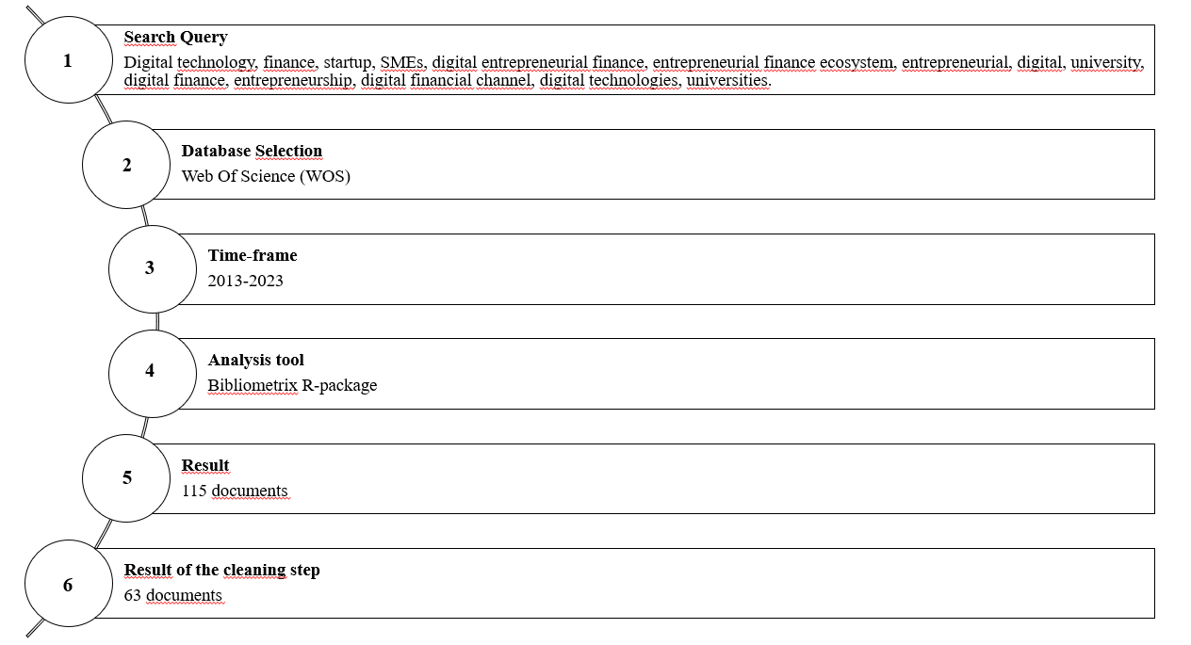
Source: our elaboration

  - Dataset building

We collected publications from the Web of Science (WoS) academic database for our analysis. This database was considered more comprehensive and preferred to others (Llanos-Herrera & Merigo, 2018). The data were downloaded in BibTex format. The sample of publications was analysed with the statistical software R-Studio and the Bibliometrix package (Aria and Cuccurullo, 2017), which allows scientific analysis of the results obtained through the multi-disciplinary database. Bibliometrix was chosen as it enables the researchers to calculate descriptive statistics, bibliometric measures, and science mapping using a large dataset and maintaining high rigor, transparency, and replicability (Dada, 2018; Rey-Martí et al., 2016; Wamba et al., 2021).
The following search string was performed in the WoS Topic field: ((((((((((((((((((TI=(Digital technology and finance and startup)) OR TI=(Digital technology and finance and SMEs)) OR TI=(Digital entrepreneurial finance)) OR TI=(entrepreneurial finance ecosystem)) OR TI=(Entrepreneurial and digital and university)) OR TI=(Digital finance and entrepreneurship)) OR TI=(Digital technology and finance startup)) OR TI=(Digital technology and finance SME)) OR TI=(Digital finance and entrepreneurial)) OR TI=(Digital financial channel)) OR TI=(Digital technology and finance)) OR TI=(digital technology and startup)) OR TI=(Digital technologies and finance)) OR TI=(Digital technologies and startup)) OR TI=(Digital technology and SMEs)) OR TI=(Digital technologies and SMEs)) OR TI=(Digital Finance and universities)) OR TI=(Digital Finance and university)) OR TI=(Finance and startup and university). Searching within the document topic field provides results that contain the selected keyword in the documents' title, abstract, author keywords, and keywords plus.
We limited the search to articles written in English; no restrictions were applied about research fields and time horizons. A total of 115 publications were retrieved from this search query. After an additional data-cleaning step, based on each publication's reading title and abstract in the initial sample, we selected 63 publications consistent with the DEF topic.

  - Data analysis

The final sample was examined through bibliometric analysis by applying different types of research: descriptive, clustering through Multiple Correspondence Analysis (MCA), and thematic analysis.
A descriptive analysis measures the main performances of the final sample of the documents by quantifying the research field (the number of published documents, the number of received citations), identifying the most influential authors, sources, and countries (Gutiérrez-Salcedo et al., 2018).
A literature review of top-cited papers is conducted.

- Results and discussion

We sampled 63 published papers. Figure 2 shows the trend of annual scientific production on the DEF topic. We see that this started in 2013 when the first paper was published. Also, we can observe a slow and sometimes steady growth in scientific production in the years following 2013, becoming more substantial in 2022. Moreover, referring to the time horizon between 2013 and 2021, the number of papers published annually is less than 5, while only from 2022 the number of documents started to increase, reaching 32 papers in 2023.

Figure 2: Annual scientific production
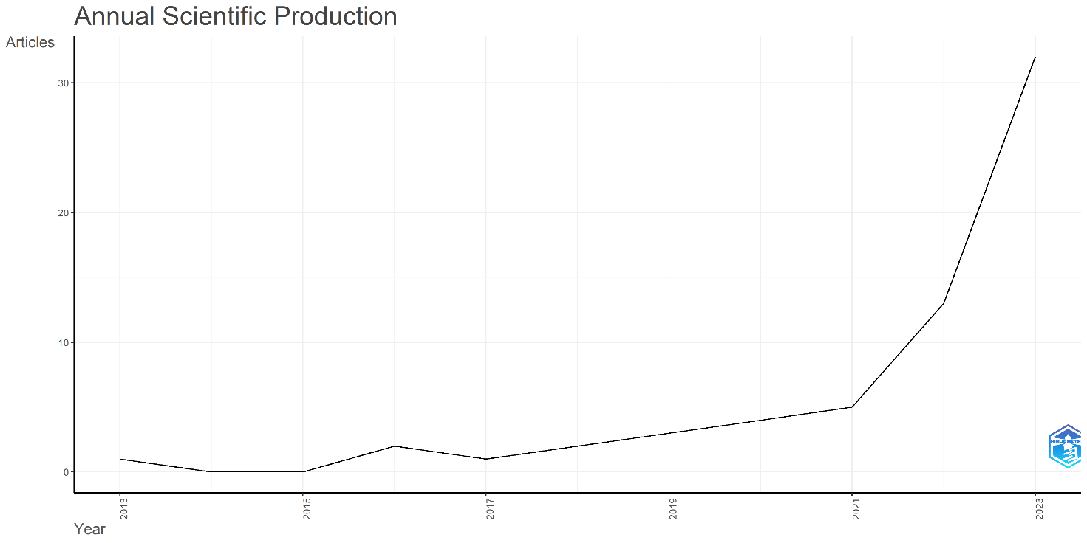
Source: Bibliometrix

Figure 3 shows the trend in scientific production by country. Specifically, it shows the total number of papers published in each country. China is the leading country in scientific production (54%), Italy is in second place (9%), followed by the United Kingdom (5%).

Figure 3: Countries’ scientific production
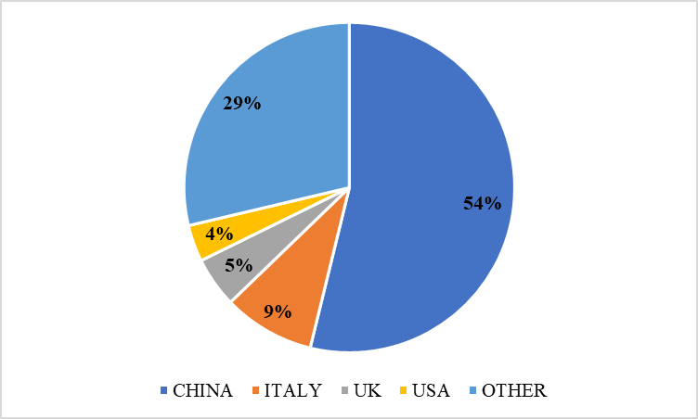
Source: Bibliometrix

Figure 4 outlines the top 10 journals published on DEF topics. Figure 4 shows that only two journals have published more than two articles: Environmental Science and Pollution Research and Sustainability. Both are management journals focused on the topic of sustainability.

Figure 4: Most relevant sources
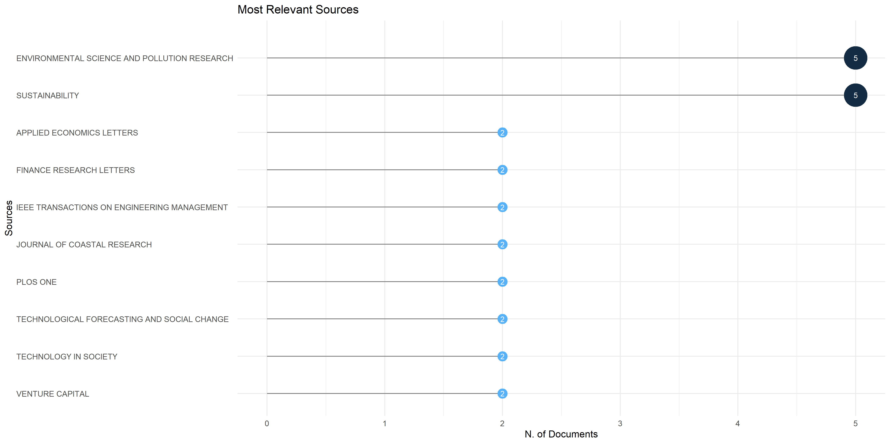
Source: Bibliometrix

Figure 5 shows the 20 most cited papers; it emerges that there are four most cited papers. The first one is “Environmental Decentralization, Digital Finance, and Green Technology Innovation.” by Feng et al. (2022) in Structural Change and Economic Dynamics, with 167 citations. The second one is “Influence of Digital Finance and Green Technology Innovation on China's Carbon Emission Efficiency: Empirical Analysis based on Spatial Metrology.” by Zhang & Liu (2022) in Science of the Total Environment, cited 106 times. The third one is “How does digital finance influence green technology innovation in China? Evidence from the financing constraints perspective” by Lin & Ma, published in 2022 in the Journal of Environmental Management and cited 96 times; the fourth one is “Democratizing Entrepreneurship? Digital Technologies and the Internationalization of Female‐Led SMEs.” by Pergelova et al. (2019) published in the Journal of Small Business Management with 94 citations.

Figure 5: Most Global Cited Documents.
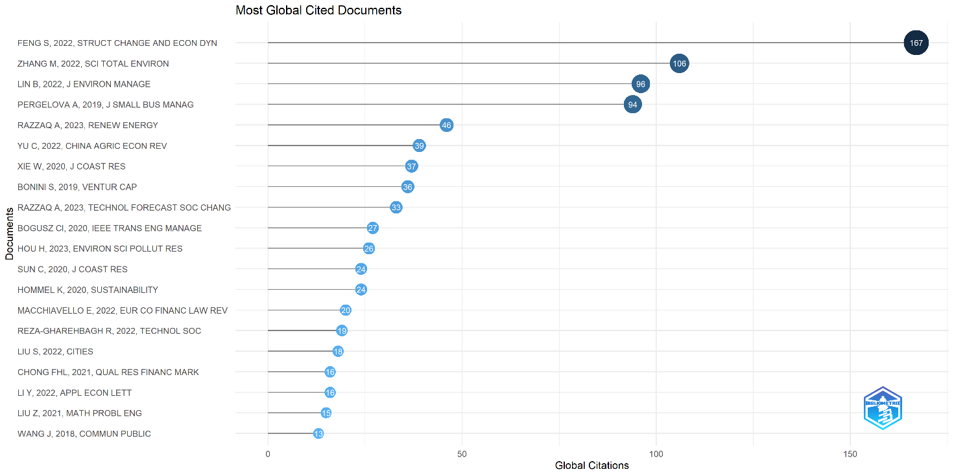
Source: Bibliometrix

From the study of the papers listed in Figure 5, three primary research strands emerge:
- Digital finance supporting environmental sustainability policy goals (45% of top-cited papers).
- Entrepreneurship driven by digital finance (30% of top-cited papers).
- Social, cultural, and geographical aspects of start-up Fintech (25% of top-cited papers).

  - Digital finance supporting environmental sustainability policy goals.

The relationship between digital finance and environmental sustainability is the most extensively explored topic by authors. Several papers investigate the impact of digital finance on ecological sustainability.
Hou et al. (2022) examine the effects of China's green financial policies on environmental quality, focusing on digital finance and green technological innovation. The study identifies how green economic policies, including digital finance and technological innovation, influence ecological quality. Compared to the existing literature, the innovative aspect of this study is the use of mediating variables, such as green technology innovation and digital finance, to better understand the impact mechanism of green finance policies on environmental quality.
However, the study must explore the heterogeneous impacts of green financial policies on different economic actors or delve into microeconomic-level analysis.
These limitations are overcome by Feng et al. (2022), who, referring to the Chinese context, focus on analysing the impact of digital finance on green technological innovation, considering both micro and macro perspectives. The results show that digital finance can significantly promote green technological innovation by reducing financial constraints on enterprises and facilitating upgrading industrial structures, especially in small businesses. In this case, the authors investigate the moderating role of environmental decentralisation in the examined relationship. However, the authors acknowledge the need for further exploration of the role of digital finance in green technological innovation in SMEs and for a more in-depth investigation of the link between digital finance and industrial structure upgrading.
A further step in this direction is taken by Lin & Ma (2022), who analyse the impact of digital finance on the quantity and quality of green technological innovation in China. Examining various dimensions of digital finance, they show that reducing financial constraints provides new opportunities to facilitate the growth of green technological innovation in China and enhance its quality. The authors also emphasise the crucial role of human capital, demonstrating that cities with better human capital more strongly promote green innovation.
Addressing the impact of digital finance on green growth in Chinese regions, Razzaq et al. (2023) also consider the impact of innovation in renewable energies, a factor yet to be explored in the existing literature. Specifically, the study employs advanced analytical tools to examine different levels of green growth in various regions, providing a more comprehensive and integrated perspective by examining the impact of digital financial technologies and innovation in renewable energies on green growth in a multivariate context. However, the territorial analysis does not capture the effects of industrial and spatial spillovers.
This limitation is overcome by Zhang & Liu (2022), who, focusing on the impact of digital finance and green technological innovation on carbon efficiency in China, demonstrate that these factors are relevant at the local level. In other words, the study highlights that the carbon efficiency of a city is influenced not only by digital finance and green technological innovation but also by spillovers from surrounding cities, revealing significant spatial autocorrelation among the carbon efficiency of Chinese cities.
Delving further, Razzaq Yang (2023) analyses the impact of digital finance on green growth in China using innovative methodologies such as web crawlers and big data. The analysis shows that inclusive digital finance significantly promotes green development in China in the eastern and central regions but not in the western areas due to differences in economic levels, education, and human capital, indicating regional heterogeneity in the impact of digital finance on green growth. Finally, the study identifies influencing mechanisms, such as the digital transformation of businesses and energy poverty, that play essential roles in the efficiency and equity of inclusive digital finance.
Furthermore, Chenghao Sun (2020) explores the intersection of digital finance, technological innovation, and marine ecology, demonstrating that developing digital finance can promote the growth of maritime ecological efficiency. Offering an innovative perspective on how these sectors can collaborate to promote sustainability and efficiency and emphasising the mediating role of technological innovation, the author explores the intersection of digital finance and other branches of environmental sciences, such as marine ecology.
Finally, although slightly diverging from the analysed research strands, we have the studies by Reza-Gharehbagh et al. (2022) and Bonini & Capizzi (2019). Reza-Gharehbagh et al. (2022) address the issue of financing for the development of green technologies and the role of digital platforms. The authors examine entrepreneurs' challenges and opportunities in the manufacturing sector when seeking financial support for green innovations and the strategies multilateral platforms offer in response to government environmental policies. The study emphasises that manufacturing entrepreneurs must consider various factors when seeking financial support for the development of green technologies, including government environmental policies, the power structure of platforms, and the characteristics of financing.
On the other hand, Bonini & Capizzi (2019) analyse venture capital's role in the entrepreneurial finance ecosystem and emerging finance dynamics.
In conclusion, the fundamental concepts of the first line of research are summarised in Figure 6.

Figure 6:
Summary of key concepts: "Digital finance in support of environmental sustainability policy goals.”
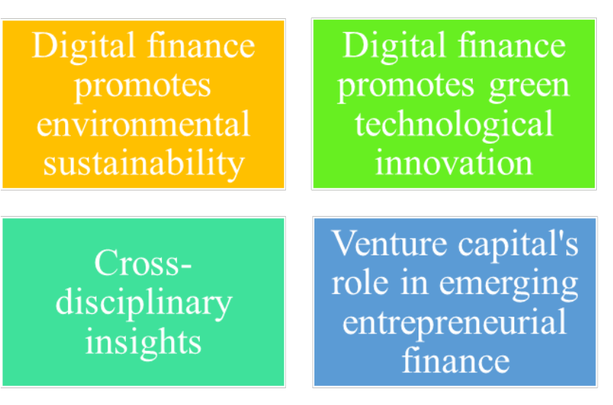
Source: our elaboration

  - Entrepreneurship driven by digital finance.

Some articles investigate the impact of digital finance on society and entrepreneurship. In particular, Yu et al. (2022) examine the effects of the development of inclusive digital finance on the consumption structure of rural families in China and recognise the existence of an intergenerational "digital gap." The main results show that developing inclusive digital finance can contribute to upgrading rural families' consumption structure.
Xie et al. (2020) focus on analysing the role of inclusive digital finance in stimulating rural entrepreneurship in coastal regions of China. It provides evidence that different indicators of inclusive digital finance affect entrepreneurship differently, showing that the development of inclusive digital finance plays a vital role in stimulating rural entrepreneurship despite being characterised by regional heterogeneity.
Similarly, Liu Z. et al. (2021) use the Static Career Choice Model to explore the impact of digital financial inclusion and multidimensional education on promoting entrepreneurial choice among farmers in China. The main results show that digital financial inclusion reduces the dependence of entrepreneurial choice on academic education. In contrast, academic education positively and significantly impacts entrepreneurial choice among rural residents. These two studies contribute to the relevant literature as they help understand the importance of inclusive digital finance in stimulating rural entrepreneurship.
Additionally, using data from different macro and micro levels, Liu Z. et al. (2021) provide a new perspective to understand the complex interactions between the digital financial environment and education in the context of entrepreneurial choice. This approach allows for a more comprehensive and detailed visualisation of the impact of digital financial inclusion on entrepreneurial choice at the individual and regional levels.
Additional studies (Liu S. et al., 2022; Li et al., 2022) focus on a specific demographic category: migrants in China. Although both analyse how digital finance can promote migrant entrepreneurship in China, their contribution to the literature differs.
For instance, Liu S. et al. (2022) argue that local development of digital finance is positively associated with migrant entrepreneurship. They highlight the potential of digital finance in bridging the gap and creating opportunities for disadvantaged entrepreneurs. In particular, the authors find that access to digital finance is a significant determinant of individual entrepreneurial incentives, especially for entrepreneurs in less developed regions of developing countries who may face more challenging financing conditions.
At the same time, Li et al. (2022) argue that digital finance can help migrants move away from survival-oriented low-income entrepreneurship because digital finance can increase employment opportunities but does not influence entrepreneurship-oriented entrepreneurship. The authors say that lacking human capital prevents migrants from becoming entrepreneurs.
These two studies (Liu S. et al., 2022 and Li et al., 2022) significantly enrich the existing literature by providing a crucial perspective on a demographic relevant to many economies, including the Chinese, as they delve into the impact of digital finance on migrant entrepreneurship. Of course, both studies have limitations that may challenge future research. Liu S. et al.'s (2022) study lacks insights into how digital finance influences migrant entrepreneurs' access to entrepreneurial financing.
Finally, although not focusing on inclusive digital finance, Pergelova et al.'s (2019) study addresses entrepreneurship themes, exploring the impact of digital technologies on the internationalisation of women-led SMEs and highlighting that digital technologies can contribute to the democratisation of female entrepreneurship.
In conclusion, the fundamental concepts of the second line of research are summarised in Figure 7.

Figure 7:
Summary of key concepts: "Entrepreneurship is driven by digital finance.”
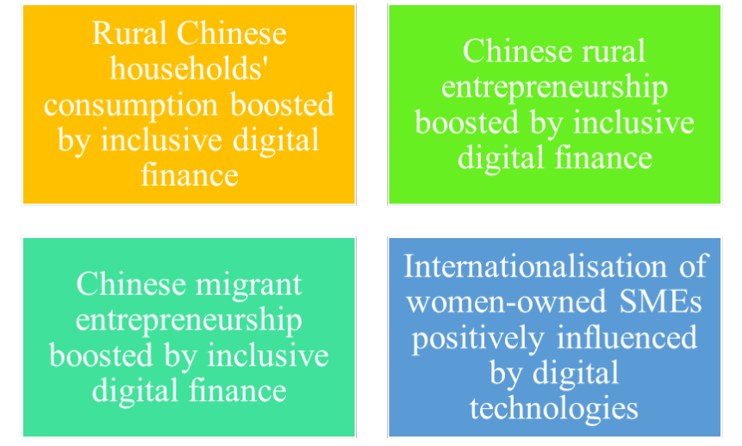
Source: our elaboration

  - Social, cultural, and geographical aspects of start-up Fintech.

Another theme of interest in academic research is start-up Fintech. Hommel & Bican (2020) examine the decision-making criteria for financing Fintech start-ups by interviewing investors and industry entrepreneurs. The analysis shows that management is a critical factor for investors in the early stages of financing but can be replaced by other criteria, such as later-stage revenue generation. Investors are also interested in the personality of start-up founders, and the gender of founders can influence investment decisions.
On the other hand, the study by Macchiavello & Siri (2022) focus on the intersection between sustainable finance and Fintech. It examines how technology can contribute to achieving environmental goals. Focusing on technical and legal implications, the authors explore the potential and challenges of using technology in sustainable finance. The conclusions identify opportunities for financial technology to improve transparency, efficiency, and access to sustainable financial services. They also explore possible barriers and regulatory issues that must be addressed to optimise its contribution to sustainable finance. These two articles significantly contribute to existing literature by taking a comprehensive approach to the Fintech theme. For example, Hommel & Bican (2020) fill a gap in understanding how innovative financial start-ups are evaluated and selected by identifying decision-making criteria of investors in the Fintech sector. They also highlight the changing role of banks as investors, partners, and competitors of Fintech. At the same time, Macchiavello & Siri (2022), by offering an innovative perspective on the intersection between sustainable finance and technology, initiate a debate on "green Fintech" that encourages research in this new and promising area.
In this research strand, additional studies (Chong, 2021; Wang, 2018) are more focused on the cultural and geographical dimensions of Fintech. Chong (2021) examines the benefits and challenges of implementing smart contracts in digital Islamic finance and the creation of new startups, discussing the application of technology in digital Islamic finance and its impact on building trust. In particular, the study considers how the complexity of Shariah-based contracts poses a regulatory challenge, revealing that implementing blockchain in digital Islamic finance can improve the transparency and efficiency of financial transactions.
At the same time, Wang (2018) explores how these new players are changing the financial landscape of China, analysing the impact of Fintech on the traditional financial structure dominated by the Chinese government. Instead of focusing on the economic outcomes of Fintech, the author concentrates on how it has created new social, economic, and political relationships, emphasising the strong connection between digital financial technologies and financial volatility, as well as the growth of investors speculating on the market in real-time, online.
Finally, Bogusz et al. (2020) analyse how crowdfunding, blockchain technology, cryptocurrencies, and Initial Coin Offerings (ICOs) interact and evolve. This study offers a better understanding of the development of blockchain, cryptocurrencies, and ICOs and their interactions in the context of financial innovation, highlighting changes in social media debates.
In conclusion, the fundamental concepts of the third line of research are summarised in Figure 8. The four squares shown in Figure 8 are a succinct representation of the dominant key concepts that have emerged from the analysis of this strand of research. These are the following: 1) the identification of decision criteria for the financing of Fintech start-ups; 2) the relationship between Fintech and sustainable finance; 3) the analysis of the cultural and geographical aspects of Fintech; 4) the analysis of crowdfunding, blockchain and cryptocurrencies.

Figure 8:
Summary of key concepts on the topic
“Social, cultural, and geographical aspects of start-up Fintech.”

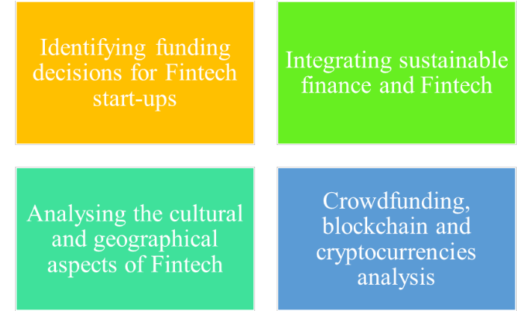
Source: our elaboration

- Conclusion

Digital technology has rapidly transformed the landscape of entrepreneurship and finance by creating new opportunities for funding, innovation, and global connectivity. Digital platforms such as crowdfunding and peer-to-peer lending have democratised access to capital, allowing entrepreneurs to raise funds from a larger pool of investors. Digital financial services, such as mobile banking and digital wallets, have expanded access to financial services for previously underserved populations. Digital technologies have simplified financial transactions, reduced costs, increased transparency, and enabled the development of new business models, such as platform-based businesses and sharing economy models. These innovative models have disrupted traditional industries and created new market opportunities for entrepreneurs.
This paper contributes by systematising knowledge of DEF in the management literature.
A systematic literature review between 2013 and 2023 was conducted using bibliometric techniques.
The temporal evolution of the research field, covering ten years and growing in the last two years, reveals that the focus on this topic is very recent. This is also reflected in the few journals covering this topic. In addition, studies are mainly focused on the Chinese market, probably because China is the world leader in the digital finance market.
From the study, three macro topics emerged: (1) digital finance supporting environmental sustainability policy goals; (2) entrepreneurship driven by digital finance; (3) social, cultural, and geographical aspects related to start-up fintech.
Future studies could analyse the three different clusters and macro themes in more depth to identify specific features of DEF in the various management research fields, including their theoretical underpinnings. Empirical studies on different management and finance challenges are also needed.
Moreover, based on the discussion of macro themes, future studies can outline a research agenda for management scholars who wish to address challenges and opportunities in DEF.
We may conclude that the management challenges and opportunities are multifaceted, and the need for further research is evident; this paper has provided one basis for future management research in the domain of DEF.

References

Alalwan, A. A., Baabdullah, A. M., Fetais, A. H. M., Algharabat, R. S., Raman, R., & Dwivedi, Y.K. (2023). SMEs entrepreneurial finance-based digital transformation: towards innovative entrepreneurial finance and entrepreneurial performance. Venture Capital, 1-29. https://doi.org/10.1080/13691066.2023.2195127
Aria, M., & Cuccurullo, C. (2017). A brief introduction to bibliometrix. Journal of Informetrics, 11(4), 959-975.
Aria, M., & Cuccurullo, C. (2017). bibliometrix: An R-tool for comprehensive science mapping analysis. Journal of informetrics, 11(4), 959-975.
Bertoni, F., Bonini, S., Capizzi, V., Colombo, M. G., & Manigart, S. (2022). Digitization in the Market for Entrepreneurial Finance: Innovative Business Models and New Financing Channels. Entrepreneurship Theory and Practice, 46(5), 1120–1135. https://doi.org/10.1177/10422587211038480
Bogusz, C. I., Laurell, C., & Sandström, C. (2020). Tracking the digital evolution of entrepreneurial finance: the interplay between crowdfunding, blockchain technologies, cryptocurrencies, and initial coin offerings. IEEE Transactions on Engineering Management, 67(4), 1099-1108.
Chatterjee, S., Chaudhuri, R., Vrontis, D., & Basile, G. (2022). Digital transformation and entrepreneurship process in SMEs of India: a moderating role of adoption of AI-CRM capability and strategic planning. Journal of Strategy and Management, 15(3), 416-433.
Chen, B., & Zhao, C. (2021). Poverty reduction in rural China: Does the digital finance matter?. Plos one, 16(12), e0261214. https://doi.org/10.1371/journal.pone.0261214
Chong, F. H. L. (2021). Enhancing trust through digital Islamic finance and blockchain technology. Qualitative Research in Financial Markets, 13(3), 328-341.
Ciampi F., Giannozzi A., Marzi G., Altman E.I. (2021), “Rethinking SME default prediction: a systematic literature review and future perspectives”, Scientometrics, vol. 126, n. 3, pp. 2141-2188
Dada, O. (2018). A model of entrepreneurial autonomy in franchised outlets: a systematic review of the empirical evidence. International Journal of Management Reviews, 20(2), 206-226.
Fakhar Manesh M., Pellegrini M., Marzi G., Dabic M. (2021), “Knowledge Management in the Fourth Industrial Revolution: Mapping the Literature and Scoping Future Avenues”, IEEE Transactions on Engineering Management, vol. 68, n. 1, pp. 289-300.
Feng, S., Zhang, R., & Li, G. (2022). Environmental decentralization, digital finance, and green technology innovation. Structural Change and Economic Dynamics, 61, 70-83.
Gaviria-Marin M., Merigó J.M., Baier-Fuentes H. (2019), “Knowledge management: A global examination based on bibliometric analysis”, Technological Forecasting and Social Change, vol. 140, pp. 194-220.
Gutiérrez-Salcedo, M., Martínez, M. Á., Moral-Munoz, J. A., Herrera-Viedma, E., & Cobo, M. J. (2018). Some bibliometric procedures for analyzing and evaluating research fields. Applied intelligence, 48, 1275-1287.
Hommel, K., & Bican, P. M. (2020). Digital entrepreneurship in finance: Fintechs and funding decision criteria. Sustainability, 12(19), 8035.
Hou, H., Zhu, Y., Wang, J., & Zhang, M. (2023). Will green financial policy help improve China’s environmental quality? The role of digital finance and green technology innovation. Environmental Science and Pollution Research, 30(4), 10527-10539.
Huang, Y., & Huang, Z. (2018). The development of digital finance in China: Present and future. China Economic Quarterly, 17(4), 205-218.
Kapoor, A. (2014). Financial inclusion and the future of the Indian economy. Futures, 56, 35-42.
Klarin A. (2019), “Mapping product and service innovation: A bibliometric analysis and a typology”, Technological Forecasting and Social Change, vol. 149, 119776, pp. 1-12.
Li, Y., Tan, J., Wu, B., & Yu, J. (2022). Does digital finance promote the entrepreneurship of migrant? Evidence from China. Applied Economics Letters, 29(19), 1829-1832.
Lin, B., & Ma, R. (2022). How does digital finance influence green technology innovation in China? Evidence from the financing constraints perspective. Journal of environmental management, 320, 115833.
Liu, S., Koster, S., & Chen, X. (2022). Digital divide or dividend? The impact of digital finance on the migrants' entrepreneurship in less developed regions of China. Cities, 131, 103896.
Liu, Z., Zhang, Y., & Li, H. (2021). Digital inclusive finance, multidimensional education, and farmers’ entrepreneurial behavior. Mathematical Problems in Engineering, 2021, 1-13.
Llanos-Herrera, G. R., & Merigo, J. M. (2018). Overview of brand personality research with bibliometric indicators. Kybernetes, 48(3), 546-569.
Lyman, T., & Lauer, K. (2015). What is digital financial inclusion and why does it matter. CGAP Blog, March, 10.
Macchiavello, E., & Siri, M. (2022). Sustainable finance and fintech: Can technology contribute to achieving environmental goals? A preliminary assessment of ‘green fintech’and ‘sustainable digital finance’. European Company and Financial Law Review, 19(1), 128-174.
OECD, “Digital Disruption in Banking and its Impact on Competition”, 2020, https://www.oecd.org/daf/competition/digital-disruption-in-banking-and-its-impact-on-competition-2020.pdf
Ozili, P. K. (2018). Impact of digital finance on financial inclusion and stability. Borsa Istanbul Review, 18(4), 329-340.
Pergelova, A., Manolova, T., Simeonova‐Ganeva, R., & Yordanova, D. (2019). Democratizing entrepreneurship? Digital technologies and the internationalization of female‐led SMEs. Journal of Small Business Management, 57(1), 14-39.
Razzaq, A., & Yang, X. (2023). Digital finance and green growth in China: Appraising inclusive digital finance using web crawler technology and big data. Technological Forecasting and Social Change, 188, 122262.
Razzaq, A., Sharif, A., Ozturk, I., & Skare, M. (2023). Asymmetric influence of digital finance, and renewable energy technology innovation on green growth in China. Renewable Energy, 202, 310-319.
Rey-Martí, A., Ribeiro-Soriano, D., & Palacios-Marqués, D. (2016). A bibliometric analysis of social entrepreneurship. Journal of business research, 69(5), 1651-1655.
Reza-Gharehbagh, R., Hafezalkotob, A., Makui, A., & Sayadi, M. K. (2022). Financing green technology development and role of digital platforms: Insourcing vs. outsourcing. Technology in Society, 69, 101967.
SAS, 2023, Economist Impact. Banking in 2035: global banking survey report.
Schiuma, G., Schettini, E., Santarsiero, F., & Carlucci, D. (2022). The transformative leadership compass: six competencies for digital transformation entrepreneurship. International Journal of Entrepreneurial Behavior & Research, 28(5), 1273-1291.
Sedunov, J. (2017). Does bank technology affect small business lending decisions?. Journal of Financial Research, 40(1), 5-32.
Stefano Bonini & Vincenzo Capizzi (2019) The role of venture capital in the emerging entrepreneurial finance ecosystem: future threats and opportunities, Venture Capital, 21:2-3, 137-175.
Sun, C. (2020). Digital finance, technology innovation, and marine ecological efficiency. Journal of Coastal Research, 108(SI), 109-112.
Tranfield D., Denyer D., Smart P. (2003), “Towards a methodology for developing evidence-informed management knowledge by means of systematic review”, British Journal of Management, vol. 14, n. 3, pp. 207-222.
Upadhyay, N., Upadhyay, S., Al-Debei, M. M., Baabdullah, A. M., & Dwivedi, Y. K. (2023). The influence of digital entrepreneurship and entrepreneurial orientation on intention of family businesses to adopt artificial intelligence: examining the mediating role of business innovativeness. International Journal of Entrepreneurial Behavior & Research, 29(1), 80-115.
Van Oorschot J.A., Hofman E., Halman J.I. (2018), “A bibliometric review of the innovation adoption literature”, Technological Forecasting and Social Change, vol. 134, pp. 1-21.
Wamba, S. F., Bawack, R. E., Guthrie, C., Queiroz, M. M., Carillo, K. D. A. (2021). Are we preparing for a good AI society? A bibliometric review and research agenda. Technological Forecasting and Social Change, 164, 120482.
Wang, J. (2018). Inclusion or expulsion: Digital technologies and the new power relations in China’s “Internet finance”. Communication and the Public, 3(1), 34-45.
Xie, W., Wang, T., & Zhao, X. (2020). Does digital inclusive finance promote coastal rural entrepreneurship?. Journal of Coastal Research, 103(SI), 240-245.
Yu, C., Jia, N., Li, W., & Wu, R. (2022). Digital inclusive finance and rural consumption structure–evidence from Peking University digital inclusive financial index and China household finance survey. China Agricultural Economic Review, 14(1), 165-183.
Zhang, M., & Liu, Y. (2022). Influence of digital finance and green technology innovation on China's carbon emission efficiency: Empirical analysis based on spatial metrology. Science of The Total Environment, 838, 156463.
Zhang, X., Wan, G., Zhang, J., He, Z., (2019). Digital Economy, Financial Inclusion and Inclusive Growth. Economic Research Journal 54 (8), 71–86.

