A configurational perspective of country viewed vulnerabilities against the level of modern slavery and government responses across the world

Malcolm J. Beynon*

and

Jean Jenkins

Cardiff Business School
Cardiff University
Cardiff
CF10 3EU

* email: beynonmj@cardiff.ac.uk

Track - Sustainable and Responsible Business

A configurational perspective of country viewed vulnerabilities against the level of modern slavery and government responses across the world

Abstract
There exists international concern on the existence of modern slavery across the world. This study demonstrates a novel ‘configurational’ approach to the understanding of the modern slavery problem across a large sample of the countries of the world. Using data from the Walk Free Foundation, conditions of country level modern slavery associated vulnerabilities, including, Governance Issues, Lack of Basic Needs, Inequality, Disenfranchised Groups and Effects of Conflict, are considered against the concomitant outcomes of Prevalence of Slavery and level of Government Responses associated with each country. Fuzzy-set Qualitative Comparative Analysis (fsQCA) is employed to consider the relationships of vulnerabilities (conditions) to each of the two outcomes. As such, the analysis progresses to the consideration of configurations of the conditions against the considered outcomes. Initial results exhibit evidence of the existence of multiple pathways of conditions describing separately the presence and absence of the high prevalence of modern slavery and high level of government responses, demonstrating the equifinality in this considered modern slavery problem. Emphasis on the graphical (including maps) exposition of results demonstrates the potential advocacy of a configurational approach in the understanding of the modern slavery problem across the world.

- Introduction
There exists international concern on the existence of modern slavery across the world (Larsen and Durgana, 2017; Han et al., 2022). The reality is that countries may or may not have unique circumstances that again may or may not infer modern slavery is a problem for them. In terms of academic research, Mehmood et al. (2023) offer an in-depth bibliometric analysis of the modern slavery issue. This study considers a configurational based analysis of countries and associated vulnerabilities pertaining to the prevalence of modern slavery and level of government responses. Its remit is to demonstrate how such an approach can offer advocacy to the understanding of the modern slavery problem across the world (supporting the need for more international level studies, see Mehmood et al., 2022).
Using data from the Walk Free Foundation (WFF, see WFF, 2023), a series of country level modern slavery related vulnerabilities (conditions) are considered, namely, Governance Issues, Lack of Basic Needs, Inequality, Disenfranchised Groups and Effects of Conflict, to describe the considered countries. The countries are also described by a pair of termed outcomes, the Prevalence of Slavery and level of Government Responses, also available in the WFF (2023). Larsen and Durgana (2017) elucidate further the issues on the measurement of country level vulnerability and prevalence of modern slavery (at the time of their article).
Since the commencement of the establishment of the considered data in 2007 (WFF, 2023), it has been viewed as data to be used with caution, see Guth et al. (2014) and Gallagher (2017). However, the WFF (2023) acknowledges this and have developed their data processing, including the association of independent working groups collaborating with their work. Further, beyond the academic based concerns on earlier forms of the data, it is a reality that the data is often included in media articles on the subject of modern slavery, as well as in ‘government’ based communities (see for example Brankovic, 2021). Hence, any analysis using this data has the dual opportunity of furthering the modern slavery debate, as well as offering a validating lens on the actual data considered, so bolstering the appropriateness of its use in media and government (as in this case).
In this study, a configurational approach is adopted, whereby an understanding of patterns and combinations of conditions and how they, as configurations, lead to outcomes is attempted (see Nikou et al., 2022). More specifically, fuzzy-set Qualitative Comparative Analysis (fsQCA) is employed, introduced in Ragin (2008), to identify pathways of conditions which explain the form of the outcome(s) considered. Since its introduction, fsQCA has gained increasing employment in research areas including (where review articles exist), entrepreneurship and innovation (Kraus et al., 2018; Nikou et al., 2022), tourism (Geremew et al., 2023) and construction management (Jordan et al., 2011). It is noted, Pettinato (2023) applied fsQCA on a modern slavery problem, considering vulnerabilities of migrant workers in Italy, using survey data.
Using fsQCA, combinations of conditions (country level vulnerabilities – as described previously) contribute to established pathways describing the possible association of configurations separately to either the presence or absence of the two outcomes of high prevalence of slavery and high level of government responses. With emphasis on the graphical and map based elucidation of findings, the study offers a novel demonstration of a configurational approach, through fsQCA, in the modern slavery problem. Moreover, as will be demonstrated, this approach will evidence the equifinality of the modern slavery problem across the world, with multiple different combinations of country vulnerabilities shown to describe the presence or absence of high prevalence of modern slavery and government responses. Such an acknowledgement of this equifinality being central to the modern slavery problem, it will guide future understanding in this problem area.
The structure of the rest of the study is as follows: In section 2, a discussion of slavery and its measurement is undertaken. Section 3 offers a description of the considered data as well as fsQCA oriented data calibration. In section 4, a novel fsQCA employment of the vulnerabilities-slavery data set. Section 5 offers a discussion around the vulnerabilities pathways to the established presence or absence of high prevalence of slavery and high level of government responses. In section 6, conclusions are given as well as directions for future research.

- Modern slavery, country vulnerabilities and their measurement
It is over 20 years since the ground breaking book on Modern Slavery, ‘Disposable People’, was written (see Bales, 1999), even now, the notion of modern slavery, to some, is considered a non-field (Caruana et al., 2020). An important starting point here is also on the interpretation of the meaning of modern slavery (see WFF, 2024), often repeated in extant literature (see Jackson, 2023);

“Essentially, it refers to situations of exploitation that a person cannot refuse or leave because of threats, violence, coercion, deception, and/or abuse of power.”

As Mehmood et al. (2022) identifies, this delineation in meaning broadens the definition of exploitation. Caruana et al. (2020) suggest that the very term ‘modern slavery’ may have prompted growing scholarly interest Iin Business and Management field). They subsequently argue the subject area remains highly underdeveloped, and even that the literature purveys unhelpful characterisations of modern slavery. Before continuing the relevant literature review, Caruana et al. (2020) also knowledge the existence in the literature of the rejection of the term ‘modern slavery’.
While Han et al. (2022) is considering supply chains, they make two generisable points to the issue of modern slavery, i) it is a complex and severe issue manifesting itself in a range of practises and ii) that while governments legislate against modern slavery it has continued to grow.
Geng et al. (2022) note specifically how COVID-19 pandemic has increased the vulnerability of workers to modern slavery (e.g. lockdown and facility closures put workers at greater exploitation).
The interest in the addressment of modern slavery goes beyond government and non-government agencies, and is importantly with the public (Gen et al., 2022).
Tickler et al. (2018), investigating modern slavery in the fisheries industry, too a country level perspective, including using national level GSI data covering socio-economic aspects.
Locatelli et al. (2022), in an introduction to a small collection of ‘darkside’ projects, including also corruption and criminal organisations, noted the important fact that with nearly 40 million people in modern slavery (see also WFF, 2023) this is roughly three times the whole of the Atlantic slave trade.
Related issues of data scarcity and high dimensionality, were also flagged as issues in the ability to pertinently analyse the modern slavery problem issue (see Lavelle-Hill et al., 2021).
In terms of related academic research on Modern Slavery, Mehmood et al. (2022) note a gradual ‘pick-up’ in the number of publications (academic papers) from 2013 being produced, increasing year on year (e.g. 62 in 2020). The majority of studies being either country specific or industry specific. However, they hint at the need for international country level understanding, with their specific discernment between developing and developed countries. Moreover, that even with these country groupings there may be sub-group differences.
Pertinent to the intended configurational analysis of concomitant vulnerability, Larsen and Durgana (2017) could not have stated it any clearer (p. 22);

“Vulnerabilities to modern slavery is affected by a complex interaction of factors related to the presence or absence of protection; respect for rights; physical safety and security; access to the necessities of life such as food, water and health care; and patterns of migration, displacement and conflict.”,

with the presence or absence discernment exactly what fsQCA embodies, with its underlying asymmetric forms of analysis.
Motivation for country level consideration comes from Lavell-Hill et al. (2021) which identified modern slavery is a phenomenon which effects, men, women and children in all countries of the world (see also ILO, 2017). Importantly, and pertinent for the reasoning of the new for research undertaken in this study, Lavelle-Hill et al. (2021) the modern slavery topic is formally articulated by the UN as part of SDGs.
It is important discernment that a country’s vulnerability to modern slavery is an equivalent to the actual prevalence of modern slavery (Lavelle-Hill et al., 2021).

- Description of data and calibration
The data considered in this study comes from the Walk Free Foundation (WFF, see WFF, 2023). Since its inception in 2007 (WFF, 2023), the WFF have published a range of measures describing aspects of the modern slavery problem across the world, at the country level. Successive developments have improved the quality of the data, an issue, for example, that mitigates the ability to considered multiple years of data (see Brankovic, 2021).
The country level vulnerability conditions considered here come from how WFF measures the extent to which a population is vulnerable to modern slavery (see WFF, 2023). The two outcomes, prevalence of modern slavery and level of government responses are similarly available at WFF. A fuller description of the data, conditions and outcomes, and descriptive statistics, is next given, see Table 1.

Table 1. Descriptions of data

Conditions (Vulnerabilities) | Description (measured over percentage domain) | Descriptive statistics – [min, max], Mean, sd
Governance Issues (Govn_Iss) | i) Political instability, ii) Government response, iii) Women’s physical security, iv) Political rights, v) Regulatory quality, vi) Disability based workplace harassment and vii) Weapons access | [3, 93]  46.117, 20.761
Lack of Basic Needs (Lack_Bsc_Nds) | i) Cell phone users, ii) Undernourishment, iii) Social safety net, iv) Ability to borrow money, v) Tuberculosis and vi) Access to clean water | [18, 76]  38.701, 14.741
Inequality (Ineqlty) | i) Emergency funds, ii) Violent crime, iii) Gini coefficient and iv) Law enforcement reliability | [11, 100]  42.273, 16.298
Disenfranchised Groups (Disfran_Grps) | i) Employers prioritise nationals, ii) Social group equality and iii) LGBTI acceptance | [11, 88]  59.591, 17.041
Effects of Conflict (Effcts_Conflct) | i) Internally displaced persons, ii) Impact of terrorism and iii) Internal conflicts fought | [1, 93]  29.649, 21.476
Outcomes | Description (measured over percentage domain) | Descriptive statistics – [min, max], Mean, sd
Prevalence of Slavery  (Prev_Slavery) | Estimated prevalence and number of people in modern slavery, by country (per thousand people and number of people) | [0.5, 32]  5.917, 4.022
Government Responses  (Govt_Rspnss) | The assessment on government responses, i) Survivors of slavery are identified and supported to exit and remain out of modern slavery, ii) Criminal justice mechanisms function effectively to prevent modern slavery, iii) Coordination occurs at the national and regional level and across borders, and governments are held to account for their response, iv) Risk factors, such as attitudes, social systems, and institutions that enable modern slavery are addressed and v) Government and business stop sourcing goods and services produced by forced labour. | [8.0, 68]  45.948, 11.814

In Table 1, the described conditions and outcomes are shown to be measured over the consistent domain of a percentage interval domain. The higher the percentage values the, i) higher the presence of the specific vulnerability, ii) the higher the prevalence of slavery and iii) the higher the level of government responses. In the descriptions, for the vulnerability conditions and government response outcome, they are made up from associated ‘granular’ measures. In the case of prevalence of slavery it is made up of regression based analyses also (WFF, 2023).
In collective terms, this data (conditions and outcomes) is termed here the vulnerability-slavery data set. A total of 154 countries are included in this study, see Figure 1.

Figure 1. Map based elucidation of included countries

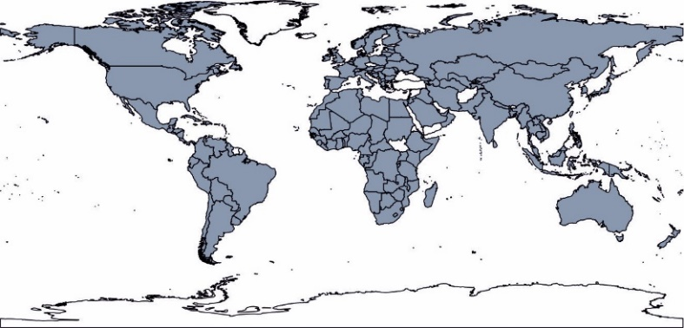

The map results in Figure 1 show the breadth of coverage of the considered 154 countries across the world (those grey shaded being included in the vulnerability-slavery data set). One feature of the use of fsQCA (see later) is the movement away from using the original interval scaled data (as described in Table 1), to data described in terms of fuzzy membership values. Ragin (2008) discusses this when they introduced fsQCA, and has since been discussed further, see for example, Nikou et al. (2022). The development to a fuzzy membership value forms of the data moves the interpretation of condition interval values to the grades of membership of cases to a hypothesis. The ability to transform the data into fuzzy membership values, in fsQCA, is termed calibration (see Ragin, 2008).
Here, the Direct method to calibration is undertaken (see Ragin, 2008), following the employed approach in Andrews et al. (2016), see Figure A1 in Appendix for graphical details. It is premised on the construction of a probability density function (pdf) for a condition or outcome, with qualitative anchors then found based on the 5th, 50th and 95th percentiles of the pdf, and termed the lower-threshold (x^{Ʇ}), crossover-point (x^{x}) and upper-threshold (x^{T}), respectively. These qualitative anchors, using a log-odds transformation, enable the creation of a fuzzy membership function transforming an original interval scale set of values to a set of fuzzy membership values (over the 0 -1 domain). The details in Figure A1 include the established fuzzy membership functions for the considered conditions and outcomes.
One feature of this calibration approach is the ‘good practise’ to sense check this initial quantitative process (see for example Douglas et al., 2020). Here, the authors did discuss the calibration results, and noted in the case of the Lack_Bsc_Nds condition, see Figure A1b, there was a natural gap in values to the left of the original crossover-point value found, hence it was felt appropriate to move this crossover point to the middle of the identified gap in the values for Lack_Bsc_Nds (hence new crossover point). In terms of qualitative thinking, the authors felt it inappropriate to commit further changes to the qualitative anchors (with no known views on the data in this regard).
To illustrate this calibration process, a sample of cases (countries) are considered, see Table 2.

Table 2. Sample cases exposition of calibration process

Scale | Case | Govn_Iss | Lack_Bsc_Nds | Ineqlty | Disfran_Grps | Effcts_Conflct |  | Prev_Slavery | Govt_Rspnss
Original | Case 1 | 39 | 31 | 44 | 68 | 22 |  | 11.8 | 62
Original | Case 2 | 54 | 27 | 30 | 58 | 34 |  | 1.9 | 36
Original | Case 3 | 51 | 63 | 55 | 71 | 29 |  | 4.1 | 44
Original | Case 4 | 41 | 29 | 53 | 43 | 15 |  | 4.2 | 58
Fuzzy membership values | Case 1 | 0.322 | 0.232 | 0.558 | 0.699 | 0.379 |  | 0.928 | 0.939
Fuzzy membership values | Case 2 | 0.631 | 0.132 | 0.187 | 0.415 | 0.622 |  | 0.068 | 0.191
Fuzzy membership values | Case 3 | 0.563 | 0.939 | 0.797 | 0.785 | 0.553 |  | 0.251 | 0.422
Fuzzy membership values | Case 4 | 0.358 | 0.176 | 0.762 | 0.180 | 0.175 |  | 0.264 | 0.885
Strong membership | Case 1 | 0 | 0 | 1 | 1 | 0
Strong membership | Case 2 | 1 | 0 | 0 | 0 | 1
Strong membership | Case 3 | 1 | 1 | 1 | 1 | 1
Strong membership | Case 4 | 0 | 0 | 1 | 0 | 0
New Labels |  | High Govn_Iss | High Lack_Bsc_Nds | High Ineqlty | High Disfran_Grps | High Effcts_Conflct |  | High Prev_Slavery | High Govt_Rspnss

In Table 2, a set of four countries are described, in the top four rows the original conditions and outcomes country values (percentages) are shown. Below these in the middle rows are the concomitant fuzzy membership values found through the calibration undertaken (see Figure A1). The bottom rows show the strong membership values for the conditions (not needed for the outcomes) showing whether the fuzzy membership values are nearer the absence (0) or presence (1) of the condition (whether fuzzy values are < 0.5 or ≥ 0.5 respectively).
The latter ‘bottom’ rows describing the cases also demonstrate how a case (country) can go from being described by a series of condition ‘percentage’ values to instead being associated with a specific configuration (in terms of absence and/or presence of the individual conditions). Indeed, with now talking about the absence (0) or presence (1) of a condition, the naming of the conditions and outcomes moves to being adjective based not noun based, as re-termed in the bottom row of Table 2 (the adjective values are associated specifically with the fuzzy membership values – hence an adjective term is given for the outcome also - e.g. Govn_Iss becomes High Govn_Iss).
To offer a further comparison between the two outcomes (as a consequence of the results in Figure A1), a scatterplot of the respective High Prev_Slavery and High Govt_Rspnss fuzzy membership values of each country are shown, see Figure 2.

Figure 2. Scatterplot of High Prev_Slavery and High Govt_Rspnss outcome values

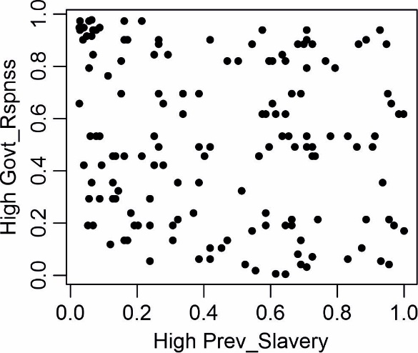

In Figure 2, each point represents a country with High Prev_Slavery (x-axis) and High Govt_Rspnss (y-axis) fuzzy membership values describing them. Inspection of the details in Figure 2 show a spread of points across the whole of the scatterplot domain. There is a cluster of points near the top left corner of the scatterplot indicating a subgroup of countries associated with absence of High Prev_Slavery and presence of High Govt_Rspnss. How this will impact on the separate fsQCA investigations of High Prev_Slavery and High Govt_Rspnss outcomes based on country vulnerabilities (conditions) will be shown later.
A further elucidation of the fuzzy membership values for the considered countries are given in Figure 3.

Figure 3. Map based elucidation of outcomes

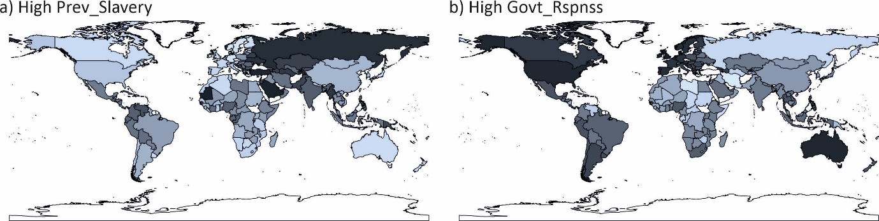

In Figure 3, two grey-shaded country world maps are shown, for each of the outcomes High Prev_Slavery and High Govt_Rspnss. Where a country is not included in the vulnerabilities-slavery data set they are shaded white (not shaded), and the greyscale shown is associated with the country fuzzy membership values to the outcomes High Prev_Slavery (3a) and High Govt_Rspnss (3b), with the darker the shading the higher the respective membership value. Variations in the shading of the considered 154 countries across the two world maps shown offers further elucidation of the outcomes’ variations across the different countries.

- FsQCA of vulnerabilities-slavery data
This section outlines the employment of fsQCA on the calibrated form of the vulnerabilities-slavery data set (see middle rows in Table 2). Following Ragin (2008), and later articles (see for example review article Kraus et al., 2018), the stages of the fsQCA approach shown here are, i) necessity analysis, ii) truth table and frequency and consistency thresholds elucidation, and iii) sufficiency analysis.

4.1 Necessity analysis
This subsection considers the necessity of conditions, whereby individual conditions are checked to see if they are a necessity to the respective outcome (see Ragin, 2008). Here, the necessity findings are presented in graphical form in Figure 4, separately for the outcomes High Prev_Slavery and High Govt_Rspnss.

Figure 4. Scatterplot plot form of Necessity based consistency values (with 0.9 thresholds)

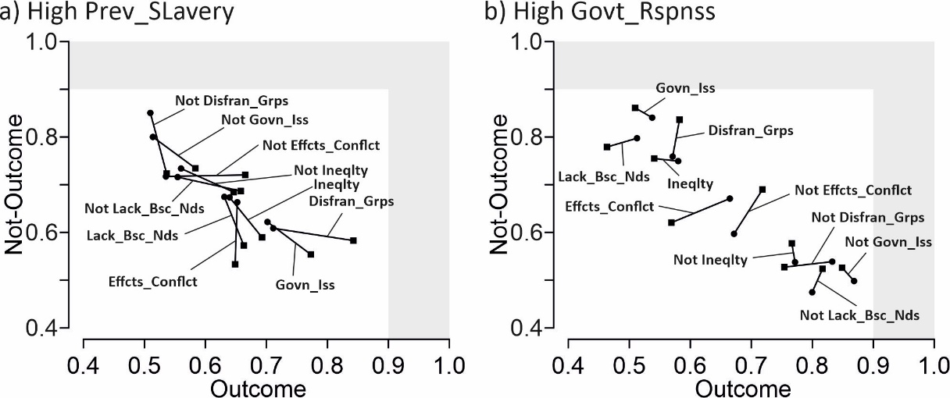

In Figure 4, in each plot, a condition is represented by two pairs of points joined by lines. These represent for a single condition (square – consistency values and circle – coverage values), the following, labelled with outcome name then condition-to-outcome and condition-to-not-outcome, and labelled with not-outcome label then not-condition-to-outcome and not-condition-to-not-outcome.
Following Ragin (2008), an important consideration here is whether any of the consistency values are large enough to require the condition (or not-condition) to be viewed as necessary. An often-used threshold for this is 0.900 (see Vis and Dul, 2018), signified in Figure 4 by the light grey shaded region (in this region means above the employed threshold). Inspection shows no condition is viewed, as necessary.

  - Truth table
This sub-section describes the logically possible configurations (as demonstrated in the bottom rows in Table 2), existing amongst those theoretically possible. Moreover, as described in fsQCA, a truth table is constructed showing configurations and their associations to the different forms (presence or absence) of the respective outcomes (see Ragin, 2008). With five conditions considered, there are 32 (= 2⁵) possible configurations which could be considered as logically possible. Table 3 shows those configurations with at least one case (country) associated with them in strong membership terms (as illustrated in bottom rows in Table 2), and associated measures next described.

Table 3. Truth table of vulnerabilities-slavery data set

 |  |  |  |  |  |  | High Prev_Slavery |  |  |  |  | High Govt_Rspnss
 |  |  |  |  |  |  | Presence |  | Absence |  |  | Presence |  | Absence
Confg | High Govn_Iss | High Lack_  Bsc_Nds | High Ineqlty | High Disfran_Grps | High Effcts_Conflct | n | Cons | Pri_score | Cons | Pri_score |  | Cons | Pri_score | Cons | Pri_score
1 | 0 | 0 | 0 | 0 | 0 | 23 | 0.563 | 0.162 | 0.906 | 0.819 |  | 0.928 | 0.854 | 0.558 | 0.111
2 | 0 | 0 | 0 | 0 | 1 | 15 | 0.643 | 0.201 | 0.910 | 0.798 |  | 0.958 | 0.896 | 0.637 | 0.104
3 | 0 | 0 | 0 | 1 | 0 | 4 | 0.860 | 0.550 | 0.829 | 0.450 |  | 0.917 | 0.715 | 0.790 | 0.282
4 | 0 | 0 | 0 | 1 | 1 | 3 | 0.902 | 0.639 | 0.825 | 0.354 |  | 0.937 | 0.706 | 0.846 | 0.281
5 | 0 | 0 | 1 | 0 | 0 | 7 | 0.791 | 0.280 | 0.917 | 0.715 |  | 0.952 | 0.828 | 0.769 | 0.168
6 | 0 | 0 | 1 | 0 | 1 | 2 | 0.884 | 0.476 | 0.891 | 0.507 |  | 0.953 | 0.787 | 0.822 | 0.198
7 | 0 | 0 | 1 | 1 | 0 | 1 | 0.907 | 0.576 | 0.874 | 0.424 |  | 0.956 | 0.770 | 0.852 | 0.230
8 | 0 | 0 | 1 | 1 | 1 | 1 | 0.934 | 0.676 | 0.863 | 0.324 |  | 0.956 | 0.744 | 0.871 | 0.256
10 | 0 | 1 | 0 | 0 | 1 | 2 | 0.858 | 0.370 | 0.916 | 0.630 |  | 0.946 | 0.607 | 0.915 | 0.379
11 | 0 | 1 | 0 | 1 | 0 | 3 | 0.861 | 0.441 | 0.890 | 0.559 |  | 0.932 | 0.554 | 0.910 | 0.415
12 | 0 | 1 | 0 | 1 | 1 | 1 | 0.901 | 0.502 | 0.900 | 0.498 |  | 0.955 | 0.621 | 0.927 | 0.379
13 | 0 | 1 | 1 | 0 | 0 | 5 | 0.810 | 0.295 | 0.921 | 0.705 |  | 0.902 | 0.459 | 0.916 | 0.535
14 | 0 | 1 | 1 | 0 | 1 | 2 | 0.871 | 0.400 | 0.914 | 0.600 |  | 0.930 | 0.617 | 0.888 | 0.383
15 | 0 | 1 | 1 | 1 | 0 | 5 | 0.828 | 0.347 | 0.908 | 0.653 |  | 0.891 | 0.386 | 0.932 | 0.614
16 | 0 | 1 | 1 | 1 | 1 | 3 | 0.894 | 0.496 | 0.896 | 0.504 |  | 0.938 | 0.607 | 0.904 | 0.393
17 | 1 | 0 | 0 | 0 | 0 | 4 | 0.844 | 0.439 | 0.877 | 0.557 |  | 0.902 | 0.456 | 0.918 | 0.544
18 | 1 | 0 | 0 | 0 | 1 | 1 | 0.879 | 0.517 | 0.870 | 0.483 |  | 0.915 | 0.468 | 0.926 | 0.532
19 | 1 | 0 | 0 | 1 | 0 | 7 | 0.897 | 0.709 | 0.749 | 0.291 |  | 0.860 | 0.438 | 0.881 | 0.522
20 | 1 | 0 | 0 | 1 | 1 | 5 | 0.898 | 0.678 | 0.784 | 0.322 |  | 0.880 | 0.490 | 0.880 | 0.487
21 | 1 | 0 | 1 | 0 | 0 | 1 | 0.889 | 0.466 | 0.903 | 0.534 |  | 0.930 | 0.589 | 0.900 | 0.411
22 | 1 | 0 | 1 | 0 | 1 | 2 | 0.927 | 0.643 | 0.868 | 0.358 |  | 0.911 | 0.545 | 0.893 | 0.455
23 | 1 | 0 | 1 | 1 | 0 | 1 | 0.914 | 0.631 | 0.854 | 0.369 |  | 0.906 | 0.479 | 0.914 | 0.521
24 | 1 | 0 | 1 | 1 | 1 | 3 | 0.938 | 0.742 | 0.823 | 0.258 |  | 0.862 | 0.406 | 0.906 | 0.594
25 | 1 | 1 | 0 | 0 | 0 | 1 | 0.836 | 0.261 | 0.942 | 0.739 |  | 0.904 | 0.344 | 0.948 | 0.644
27 | 1 | 1 | 0 | 1 | 0 | 6 | 0.841 | 0.466 | 0.858 | 0.524 |  | 0.814 | 0.238 | 0.942 | 0.762
28 | 1 | 1 | 0 | 1 | 1 | 5 | 0.905 | 0.640 | 0.831 | 0.360 |  | 0.858 | 0.298 | 0.936 | 0.682
29 | 1 | 1 | 1 | 0 | 0 | 3 | 0.824 | 0.330 | 0.913 | 0.670 |  | 0.849 | 0.273 | 0.943 | 0.727
30 | 1 | 1 | 1 | 0 | 1 | 5 | 0.886 | 0.535 | 0.869 | 0.465 |  | 0.863 | 0.393 | 0.907 | 0.590
31 | 1 | 1 | 1 | 1 | 0 | 11 | 0.796 | 0.403 | 0.856 | 0.580 |  | 0.718 | 0.132 | 0.957 | 0.868
32 | 1 | 1 | 1 | 1 | 1 | 22 | 0.833 | 0.514 | 0.774 | 0.345 |  | 0.670 | 0.160 | 0.929 | 0.820
 |  | Freq >= 2 |  | 0.895 | 0.916 |  | 6 (25) |  | 8 (58) |  |  | 10 (64) |  | 8 (61)

In Table 3, a total of 30 configurations are shown for which at least one case is associated with them in strong membership terms (meaning two configurations are not shown (Cnfgs 9 and 26) since had no evidence of case level associations to them – so demonstrating the issue of limited diversity – see Ragin, 2008). The first five columns describe the 0 (absence) or 1 (presence) indicators of each condition for the shown configurations. The No column denotes the number of cases associated with each configuration (in strong membership terms – see Table 2), which sum to 154 the number of considered countries in this study (shown in Figure 1). The next pairs of columns give the respective consistency and PRI-score values for each configuration to their association to the outcome (left) and not-outcome (right) for each considered outcome (High Prev_Slavery and High Govt_Rspnss).
One feature of this approach is the understanding of the association of configurations to the outcome or not-outcome, based on the available evidence, namely number of cases associated with them, and the respective consistency and PRI-score measures. For each of these ‘evidential’ measures, a respective threshold consideration is necessary. Here, following Andrews and Beynon (2023), a graphical elucidation to the dual frequency and consistency threshold values are considered, see Figure A2 in Appendix A.
It follows, with a view to retaining the most cases to the outcome or not-outcome, a combination of frequency threshold 1.5 (meaning ≥ 2) and i) for High Prev_slavery - consistency threshold (≥) 0.895 and ii) for High Govt_Rspnss - consistency threshold (≥) 0.916, will enable the most cases to be future considered in each outcome. It is noted, using a frequency threshold of ≥ 2 means, from Table 3, seven configurations (Cnfgs 7, 8, 12, 18, 21, 23 and 25), are not further considered (even though have case evidence), and here termed remainders and considered later (see Ragin, 2008).
A mapped based visualisation of association of configurations of cases (in strong membership terms) is exposited in Figure 5.

Figure 5. Map based elucidation of association of configurations of cases to outcome, not-outcome or neither

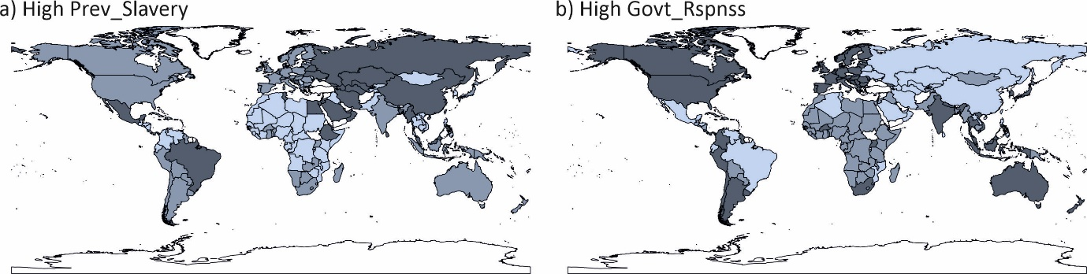

In each map in Figure 5, a categorical representation of the impact of the findings in the truth tables in Table 3 are shown. Moreover, i) the white non-shaded countries were not present in the considered vulnerabilities-slavery data set (as in Figure 1), ii) the light grey shaded countries are associated with configurations not future associated with either the outcome or not-outcome (due to frequency and consistency thresholds employed – the remainders), iii) the medium grey shaded countries are associated with the not-outcome (absence of High Prev_Slavery or High Govt_Rspnss), and iv) the dark grey shaded countries are associated with the outcome (presence of High Prev_Slavery or High Govt_Rspnss).

4.1 Sufficiency analysis
This subsection outlines the fsQCA based sufficiency analysis (see Ragin, 2008). An immediate consideration here, is how the remainder configurations are considered (the light grey shaded countries in each map in Figure 5a (for High Prev_Slavery) and 5b (for High Govt_Rspnss)), in terms of the choice of solutions to report. Moreover, there are tree forms of solutions to consider (see Ragin, 2008), Complex, Intermediate and Parsimonious.
There continues notable debate on which solution(s) to report (see Douglas et al., 2020), with relevant arguments for the pertinence of each solution. In the case of the intermediate solution, it incorporates a priori knowledge on connections of absence or presence of specific conditions to an outcome. In this problem, with countries being their own entities it was felt not possible in this exploratory study to generalise any conditions (absence or presence) to an outcome. Hence, here the complex and parsimonious solutions are reported to.
The sufficiency results are presented in Tables 4 (High Prev_Slavery) and 5 (High Govt_Rspnss). These results utilise Boolean algebra to minimise the combination of conditions necessary to describe the associations of configurations to outcomes (see Ragin, 2008). A series of pathways (combinations of conditions) are established. The circle notation adopted, follows Ragin and Fiss (2008), whereby filled and not-filled circles denote the presence and absence of the condition, respectively, and no circle indicates ‘doesn’t’ matter. Small and large circle denote peripheral and core conditions (subject to filled or not-filled).

Table 4. Sufficiency analysis to High Prev_Slavery (outcome and not-outcome form)

Conditions | Presence of High Prev_Slavery |  |  |  | Absence of High Prev_Slavery
Complex | PS_CT1 | PS_CT2 | PS_CT3 | PS_CT4 | PS_CNT1 | PS_CNT2 | PS_CNT3 | PS_CNT4
High Govn_Iss
High Lack_Bsc_Nds
High Ineqlty
High Disfran_Grps
High Effcts_Conflct
Configurations_Complex | 19, 20 | 22, 24 | 20, 28 | 4, 20 | 13, 14, 15, 16 | 1, 5 | 2, 10 | 13, 29
Consistency* | 0.891 | 0.929 | 0.883 | 0.895 | 0.889 | 0.901 | 0.907 | 0.902
PRIscore* | 0.720 | 0.714 | 0.664 | 0.681 | 0.647 | 0.810 | 0.794 | 0.671
Raw Coverage* | 0.398 | 0.356 | 0.377 | 0.356 | 0.340 | 0.476 | 0.331 | 0.282
Unique Coverage* | 0.078 | 0.068 | 0.057 | 0.036 | 0.073 | 0.157 | 0.022 | 0.030
Solution Cons, PRI score, Cov | 0.885, 0.709, 0.560 |  |  |  | 0.876, 0.770, 0.666
Configurations_Parsimonious | 19, 20, 24 | 22, 24 | 4, 20, 28 |  | 13, 14, 15, 16 |  | 1, 2, 10 | 5, 13, 29

Table 5. Sufficiency analysis to High Govt_Respnss (outcome and not-outcome form)

Conditions | Presence of High Govt_Rspnss |  |  |  |  |  | Absence of High Govt_Rspnss
Complex | GR_CT1 | GR_CT2 | GR_CT3 | GR_CT4 | GR_CT5 |  | GR_CNT1 | GR_CNT2 | GR_CNT3
High Govn_Iss
High Lack_Bsc_Nds
High Ineqlty
High Disfran_Grps
High Effcts_Conflct
Configurations_Complex | 1, 2, 3, 4 | 1, 2, 5, 6 | 2, 6, 10, 14 | 14, 16 | 3, 11 |  | 27, 28, 31, 32 | 13, 15, 29, 31 | 17
Consistency | 0.911 | 0.925 | 0.934 | 0.934 | 0.899 |  | 0.927 | 0.911 | 0.918
PRIscore | 0.847 | 0.868 | 0.838 | 0.646 | 0.660 |  | 0.849 | 0.774 | 0.544
Raw Coverage | 0.630 | 0.643 | 0.419 | 0.298 | 0.354 |  | 0.677 | 0.479 | 0.276
Unique Coverage | 0.031 | 0.049 | 0.001 | 0.020 | 0.018 |  | 0.231 | 0.046 | 0.052
Solution Cons, PRI score, Cov | 0.899, 0.820, 0.798 |  |  |  |  |  | 0.896, 0.794, 0.780
Configurations_Parsimonious | 1, 2, 3, 4, 5, 6 |  | 2, 4, 6, 10, 14, 16 |  | 1, 2, 3, 4, 10, 11 |  | 27, 28, 31, 32 | 13, 15, 29, 31 | 17, 29

In Table 4 (High Prev_Slavery) it is shown there are four and four sets of pathways describing configurational relationships between the conditions and the outcome and not-outcome, respectively. In Table 5 (High Govt_Rspnss) it is shown there are five and three sets of pathways describing configurational relationships between the conditions and the outcome and not-outcome, respectively. Below the pathway structures further details are given, including the configurations associated with each pathway (both complex and parsimonious), and the mesures, Consistency, PRIscore, Raw Coverage, Unique Coverage and Solution Cons, PRI score, Cov (see Ragin, 2008).
To get a clearer understanding of the sufficiency results presented in Table 4, a map based elucidation of the pathways is given, see Figures 6 and 7 (presence and absence of High Prev_Slavery) and Figures 8 and 9 (presence and absence of High Govt_Rspnss). The shading follows the same shading as in the respective maps in Figure 5, but now the countries associated with a specific pathway (in strong membership terms) are shaded in a near black shade of grey.

Figure 6. Map based elucidation of presence of High Prev_Slavery pathways (PS_CT?)

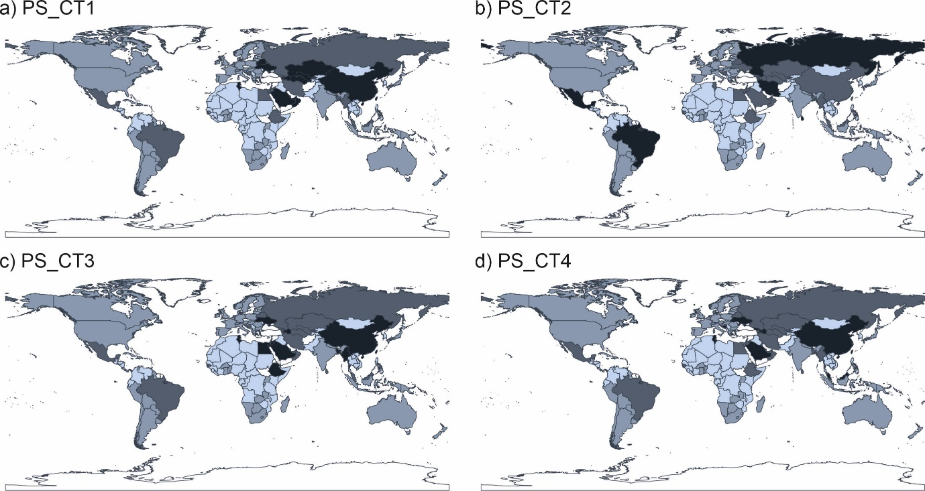

Figure 7. Map based elucidation of absence of High Prev_Slavery pathways (PS_CNT?)

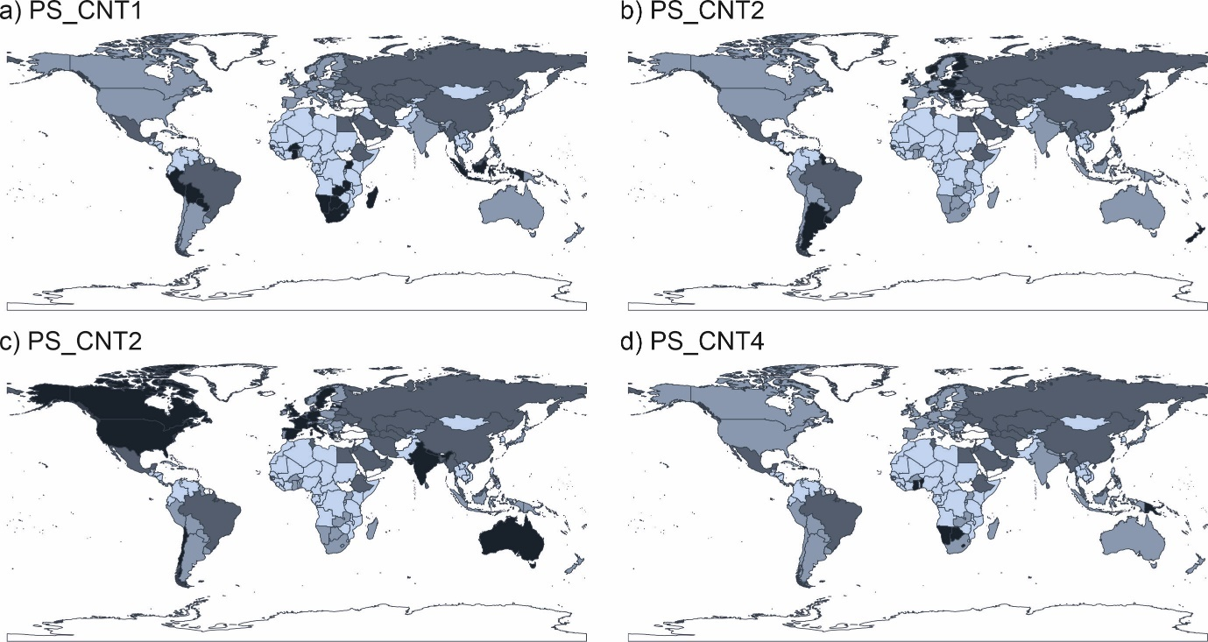

Figure 8. Map based elucidation of presence of High Govt_Rspnss pathways (GR_CT?)

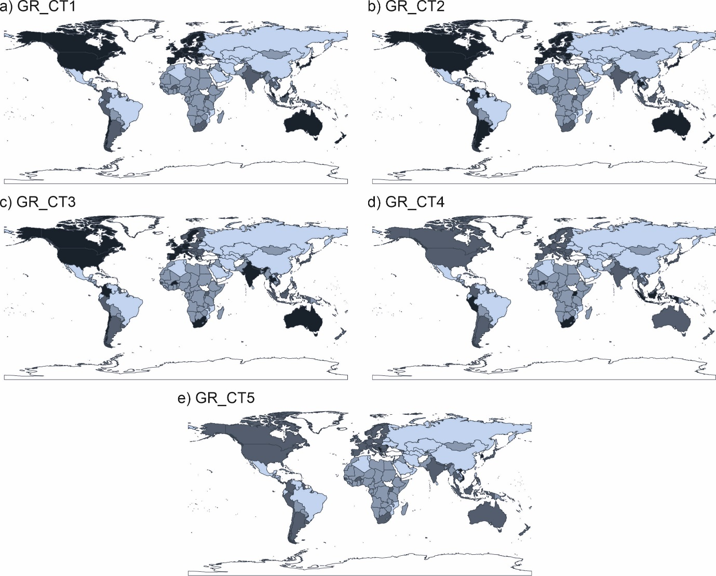

Figure 9. Map based elucidation of absence of High Govt_Rspnss pathways (GR_CNT?)

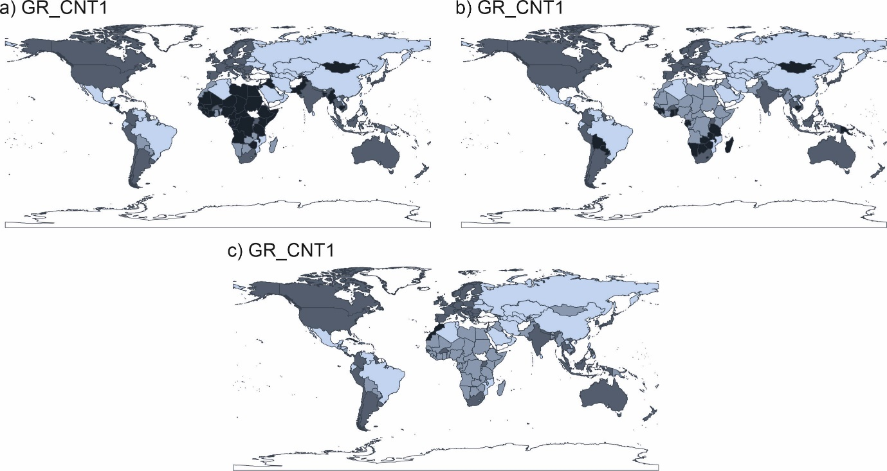

The pathway details in Tables 4 and 5, combined with the map based evidence in Figure 6 to 8 are discussed in the next section.

- Discussion
In this section a more in-depth discussion of the established pathways is given. One feature of fsQCA is that a configuration (of countries in strong membership terms) may be associated with multiple pathways in the same solution.

Prev_Slavery
PS_CT1 – This pathway suggests the presence of High Govn_Iss and High Disfran_Grps and absence of High Lack_Bsc_Nds and High Ineqlty is associated with presence of High Prev_Slavery. In geographic terms it may be a Middle-East, Cantral Asia, China and Ukraine based pathway.
PS_CT2 – This pathway suggests the presence of High Govn_Iss, High Ineqlty and High Effcts_Conflct and absence of High Lack_Bsc_Nds is associated with presence of High Prev_Slavery. In geographic terms it may be across multiple continents, but noticeable countries (e.g., Brazil, Mexico, Russia and Iran) based pathway.
PS_CT3 – This pathway suggests the presence of High Govn_Iss, High Disfran_Grps and High Effcts_Conflct and absence of High Ineqlty is associated with presence of High Prev_Slavery. In geographic terms it may be similar to PS_CT1, but further North-East Africa countries, based pathway.
PS_CT4 – This pathway suggests the presence of High Disfran_Grps and High Effcts_Conflct and absence of High Lack_Bsc_Nds and High Ineqlty is associated with presence of High Prev_Slavery. In geographic terms it is similar to PS_CT1, but less with Central Asia, based pathway.

and

PS_CNT1 – This pathway suggests the presence of High Lack_Bsc_Nds and High Ineqlty and absence of High Govn_Iss is associated with absence of High Prev_Slavery. In geographic terms it may be individual countries spread across South America, South Africa and Indonesia based pathway.
PS_CNT2 – This pathway suggests the absence of High Govn_Iss, High Lack_Bsc_Nds, High Disfran_Grps and High Effcts_Conflct is associated with absence of High Prev_Slavery. In geographic terms it may be an Eastern Europe and Argentina based pathway.
PS_CNT3 – This pathway suggests the presence of High Effcts_Conflct and absence of High Govn_Iss, High Ineqlty and High Disfran_Grps is associated with absence of High Prev_Slavery. In geographic terms it may be a North America, Western Europe and Australia based pathway.
PS_CNT4 – This pathway suggests the presence of High Lack_Bsc_Nds and High Ineqlty and absence of High Disfran_Grps and High Effcts_Conflct is associated with absence of High Prev_Slavery. In geographic terms it may be a bespoke pathway to few countries (in strong membership terms).

Govt_Rspnss

GR_CT1 – This pathway suggests the absence of High Govn_Iss, High Lack_Bsc_Nds and High Ineqlty is associated with presence of High Govt_Rspnss. In geographic terms it may be a North America, Western Europe, Japan, Australia and New Zealand based pathway.
GR_CT2 – This pathway suggests the absence of High Govn_Iss, High Lack_Bsc_Nds and High Disfran_Grps is associated with presence of High Govt_Rspnss. In geographic terms it may be a North America, All Europe, Japan, Australia and New Zealand based pathway
GR_CT3 – This pathway suggests the presence of High Effcts_Conflct and absence of High Govn_Iss and High Disfran_Grps is associated with presence of High Govt_Rspnss. In geographic terms it may be similar to GR_CNT1, with India and South Africa.
GR_CT4 – This pathway suggests the presence of High Lack_Bsc_Nds, High Ineqlty and High Effcts_Conflct and absence of High Govn_Iss is associated with presence of High Govt_Rspnss. In geographic terms it may be a bespoke country pathway, ncluded in Africa
GR_CT5 – This pathway suggests the presence of High Disfran_Grps and absence of High Govn_Iss, High Ineqlty and High Effcts_Conflct is associated with presence of High Govt_Rspnss. In geographic terms it may be a bespoke country pathway.

and

GR_CNT1 - This pathway suggests the presence of High Govn_Iss, High Lack_Bsc_Nds and High Disfran_Grps is associated with absence of High Govt_Rspnss. In geographic terms it may be a Central Africa based pathway.
GR_CNT2 - This pathway suggests the presence of High Lack_Bsc_Nds and High Ineqlty and absence of High Effcts_Conflct is associated with absence of High Govt_Rspnss. In geographic terms it may be a near South Africa and other individual countries, based pathway.
GR_CNT3 – This pathway suggests the presence of High Govn_Iss and absence of High Lack_Bsc_Nds, High Ineqlty, High Disfran_Grps and High Effcts_Conflct is associated with absence of High Govt_Rspnss. In geographic terms it may be a North Western Africa based pathway.

- Conclusions
This study has undertaken a novel configuration based analysis of the understanding of how country level vulnerabilities may be associated with, in different ways, to the prevalence of modern slavery across the world, and separately to the level of government responses. The use of fuzzy-set Qualitative Comparative Analysis (fsQCA) enables this novel configurational oriented investigation to be undertaken. It follows at the heart of this study us that different groups of countries may be associated with particular vulnerabilities, which identify them to the two outcomes
The fsQCA based necessity and sufficiency based findings do demonstrate that there is the requirement for combinations of vulnerabilities (conditions) to be considered against the different outcomes High Prev_Slavery and High Govt_Rspnss. Moreover, that different combination of such conditions may achieve the same outcome (or not-outcome). Hence, in general terms, there is clear evidence of equifinality inherent in the relations between country vulnerability and Prev_slavery and Govt_Rspnss.
While the pathway results offer inferences on the combinations of conditions which describe countries to the presence or absence of each outcome, it is interesting to note those countries included in the vulnerabilities-slavery data set, but not considered in the pathways established (the light grey shaded countries in respective maps in Figure 5). Moreover, it does exposit interesting countries, which in Figure 5, may show high or not high prevalence of slavery, they are grouped in a configuration with other countries which has meant an ‘ambiguous’ association of countries I a configuration to either the presence or absence of high prevalence of slavery.
Clearly, this analysis has used data from a single source, namely WFF. The limited form of available vulnerability conditions considered may be a factor in the previous paragraphs comment, on ‘ambiguous’ configuration associations with some countries. In future research, it may be interesting to expand on the considered conditions (even if from alternative data sources).

Appendix
This appendix outlines a number of technical details of the fsQCA work undertaken.
The first results are further calibrations details, using the Direct method, which transforms the original percentage interval scale domain based values of each condition and outcome to fuzzy membership values, see Figure A1.

Figure A1. Calibration details of the conditions and outcome

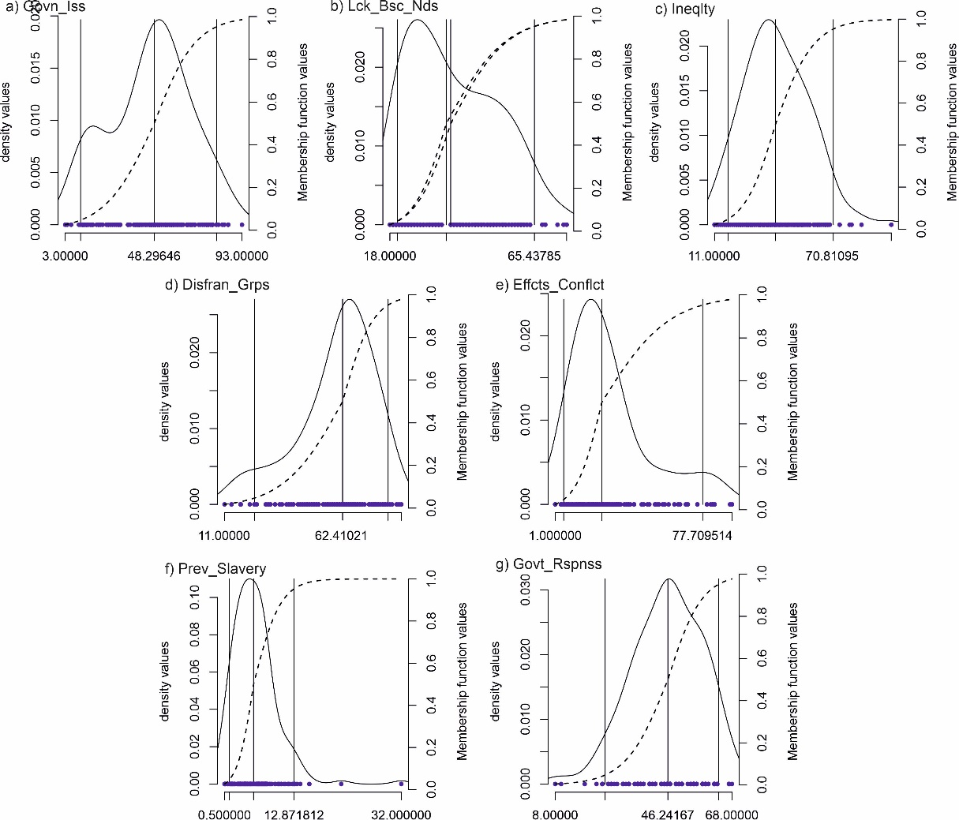

In each plot in Figure A1, the solid curved line is the associated pdf of the respective sets of values (themselves shown along the bottom of a plot), the three dotted vertical lines are the respective qualitative anchors (x^{Ʇ}, x^{x} and x^{T}), and curved dashed line the created fuzzy membership function (over 0-1 domain on the right hand y-axis).
The next set of graphical results are the map based elucidations of the fuzzy membership values given to each country for the considered conditions in the vulnerability-slavery data set, see Figure A2 (noting the same results for the outcomes are given in Figure 3 in main text).

Figure A2. World map of fuzzy membership values of countries across different conditions

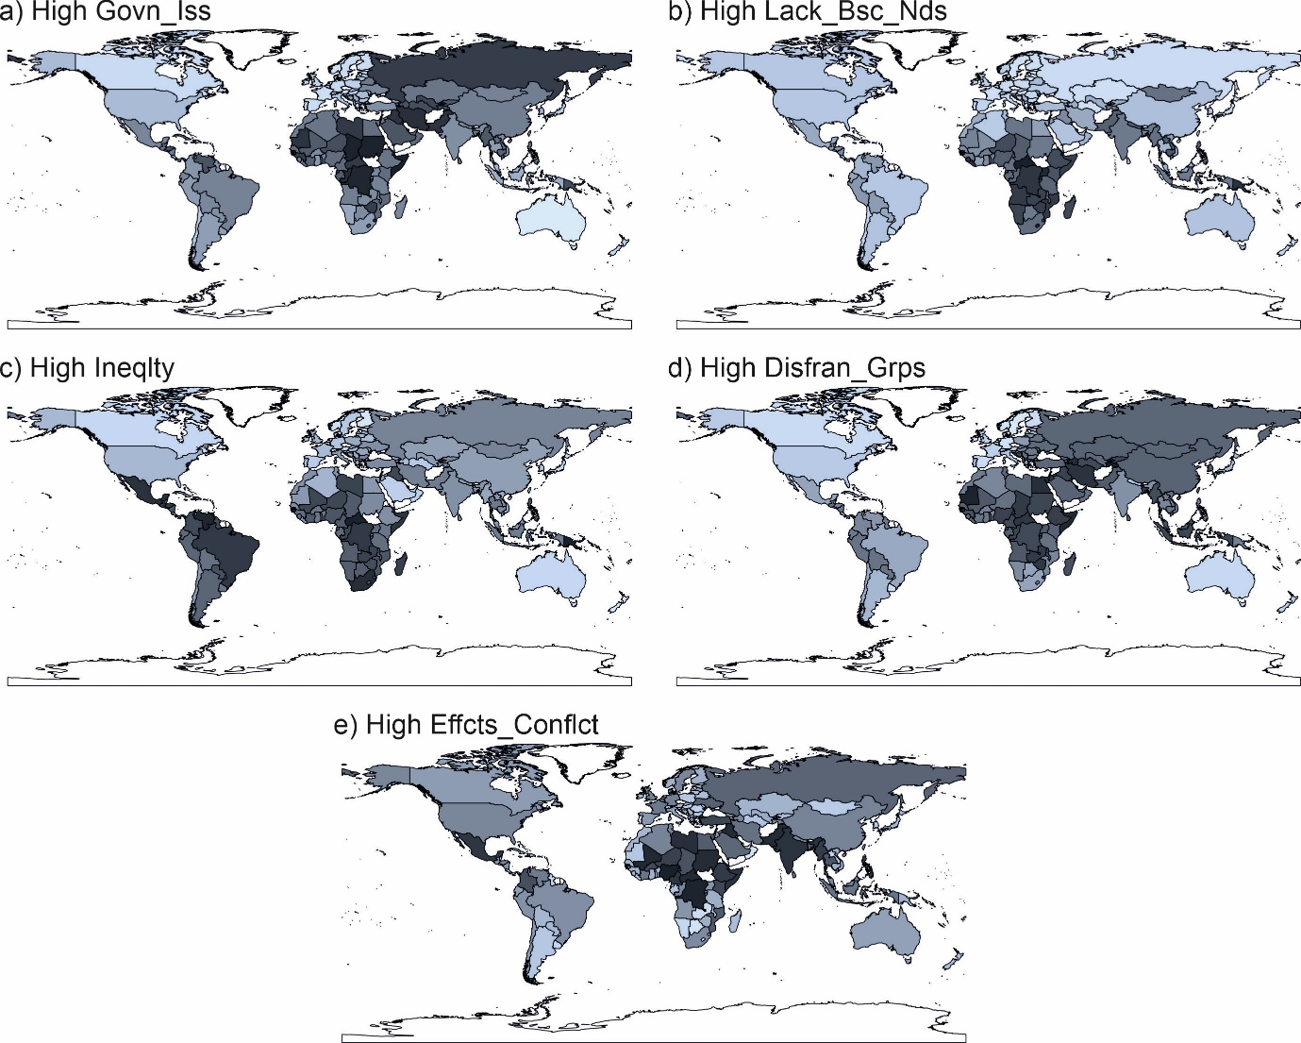

In each map in Figure A2, the darker the shaded countries the higher the fuzzy membership values, and therefore association to the condition. The next results are in terms of details to help create necessary frequency and consistency thresholds, see Figure A3.

Figure A3. Frequency and Consistency plots (Frqthld - 1.5)

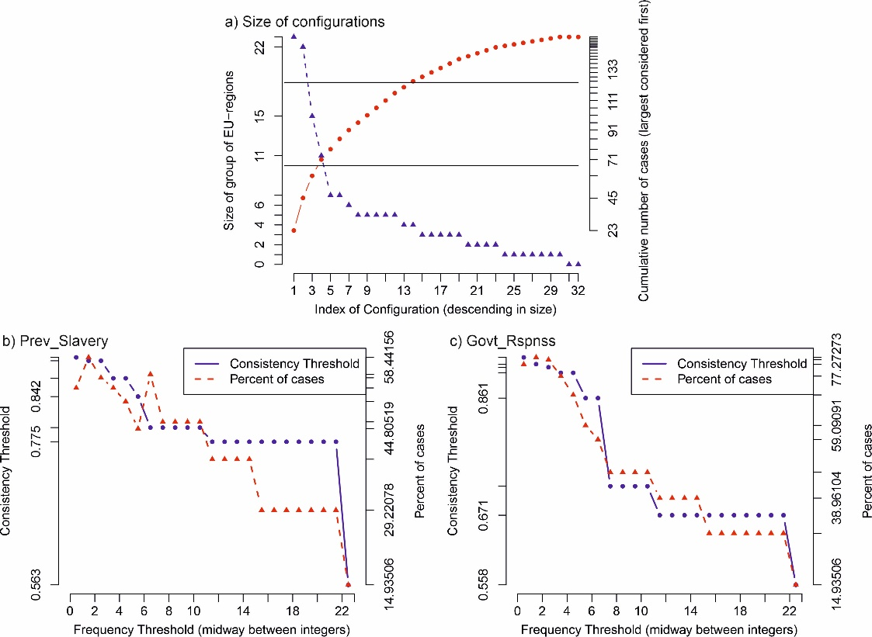

In Figure A3, three plots are presented to facilitate an overview of the appropriate levels of frequency and consistency threshold to employ in this study. In Figure A3a, the scale of the numbers of cases to a configuration in strong membership terms is exposited (noting these details are concerned with the conditions only – so are pertinent to both investigated outcomes). Moreover, going left to right on the x-axis, the frequency of cases to each configuration are frequency size ordered, from largest of 23 (Cnfg 1 in Table 3) to 0 (Cnfgs 9 and 26 not shown in Table 3). The successive cumulative sums of most largest associated configurations is also shown on the left y-axis (for example largest two configurations are of size 23 and 22 in size which sum to 45 as shown on right y-axis).
In Figure A3b and A3c denotes respective results for the consistency thresholds associated with each outcome (High Prev_slavery and High Govt_Rspnss). Moroever, in each plot, the x-axis denotes a possible frequency threshold and then the respective circle (joined by solid lines) are the minimum consistency threshold which would assure that no configuration, based on consistency values, could be future associated with both the outcme and not-outcome (as exposited in Andrews et al., 2016). It follows, the combination of frequency and consistency thresholds (and imposed PRI-score 0.5 threshold), will dictate the number of cases future considered (in the configurations), as shown in the triangle points (dashed line joined) sets of points also shown (with gradation of percentage of cases shown on the right y-axis). Inspection shows respective largest number of cases future considered are both when using frquency threshold 1.5 (≥ 2) and respective consistency threshold values.

References
Andrews, R., Beynon, M. J., & McDermott, A. M. (2016). Organizational capability in the public sector: A configurational approach. Journal of Public Administration Research and Theory, 26(2), 239-258.
Brankovic, J. (2021). “Measure of shame”: Media career of the Global Slavery Index. In Worlds of rankings (pp. 103-125). Emerald Publishing Limited.
Douglas, E. J., Shepherd, D. A., & Prentice, C. (2020). Using fuzzy-set qualitative comparative analysis for a finer-grained understanding of entrepreneurship. Journal of Business Venturing, 35(1), 105970.
Gallagher, A. T. (2017). What's wrong with the Global Slavery Index?. Anti-Trafficking Review, (8).
Geremew, Y. M., Huang, W. J., & Hung, K. (2023). Fuzzy-set qualitative comparative analysis as a mixed-method and analysis technique: A comprehensive systematic review. Journal of Travel Research, 00472875231168619.
Guth, A., Anderson, R., Kinnard, K., & Tran, H. (2014). Proper methodology and methods of collecting and analyzing slavery data: An examination of the global slavery index.
Han, C., Jia, F., Jiang, M., & Chen, L. (2022). Modern slavery in supply chains: a systematic literature review. International Journal of Logistics Research and Applications, 1-22.
Jackson, L. (2023). Re-(B) ordering: The Impact of the European Union’s Externalisation of Migration on the Human Rights of Migrants in Libya. Forced Migration and Modern Slavery: Unplanned Journeys of Exploitation and Survival, 8(1), 65.
Jordan, E., Gross, M. E., Javernick-Will, A. N., & Garvin, M. J. (2011). Use and misuse of qualitative comparative analysis. Construction Management and Economics, 29(11), 1159-1173.
Kraus, S., Ribeiro-Soriano, D., & Schüssler, M. (2018). Fuzzy-set qualitative comparative analysis (fsQCA) in entrepreneurship and innovation research–the rise of a method. International Entrepreneurship and Management Journal, 14, 15-33.
Larsen, J. J., & Durgana, D. P. (2017). Measuring vulnerability and estimating prevalence of modern slavery. Chance, 30(3), 21-29.
Lavelle-Hill, R., Smith, G., Mazumder, A., Landman, T., & Goulding, J. (2021). Machine learning methods for “wicked” problems: exploring the complex drivers of modern slavery. Humanities and Social Sciences Communications, 8(1), 1-11.
Locatelli, G., Konstantinou, E., Geraldi, J., & Sainati, T. (2022). The dark side of projects: Uncovering slavery, corruption, criminal organizations, and other uncomfortable topics. Project Management Journal, 53(4), 327-330.
Mehmood, W., Ahmad, A., Aman‐Ullah, A., & Mohd‐Rashid, R. (2023). Modern slavery: A literature review using bibliometric analysis and the nexus of governance. Journal of Public Affairs, 23(1), e2832.
Mello, P. A. (2021). Qualitative comparative analysis: An introduction to research design and application. Georgetown University Press.
Nikou, S., Mezei, J., Liguori, E. W., & El Tarabishy, A. (2022). FsQCA in entrepreneurship research: Opportunities and best practices. Journal of Small Business Management, 1-18.
Pettinato, T. (2023). Modern Slavery: a System of Exploitation. Study on Vulnerability Factors’ Dynamics.
Ragin, C. C. (2008). Redesigning social inquiry: Fuzzy sets and beyond. University of Chicago Press.
Ragin, C. C., and P. Fiss (2008). Net effects versus configurations: An empirical demonstration. In Redesigning social inquiry: Fuzzy sets and beyond, ed. Charles C. Ragin, 190–212. Chicago, IL: University of Chicago Press.
Tickler, D., Meeuwig, J. J., Bryant, K., David, F., Forrest, J. A., Gordon, E., ... & Zeller, D. (2018). Modern slavery and the race to fish. Nature communications, 9(1), 4643.
Vis, B., & Dul, J. (2018). Analyzing relationships of necessity not just in kind but also in degree: Complementing fsQCA with NCA. Sociological methods & research, 47(4), 872-899.
WFF (2023) https://www.walkfree.org, Accessed 10-07-2023

One aspect of this data quality issue is the acknowledged inability to compare the data over multiple years, hence discounting ‘panel’ based analysis opportunities.
The non-inclusion of other countries is discussed in WFF (2023).
Two further countries are excluded from this study, namely, North Korea and Eritrea, the reasons being the extreme outlier values of prevalence of slavery indicated.
The use of 5th, 50th and 95th percentiles is similar to what is often undertaken on condition and outcome values, but here they are in respect to the constructed pdfs.
Equivalent world maps for each of the conditions are shown in Appendix A (see Figure A2).
The domains in the scatterplots in Figure 4 are from 0.4 to 1.0 (and not from the more general 0.0 to 1.0).
Following Mello (2021) a PRI-score threshold of 0.5 is imposed, post the impact of the dual frequency and consistency threshold values.
Numerical ‘measure’ details are only given for the complex solution based pathways.

